**Assignment 24.1**

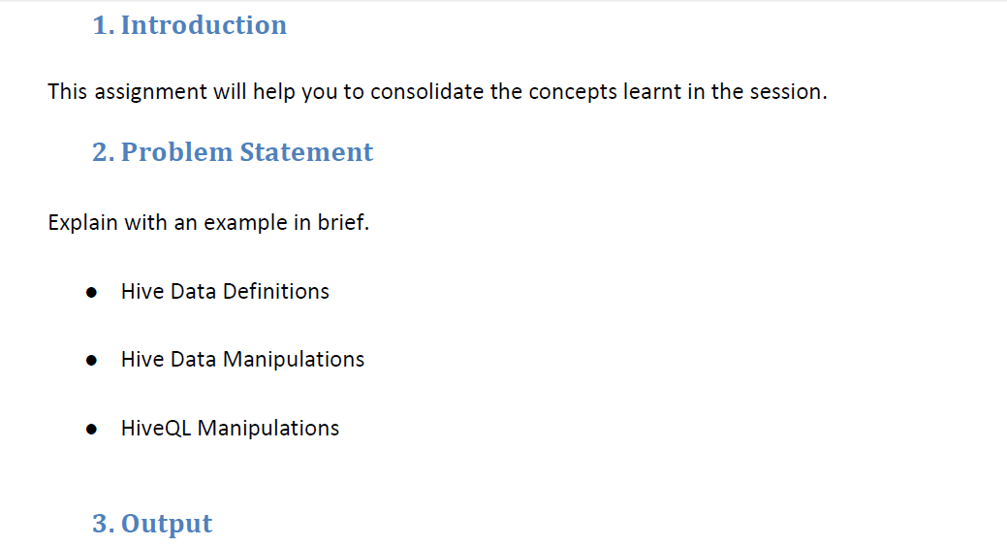

|  |
| --- |
| * **Hive Data Definitions:** |
| * hive data definition language act as a part of HiveQL and it is used for the process of create or alteror drop the database,view,index or table. |
|  |

|  |
| --- |
| **For eg:** |
| * ***create command:*** * It is used to create table which is followed by SQL conventions. * When hive version is included then it provides with excessive support as well wide flexibility range. * Where the data files will be stored for the tables provided as well the format which is used. * ***Create database department:*** * When IF NOT EXISTS command is used in hive create command then it will not consider that even when the table exists. * When a table is created and run for the first time then this will be useful. |
|  |
|  |

|  |
| --- |
|  |
| *CREATE TABLE IF NOT EXISTS (mb.travel):*  Here mb-database  travel-tablename | |
|  | |

|  |
| --- |
|  |
|  |

|  |
| --- |
| * ***Drop command***   There will not be any warning from the hive side when the table specified is already present.  So we should drop the table which already exists so there are chances to lose your previous data and to create those again. |
|  |

|  |
| --- |
|  |
|  | |

|  |
| --- |
|  |
|  |

|  |
| --- |
| *DROP DATABASE IF EXISTS human_resource:* |
|  |

|  |
| --- |
|  |
|  |
| * **Alter command** | |
| ALTER TABLE can be used to alter | |
| Most of the table properties where there will be metadata exchange | |

Between the tables but

|  |
| --- |
| But there will not be any data exchange.   * And these help to fix the mistakes present as well to move the location of the partitions as well some other operations. |
|  |

|  |
| --- |
|  |
|  |
|  |
|  |

|  |
| --- |
|  |
|  |

|  |
| --- |
|  |
|  |

|  |
| --- |
| * **Hive Data Manipulations:** |
|  |
|  |

|  |
| --- |
| * It is a language which is useful to put the data into the tables of hivewhich is used to extract the data to the file system present. * And helps in exploring data with queries or grouping,joining,filtering etc. * They are also used to load the data. |
|  |

|  |
| --- |
|  |
|  |

|  |
| --- |
| ***EXAMPLES:*** |
|  |
|  |

|  |
| --- |
|  |
|  |

|  |
| --- |
| Load data local inpath **'${env:home}/cognizant-employees'** |
|  |

|  |
| --- |
| Overwrite those into the table employees |
|  |

|  |
| --- |
| Partition using **(country = 'us', state = 'ca');** |
|  |

|  |
| --- |
|  |
|  |

|  |
| --- |
|  |
| --------------------------------------------------------------------------------------------------------------------- |

|  |
| --- |
| * **HiveQL Manipulations:** |
|  |
|  |

|  |
| --- |
|  |
|  |

|  |
| --- |
| **For Examples:** |
|  |

|  |
| --- |
|  |
|  |

|  |
| --- |
| **• LOAD** |
| It is used to load the files into the table.  Ther will not be nay transformation when data is loaded into table.  It will be copy/move operations which helps to move the data between hive tables. |
|  |

|  |
| --- |
|  |
|  |
|  | |

|  |
| --- |
| * **Syntax** |
|  |

|  |
| --- |
|  |
|  |

|  |
| --- |
| LOAD DATA [LOCAL] INPATH **'filepath'** [OVERWRITE] INTO TABLE tablename |
|  |

|  |
| --- |
| [PARTITION (partcol1=val1, partcol2=val2 ...)] |
|  |

|  |
| --- |
|  |
|  |

|  |
| --- |
| **• INSERT** |
|  |
|  |

|  |
| --- |
| * Inserting data into Hive Tables from queries. |
|  |

|  |
| --- |
| * Query Results can be inserted into tables by using the insert clause. |
|  |
|  |

|  |
| --- |
| **Syntax** |
|  |

|  |
| --- |
|  |
|  |

|  |
| --- |
| INSERT OVERWRITE TABLE tablename1 [PARTITION (partcol1=val1, partcol2=val2 ...) |
|  |

|  |
| --- |
| [IF NOT EXISTS]] select_statement1 FROM from_statement; |
|  |

|  |
| --- |
| INSERT INTO TABLE tablename1 [PARTITION (partcol1=val1, partcol2=val2 ...)] |
|  |

|  |
| --- |
| select_statement1 FROM from_statement |
|  |
|  |

|  |
| --- |
|  |
|  |

|  |
| --- |
| **• UPDATE** |
|  |
|  |

|  |
| --- |
| **Syntax** |
|  |

|  |
| --- |
|  |
|  |

|  |
| --- |
| UPDATE tablename SET column = value [, column = value ...] [WHERE expression] |
|  |

|  |
| --- |
|  |
|  |

|  |
| --- |
| **• DELETE** |
|  |
|  |

|  |
| --- |
| **Syntax** |
|  |

|  |
| --- |
| DELETE FROM tablename [WHERE expression] |
|  |
|  |

|  |
| --- |
|  |
|  |

|  |
| --- |
|  |
|  |

|  |
| --- |
| • **MERGE** |
|  |
|  |

|  |
| --- |
| **Syntax** |
|  |

|  |
| --- |
| MERGE INTO <target table> AS T USING <source expression/table> AS S |
|  |

|  |
| --- |
| ON <boolean expression1> |
|  |

|  |
| --- |
| WHEN MATCHED [AND <boolean expression2>] THEN UPDATE SET <set clause list> |
|  |

|  |
| --- |
| WHEN MATCHED [AND <boolean expression3>] THEN DELETE |
|  |

|  |
| --- |
| WHEN NOT MATCHED [AND <boolean expression4>] THEN INSERT VALUES<value list> |
|  |