**Assignment 24.2**

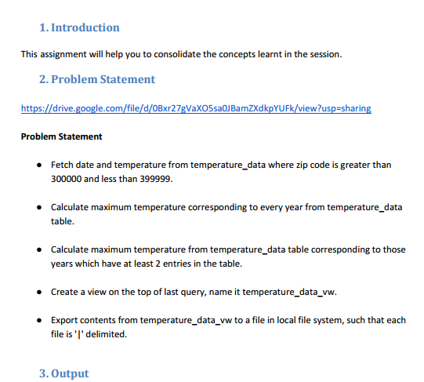

* **Creating databases**

first we will create a database where we will create our views and tables,using following

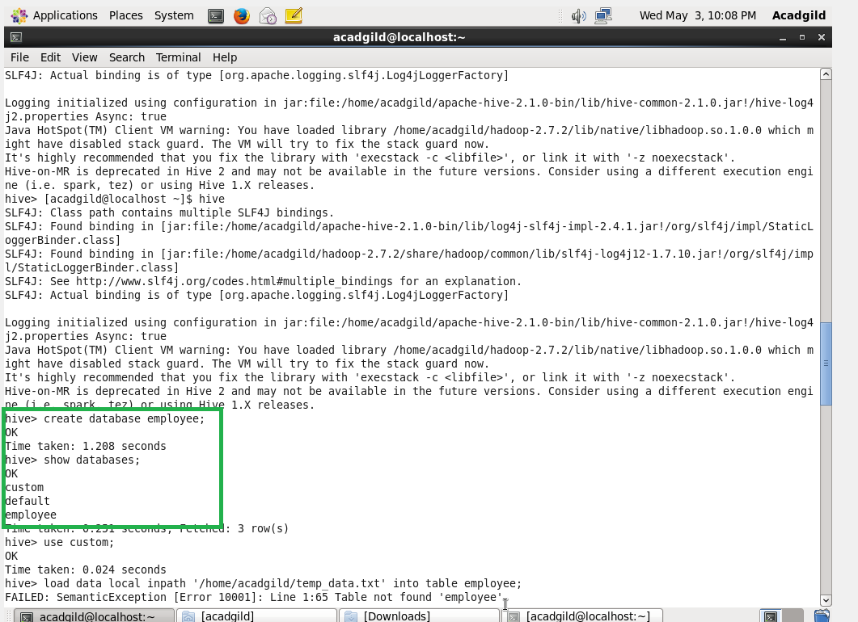

* **Creating table**

Now using create command we will create temperature table –

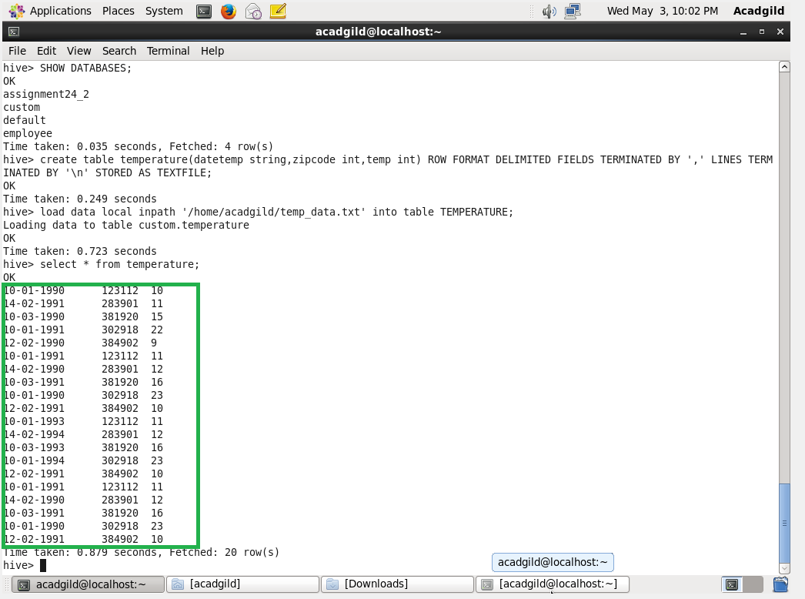

* **Loading data**

Now we will load our data file that us temperature_data into our temperature table as :

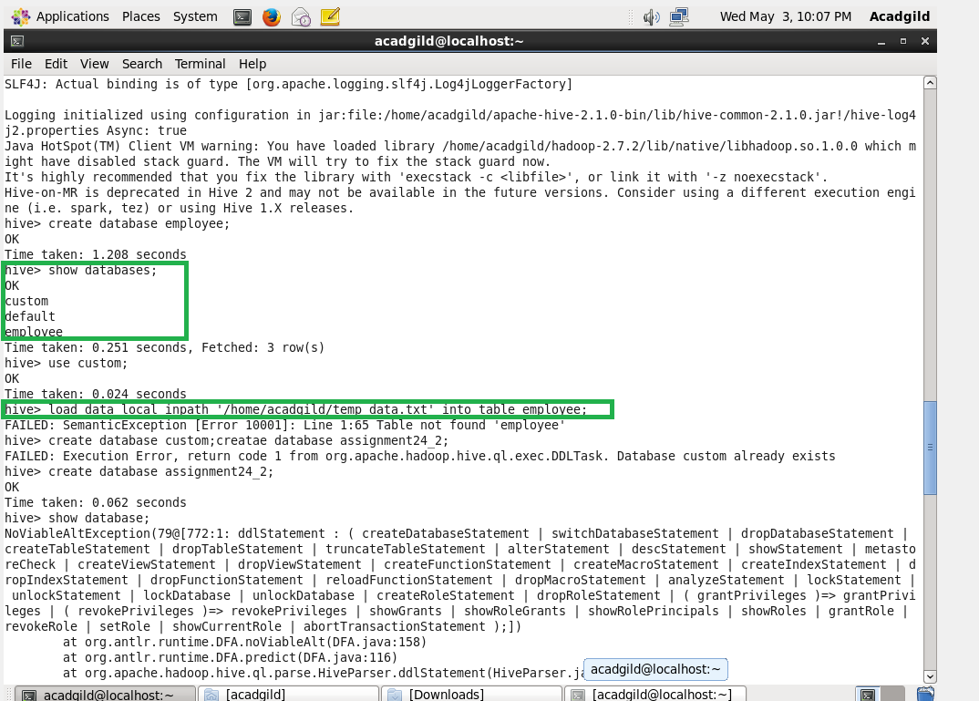

So now using select command we can see the data inside the table-



* **1. Fetch date and temperature from temperature_data where zip code is greater than 300000 and less than 399999.**
* The temperature for the particular will be chosen.
* So where condition will be used here.
* And the zipcode to be used should be 300000 and 399999 .

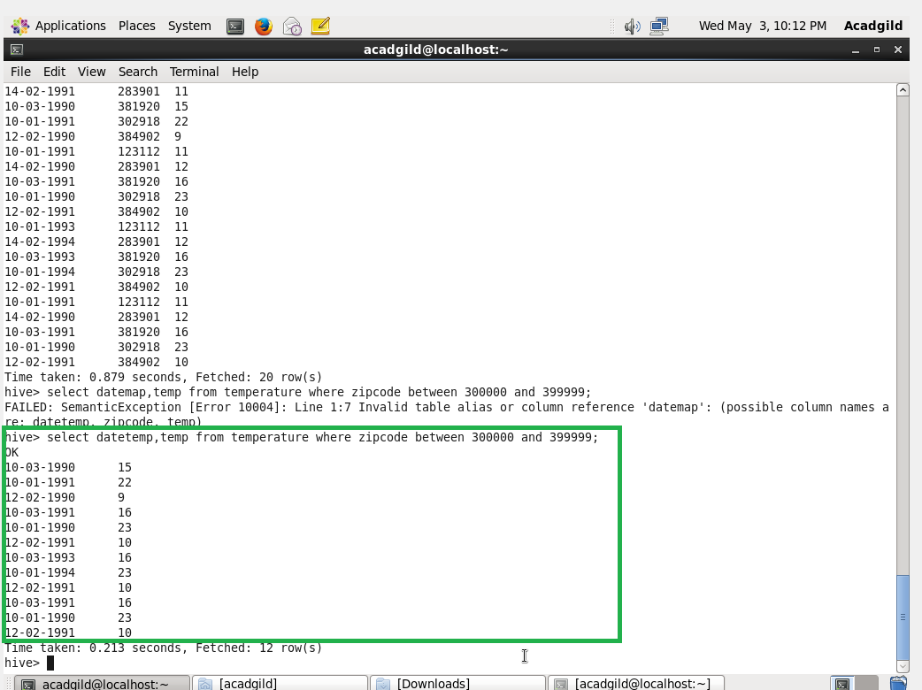

a

* **2. Calculate maximum temperature corresponding to every year from temperature_data table.**
* Substring method will be used for extracting the year.
* In order to find the maximum temperature max function will be used.
* Group by to group the result.
* 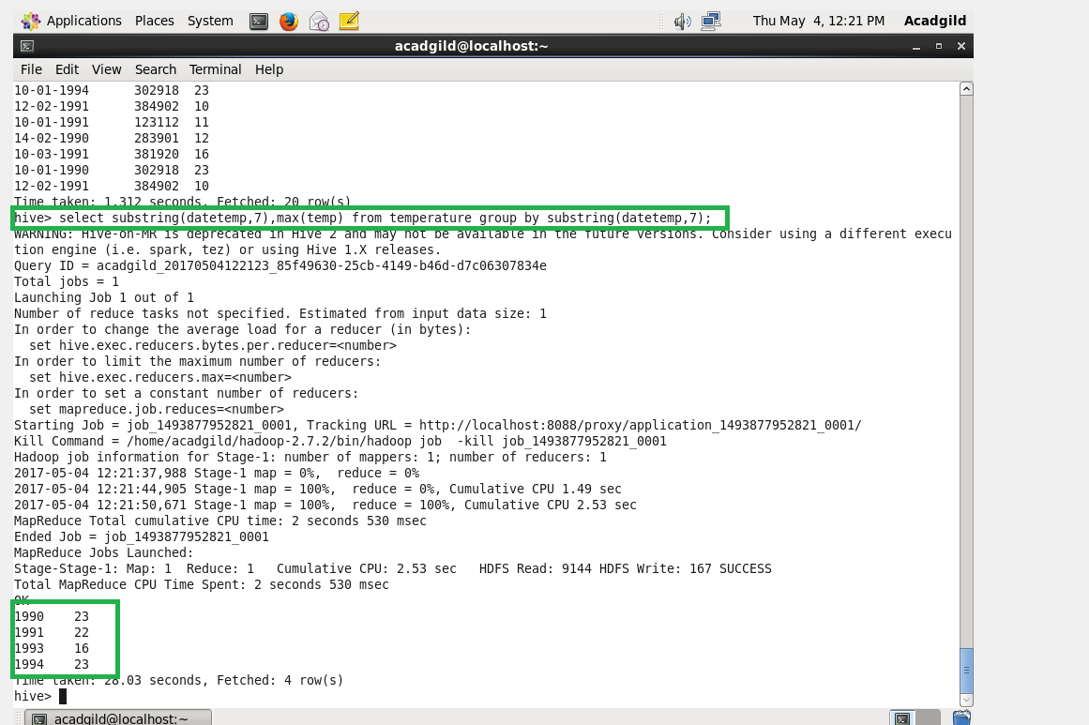
* **3. Calculate maximum temperature from temperature_data table corresponding to those years which have at least 2 entries in the table.**
* This is calculate the maximum temperature from the table.
* Count function is used because it will have a least of 2 entries in each table.
* So that it will be useful to check more than 1 entry which is greater then 1.
* Count –aggregate function.

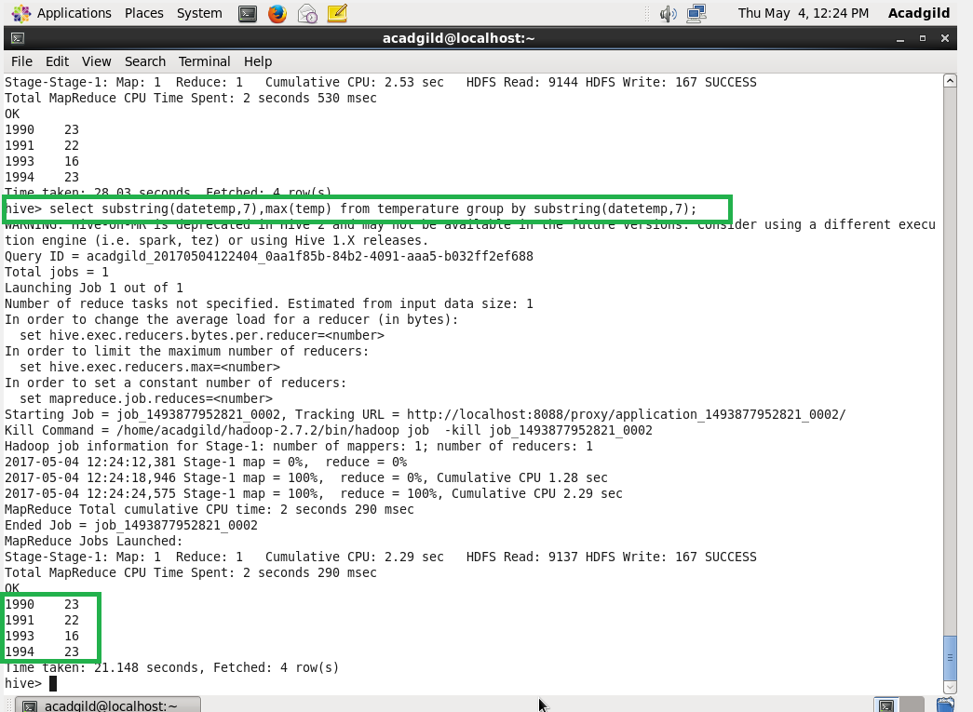

* **4. Create a view on the top of last query, name it temperature_data_vw.**

Now using create view command we will create view on the top of previous query

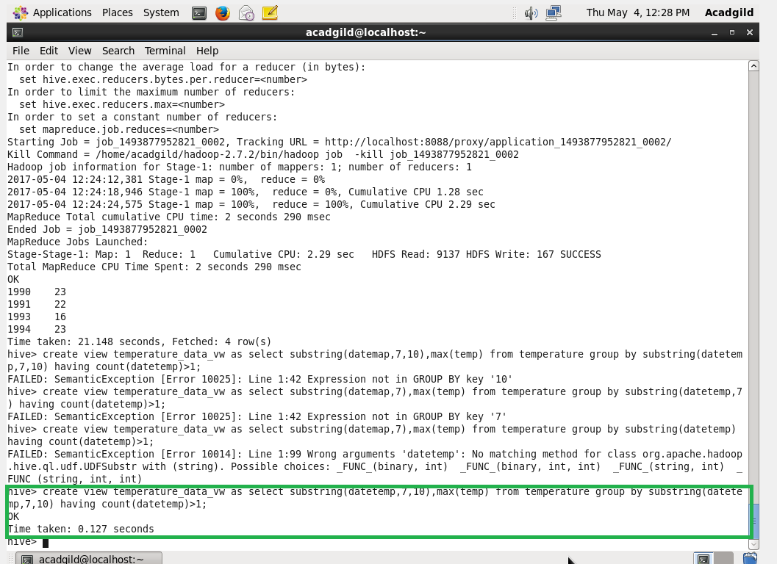

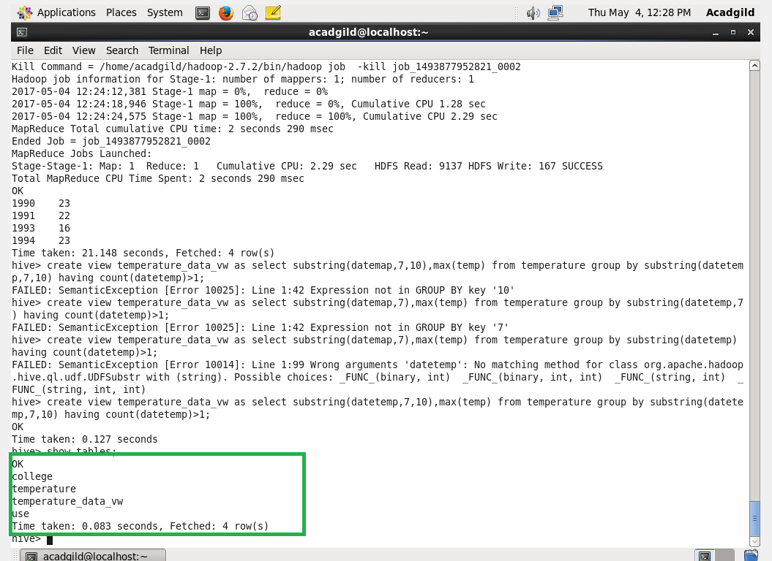

**Output:**

Select query is used to view the data as per our wish.

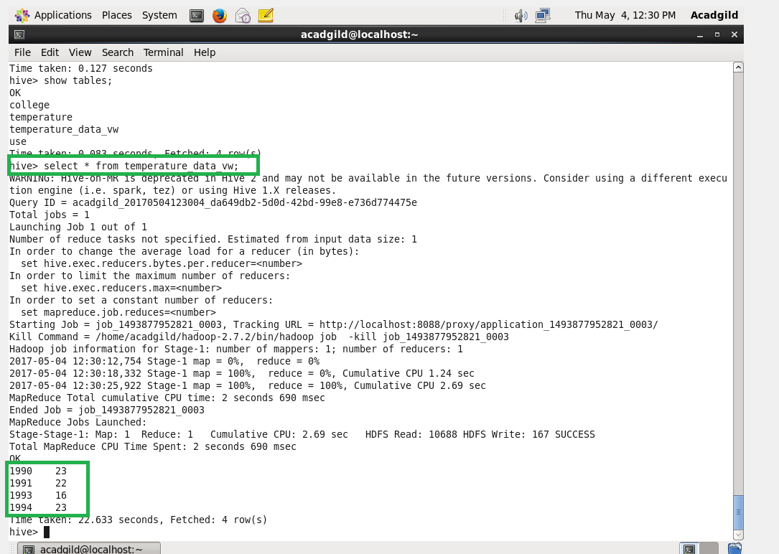

* **5. Export contents from temperature_data_vw to a file in local file system, such that each file is '|' delimited.**

Insert command is used to export the contents from view format to local file format.

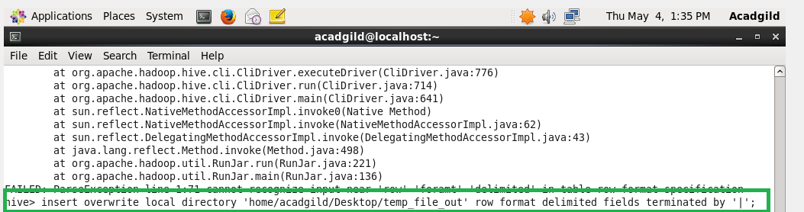

**We can see the data in our local file –**

