***1.Write a hive query find the average age of male and female persons died in the titanic tragedy***

* All the data were grouped.
* And will be stored as Text file.

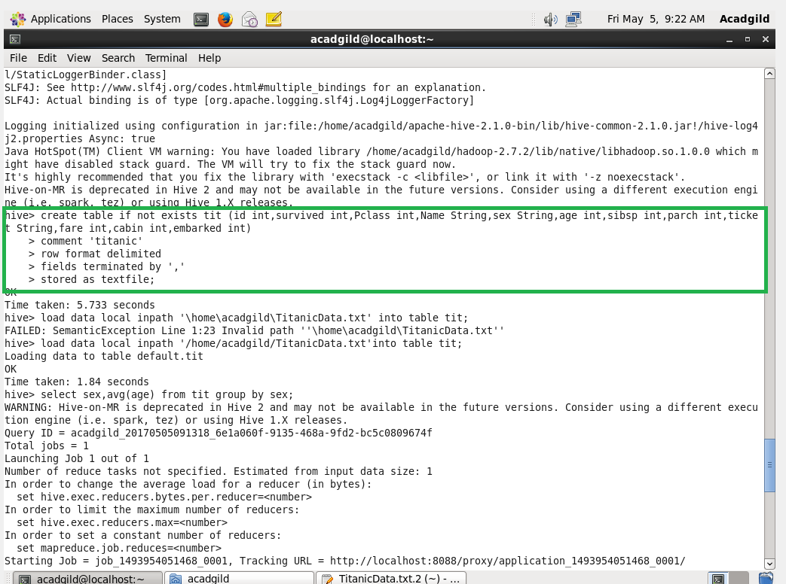

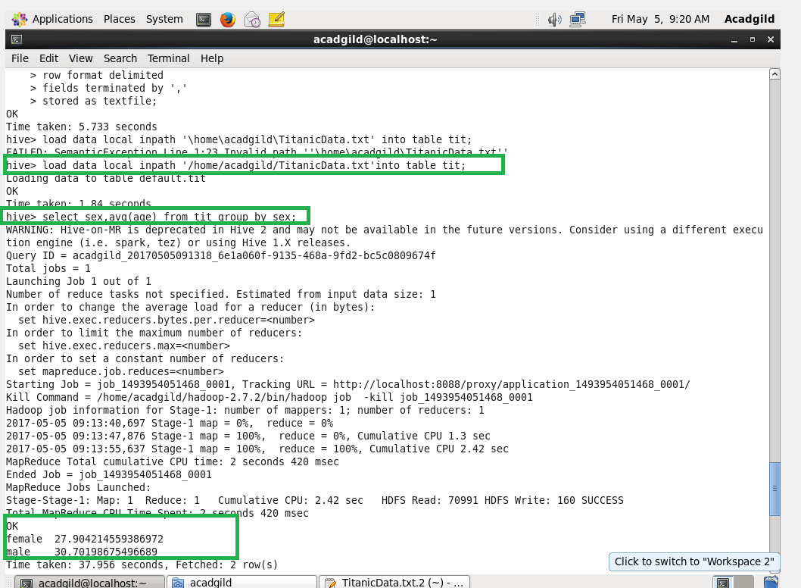

***2.Write a hive query to find the number of people died and survived in each class.***

* Passenger class and the survived will be selected.
* And all those selected will be counted.
* And later will be grouped by Passenger class and survived.

