***1.Write a hive query to find the minimum temperature observed in a given weather station in a particular year.***

* *Using substring only the date will be filtered.*
* *And group by will be done to pick the weather data details.*

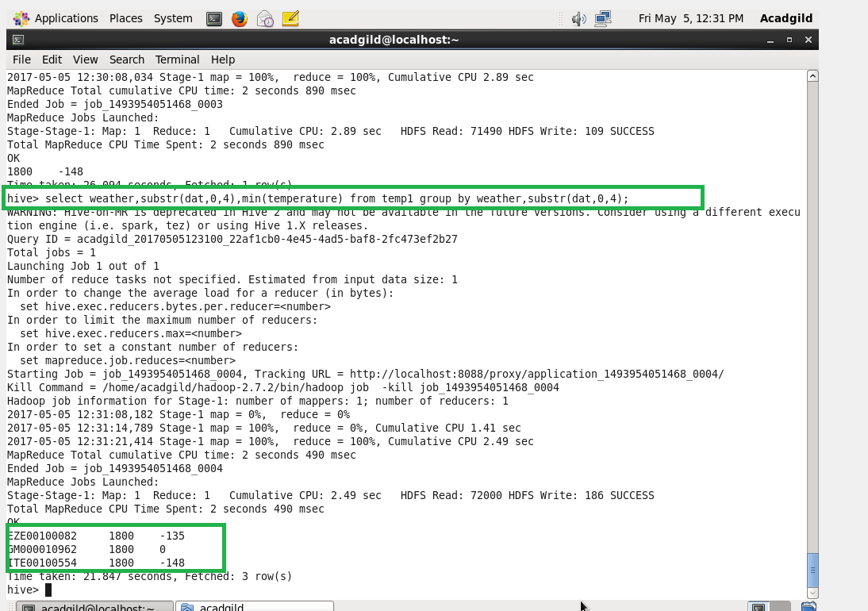

***2. Write a hive query to find the maximum temperature observed in a given weather station in a particular year.***

* ***By using max command the maximum temperature can be retrieved.***
* ***Sub string is used to fetch some data (yea).***

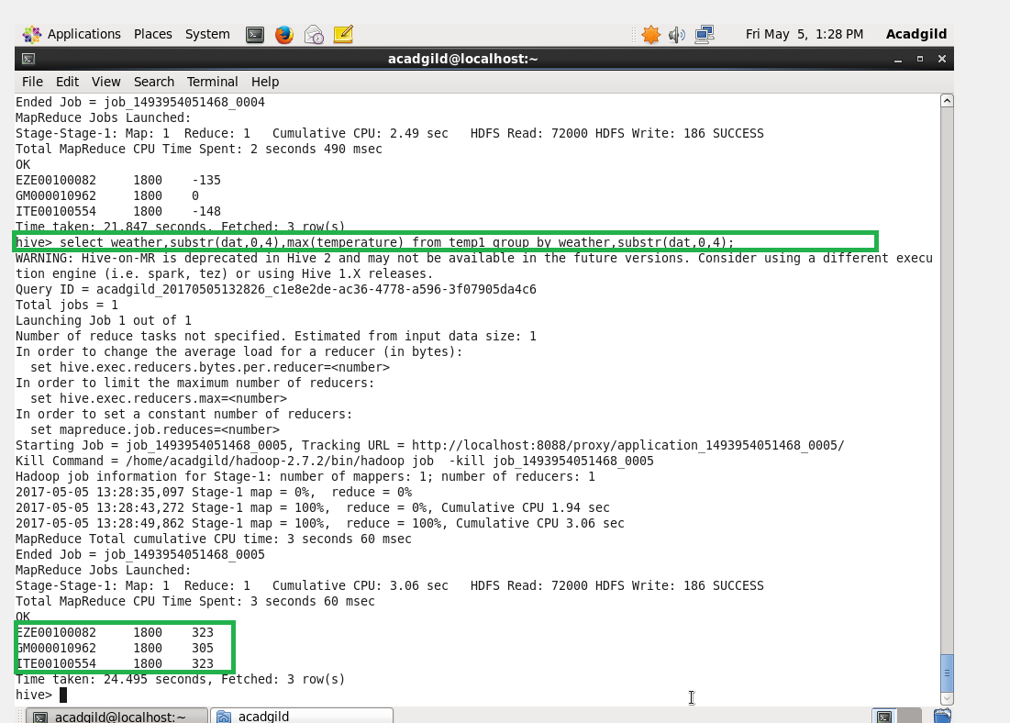

***3. Write a hive query to find the number of readings given by each weather station according to the dataset. You can download the dataset from the below link.***

* *Is used to count all the details in the weather.*

