***ASSIGNMENT-25.4***

**1.Write a hive query to find the top 20 destination people travel the most: Based on the given data**

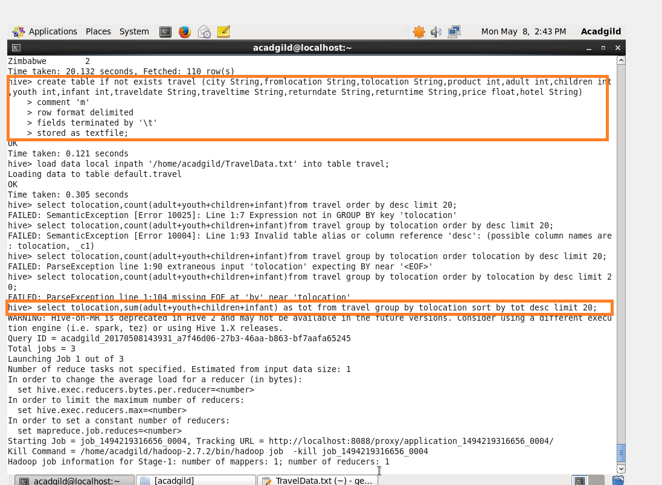

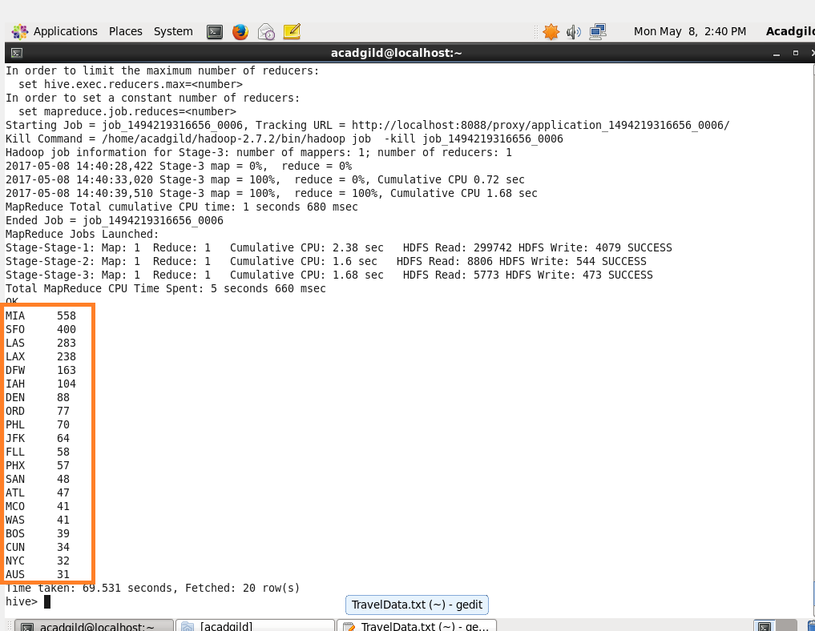

**2. Write a hive query to find the top 20 locations from where people travel the most**

* Add (adult+infant+youth and children) and named it as ‘tot’.
* In order to sort them.

