**Perform word count in Hive for above given dataset.**

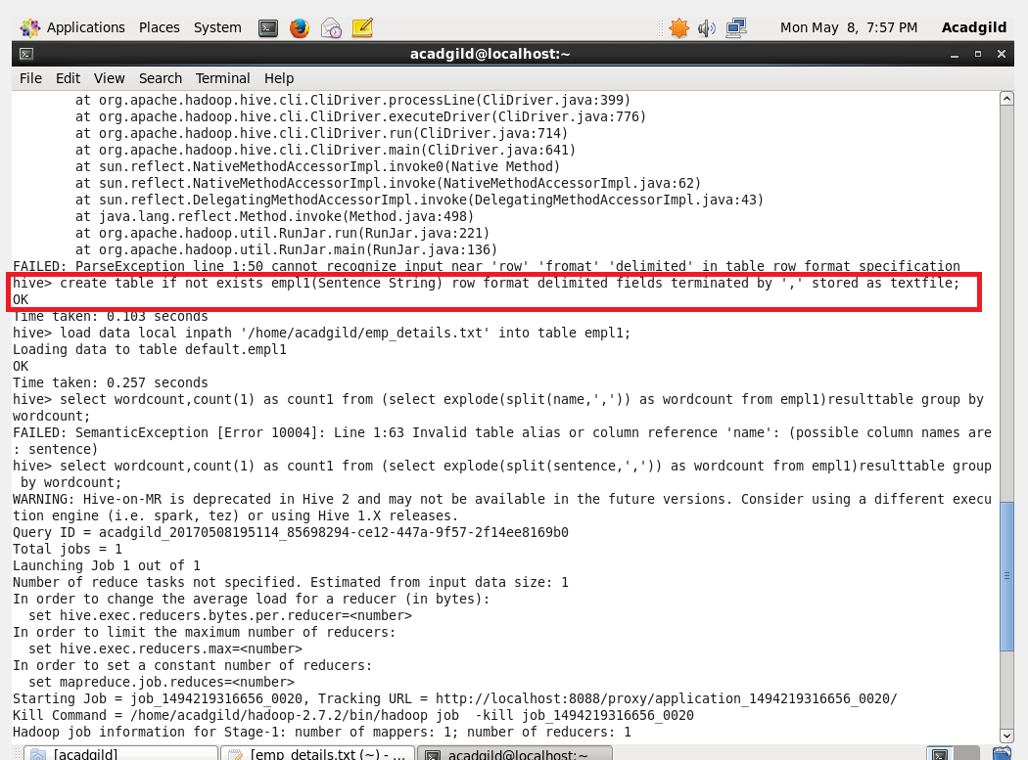

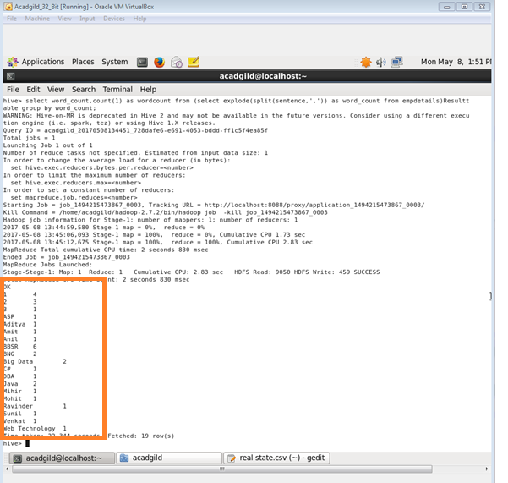

**2. Explain the working of Partitioning in brief.**

* The term ‘Table partitioning’ - dividing the data inside the table into number of parts which is based on column values.
* (eg date or country, segregating the input records which is into the different types of files/directories which was based on date or country).
* Partitioning will be done on the basis of column
* Where multi_dimensional structure will be imposed on the directory for storage.
* For example- additional to partitioning log the records of the date column we can also sub divide to a single day record which will be country wise separate files
* And it will include country column into partitioning.

*There are two types,*

*1)Static partitioning*

*2)Dynamic partitioning*

***1.)Static partitioning:***

* In static partitioning the input data will contain all the columns listed detail which will be done only in table definition
* but columns will not be defined in partitioned by clause.
* If input column layout = expected layout
* Then the input files will be separated for each partitioned key value pairs
* For example- there will be one separate file allotted for each combination of country and state values
* These files can be easily loaded into partitioned table

***2.)Dynamic partitioning:***

* Partition will be loaded for for each partition.
* Which will be will be with the help of SQL statements.
* And it will result in a lot of SQL statements
* As well there will be a huge no of partition.
* HIVE will support dynamic partition
* So we can add any number of partitions using a single SQL execution.
* Using Hive automatic splitting of data into separate partition files based on the values of partition keys present in the input files.

***3. Explain the difference between Static and Dynamic Partitioning in Hive with an example.***

S**tatic Partition in Hive**

* Individually input data files were inserted into the partition table
* Static Partition is usual while loading files (big files) into Hive tables
* Mostly static partitions are preferred.
* Using Static Partition will save the time of data loading when compared to dynamic partition
* “Statically” one can add data to the a partition table and move the file into the table.
* One can even alter the partition in static.
* Using file name you can get value of the partition column.
* Eg-day of date etc..
* Without reading the whole big file.
* Hive should be proper if one needs to use Static partition.

set hive.mapred.mode = strict

* It will be set default in hive-site.xml
* Strict Mode will be followed in Static partition.
* You should use where clause to use limit in static partition
* One can perform Static partition on Hive Manage table or external table.

***Dynamic Partition in Hive***

* When there is a Single insert to partition table is known as dynamic partition
* dynamic partition will usually load data from non partitioned table.
* But more time is needed for data loading when compared to static partition.
* There will be large data stored in a table so Dynamic partition is suitable.
* When there is a need to partition number of column but number of column’s were not known to know the column number dynamic partition is suitable
* No requirement of where clause to use limit.
* Alteration can’t be performed on Dynamic partition.
* You can perform dynamic partition on hive external table
* If one need to use Dynamic partition in hive then mode should be in nonstrict mode
* In hive dynamic partition properties you should allow.