***Create table RealEstate in Hive database, with all the columns present in dataset.***

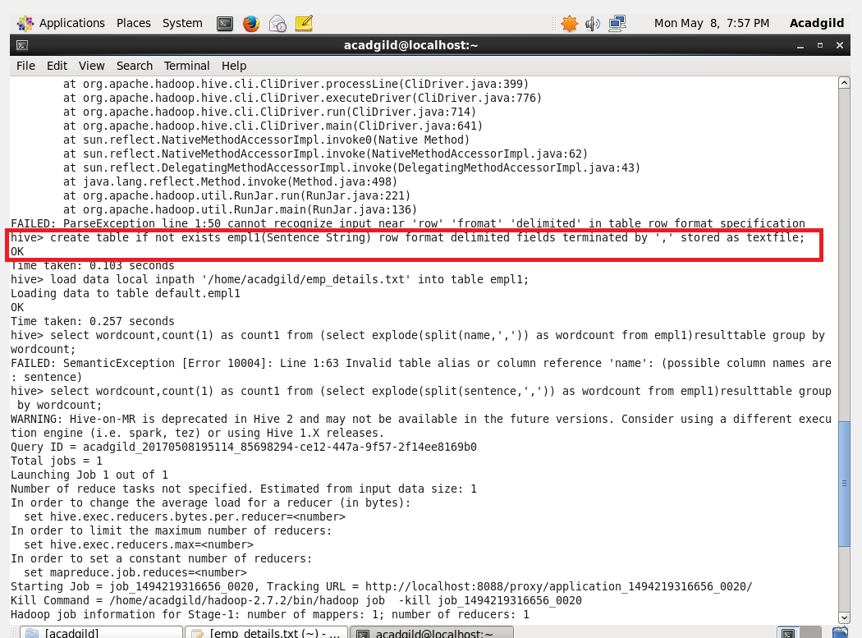

***Load dataset into table realEstate.***

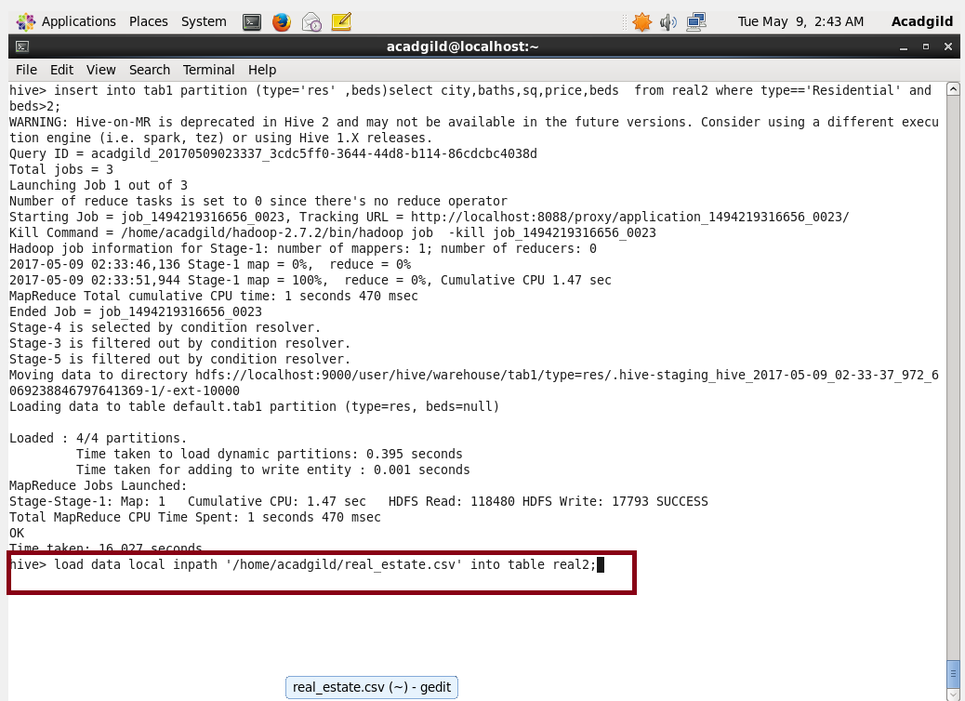

***Using Dynamic partition get separate lists of residential apartments with more than 2 beds and include columns in following order City,Baths,Sq_feet,Price,flat_type,Beds respectively.***

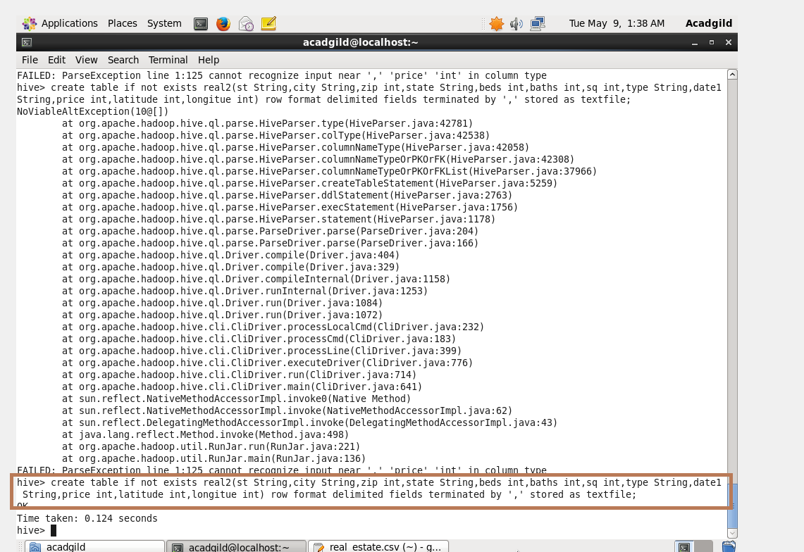

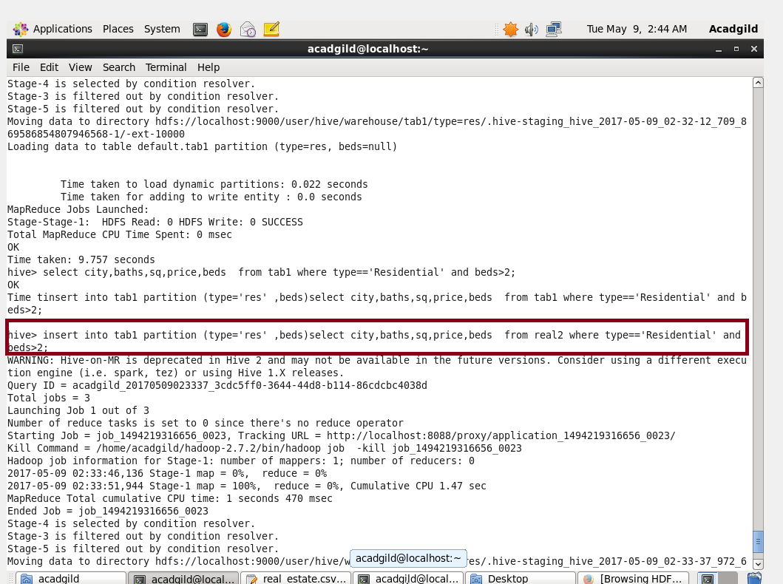

* Table tab1 was created and since beds were dynamic partition since their number were defined they were provided inside the partition.
* And other parameters were selected.

***Output***

