***Assisgnment-27.4***

***Run parallel jobs in hive by following the steps in the below blog link.***

* Three of customer tables were created and those three tables were joined by using normal join by making use of their ID.

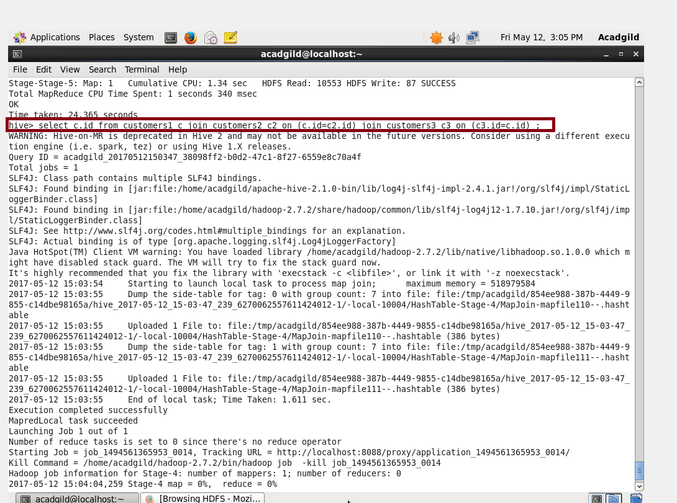

Output after joining three tables.

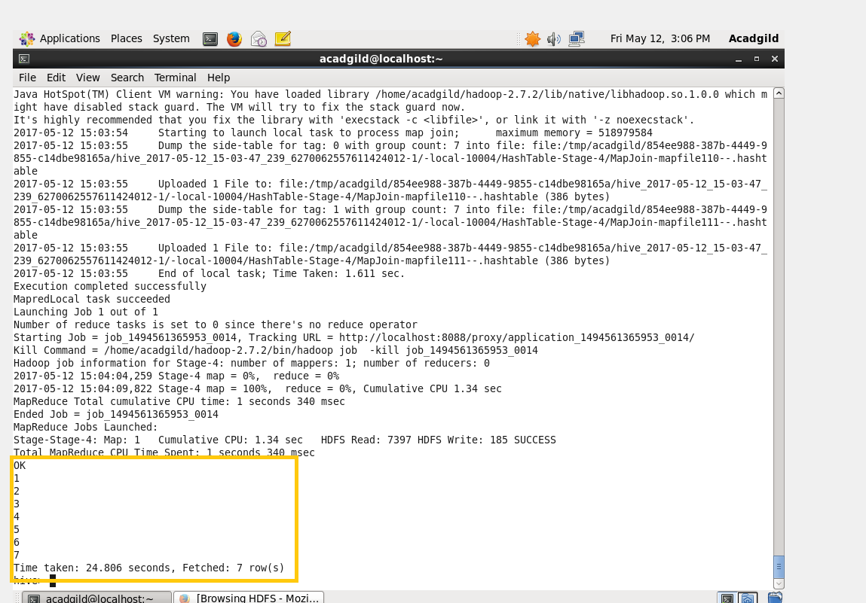

Since 4 data for those tables were already loaded.

Description of those 4 tables were provided:

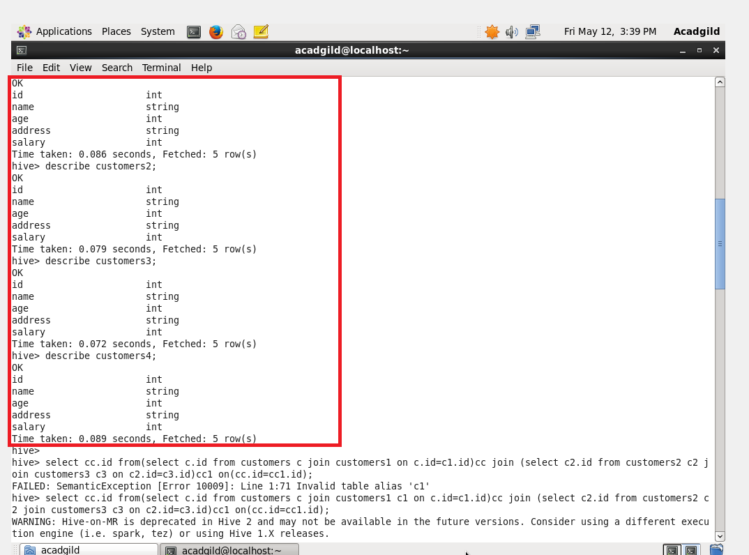

When 4 tables were in a two way manner

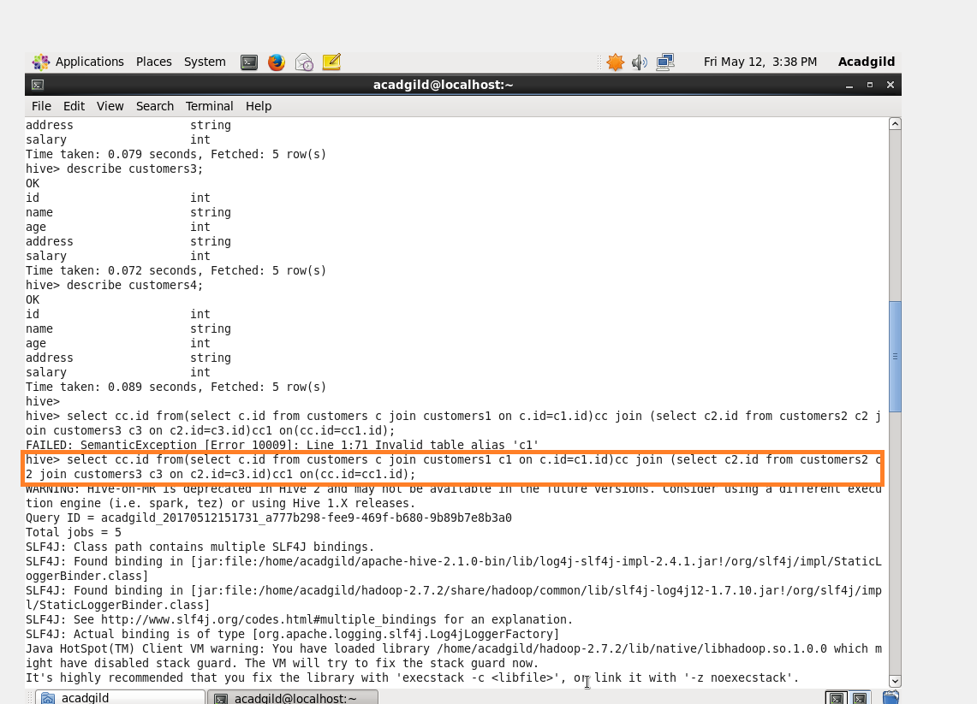

Output after 4 tables were Joined.

