**ASSIGNMENT 29.2**

**Write a hive UDAF to find the largest integer in a column. Use your own dataset for the above problem statement and attach the steps performed, codes used with the result.**

**STEP 1: WRITING JAVA CODE TO FIND LARGEST INTEGER IN THE COLUMN**

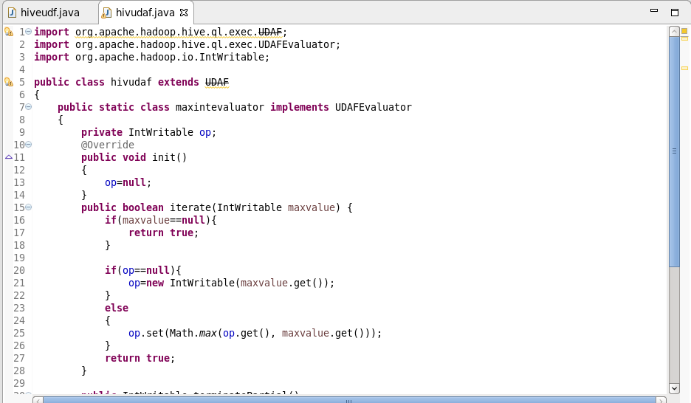

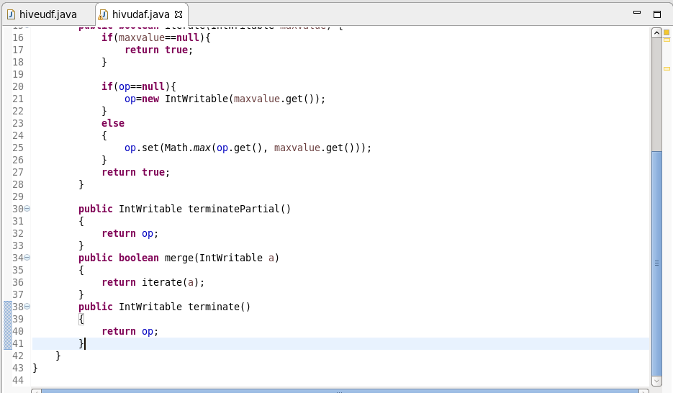

**STEP 2: ADDING JAR TO THE HIVE SHELL**

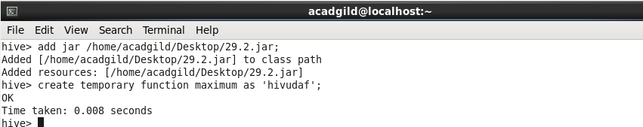

**STEP 3: I AM USING CUSTOMER TABLE FOR FINDING MAXIMUM SALARY**

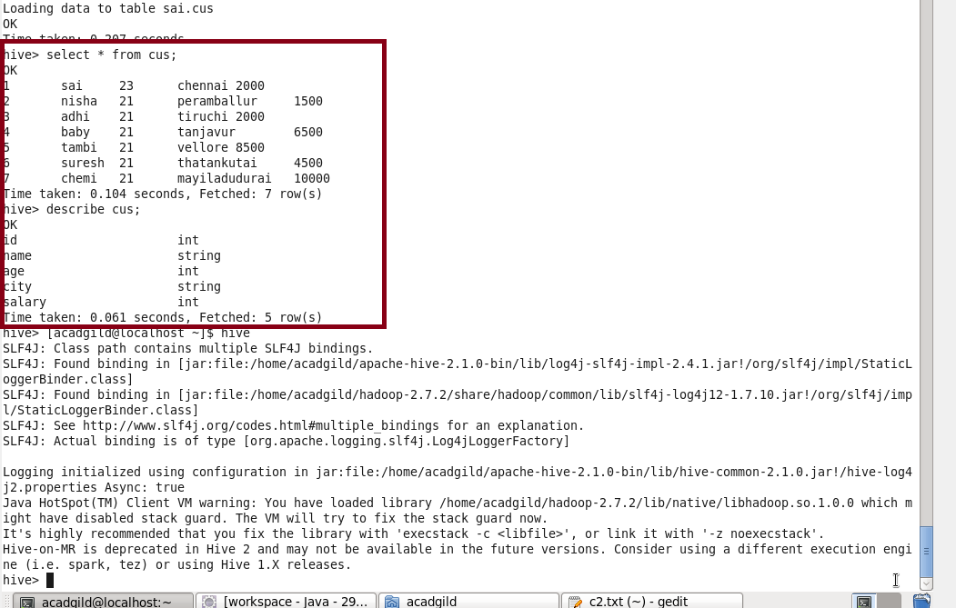

**STEP 4: USING MAXIMUM TEMPORARY FUNCTION**

