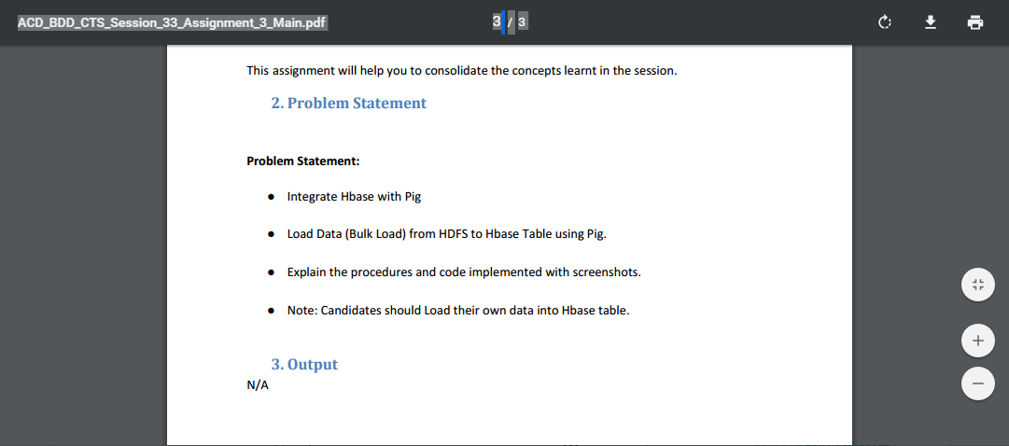

**STEP 1: creating the table “custo1” and loading data into it in HIVE**

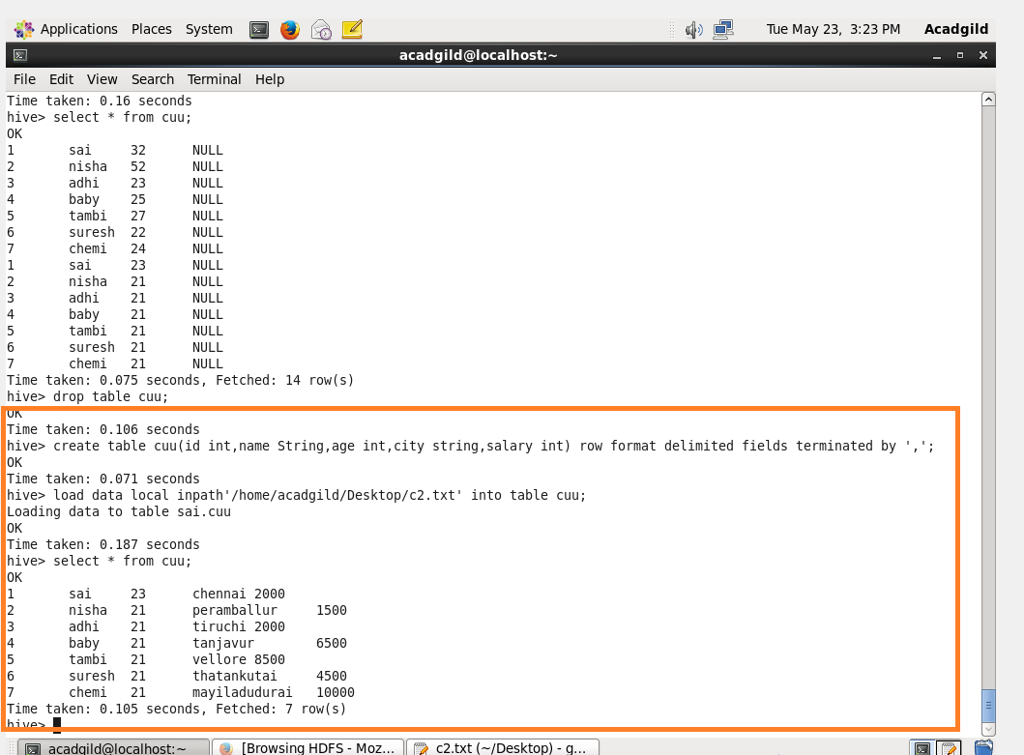

**Step 2: creating a table ‘customer1’ with details as column family in HBASE**

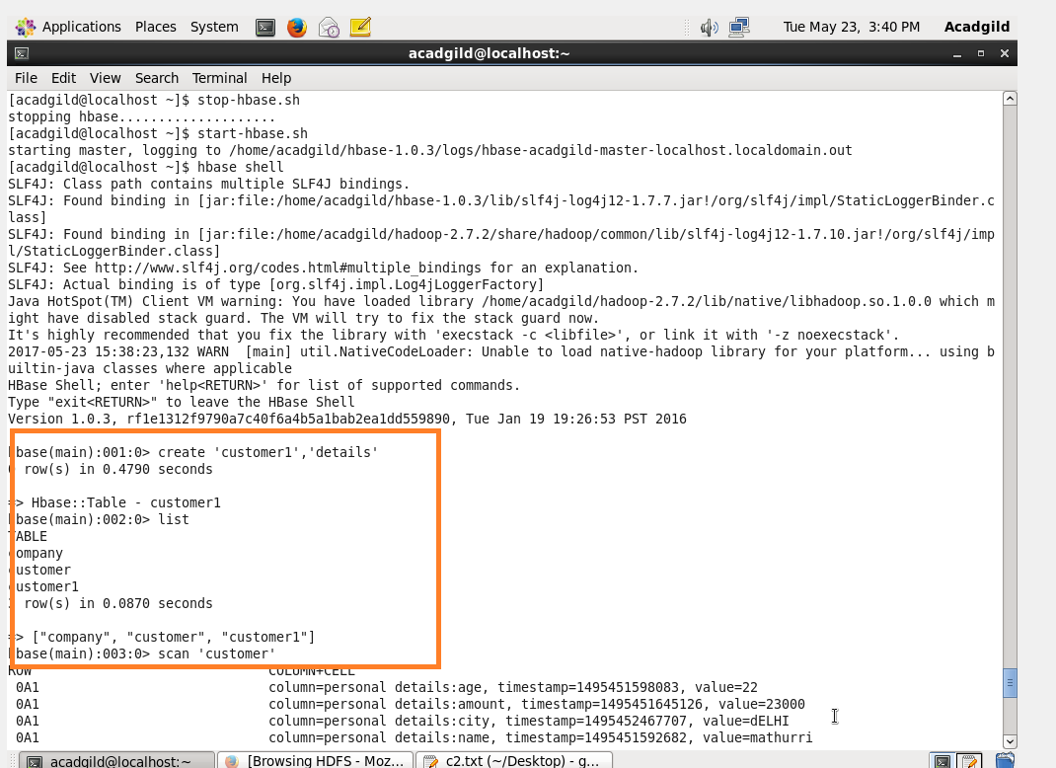

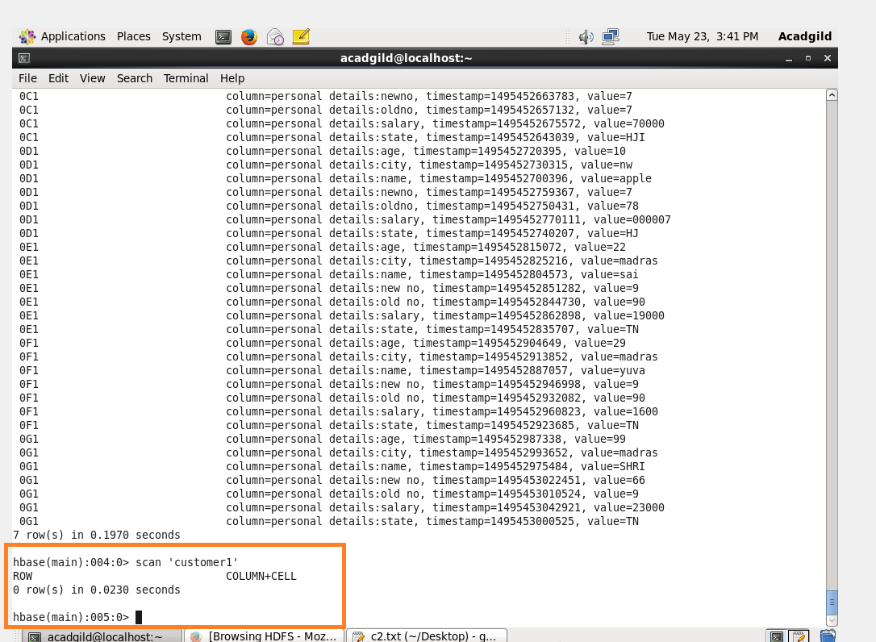

**STEP 3:**

**creating external table and loading data into it from hive**

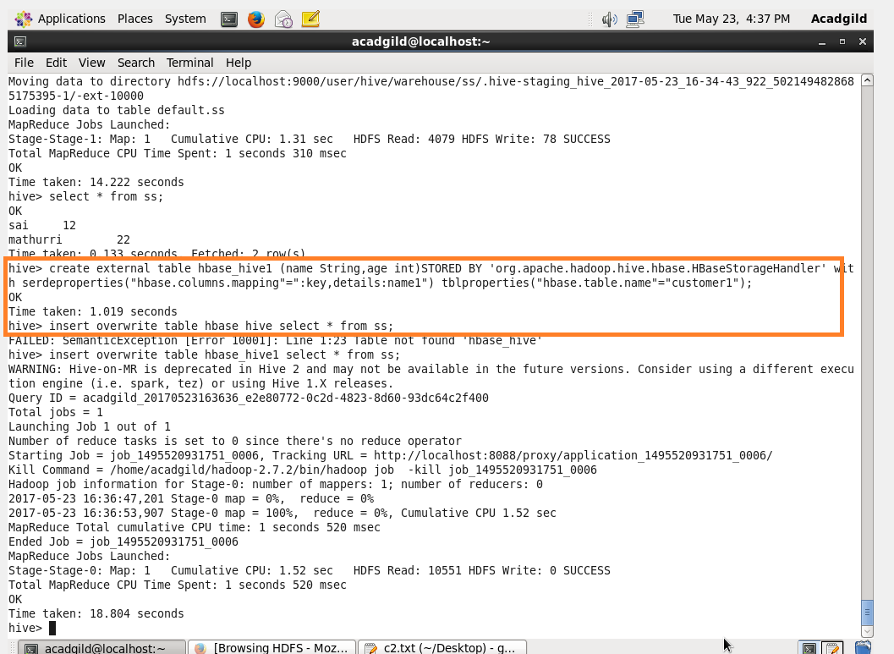

**Step 4:**

**Data automatically gets transferred from hive to hbase**

