**ASSIGNMENT 35.1**

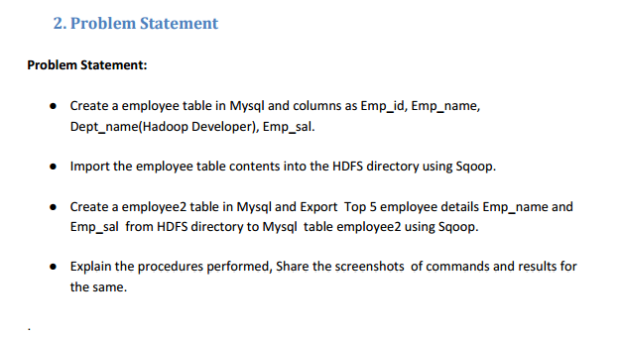

**Step 1: creating a database and table in mysql and inserting data into the table**

**Step 2: displaying the contents of the table employee**

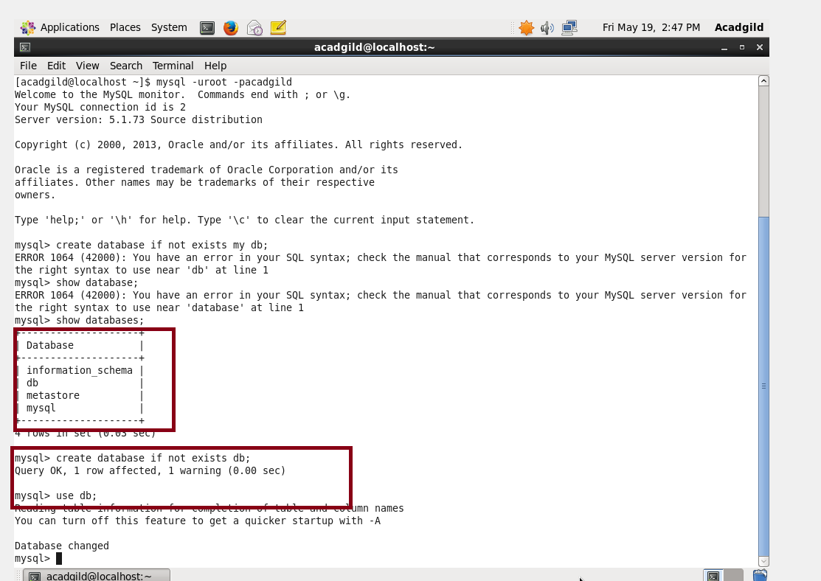

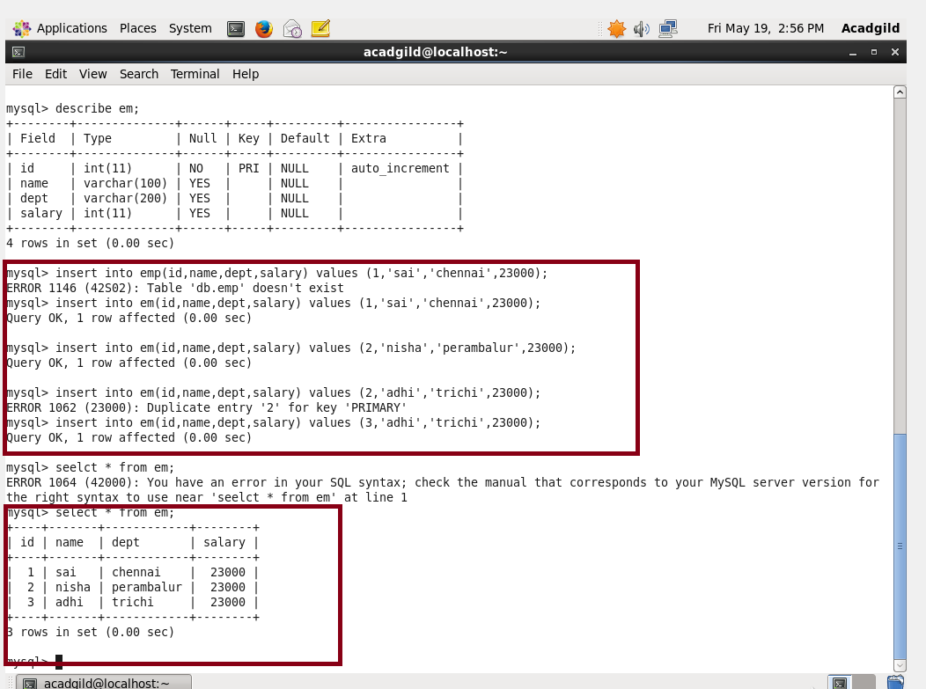

**Step 3: importing the data in mysql to hdfs by giving passworseled**

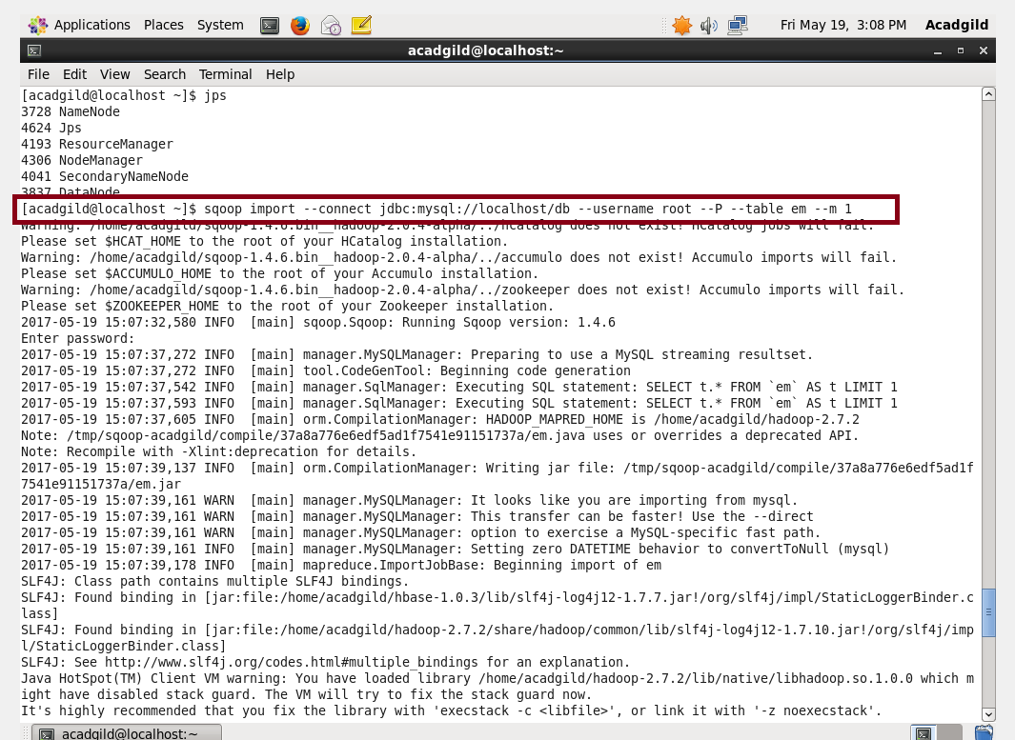

**Step 4: successfully imported to the hdfs from mysql**

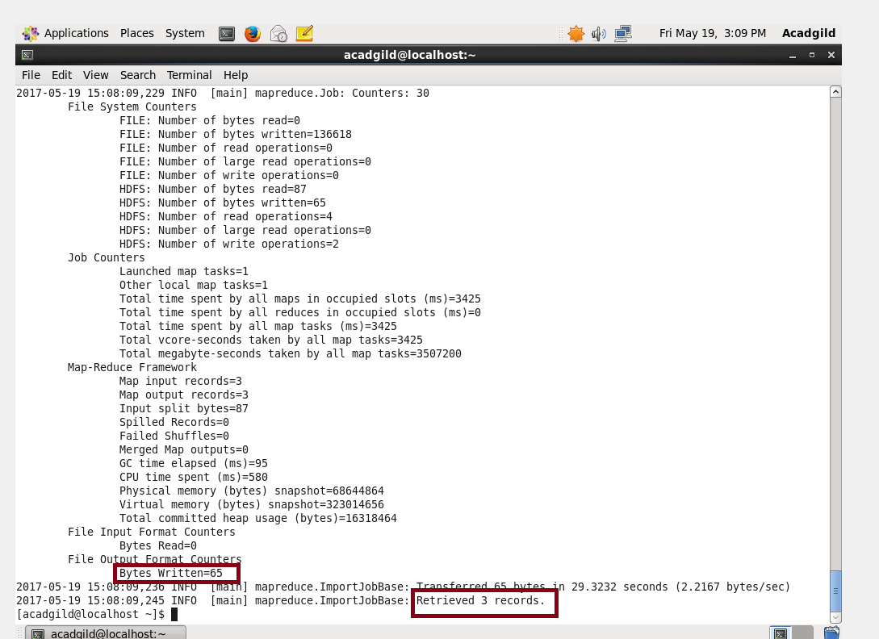

**Step 5: listing the files and reading the file using ls and cat command**

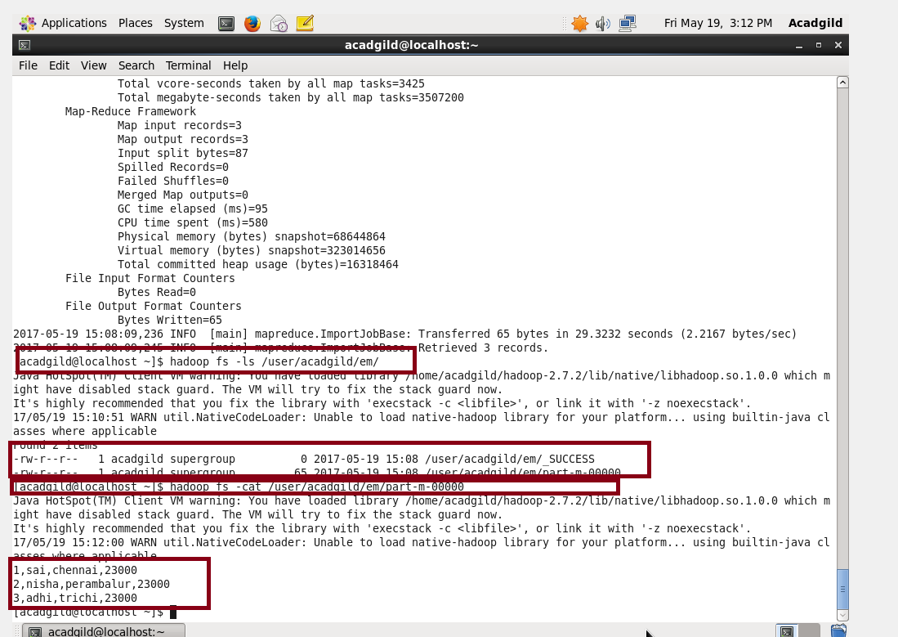

* **Create a em2 table in Mysql and Export employee details file from HDFS directory to Mysql table employee2 using Sqoop.**
* **Explain the procedures performed, Share the screenshots of commands and results for the same.**

**Step 1: creating “employee2” table and keeping it empty because we have to import it from hdfs**



**STEP 2: showing the contents of the table employee2 (it is empty)**

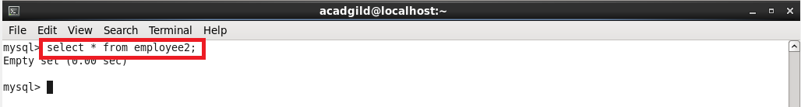

**Step 3: exporting the table from hdfs to mysql**



**Step 4: successfully exported to mysql using scoop**



**Step 5: previously this table was empty, after exporting this table contains data.**

