QUESTION

We have a dataset of sales of different TV sets across different locations. Records look like: Samsung|Optima|14|Madhya Pradesh|132401|14200 The fields are arranged like: Company Name|Product Name|Size in inches|State|Pin Code|Price.

DATA SET:

Samsung|Optima|14|Madhya Pradesh|132401|14200

Onida|Lucid|18|Uttar Pradesh|232401|16200

Akai|Decent|16|Kerala|922401|12200

Lava|Attention|20|Assam|454601|24200

Zen|Super|14|Maharashtra|619082|9200

Samsung|Optima|14|Madhya Pradesh|132401|14200

Onida|Lucid|18|Uttar Pradesh|232401|16200

Onida|Decent|14|Uttar Pradesh|232401|16200

Onida|NA|16|Kerala|922401|12200

Lava|Attention|20|Assam|454601|24200

Zen|Super|14|Maharashtra|619082|9200

Samsung|Optima|14|Madhya Pradesh|132401|14200

NA|Lucid|18|Uttar Pradesh|232401|16200

Samsung|Decent|16|Kerala|922401|12200

Lava|Attention|20|Assam|454601|24200

Samsung|Super|14|Maharashtra|619082|9200

Samsung|Super|14|Maharashtra|619082|9200

Samsung|Super|14|Maharashtra|619082|9200

Mapper 1

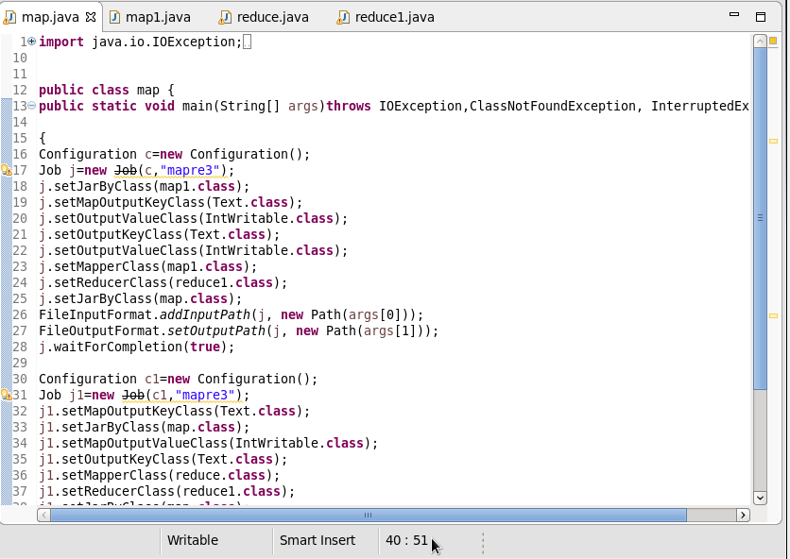

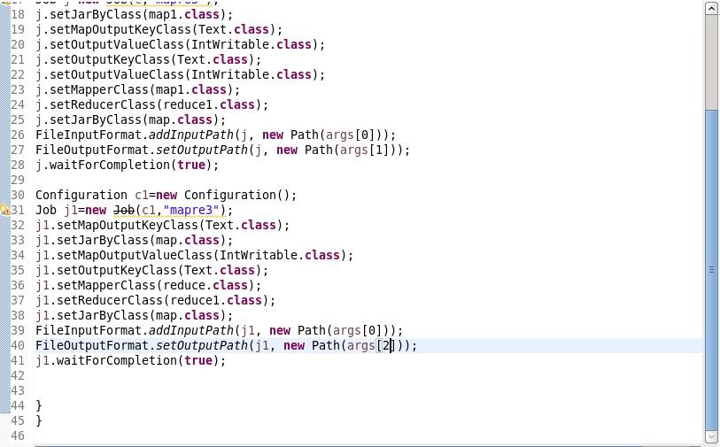

Mapper 2

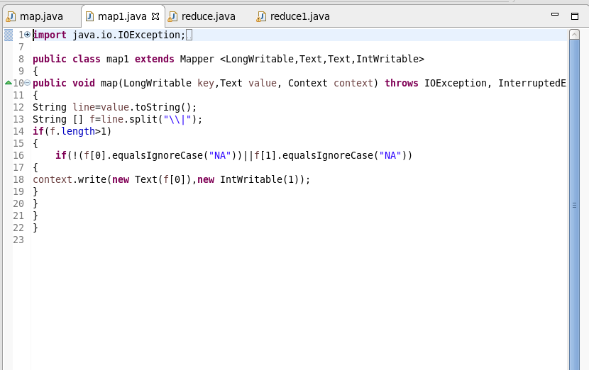

Reducer 1

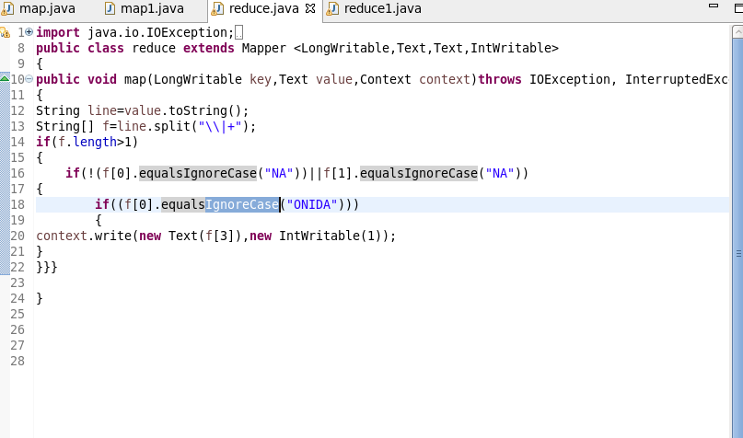

Reducer 2

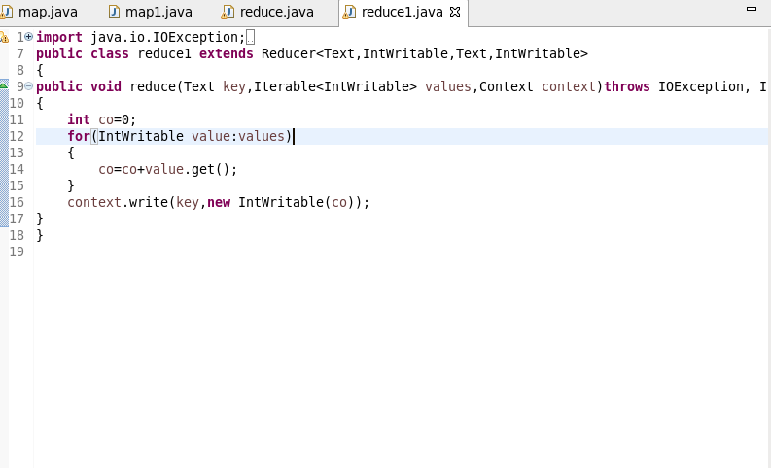

OUTPUT