Problem:

1. Introduction In this assignment you need to write Java Map reduce programs for the given problem statement 2. Problem Statement Titanic Data Analysis Write a mapreduce program to find out number of males and females died in the titanic tragedy.

Main

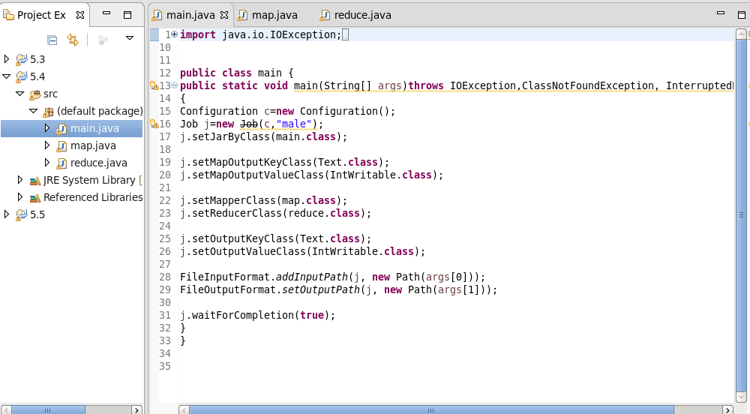

Map

It will count only the number of people who are alive and will filter the people who all died.

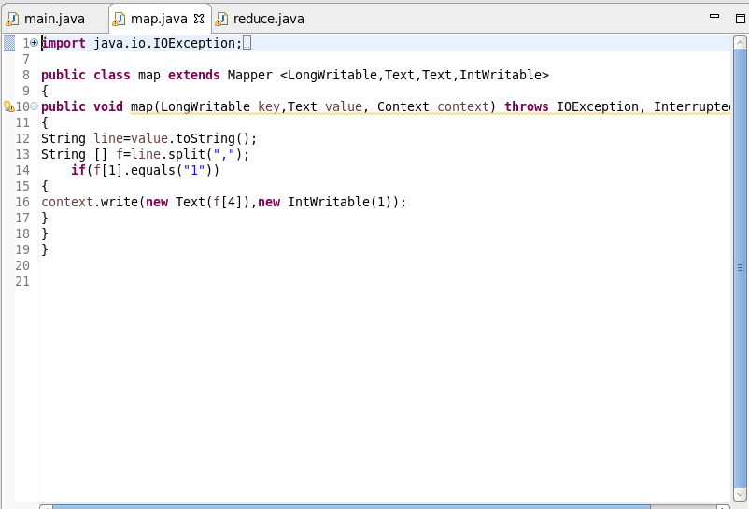

Reduce

To count the male and female count

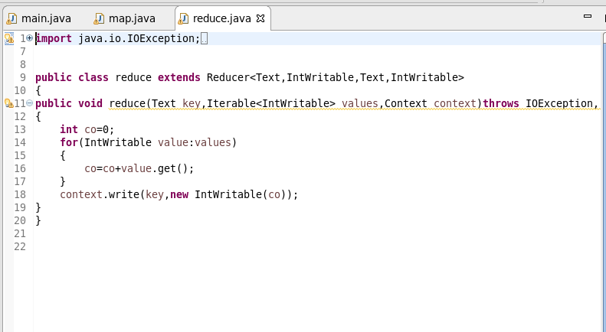

OUTPUT

