PROBLEM:

1. Introduction In this assignment you need to write Java Map reduce programs for the given problem statement 2. Problem Statement Titanic Data Analysis Write a map reduce program to find out number of males and females survived in the titanic tragedy.

Main

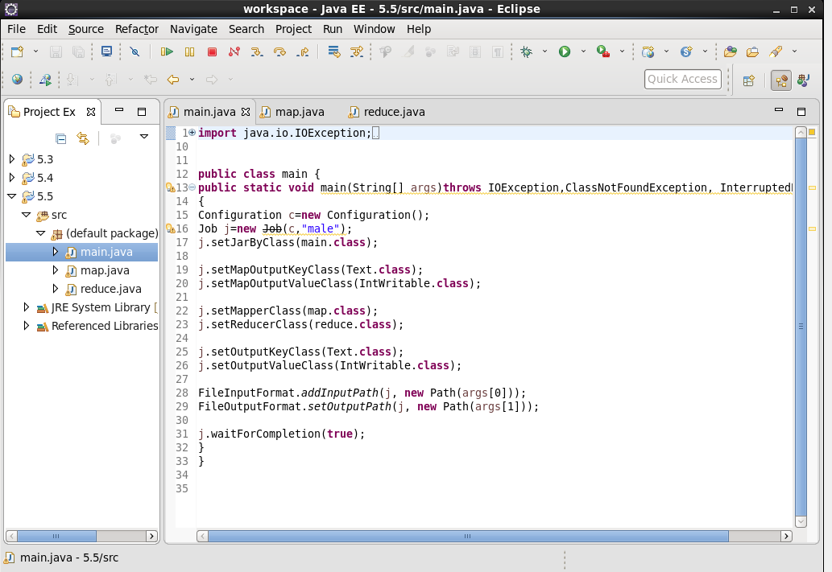

Map

Will filter the count of survived people

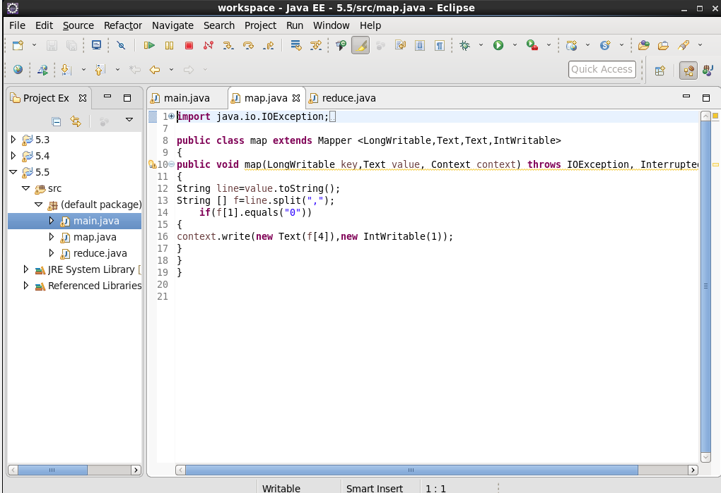

Reduce

To count the male and female

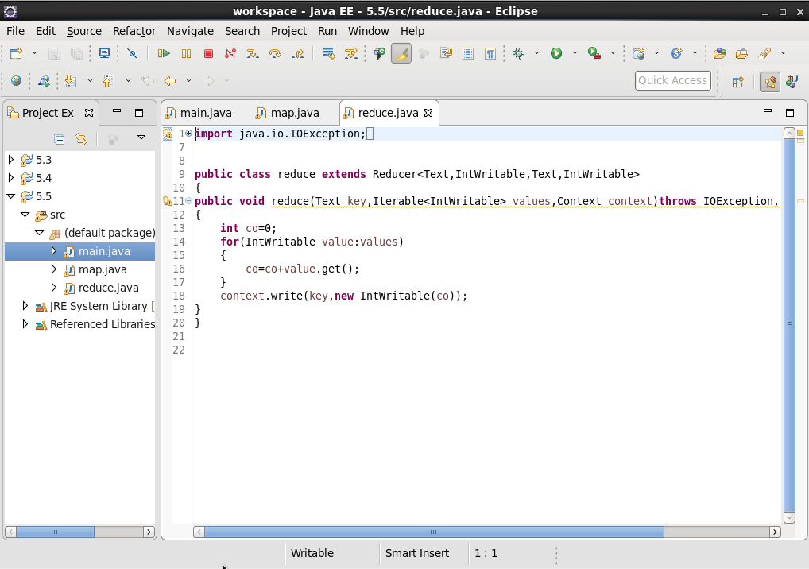

Output:

