QUESTION

Problem statement 1: Find out how many people has chosen their destination as MIA and MCO Problem statement 2: Find out the number of people undertaken the trips from the places MIA and HOU Problem statement 3: Find out how many people has chosen airline mode of travel for the places LAS and LAX

MAIN

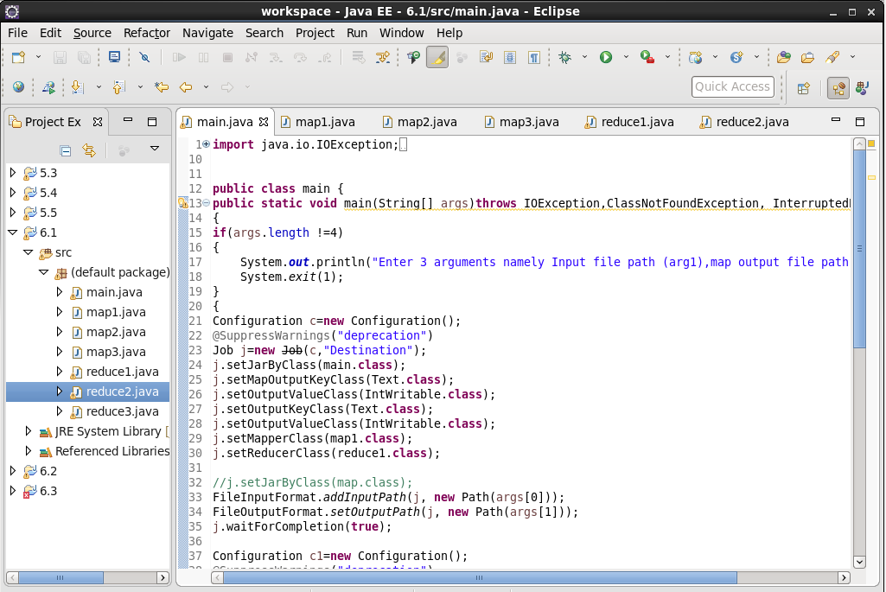

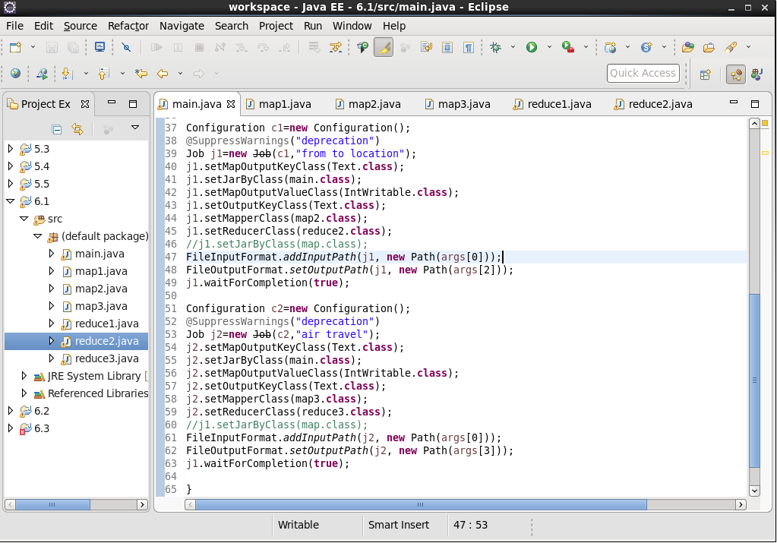

MAP1

Checking the Destination as “MIA” and “MCO”

Will check the destination also will send the key to add adult,senior,children,youth and kids will send it as value.

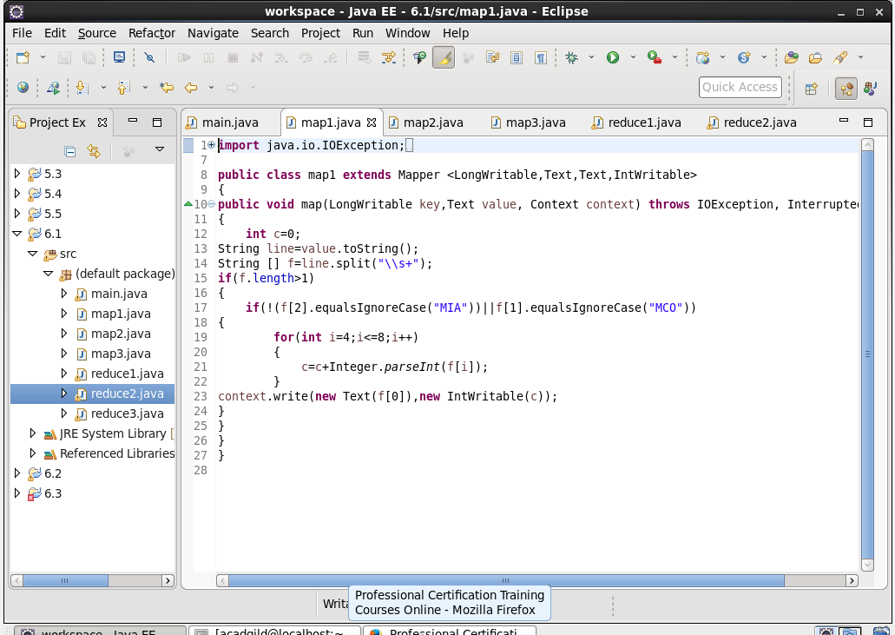

MAP2

Checking the Destination as “MIA” and “MCO”

Will check the destination also will send the key to add adult,senior,children,youth and kids will send it as value.

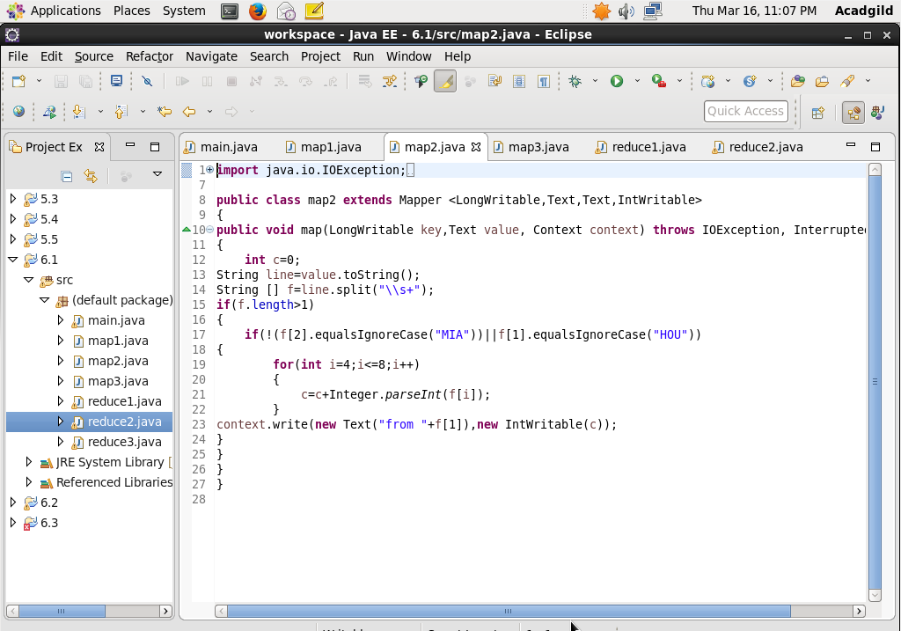

MAP3

Checking the Destination as “MIA” and “MCO”

Will check the destination also will send the key to add adult,senior,children,youth and kids will send it as value.

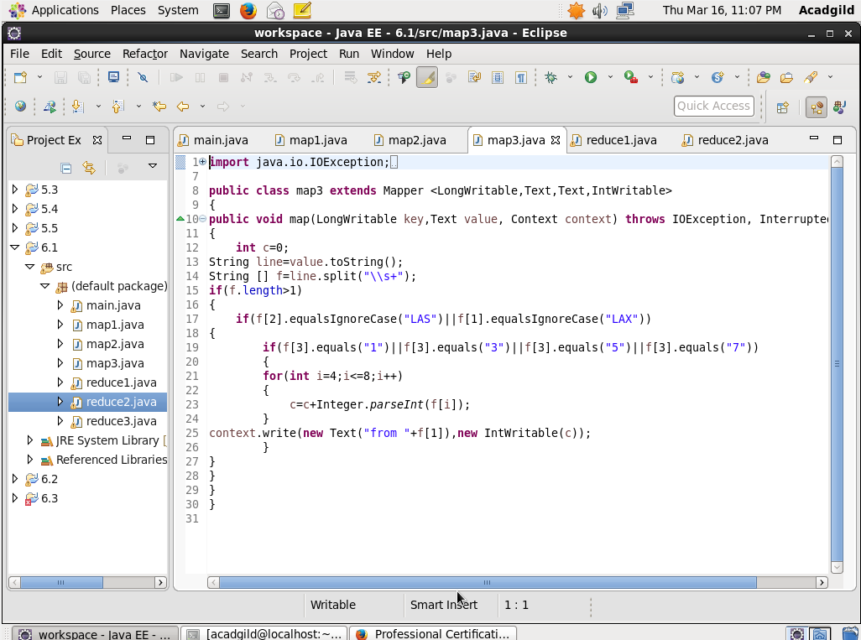

REDUCE 1

Will give the passenger count.

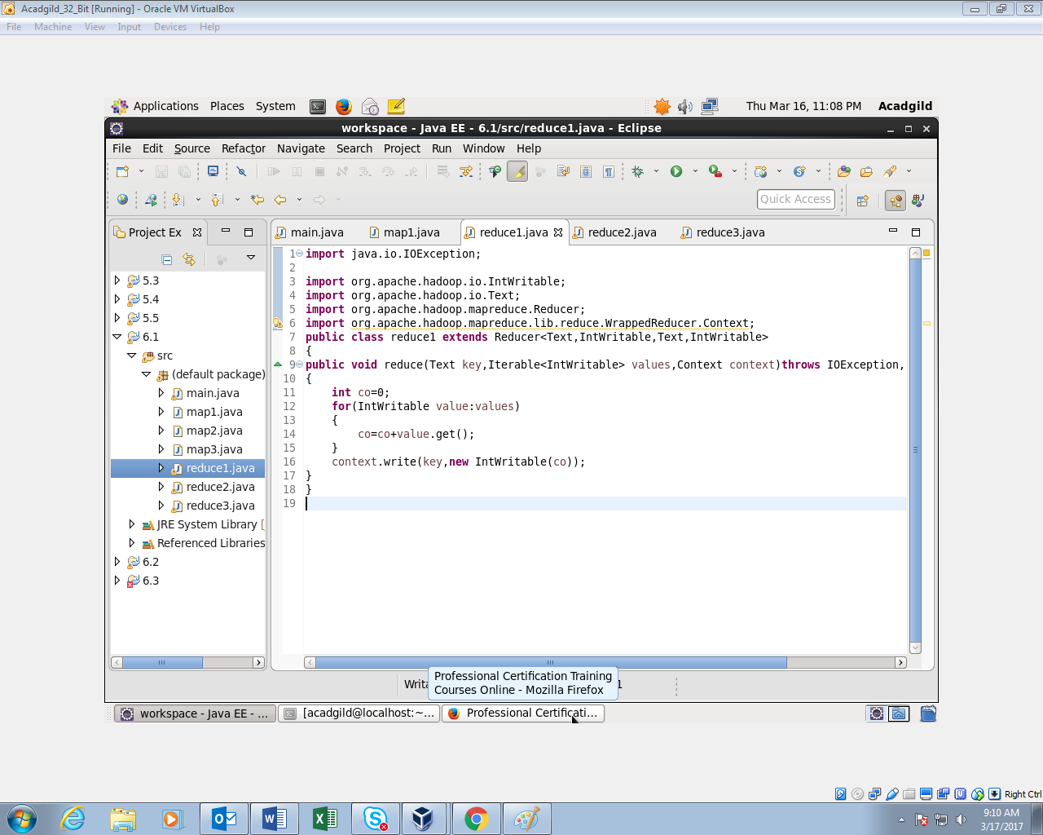

REDUCER 2

Will give the passenger count.

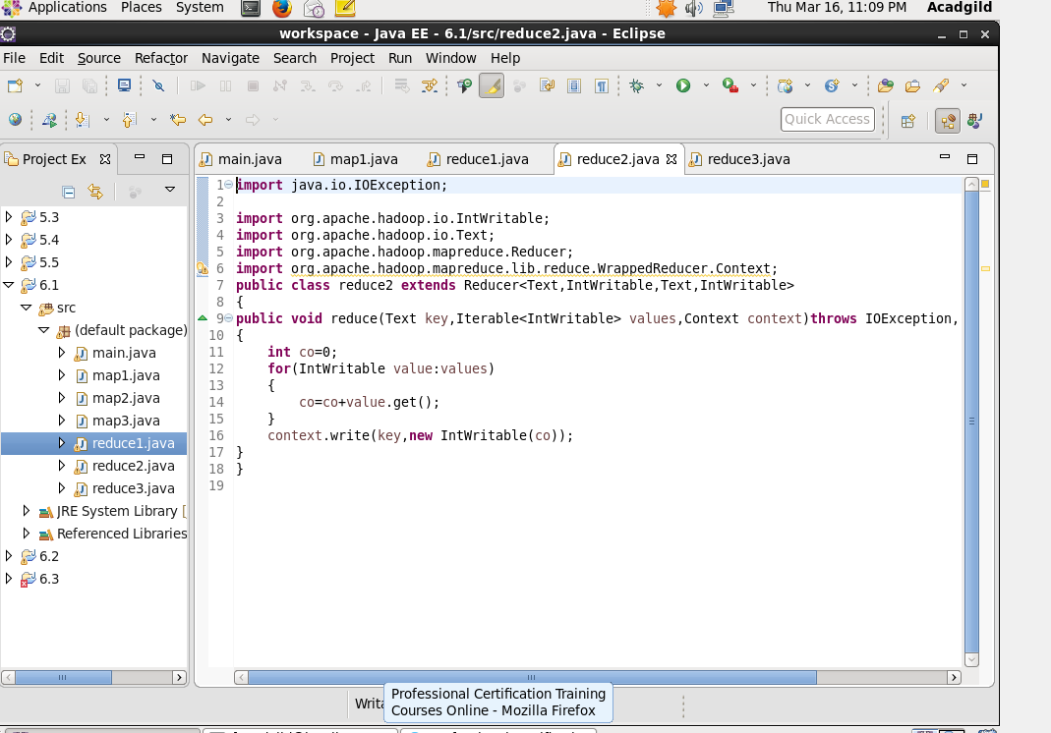

REDUCER 3

Will give the passenger count.

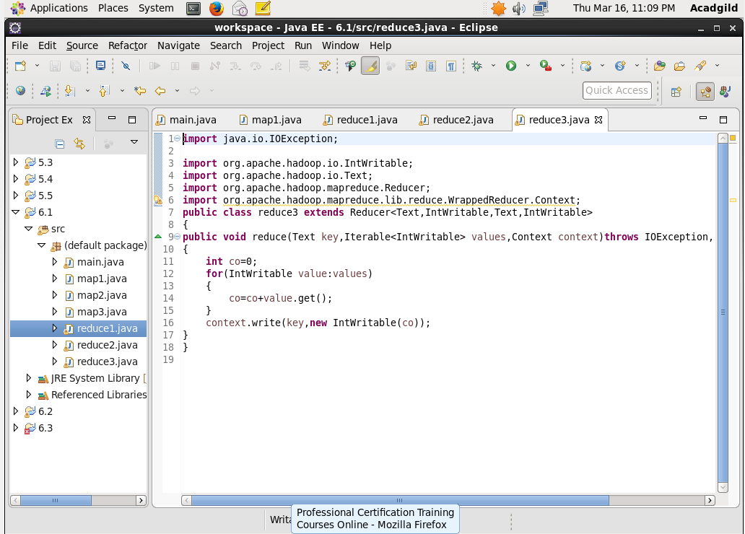

OUTPUT

