Problem statement1: Find the number of GoogleKnowlege_Occupation people who were guests in the show, in a particular time period. Take the time period as 1/11/99 to 6/11/99 i.e., 6 months

Problem statement2: Find the number of GoogleKnowledge occupation types in each group, who have been guests on the show.

MAIN

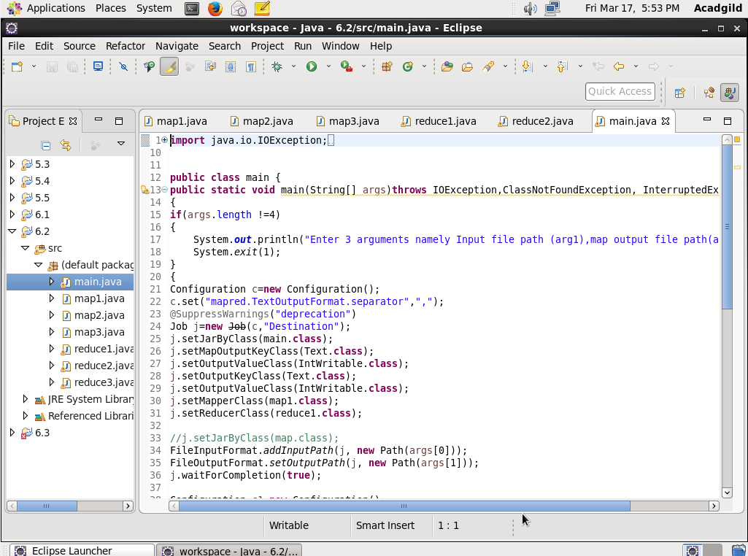

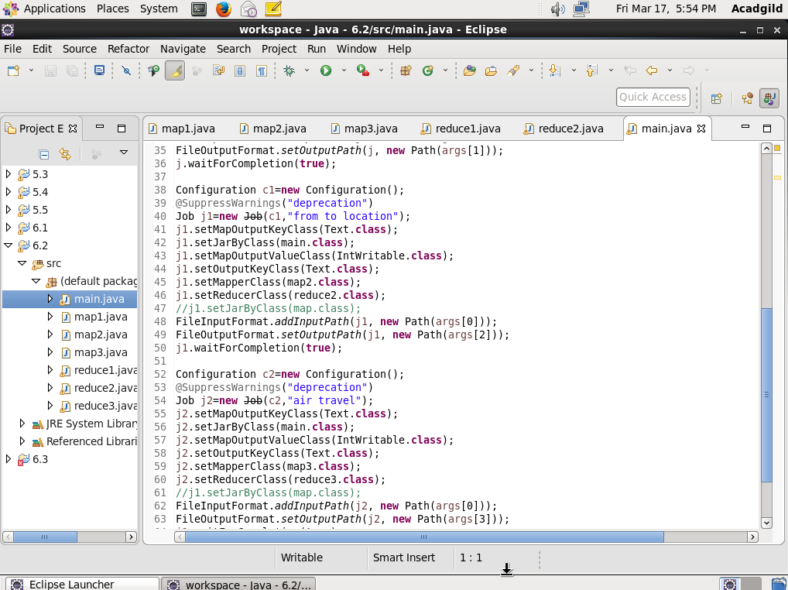

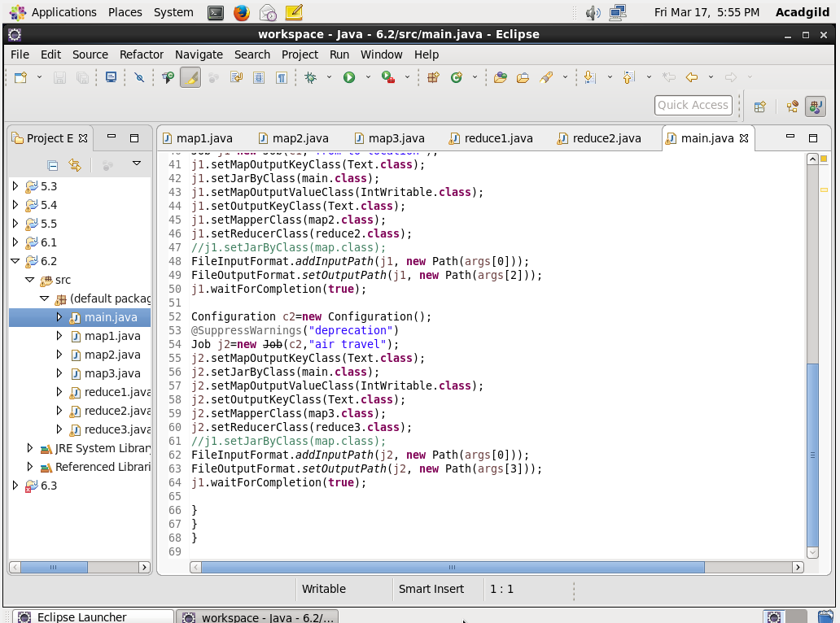

MAPPER 1

To check the destination “MIA” and “MCO” will send the key as well add adult,senior,children,youth and infants later will send those values.

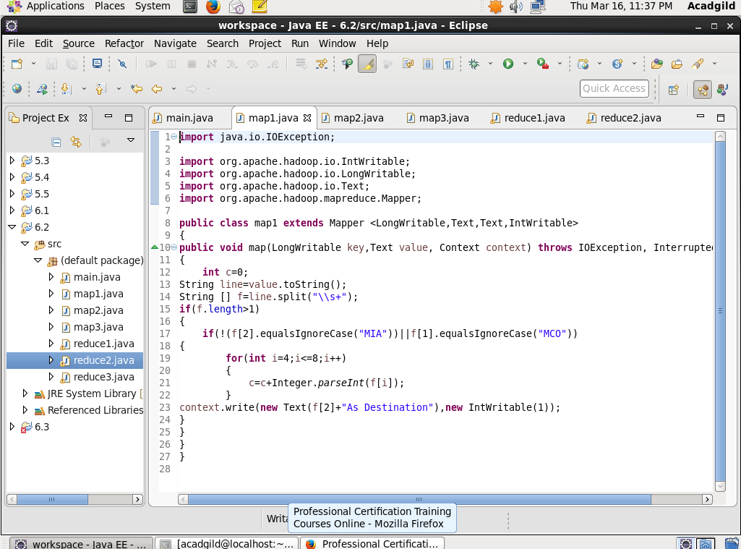

REDUCER 1

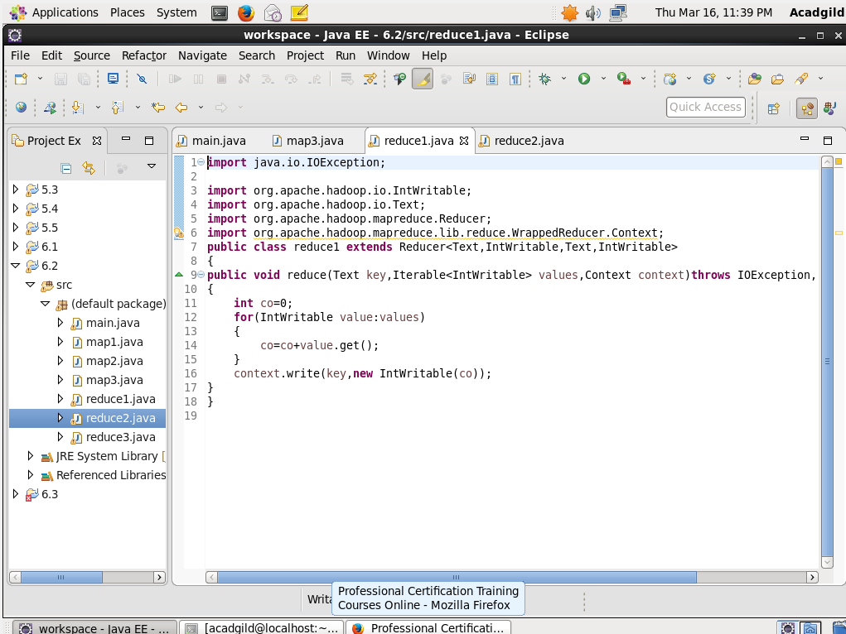

MAPPER 2

To check the destination “MIA” and “MCO” will send the key as well add adult,senior,children,youth and infants later will send those values.

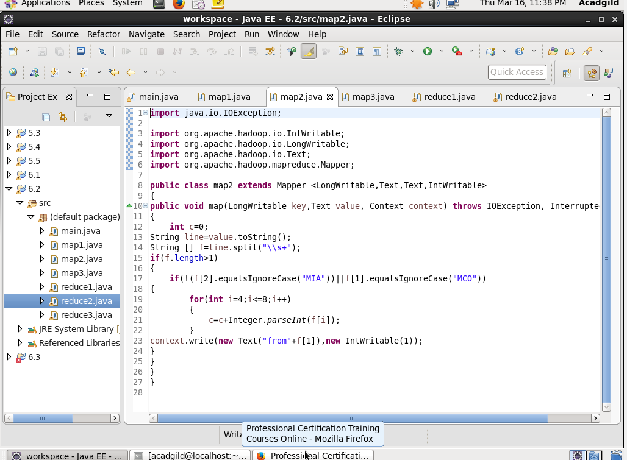

REDUCER 2

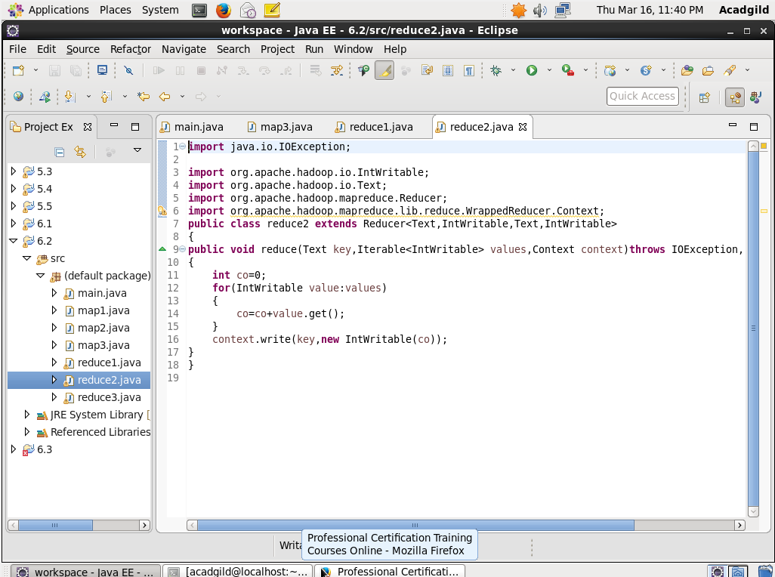

MAP 3

To check the destination “LAS” and “LAX” will send the key as well add adult,senior,children,youth and infants later will send those values.

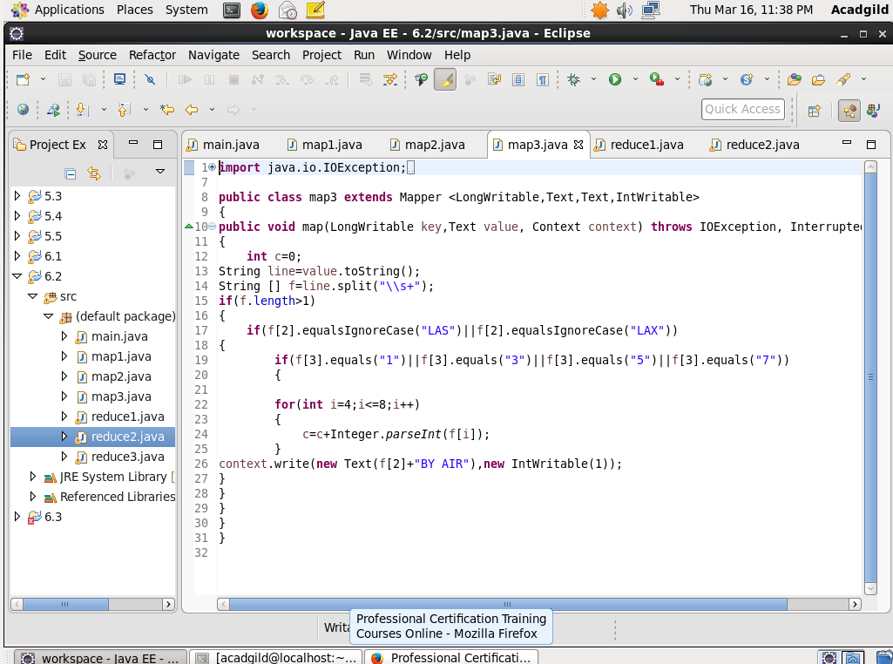

REDUCE 3

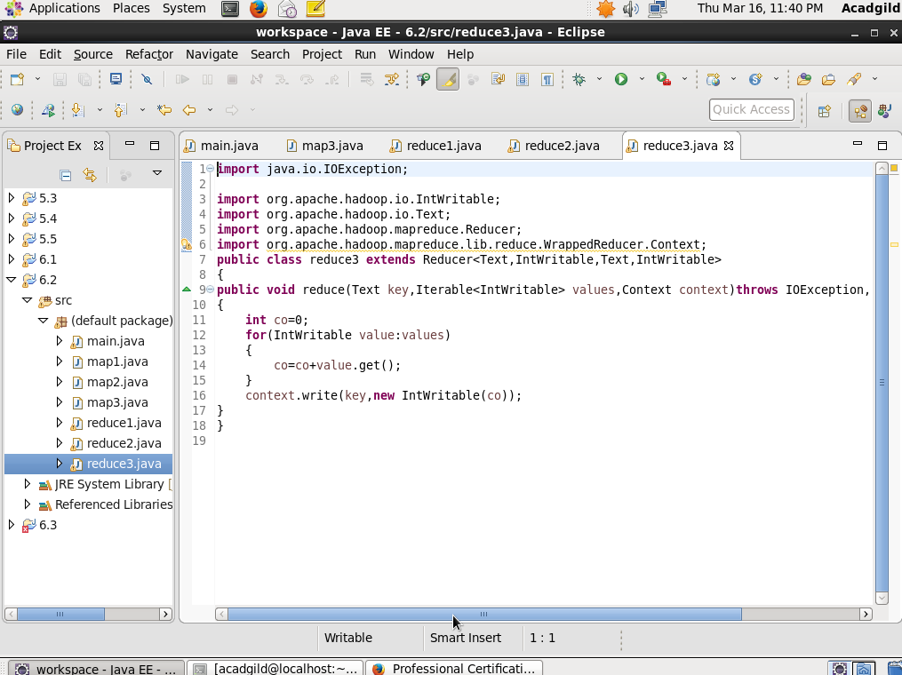

OUTPUT

