**Problem statement1: Find the number of GoogleKnowlege_Occupation people who were guests in the show, in a particular time period. Take the time period as 1/11/99 to 6/11/99 i.e., 6 months**

**Problem statement2: Find the number of GoogleKnowledge occupation types in each group, who have been guests on the show.**

**Driver Class**

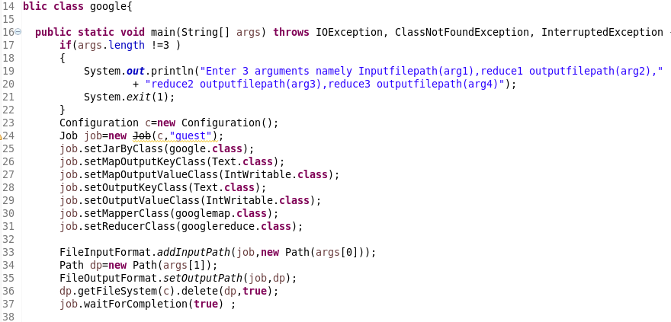

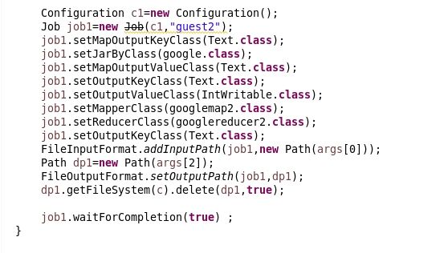

**MAPPPER CLASS for question1**

LOGIC:

* Split by (,)
* then filter them by date *BY USING LOCAL DATE*
* send the guest key value as 1 for each people

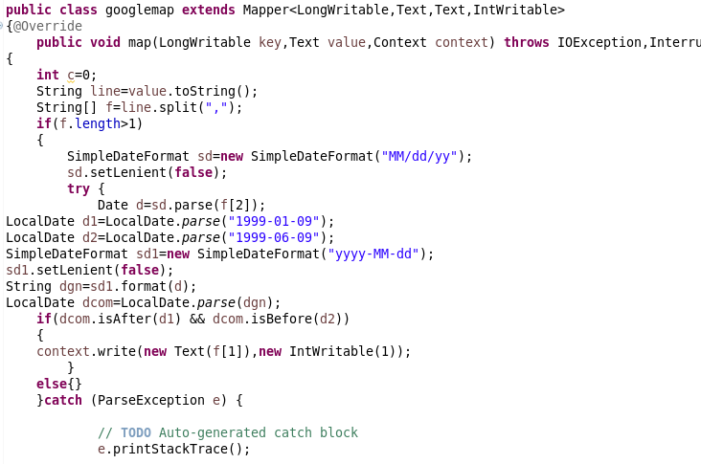

**REDUCER**

Will Count the guests count

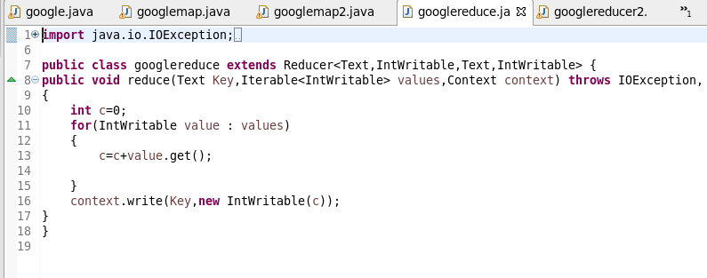

**MAPPER for question 2**

Splitting by (“, “)

Will send the Guests as key and value

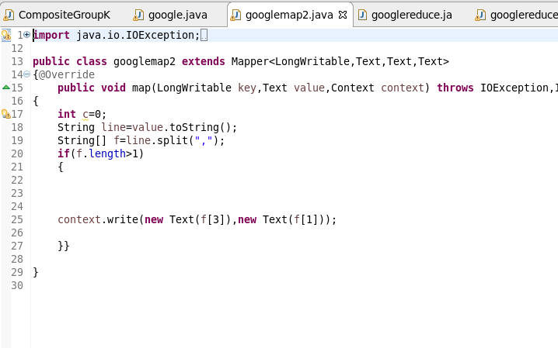

**REDUCER**

* USED hash set to remove Duplicate guests
* send it as value since we need the guest to be unique.

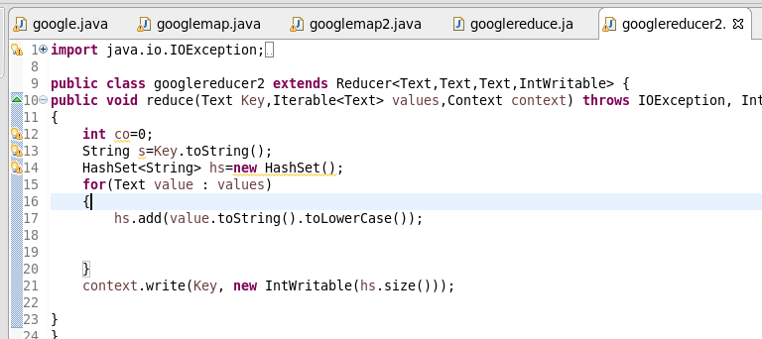

**RUNNING JAR**

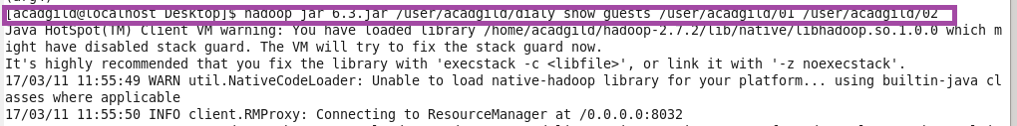

**OUTPUT FOR 1**

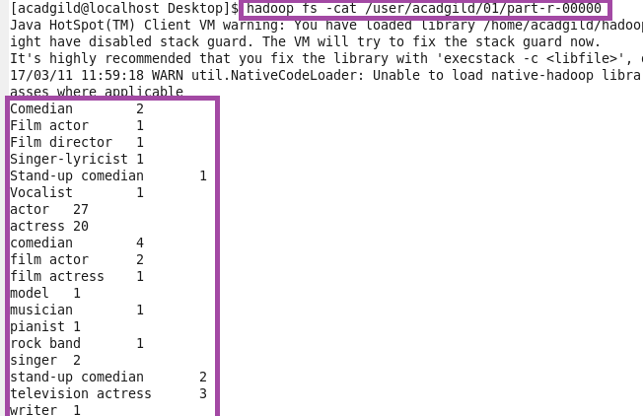

OTPT2

