Titanic Data Analysis Write a mapreduce program to find out number of males and females died in the titanic tragedy and save the output in KeyValue Output format.

Main

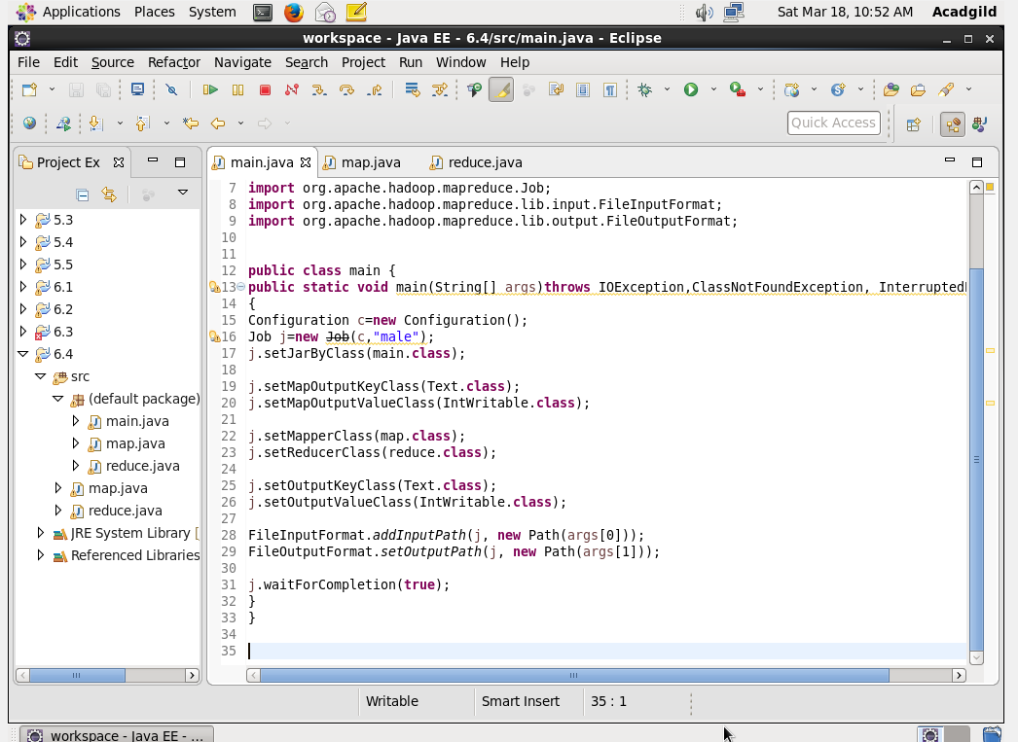

Map

Will filter the number of people who have died.

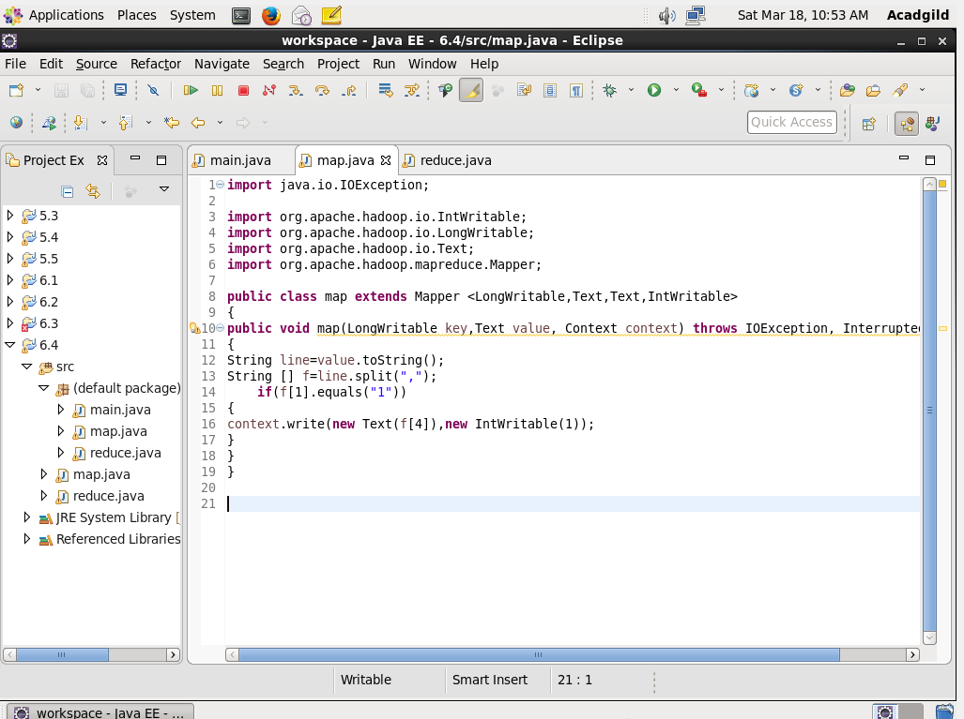

Reduce

Male and female count

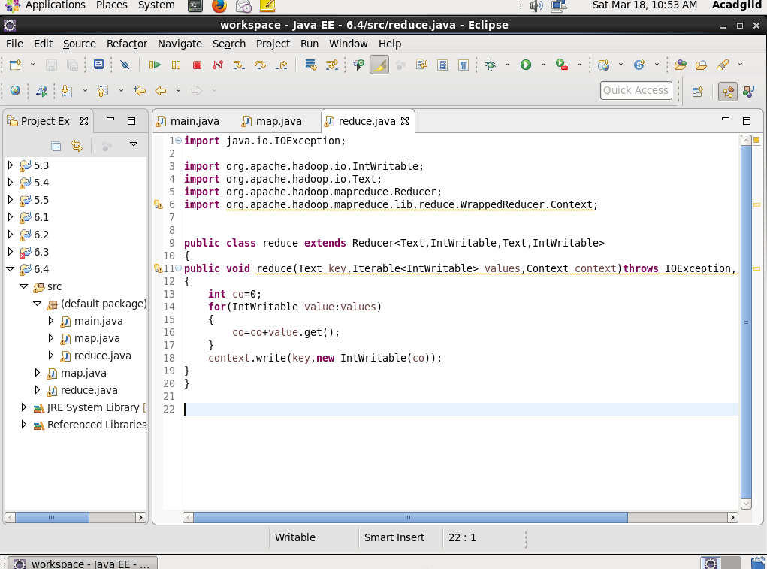

OUTPUT

