Titanic Data Analysis Write a mapreduce code to find out number of males and females survived in the titanic tragedy and save the output in sequence file output format.

Main

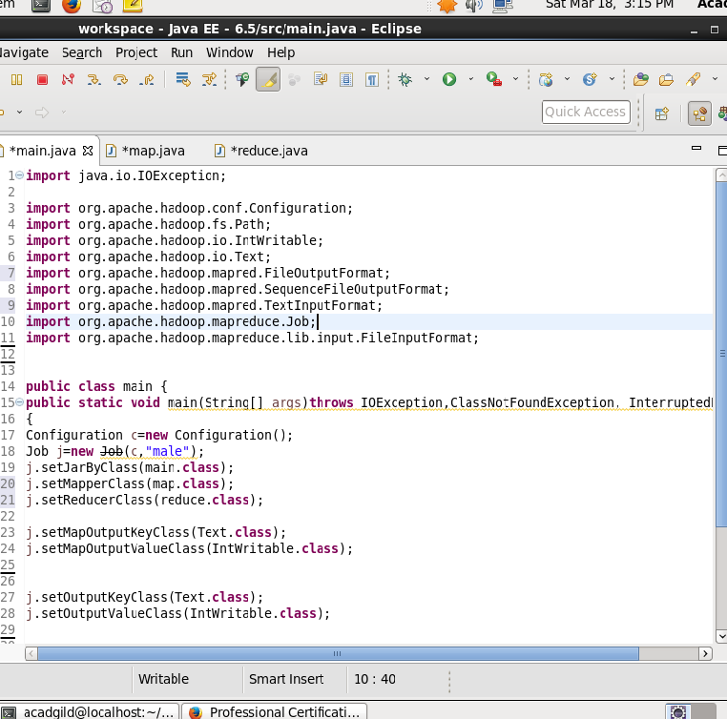

Main with Sequence file output

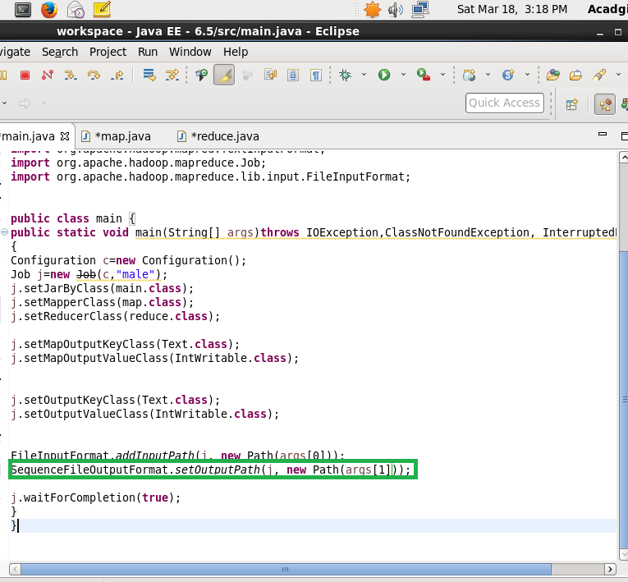

Map

Will filter the number of people who all survived

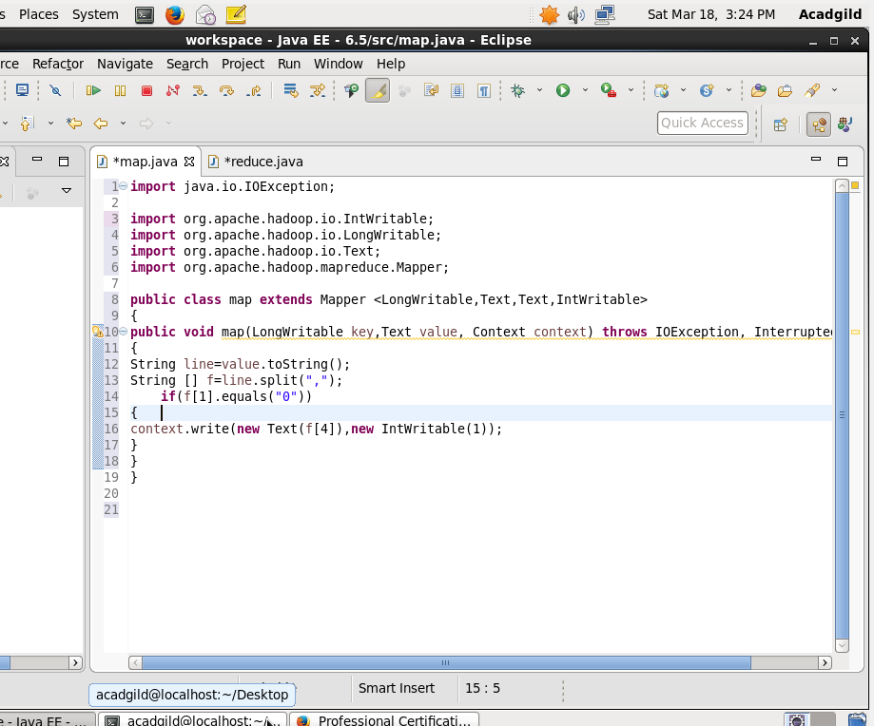

Reduce

Will count the number of female and male

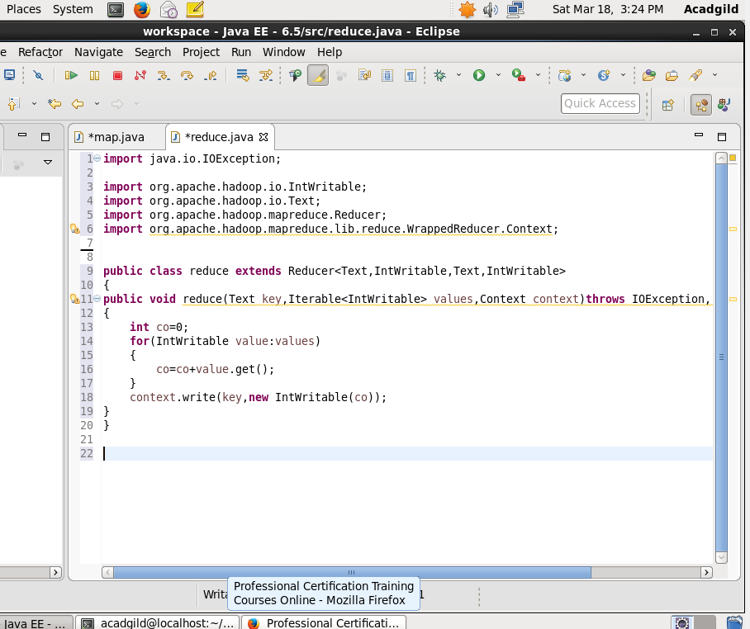

Output

