Write a map reduce program to use Sequence file as input and save the output in key value output format.

Note : You can use the sequence file output which you have got in the earlier assignment of the same session.

Main

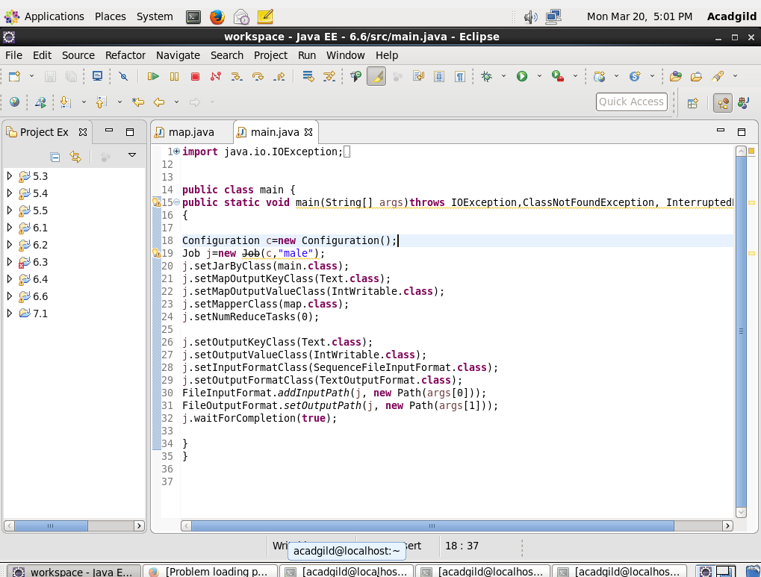

Map

Map will read the input from sequence file

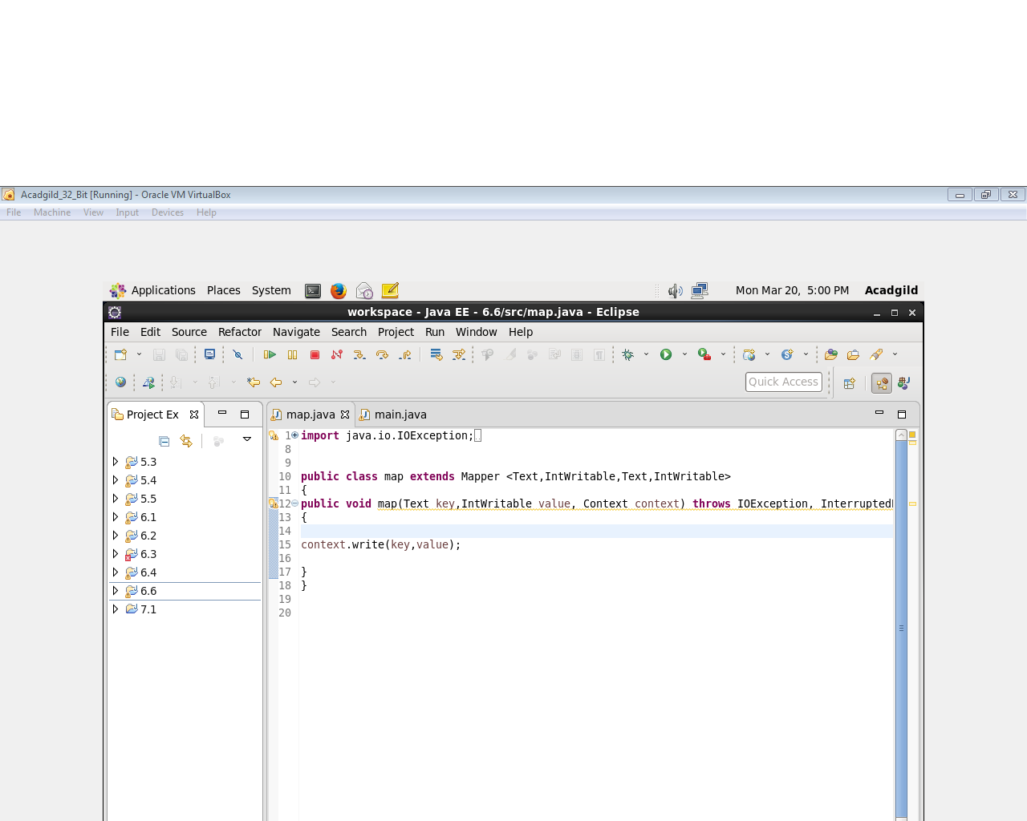

Output

Output of assignment 6.5 is taken as input

