1.Write a Mapreduce program to modify Sales of different TV Task 2 ( refer session 5 assignment 2 ) to use a custom partitioner with 4 reducers. Make sure that all records whose company name starts with A-F (upper or lower case) should go to 1st reducer, those starting with G-L to 2nd reducer, those starting with M-R to 3rd reducer and others to 4th reducer.

DRIVER CLASS

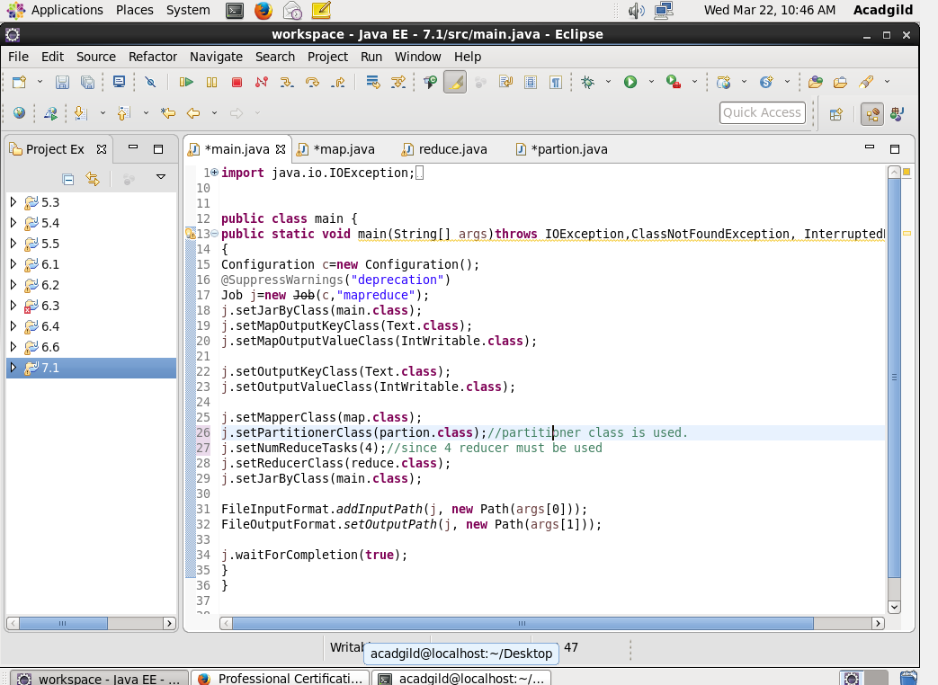

Map

Each line is splitted by |

And will ignore the output which contains “NA” in them. And the company name will be sent as a key. And each key will be counted as 1 in the reducer.

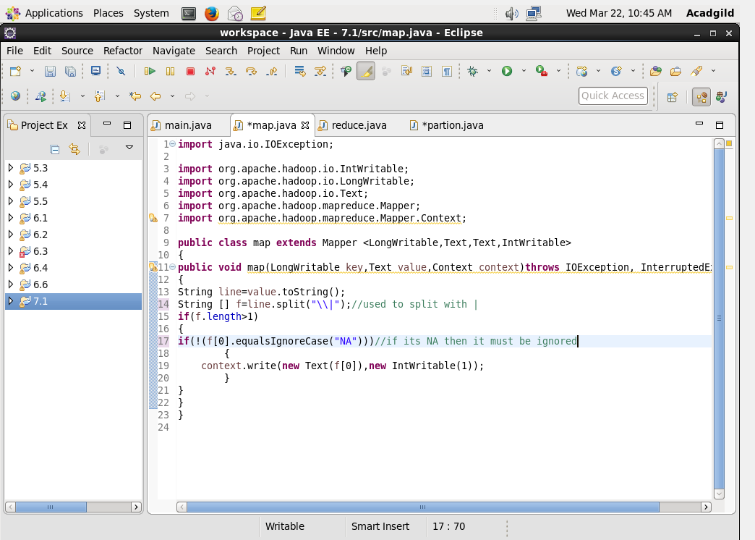

Reduce

Will count the number of keys from the mapper.

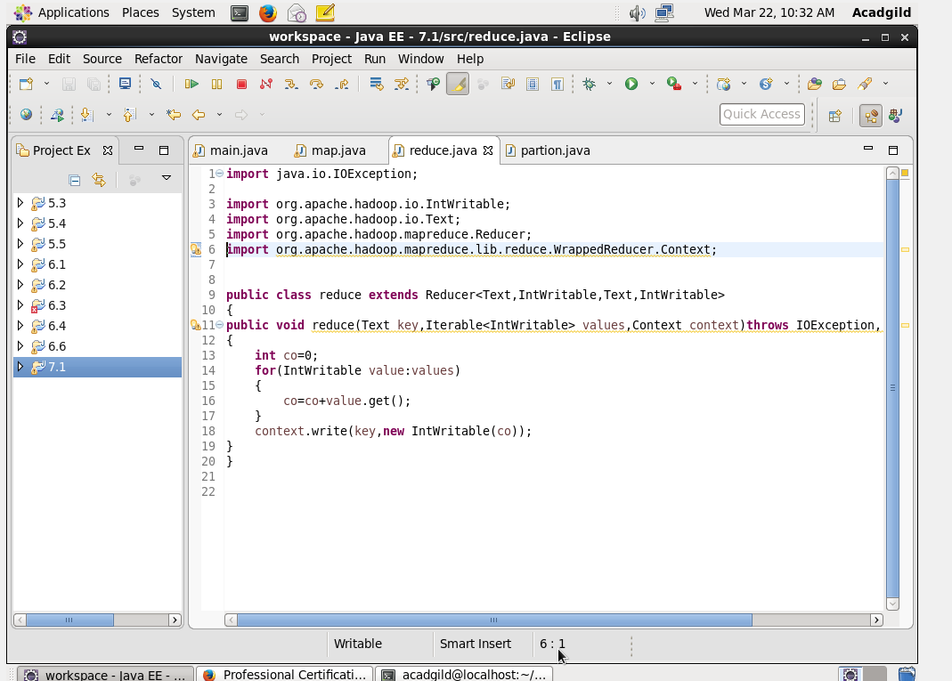

Partitioner

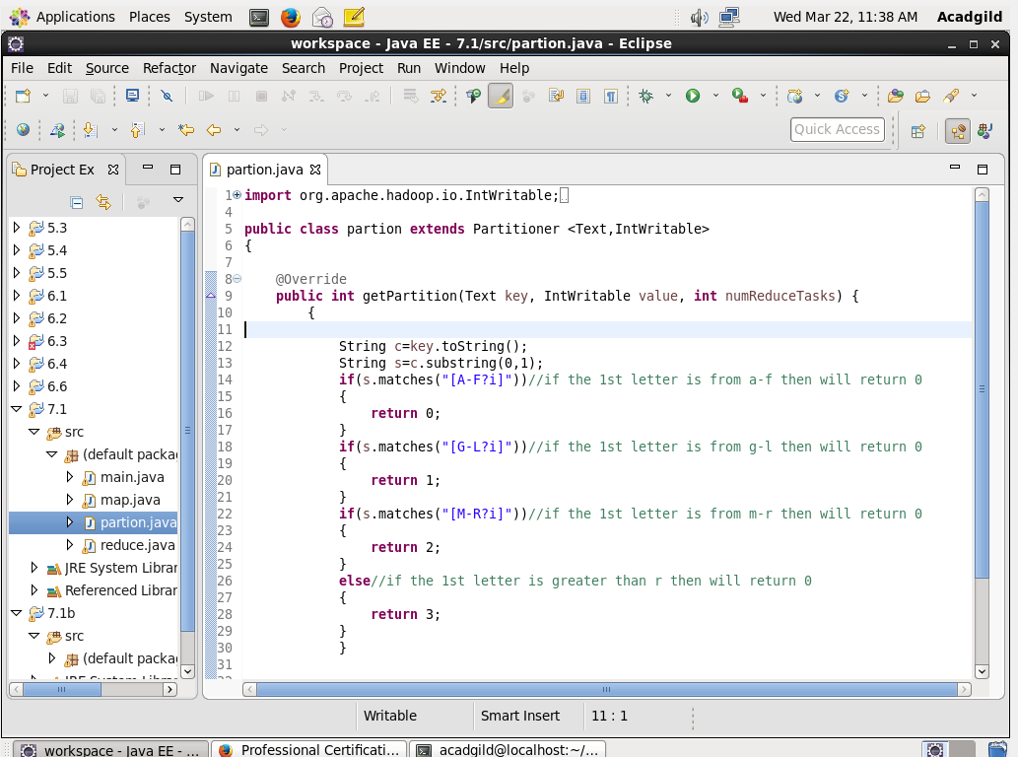

Output

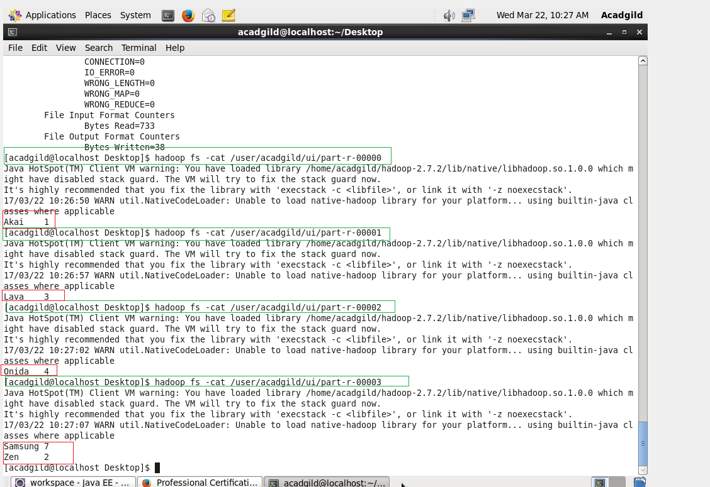

**QN2:Modify Sales of different TV Task 2 (refer session 5, assignment 2) to take advantage of Combiner.**

Main

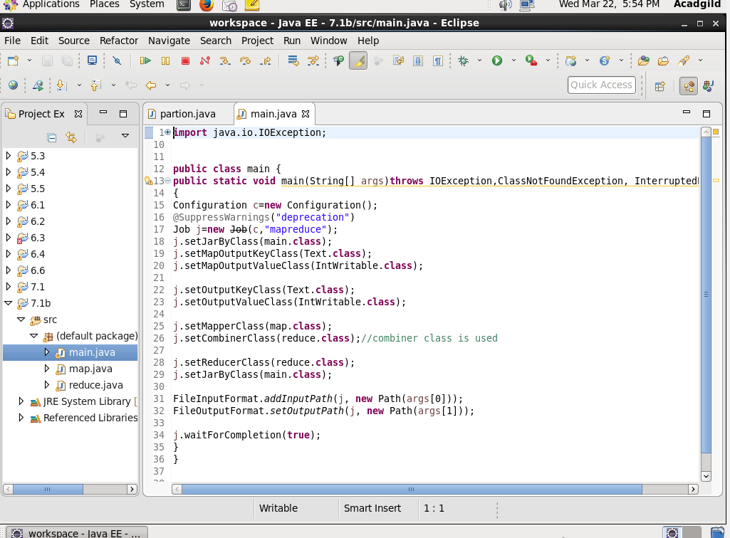

Map

Each line is splitted by |

And will ignore the output which contains “NA” in them. And the company name will be sent as a key. And each key will be counted as 1 in the reducer.

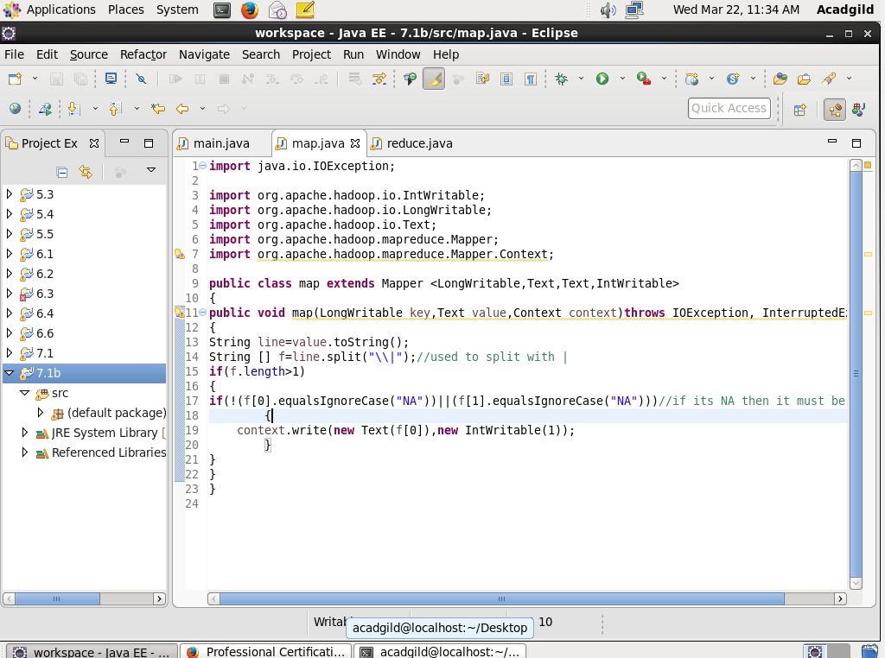

Reduce

Will count the number of keys from the mapper.

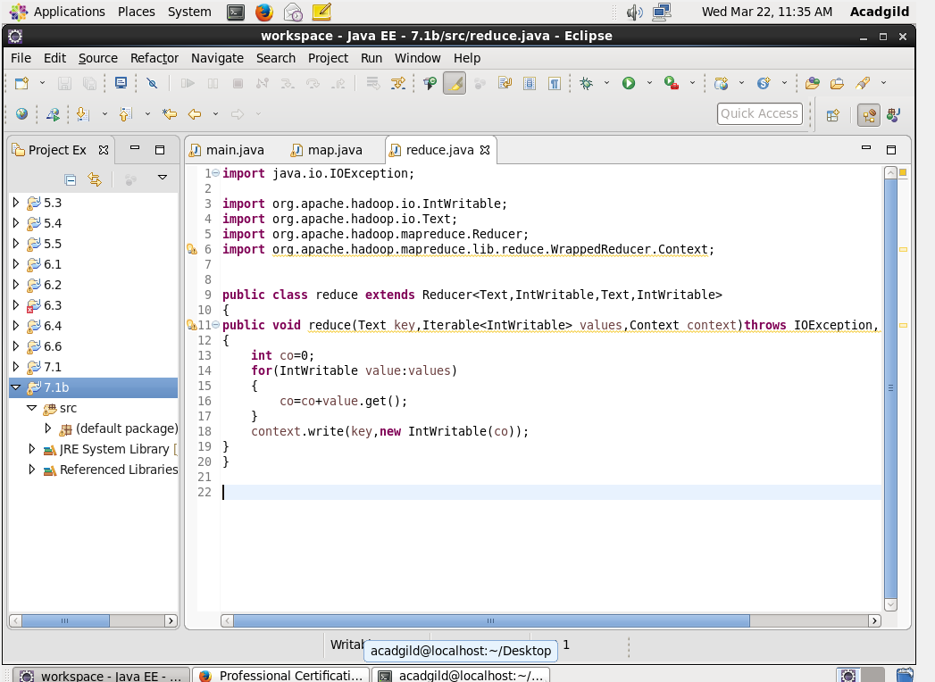

Output

