Write a custom key to evaluate the number of people who died and the number of people who survived, along with their genders.

DRIVER CLASS

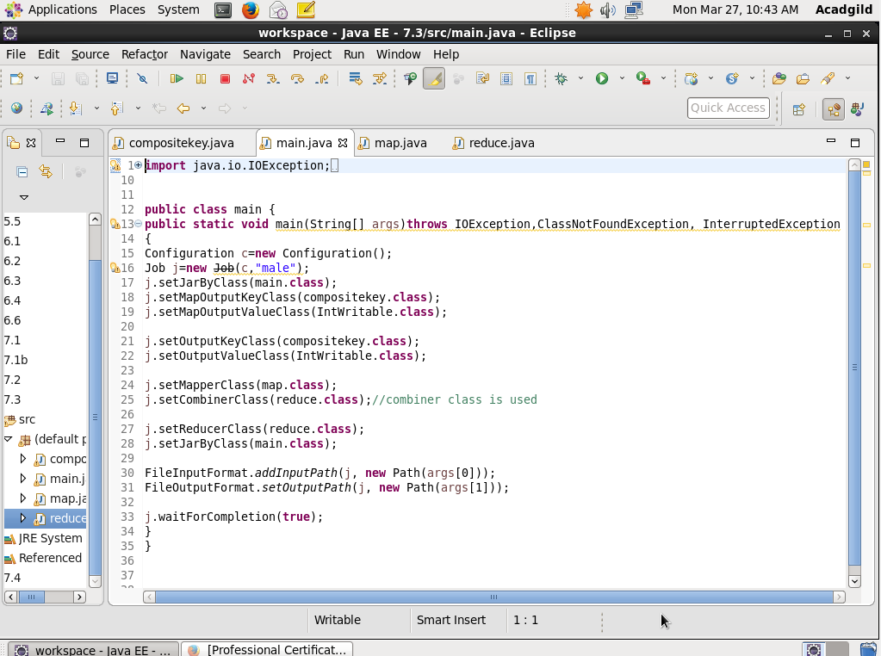

MAPPER CLASS:

It is to check whether the person is dead or alive and will send the key value as 1 as well send the gender.

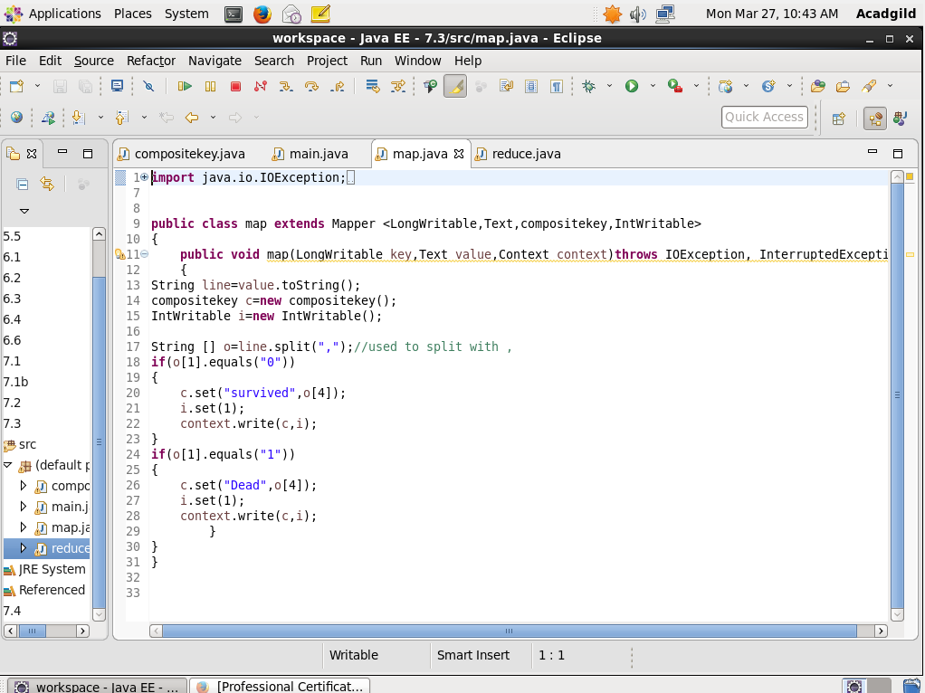

REDUCER CLASS:

Will count the number of people dead as well alive depending upon the gender

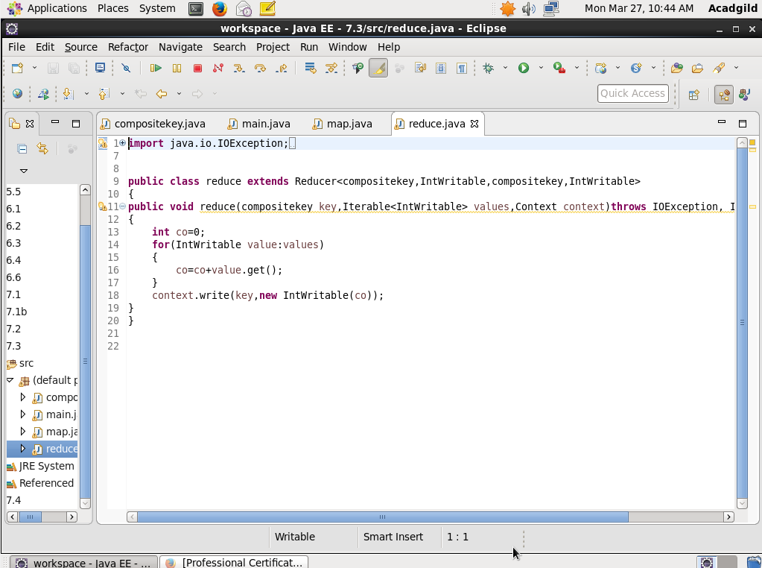

COMPOSITE KEY:

Step 1: The hash code will return whether the person is dead or alive.

Step 2: Overriding equals method-will check every object whether the status and gender are equal later if equal then will send the location of the hash code or else will again compare.

Step 3: Overriding compare to method- if suppose both the gender and the status are equal then will compare then framework sorting will be done or else if framework sorting will be done.

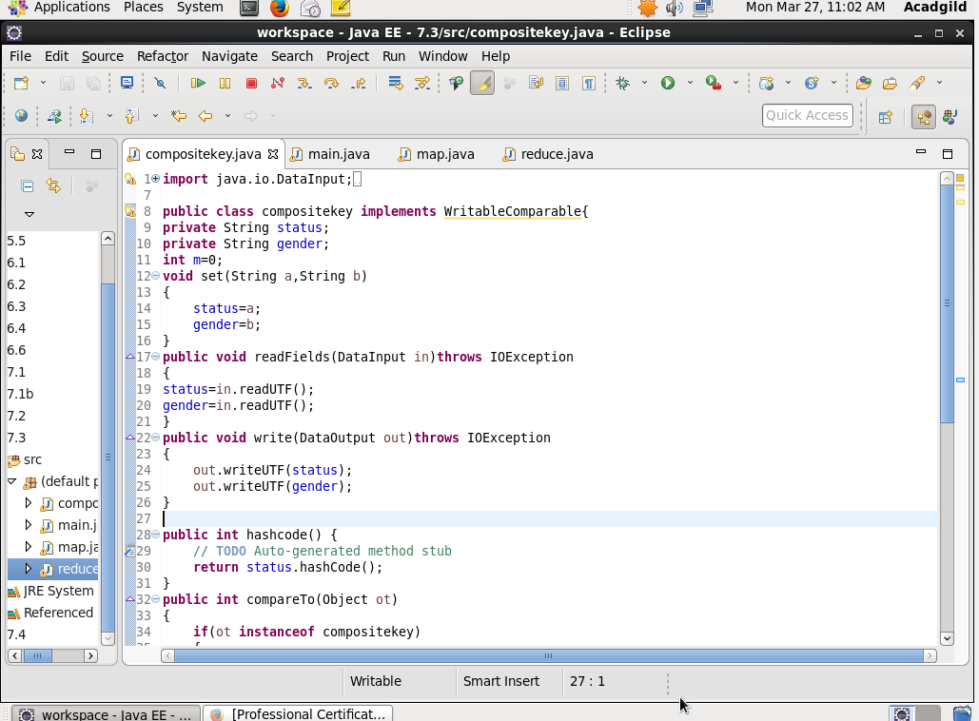

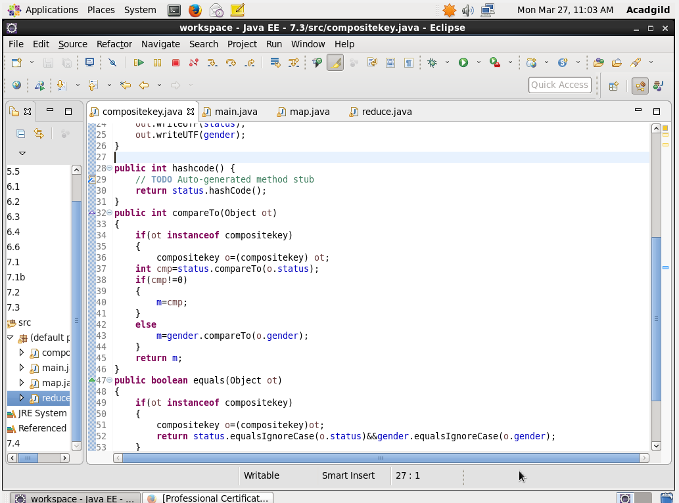

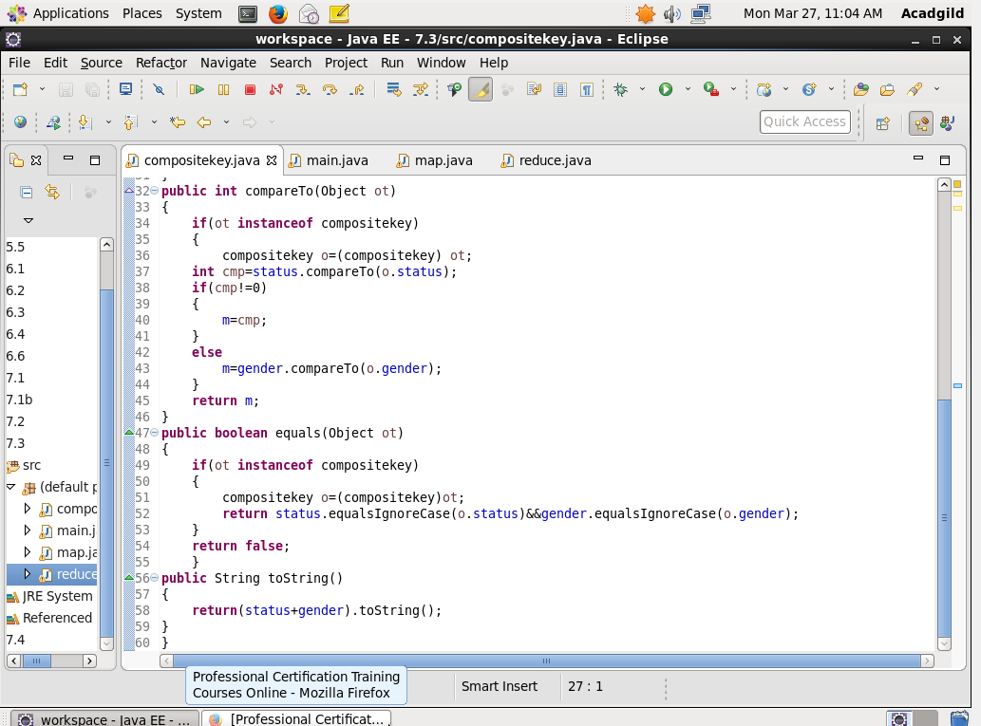

Output:

