Problem Statement:

Write a word count program using partitioner and implement the following logic in the partitioner words with length 5 should go into reducer 1 and words with length 6 should go into reduer 2 and the rest of the words should go into reducer 3.

Note:

You can use the dataset of your choice.

DRIVER CLASS:

In Driver class here ,we set Partitioner class and number of reducers as well customize partitioner class

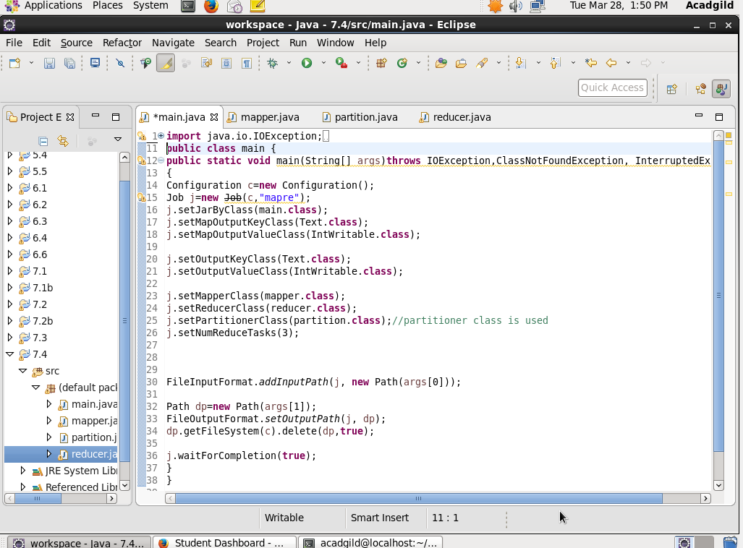

MAPPER CLASS

Data is sent as code

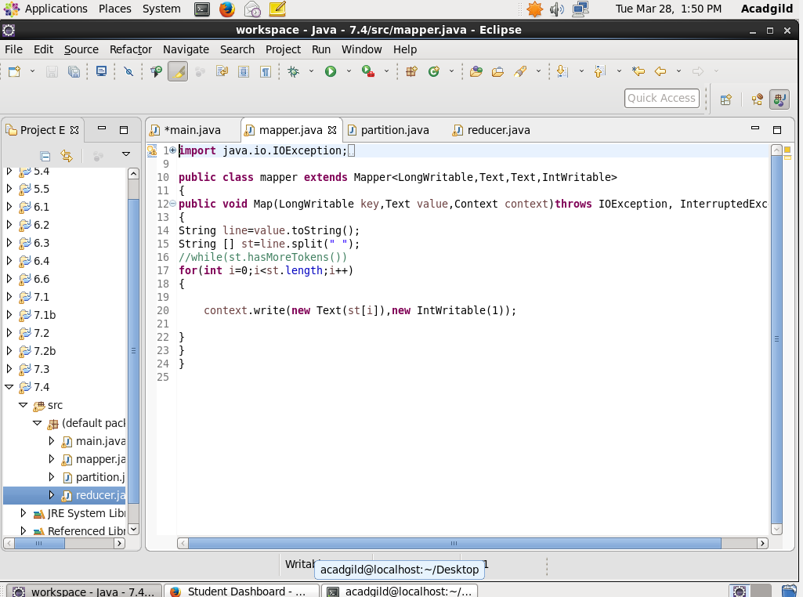

REDUCER CLASS

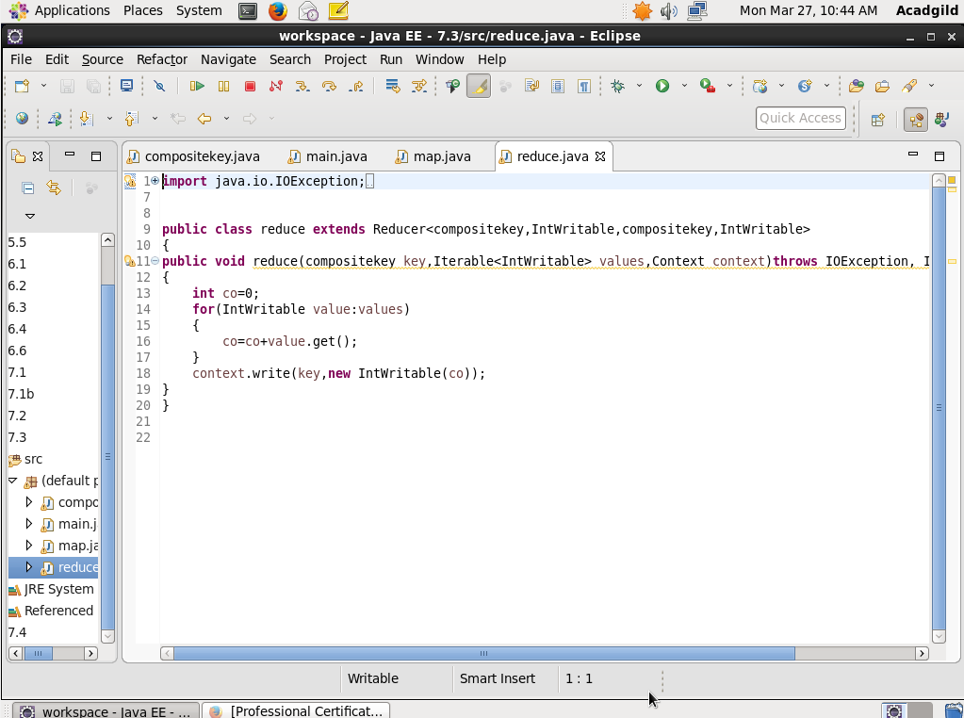

PARTITIONER CLASS:

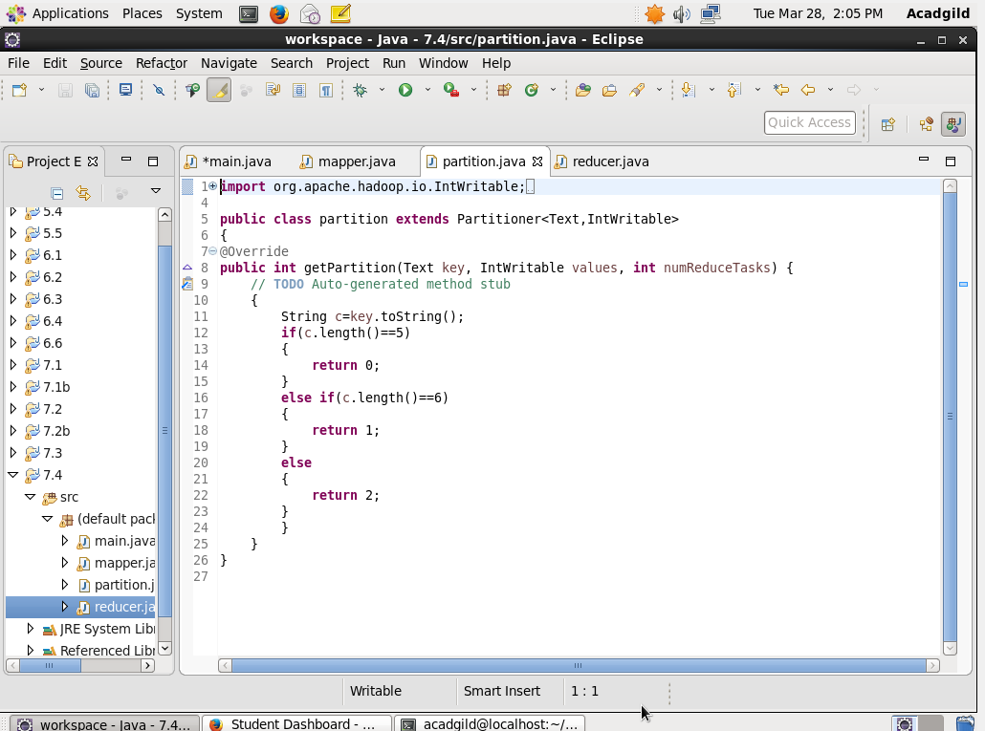

Output

