**Problem Statement :**

Write a map only job for the word count program and set the output format as sequence file. Note : You can use the dataset of your choice

***DRIVER***

* Since we have only mapper class so set num reduce task to 0.
* Set the output file format as Sequence Output File format.

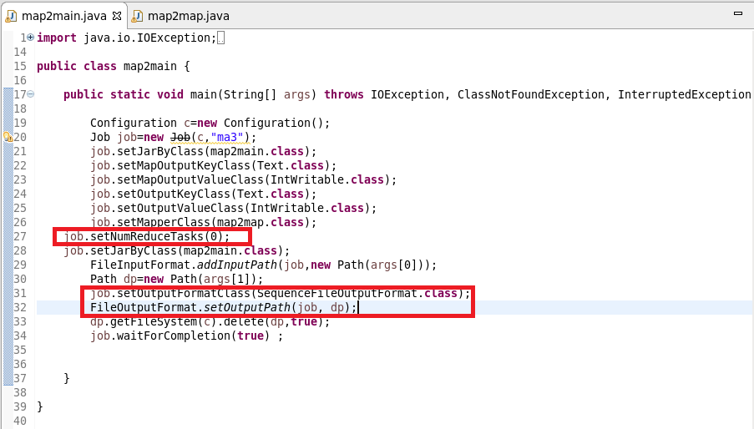

***MAPPER CLASS***

* In mapper class we use hashmap and was updated to make the word repeat and will increase by 1 or else will give 1 as value.
* Cleanup: it is a method which was used to clean the override method and will give as final key instead of writing the mapper for each line.

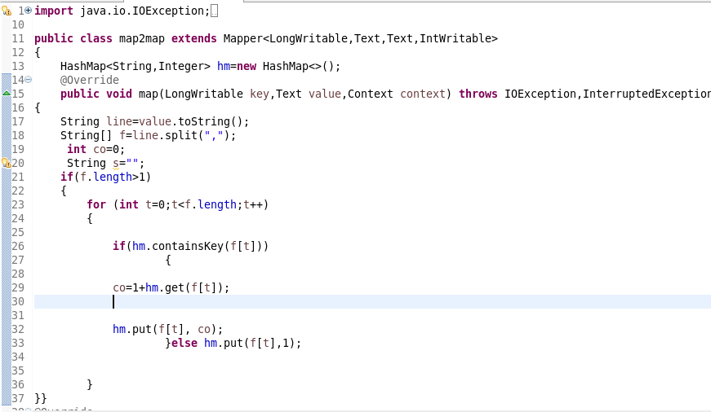

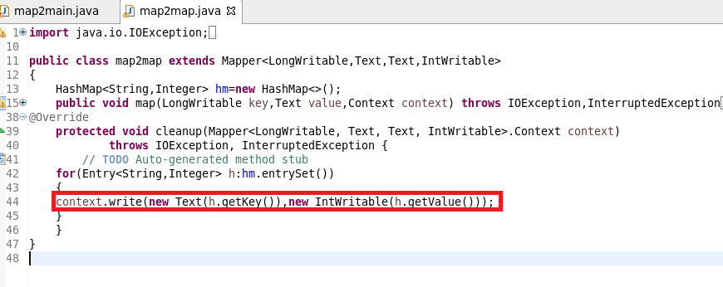

RUNNING JAR

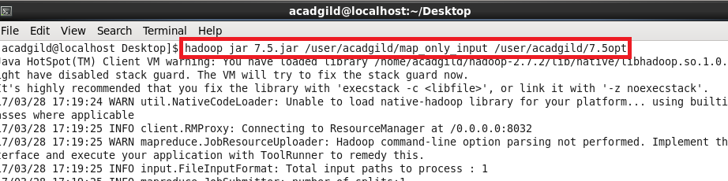

**OUTPUT**

* Text command is used to open the sequence file.

