1. LOAD AND DUMP

Load data from file system.

pig –x is used as local to start in the local mode and then a demo folder is created in order to load the file into S.

Then Dump command is used in order display the Output on grunt shell.

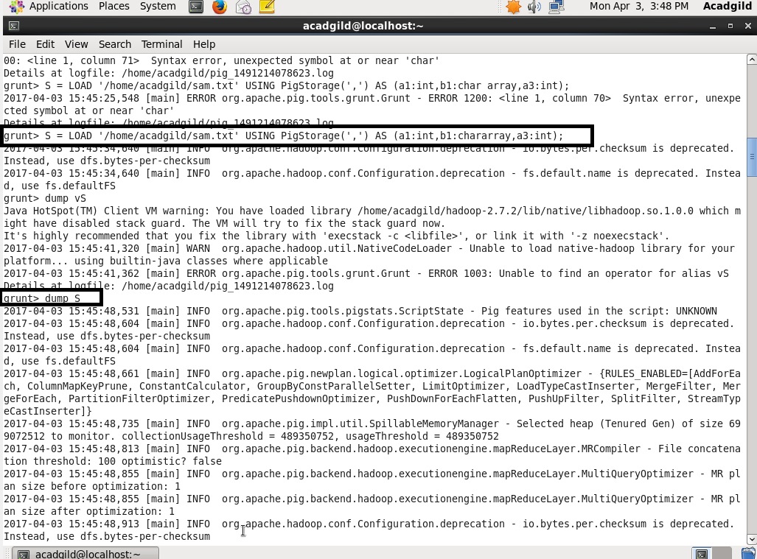

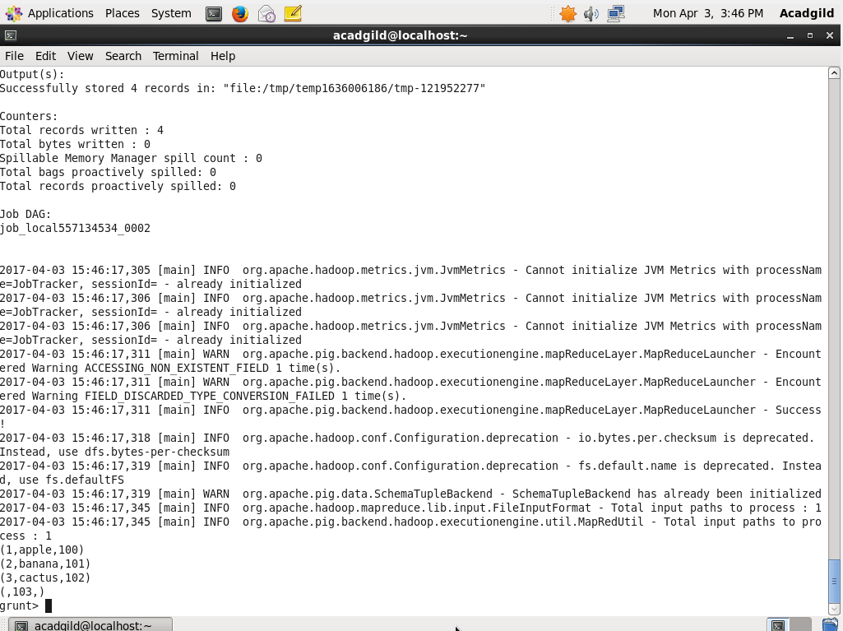

2.STORE

* In case of grunt shell the data provided need to be stored because once we come out of shell all the data provided will be automatically get erased so storage is mandatory here .
* For such case store command is used.
* If the pig storage was not provided then the output will be delimited to the tab (i.e samcopy.txt)
* In this S output will be stored in samcopy.txt which is in the desktop

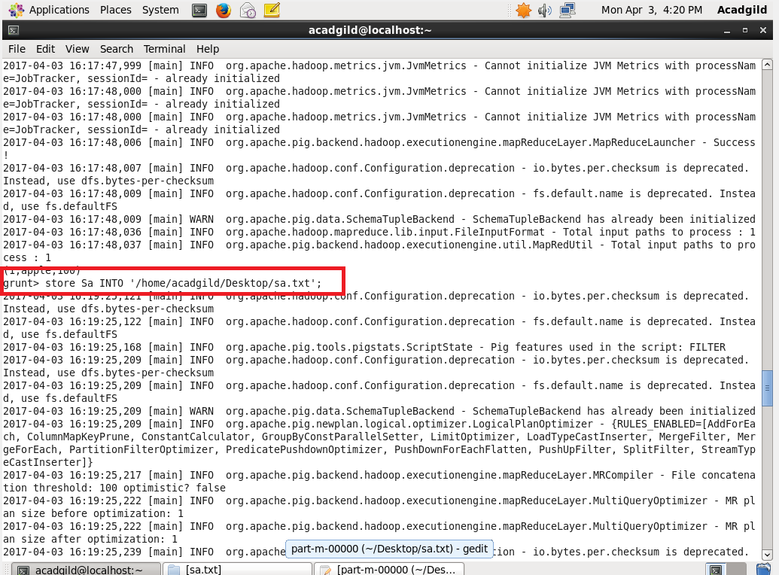

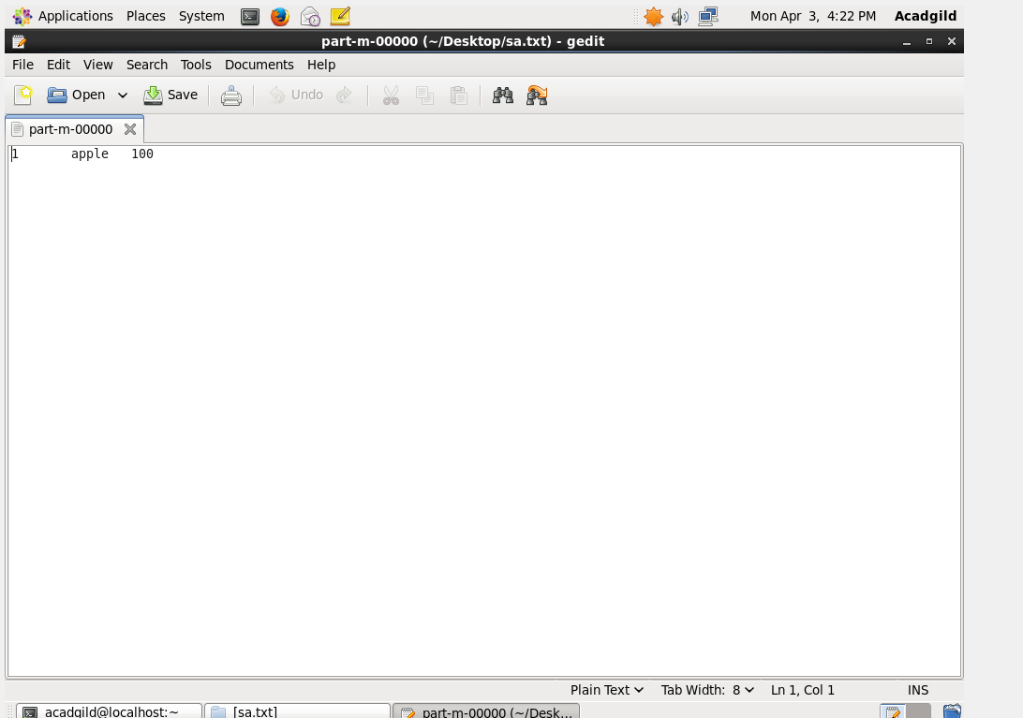

3.FOREACH

Generates data transformations based on columns of data.

It is similar to \* command which is used in in SQL

Simple row manipulation is done here

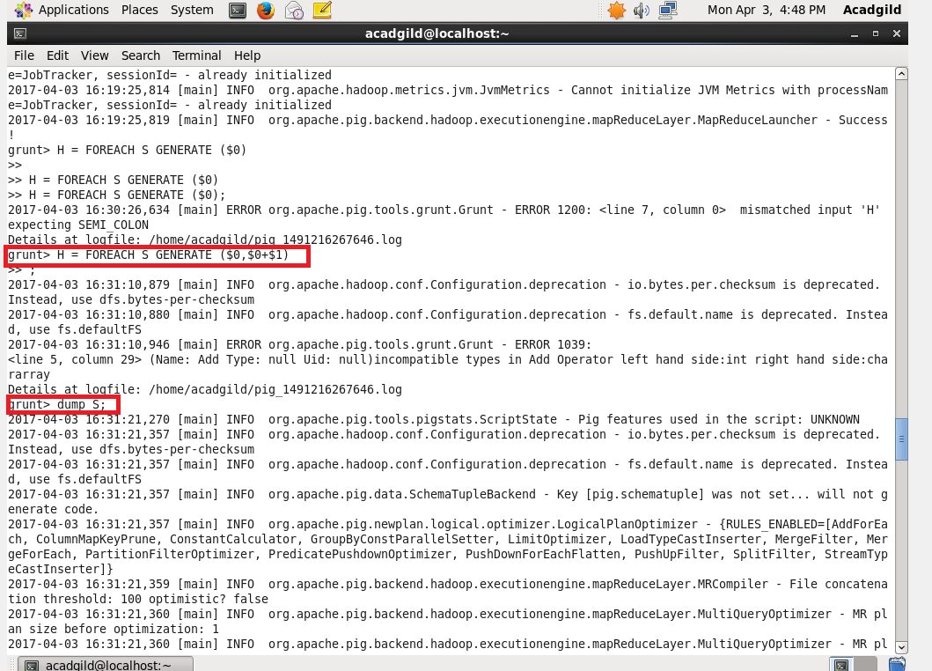

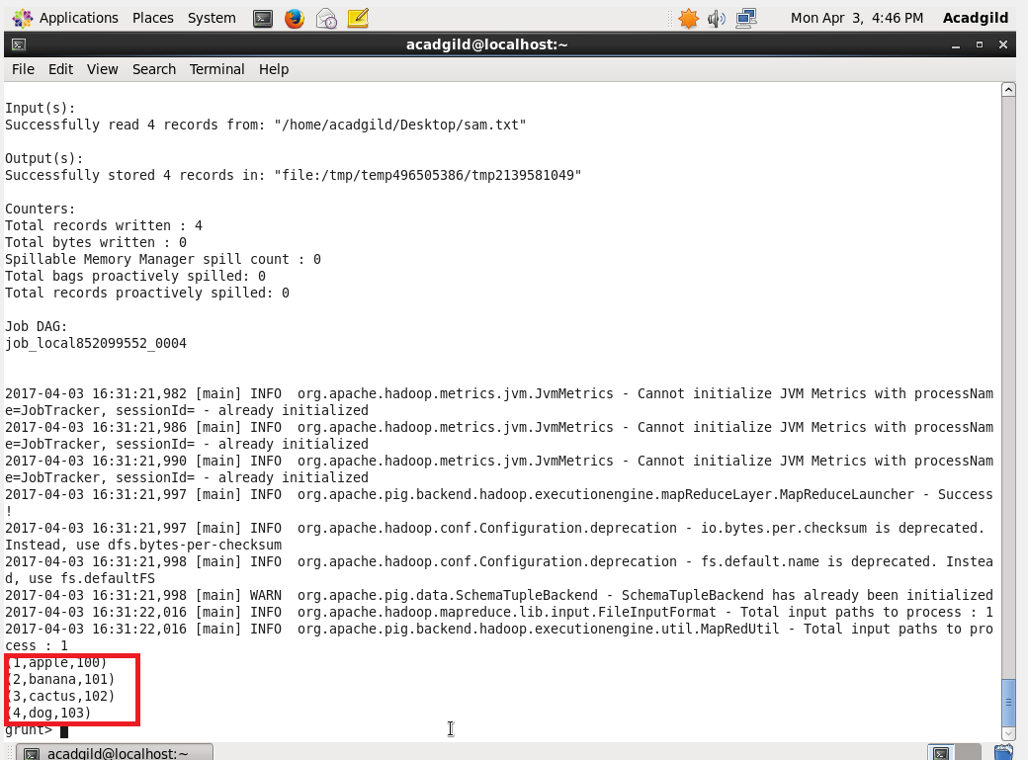

4. FILTER

It is used for filter the data given

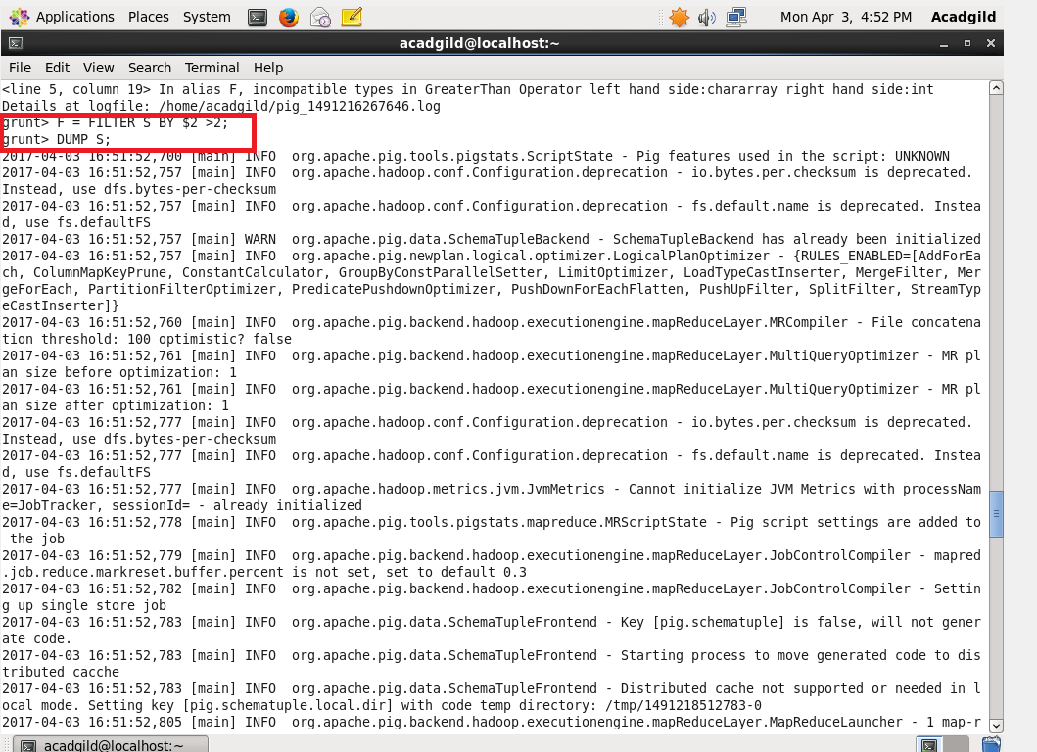

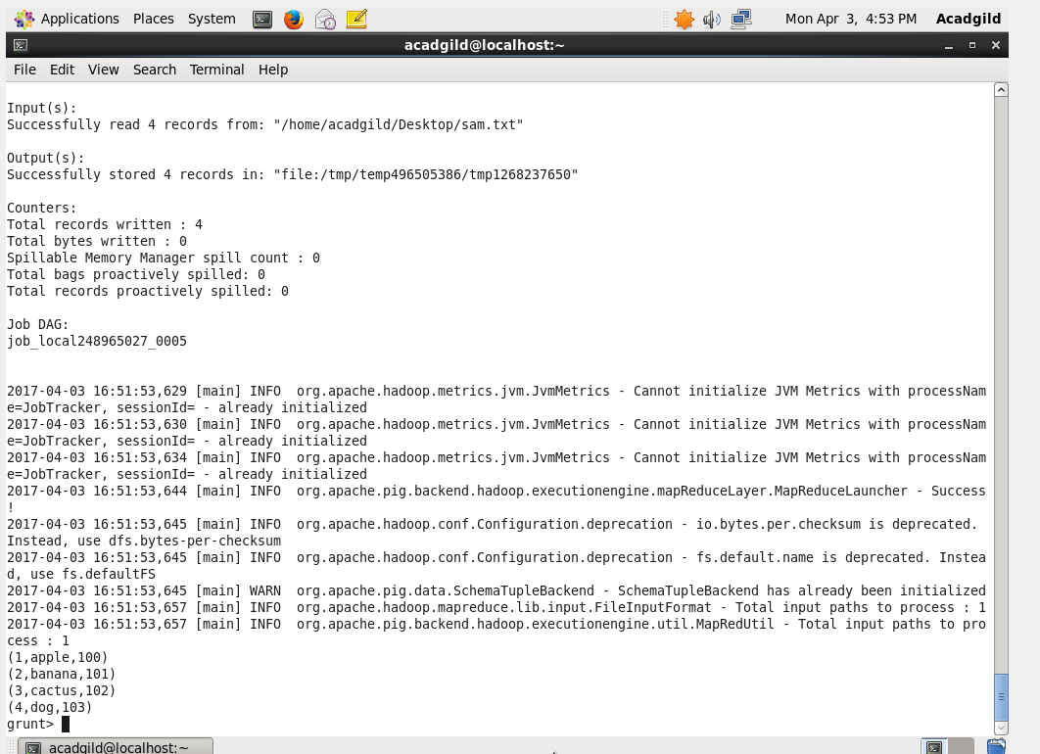

5.GROUP BY

It is used to group data base which is provided

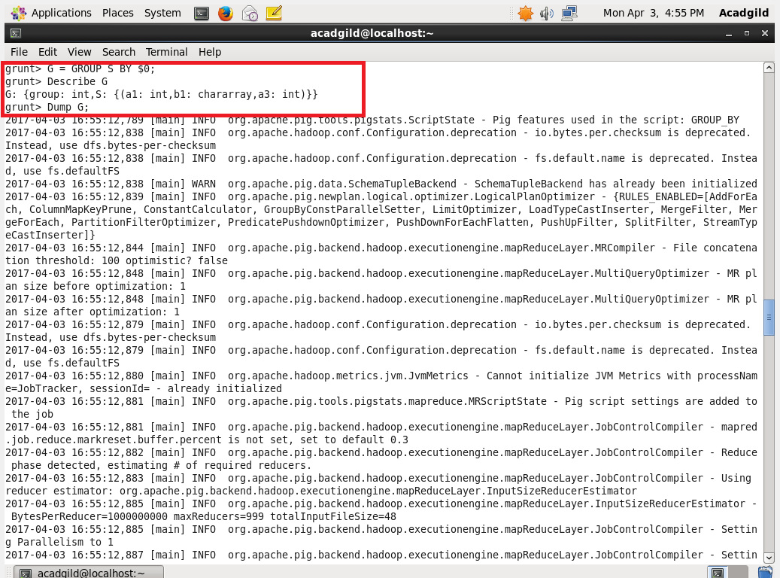

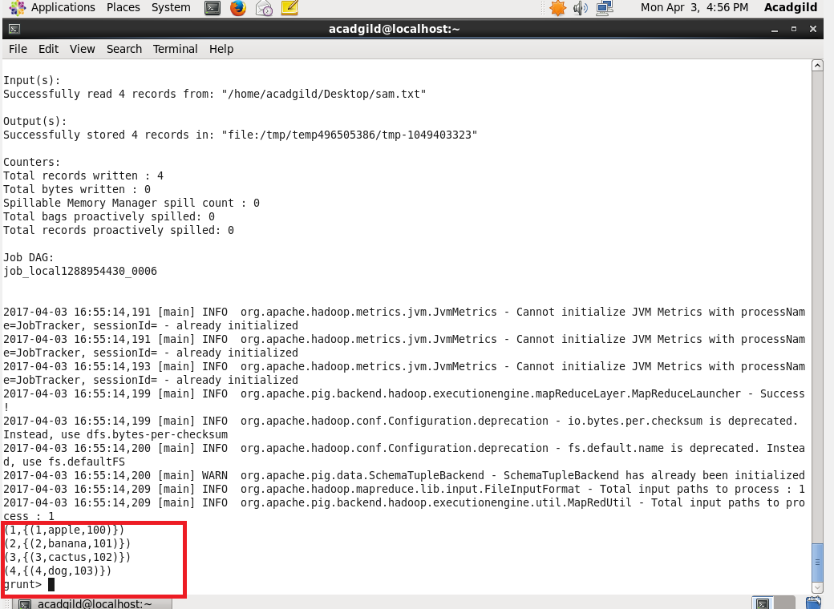

6.ORDER BY:

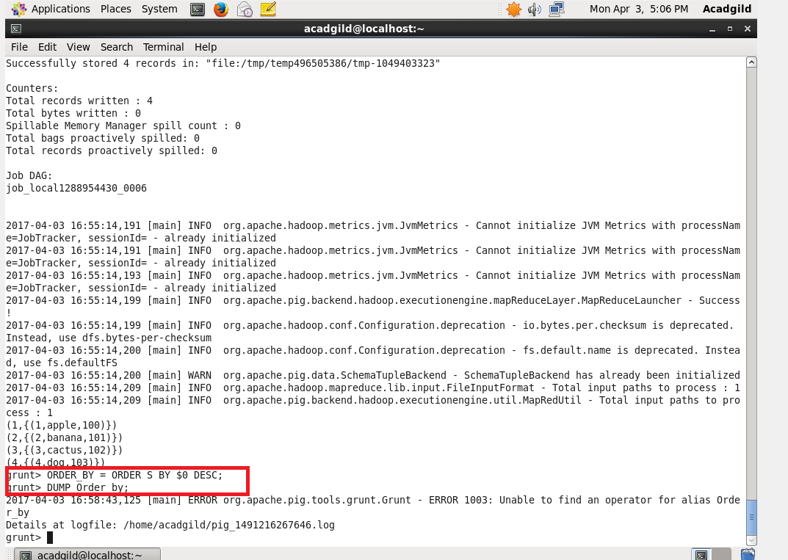

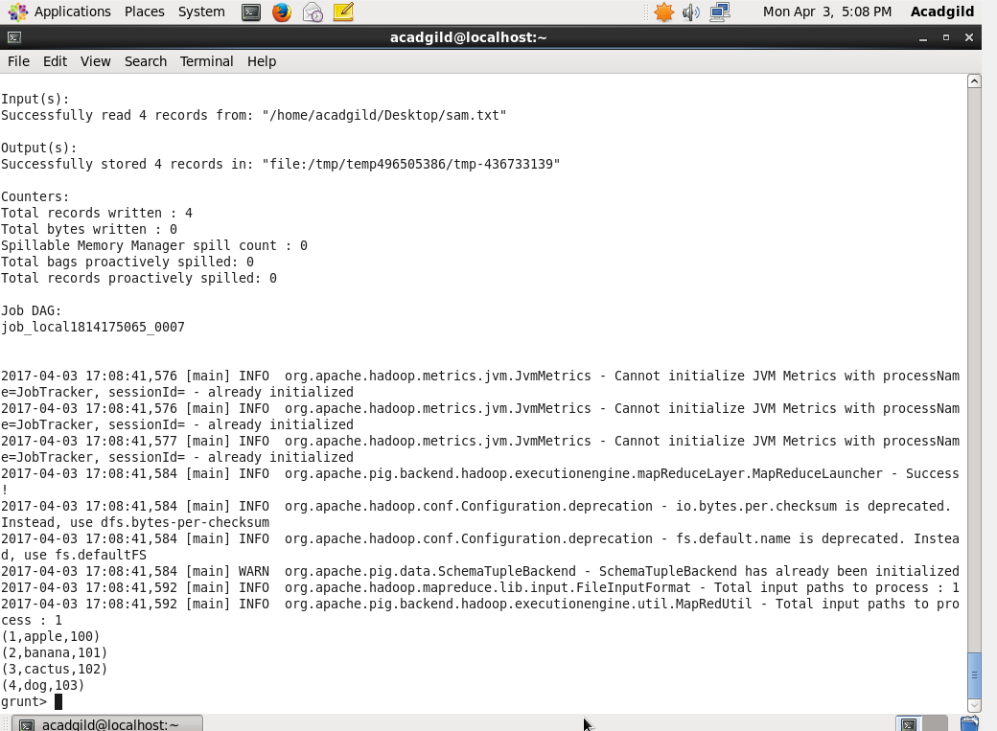

8.)DESCRIBE:

Describe command is used .

