INPUT

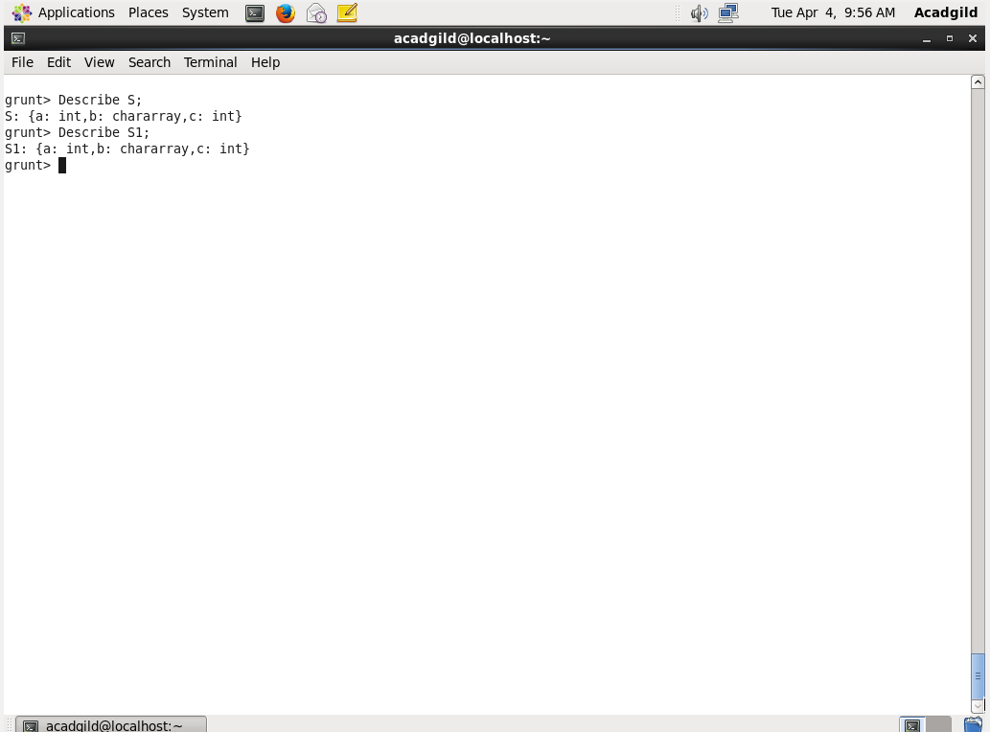

SELF JOIN

Using self join a table can be joined as well comared with itself.

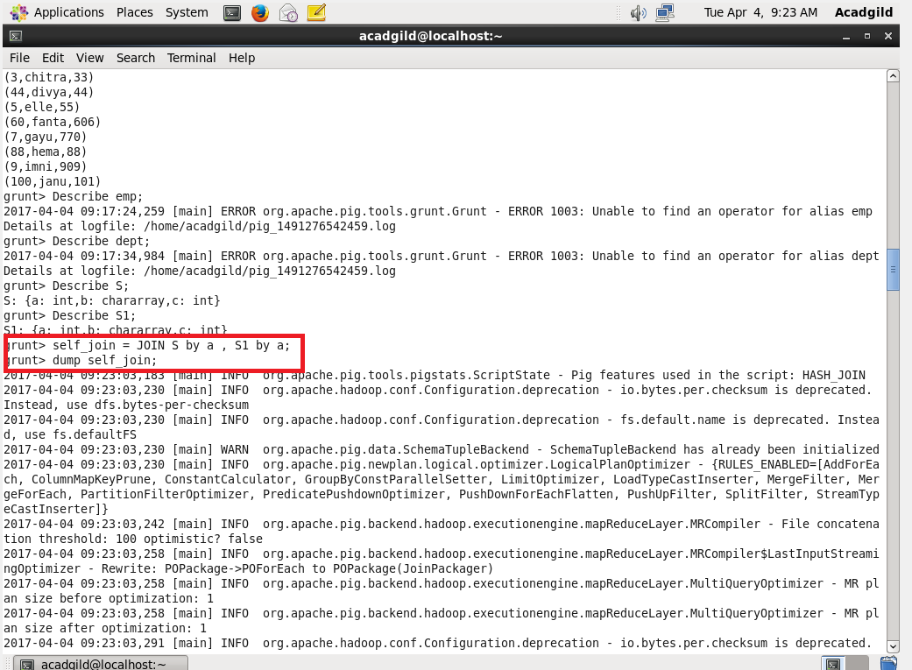

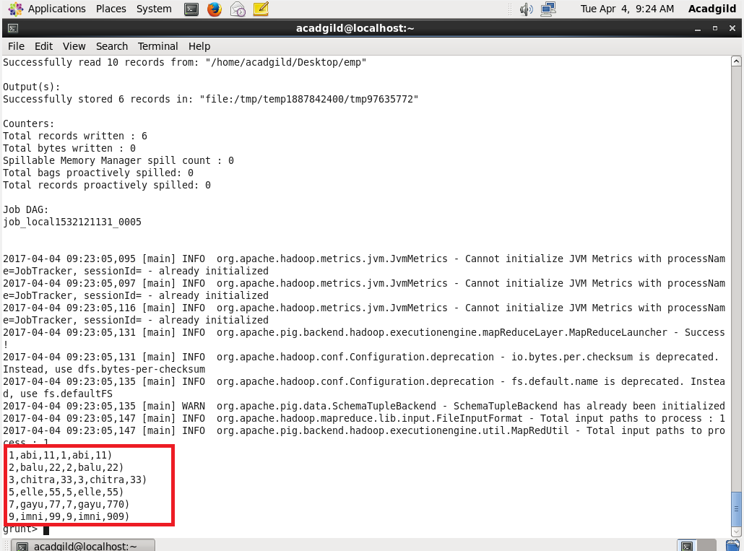

INNER JOIN

Other name of inner join is called *equijoin.*

And it is used to return the rows which have the same values or characters in them.

Here we compare the two tables with the person having same dept_id.

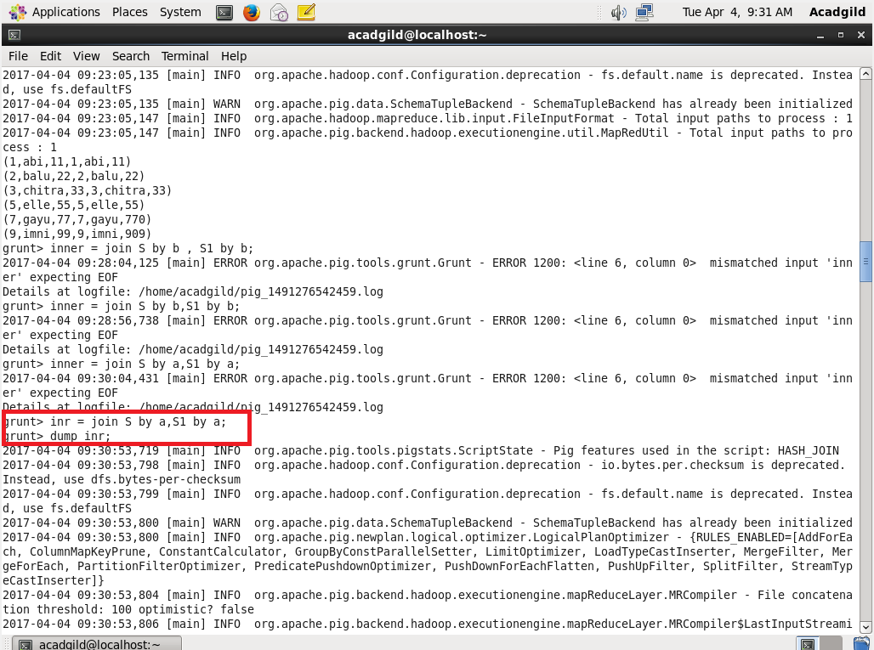

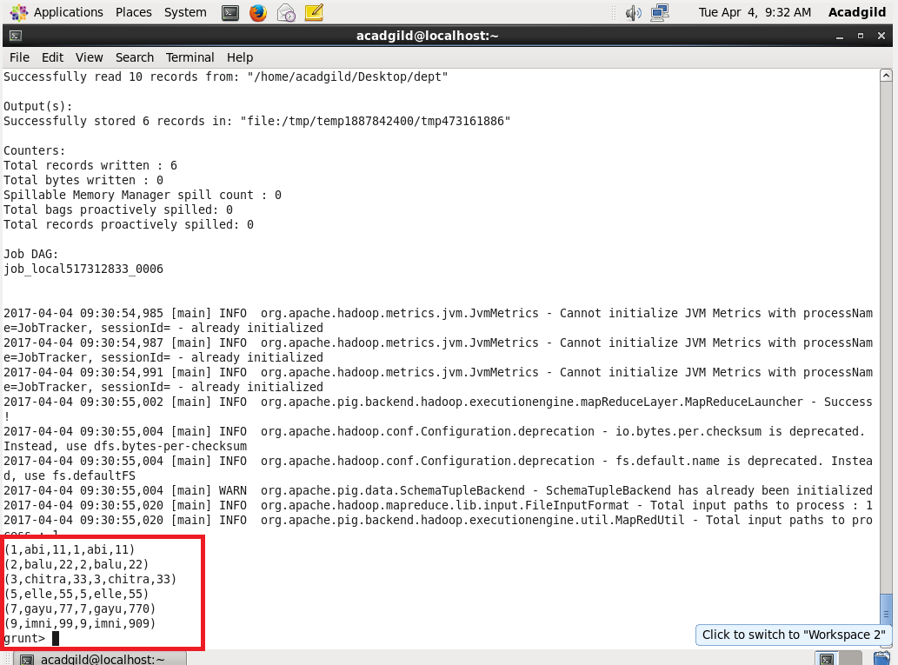

LEFT OUTER JOIN

In this type of join all the details from the left table will be loaded irrespective of the common factors.

And it can return even when there is no common factor.

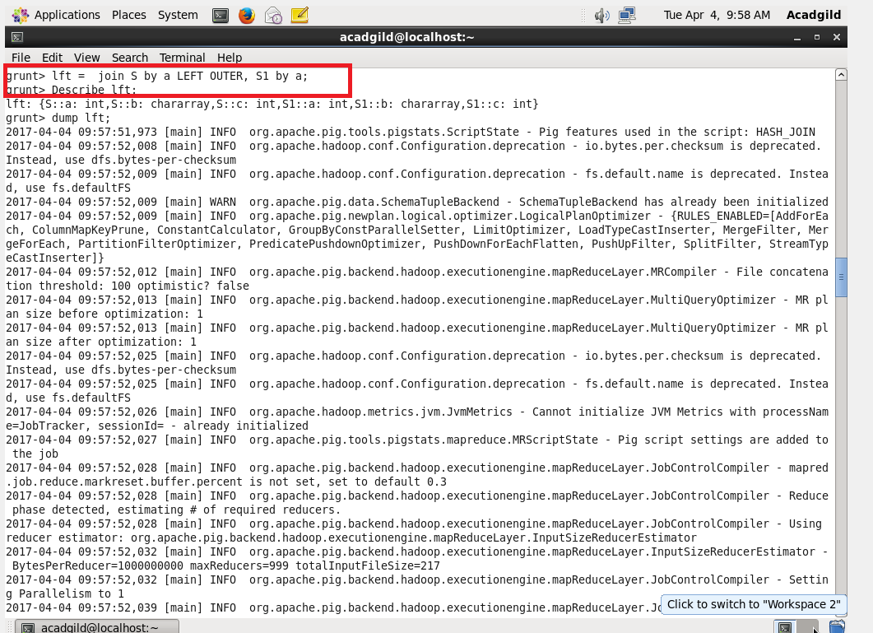

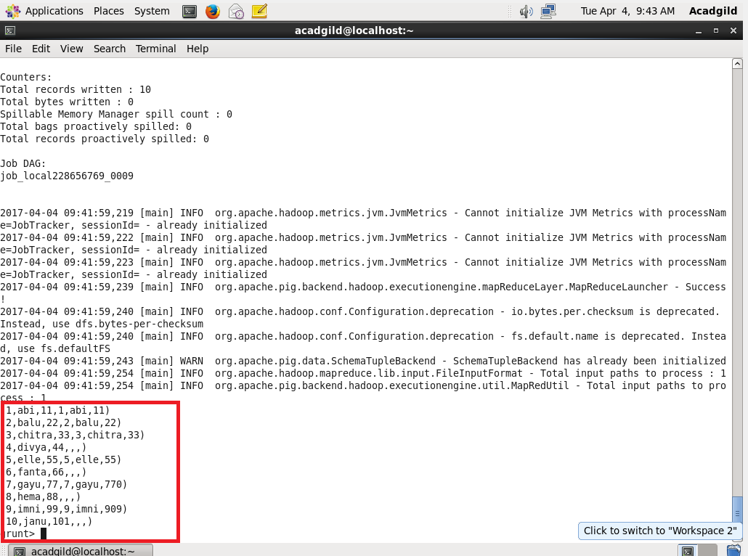

RIGHT OUTER JOIN

In this type of join all the details from the right table will be loaded irrespective of the common factors.

And it can return even when there is no common factor.

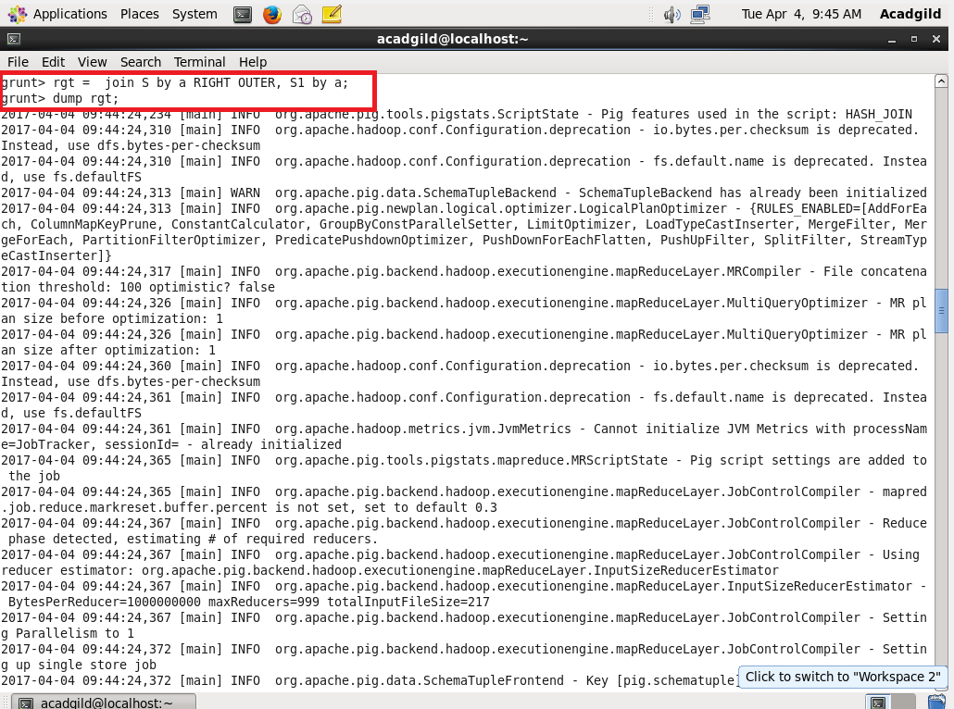

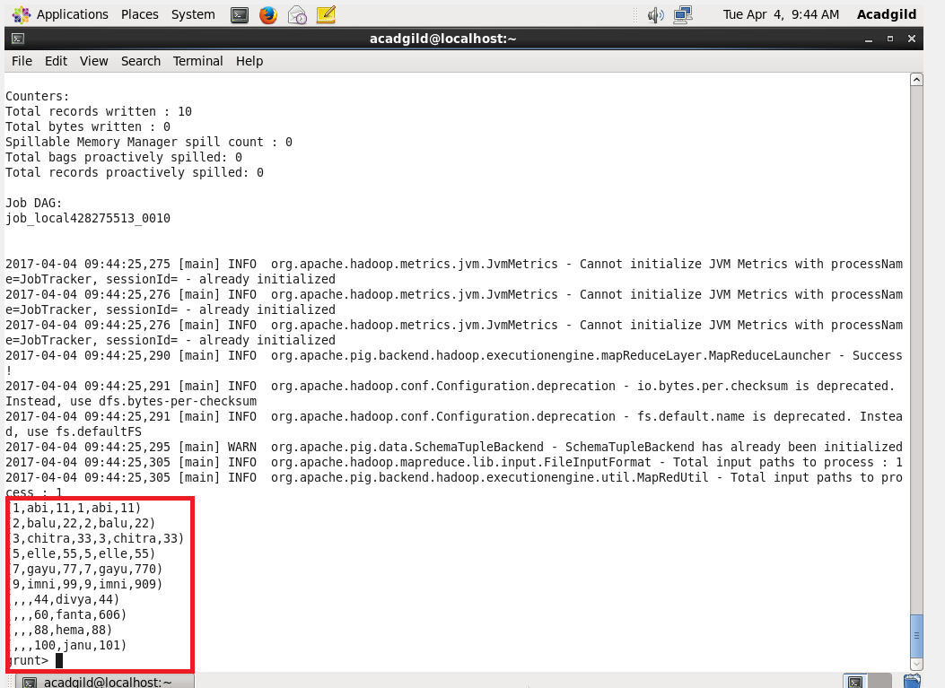

FULL OUTER JOIN

Will return only when there is a match available.

