LOAD AND DUMP

It is to load data from the file to the program

For local mode here we use pig -x local to load from S1

Then dump command is used to display the output

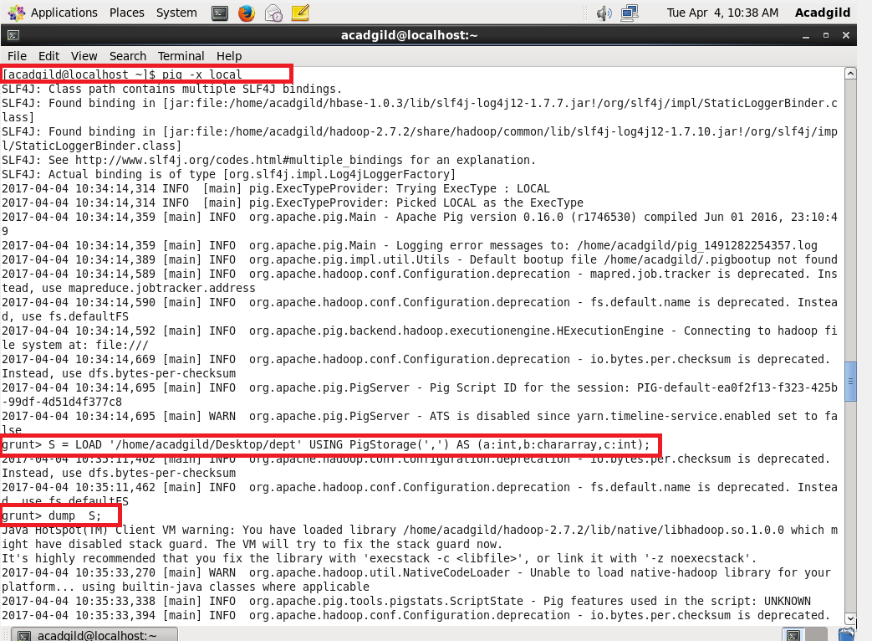

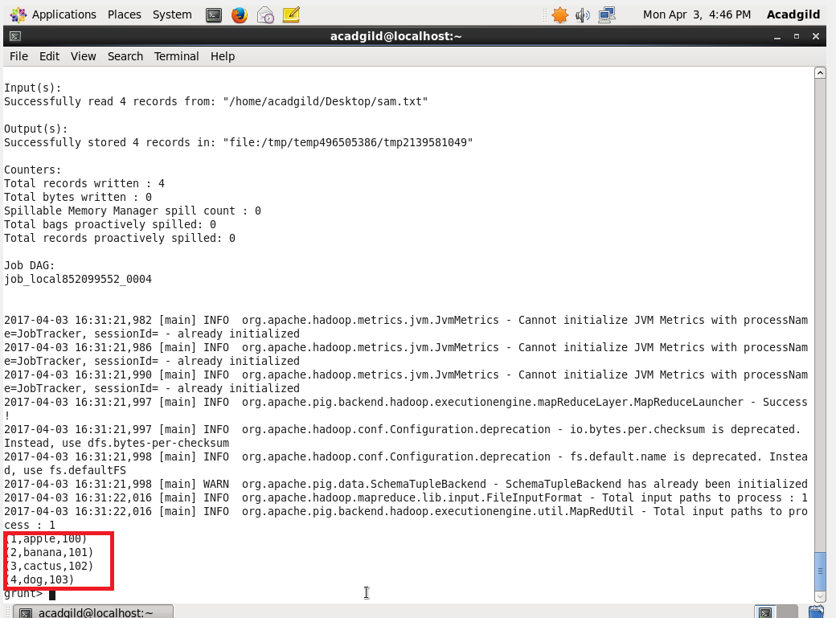

2. STORE

The command should be stored before coming out of grunt shell because the data will be erased.

So it is compulsory to store the data IN THE GRUNT SHELL

The pig storage must be specified while we store.and in this it is stored in S.

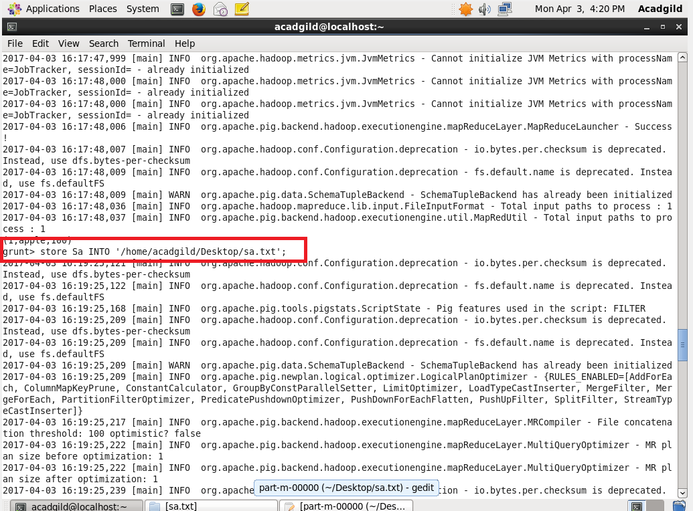

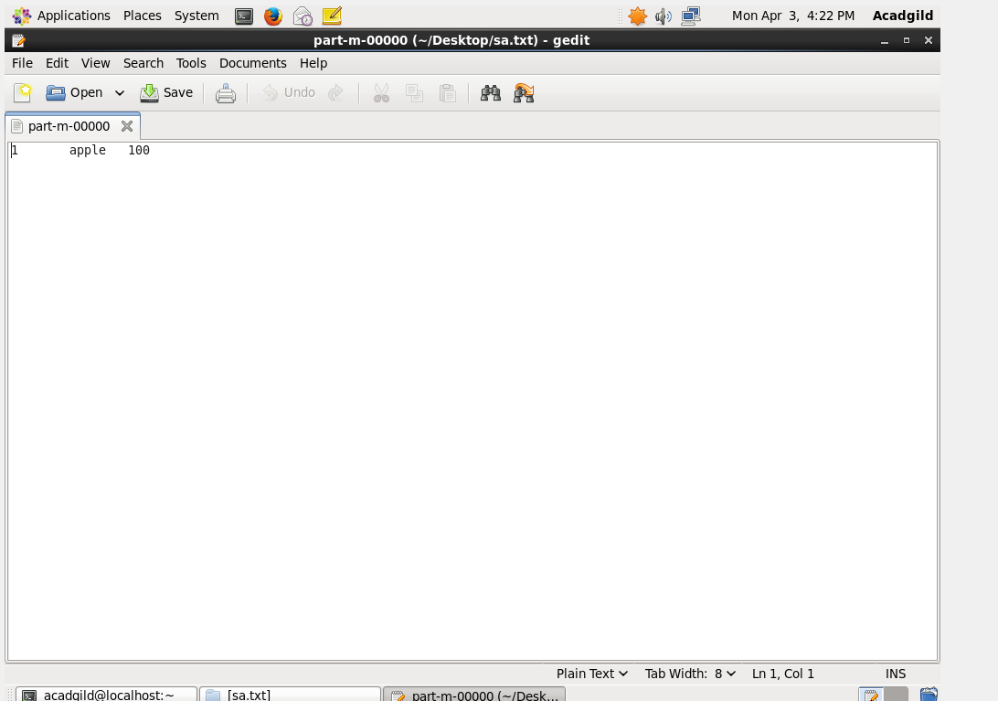

3.FOREACH :

data transformations is done based on data column.

It is similar to \* command used in SQL.

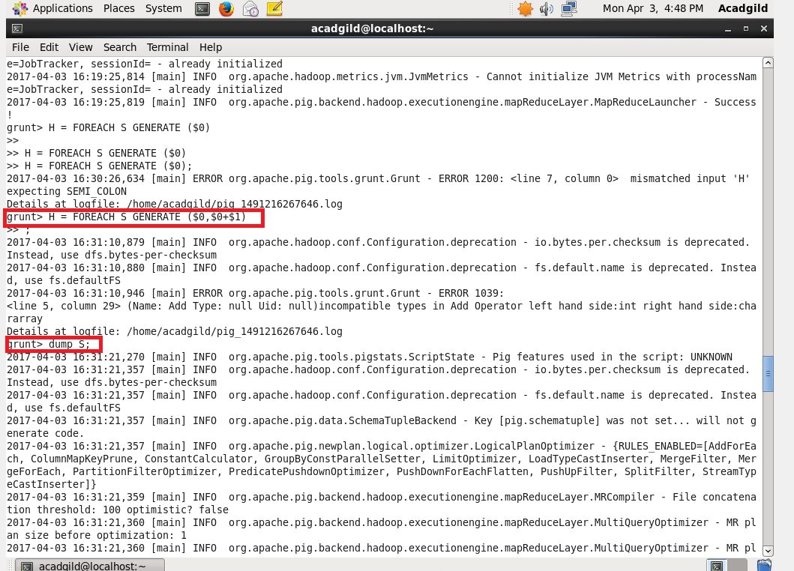



4.FILTER

It is used for filter the data

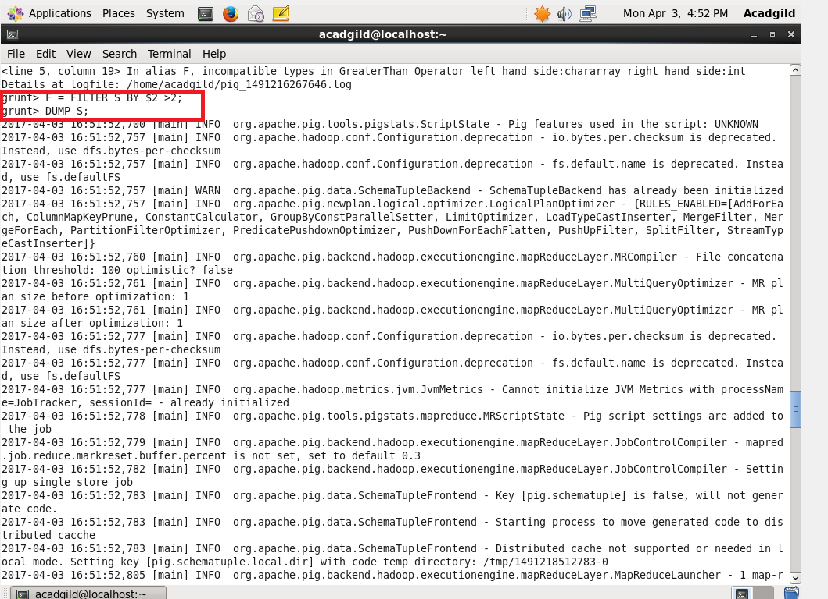



5. GROUP BY

It is used to group data based on the given criteria

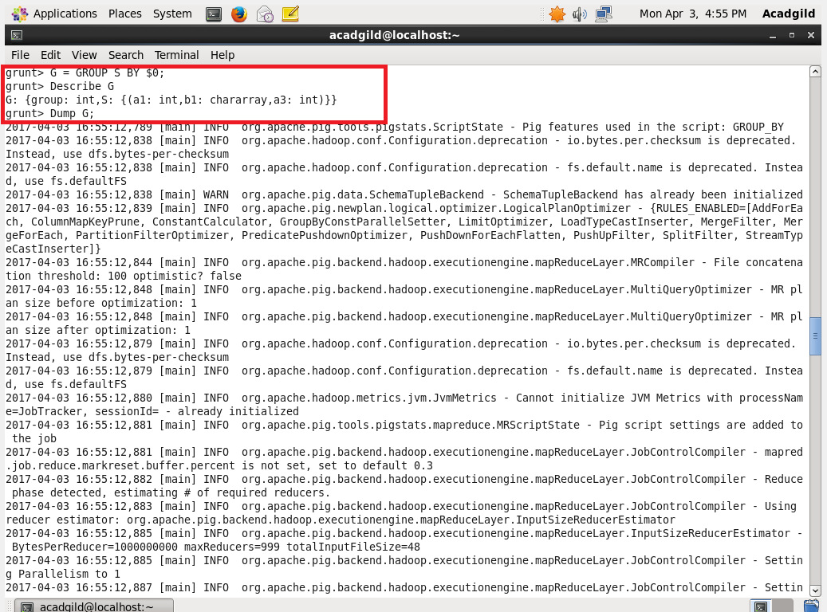

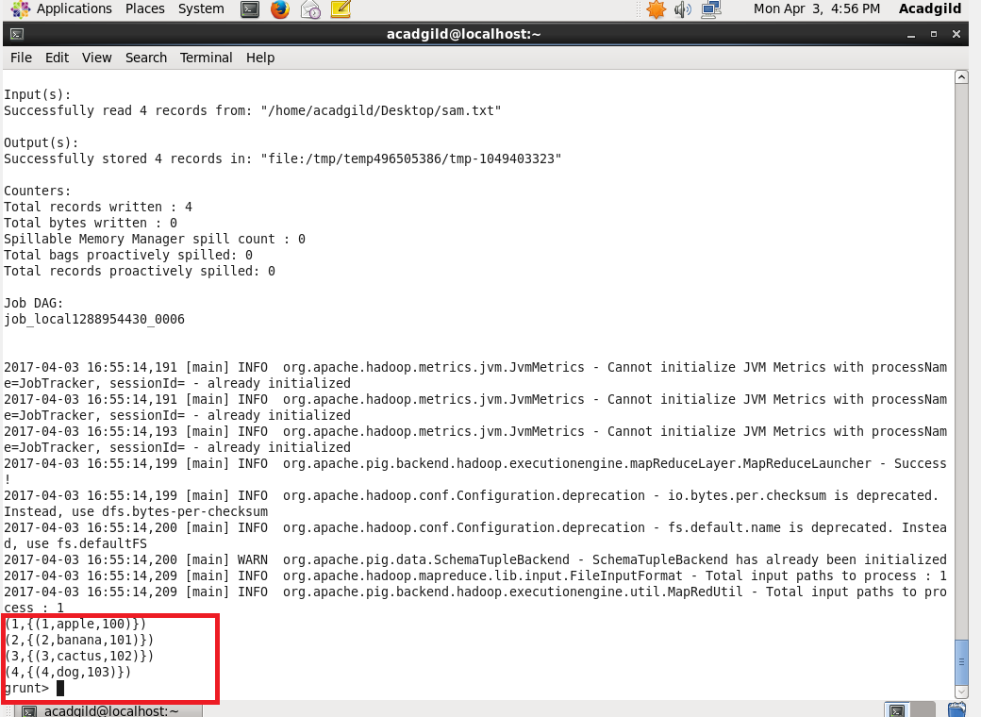

6.ORDER BY

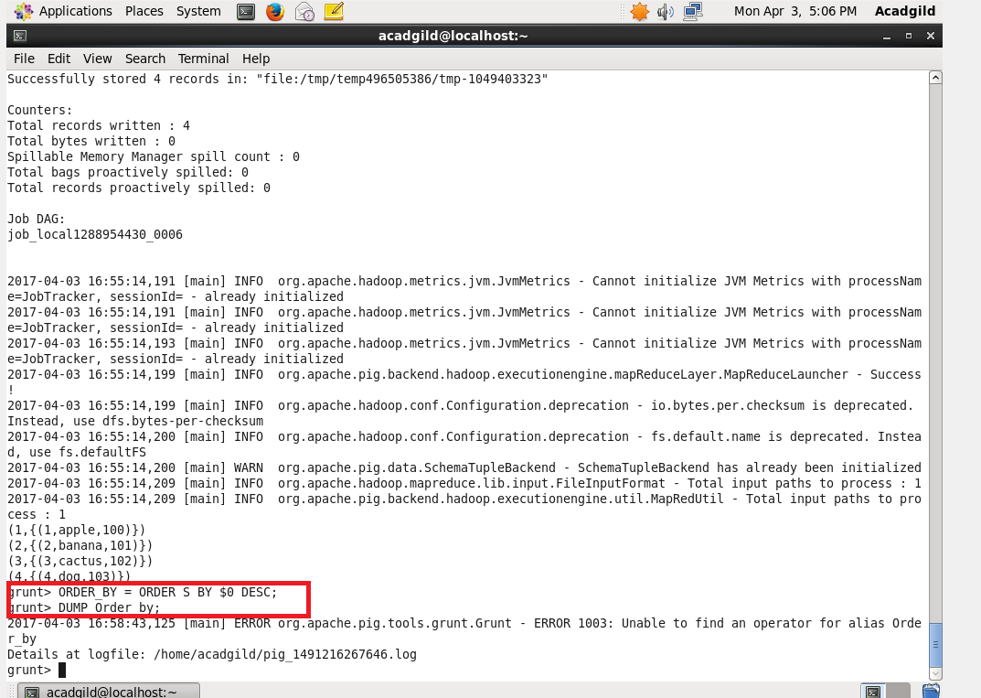

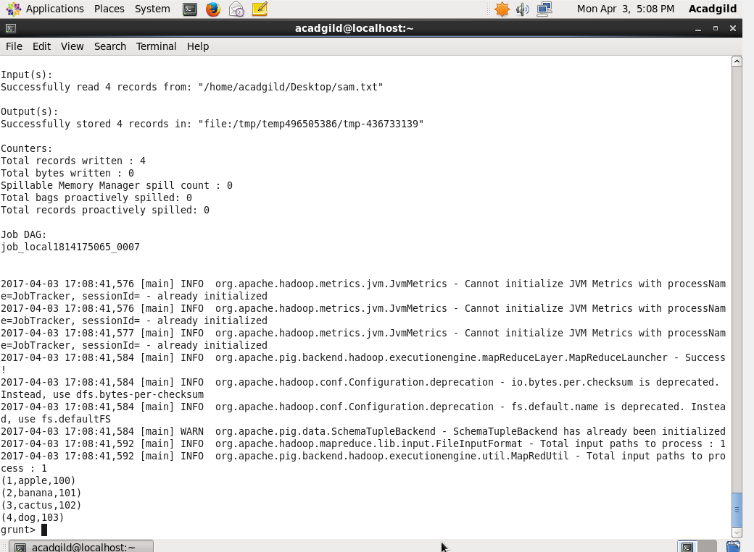

7.DESCRIBE

Describe command is used to describe the Schema.

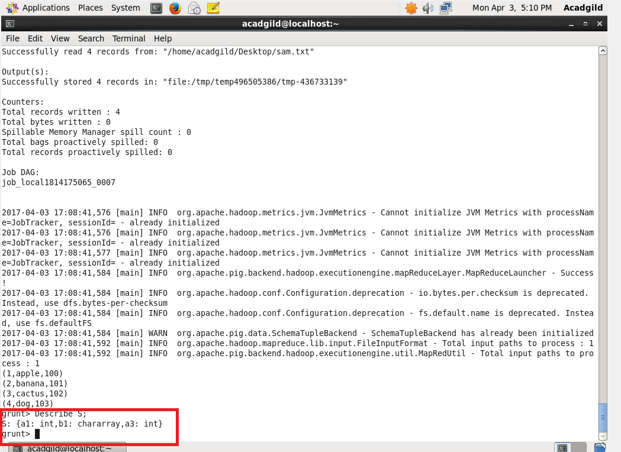

9. Limit:

Output can be limited from vast number to a limited count.

Here the first three data were limited from the volume of data

