Banking app

report

Mateusz Krawczyk 2019 (N0851359)

2020

# Requirements

* This banking app will allow you to log in into your bank account by entering login and password.
* When logged in, you can make a payment to someone from your list.
* You can add new person to your list
* You can delete someone from the list
* You will be able to change your password
* You will be able to see your balance
* You will be able to see the history of your payments
* Data will be stored in a database
* Will use sqlite3 library to add database functionality (SQLite)
* Code will test itself for any bugs or incorrect inputs

# Design/Implementation

## Classes:

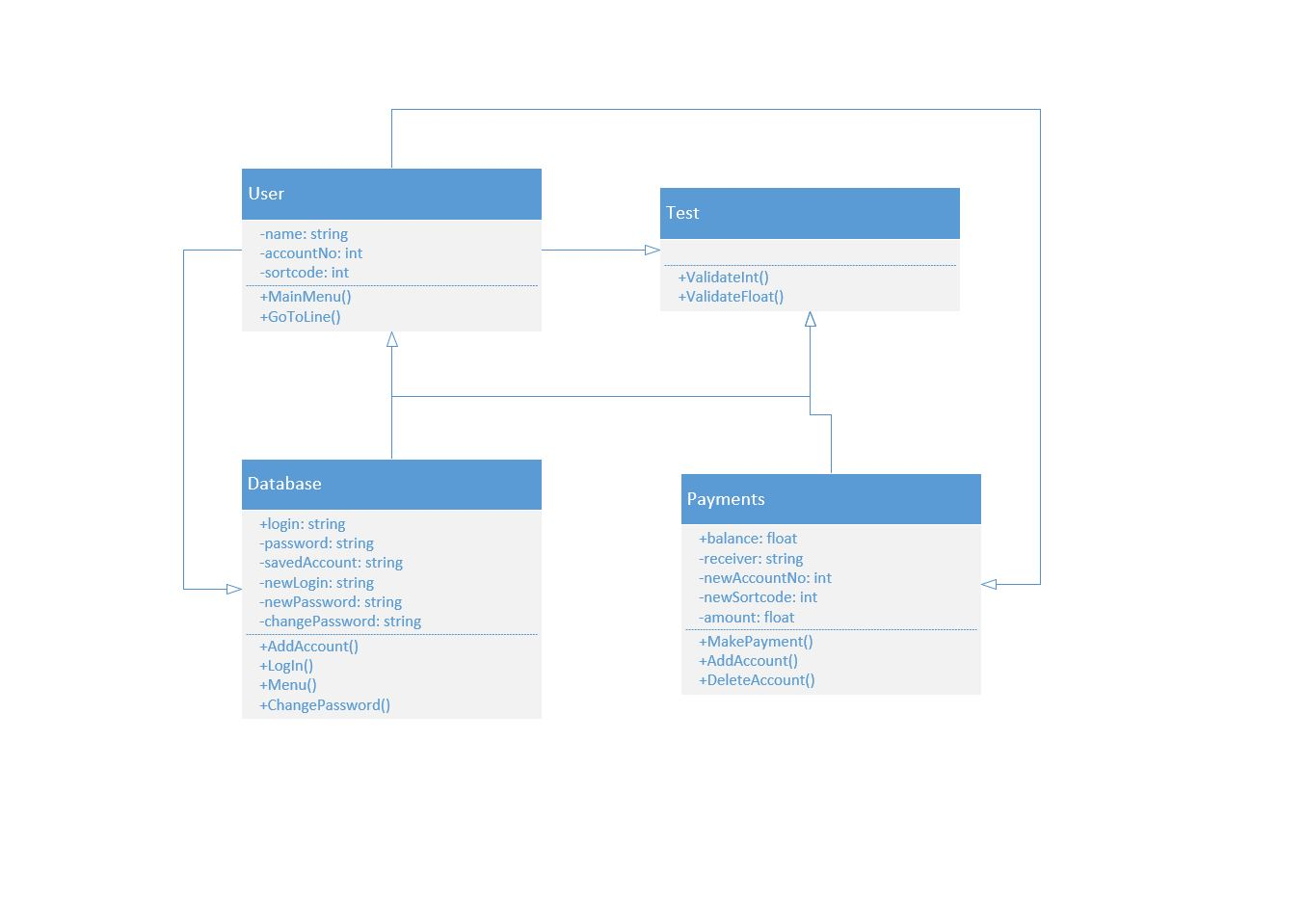

## File structure:

Each user has its own file. First two lines are login and password respectively. This data is saved when user creates an account. Then each line is a new transaction of this account (money in or money out).

For example:

Log

Pas

0

1000

-50

User can also create recipients, these are new files where their name, account number and sort code are stored. Example file looks like this:

Pas

11223344

112233

## Implementation

While creating my app I run over a few problems. Some problems I could fix, and other problems I couldn’t. One of them was using SQLite. When doing my research before sending the project proposal, I’ve found good materials about using it. However, when I tried using SQLite nothing worked as expected and I had to use txt files instead. Another problem that I had was changing the password. However, this problem I was able to fix. It was challenging for me to access the second line of a text file and replace it but after some time I was able to do it (I create a temporary file where I copy everything except the second line). The program also checks itself for any invalid inputs e.g. negative number for making a payment.

# Test Plan

|  |  |  |
| --- | --- | --- |
| Action | Test Method | Success Criteria |
| Log in | Press 1 and enter login and password | Main menu is displayed, username is displayed, and current balance is showed |
| Create new account | Press 2 and enter new username and password | New account is created, and user can log in |
| Close app | Press 3 | App closes |
| Make a payment | Press 1 after you log in, enter a recipient and the amount | Money is reduced from the sender and added to the receiver |
| Add new recipient | Press 2 after you log in, enter the name, account number and sort code of recipient | New recipient is created |
| Delete recipient | Press 3 after you log in, enter a recipient name | A recipient is deleted |
| Check transaction history | Press 4 after you log in | Transaction history is displayed |
| Change password | Press 5 after you log in, enter old password and then new | Password changed successfully |
| Log out | Press 6 after you log in | Logs out |