B.Sc Computer Games Development, Year 3, Project I

Game Design Document

05/10/2021

**“Totally a 2D Game”**

*Authors: Andrew Greenslade, Sten-Matias Kutt*

Project Supervisor: Noel O'Hara

1.1. Overview/Pitch

This game is a 2D/”3D like” game that is set in an apartment complex, it is your job to find your way out by progressing through each level, which combatting enemies that want to rob you of your valuables. It does have a novel mechanic in the form of using raycasting to render a two-dimensional space into a three-dimensional view, like the classic Doom title.

# 1.2. Theme, Setting and Genre

The theme of the game is a grubby/run-down theme, along with being set in a current-day Dublin. It will be an adventure/first-person shooter type of game. The player must destroy enemies to progress through levels, which in turn provides the player with new gameplay elements such as weapons; the gameplay takes heavy influence from old first-person shooters such as Doom and Wolfenstein.

# Player Experience Goals

The player's experience goals include the following:

* The player should feel the need to escape
* The player wants to combat enemies
* The player should feel strong and in control while not being terminator like.
* The player should feel a sense of progression between levels through weapon upgrades and a noticeable increase in level difficulty(See 4.2, Weapons).
* The player should feel satisfied when completing a level or destroying an enemy

# View

The player will be in a first-person view for the actual game while having a top-down view of the map and enemies in a separate window; this is both for gameplay purposes to provide the player with a minimap of potential objectives and enemies, but also because all the logic will be based on the two-dimensional world.

# 1.5. Targeted platform(s)

The leading targeted platforms are Windows 7/8/10/11.

The main resolution would be 1280 x 960 to accommodate the two-game windows of 640x480.

# 1.6. Technical requirements(s)

***Game itself***

Windows-based system (7 or later)

GTX 980 or later

8GB’s ram

Intel 6700K CPU or Ryzen 7 3800X or newer

Keyboard

***Making Game***

Windows-based system (10 or later)

GTX 980 or later

8GB’s ram

Intel 6700K CPU or Ryzen 5 2600X or newer

SFML (Game Frontend)

Gimp (Photo Manipulation)

Visual Studio 2019 (IDE)

Audacity/Reaper (Audio)

# 2. Gameplay

# 2.1 The First Minute (60 seconds of play)

After the Splash Screen/title screen and level select screen, the player is placed in the middle of the map. The words “Escape” appears on the screen, and the player is introduced shortly after the message disappears to a singular enemy, a masked robber which they can choose to combat by using their starting weapons. This pipe is a noticeably short-range melee weapon, or a pistol, which has better range but limited ammo. When they find the exit after the combat introduction, they progress onto the second level after approaching the red exit door, which unlocks after all the enemies in the room are destroyed. For the sake of being an introduction, it will be a straight hallway on the first level. After that, they are introduced to the second weapon, a submachine gun. There are several more enemies to fight, all while trying to escape. The second level will be several large rooms.

# 2.2 Game Progression

* The player progresses by finding the exit door, clearly marked with a sign and by being red
* The game is divided into several “rooms,” the player must destroy all the enemies in any given room to progress into the next room.
* The game increases in difficulty by having several enemy types and increasing enemy count (See 4.2, Enemies).
* The rewards are new weapons for the player to use I.e., sub machine gun, assault rifle (See 4.2, Weapons).

# 2.3 Level Progression

* To complete levels, the player must destroy each enemy within a given level and then progress to the exit door.
* The main game loop will consist of randomly generated levels, but we will also incorporate a level editor to allow for custom levels.
* As the game progresses, the amount of exits within a level decrease, and the number of enemies increases which leads to a progressively more difficult experience.
* The difficulty will be offset by the player unlocking more powerful weapons. (See 4.2, Weapons).
* When the player completes the game, they will be offered a new game + mode, in which they can use all their unlocked weapons from the beginning.

# 2.4 Objectives/Victory conditions

* The final objective of the game will be to reach and complete the final level.
* Within the final level will be a boss fight, a more dangerous enemy that will require the player to use more resources than usual.
* The player will lose when their health is reduced to 0.
* A player's health will be reduced by various attacks made by enemies.
* The player can regain health by picking up various health items scattered throughout the level.

# 3.0. Features

*Features for our game include (In order of importance):*

* ***Mechanics***

* + **Movement**
    - This is done in the 2d space, where the player will move at a set speed, but when they hold the run key they move faster as if they were running. shooting. This is also done in the 2d space and as the distance grows from the player the sprite in 3D space shrinks.
  + **Shooting**
    - There will be different weapon types with different. Fire rates, projective speeds and ammo counts. The weapons can be switched with 1-4 keys on the keyboard. (See 4.2, weapons).
  + **3D like rendering**
    - The game world will be simulated in 2d, then converted to 3D.
  + **World** **editor**
    - This will be a grid where you have a selection of tiles to choose from, and you click where you want to place the tile, from this when you exit the world will be generated when you go to click play and choose the map.
* **audio/visual elements**
  + **Retro sound effects**
    - The game will have a retro, 8-bit audio aesthetic that takes inspiration from old first-person shooters such as DOOM or Wolfenstein.(See 4.2, Audio)
  + **Different textures on 3d walls**
    - There will be different textures of the different wall types. For example, exterior walls will be, windows, brick, etc. interior walls will be wood panels, plaster, etc.
  + **Sprite sheet animations**
    - examples of animations in the game world would be muzzle flash, different enemy cycles (walking, shooting, etc).
    - Enemy response when hit, I.e. enemy becomes red when hit.
  + **Responsive UI (in reference to health)**
    - we will have a face of our character, and when he gains or loses health, he will make a certain facial expression.

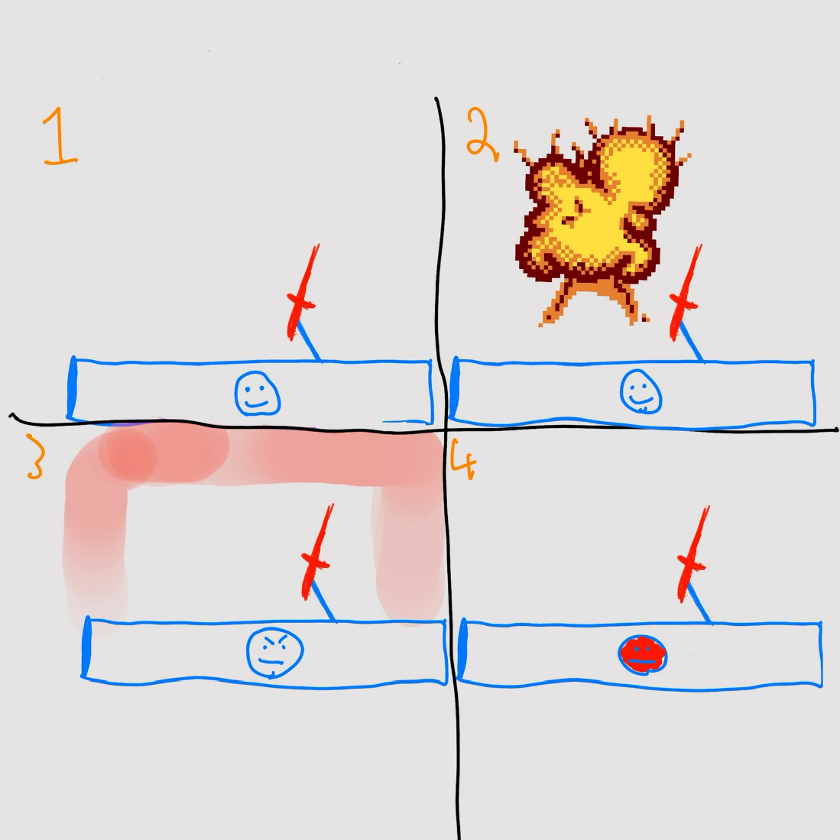

* **structural elements:**
  + **Weapon progression system**
    - As the player progresses levels, they will be awarded certain weapons, i.e. player starts with a melee weapon, then they are first awarded a pistol, then a sub-machine gun, and so on. Where there are 10 levels in total, every 2nd level you will gain a new weapon.
  + **Set number of levels to press to boss**
    - There will be a set number of levels to complete, in this case, 10 levels. When the player completes that number of levels, they will be taken to a boss level, aka. Your landlord (See 4.2, enemies).
  + **Random generated levels**
    - This will be done for making the player’s experience non-repetitive. The player will also have the choice to play a premade level, that will be the tutorial. There will also be a set story mode, where you can progress a set number of pre-made levels by us. Finally, there will be a ‘speed running’ game mode where the levels are endless instead of a set number, and you will fight a boss at certain intervals.
    - There will be a largest tile count, there will always be an exit route, there will be no overlapping tiles.
  + **Menu system**
    - There will be a settings screen, main menu screen, game-mode selection screen, level select screen and game screen.
* **game control elements** 
  + *Save game for random levels progression,*
    - *You will be given the option to save the game, i.e. what level number you are on for the roguelike mode, what levels are unlocked for the story mode, and what high score you have for the speed running mode*
  + *Save the custom world for the map editor*
    - *There will also be a map editor, where you can save a custom map, that you can create yourself.*
* **Enemies**
  + - Multiple enemy types (See 4.2 Enemies)
    - The game will feature multiple enemy types Each enemy will have a unique sprite associated with it
    - Each enemy will have their own abilities, weapons and weaknesses the player must avoid or exploit to defeat the enemy.
    - There will be a boss type enemy the player must defeat to complete the game (See 4.2, Enemies).

# 4. Game World

## 4.1 Game geography

*The game geography will simulate a rundown apartment area within central Dublin, the game will make heavy use brickwork textures and gritty sprites to drive home the urban, rundown aesthetic we are going for. The atmosphere of the game is supposed to be bleak and dreary, and will make use of dull, muted colors to achieve this.*

*In each level, there will be one or multiple doors that allow the player to ascend to the next floor, supplying the core gameplay element.*

## 4.2 Game World Elements

Enemies

|  |  |  |  |  |  |
| --- | --- | --- | --- | --- | --- |
| **Name** | **Weapon/Ability** | **Movement Speed** | **Sprite/aesthetics** | **Detection Range** | **Weakness** |
| Grunt | Lead pipe, melee attack | fast | Hooded individual person | Short | Pistol |
| Gunner | Pistol | Average | Suit/Mafia aesthetic | Average | Sniper |
| Rocket Gunner | Launcher | Slow | Soldier/Military aesthetic | Far | Rifle |
| Exploder | Self-destroy | Above average | Robotic | Average | Anything |
| Landlord | Homing projectiles, random projectiles | Below average | Old man with weapons | Far | Player can shoot and destroy the enemy's projectile to deal bonus damage |

*Weapons*

|  |  |  |  |
| --- | --- | --- | --- |
| ***Name*** | ***Power*** | ***Advantage/Disadvantage*** | ***Ammo type*** |
| Pistol | low | Abundant ammo/low damage | Pistol |
| Pipe | medium | Infinite ammo/low range | None |
| SMG | Low | High rate of fire/Low range and damage | Pistol |
| Shotgun | High | High damage/ extremely short range | Shotgun |
| Rifle | High | High damage and range/Hard to find ammo | Rifle |

Consumables

|  |  |  |
| --- | --- | --- |
| **Name** | **Effect/Downside** | **Rarity** |
| Pint | Immediate small health gain/Blurred View | Common |
| Grenade | Throwable projectile, high damage/Can damage player | Medium |
| Armor Vest | Adds to players armor rating/None | Common |
| Med pack | Large health gain over time/Cannot be carried by player, used on pickup | Rare |

Audio Effects

|  |  |  |  |
| --- | --- | --- | --- |
| **Name** | **Trigger** | **Length** | **Looping** |
| Gunshot | Player presses a key and shoots, Enemy shoots | Short | Depending on weapon fire rate, automatic yes single no |
| Player hurt | Player takes damage | Short | No |
| Background music | Level loaded | Long | **Yes** |
| Enemy Alert | Enemy detects player | Very short | **No** |
| Player Consumable used | Player uses consumable | Very short | **No** |

# 5.0 Levels

### 5.1 Level description

* *The player will be given the option to play a tutorial level at the beginning of the game, this tutorial will introduce the player to the core mechanics, I.e., attacking, health, doors, and enemies.*
* *The objective of the game is to complete 10 levels and defeat the boss. The objective of each individual level is to defeat the enemies and find the exit.*
* *The player will need to dodge enemy attacks, explore, and manage resources such as health, ammo, armor, and consumables ( See 4.2, consumables).*
* *The aim is to have two types of level, the main game will consist of randomly generated levels, and there will be a secondary game mode that allows players to create and play custom levels, the game will come with 10 premade levels that have some coherent story to them.*
* *Since all the enemies are randomly generated, the only “Important” enemy the player will encounter will be the final boss*
* *As the player progresses throughout levels, they will unlock more weapons to use to fight the enemies. The player must explore the level thoroughly to gather resources such as ammo and consumables for the final fight. This is by design to avoid players simply rushing to the exit.*

# 6.0. Interface

## 6.1. Controls

Example

The game will follow the standard WASD layout for controls. The only interesting thing is the camera rotation will be dependent on the A and D keys, while the W and S keys are used to move forwards and backwards respectively. This means the player will be unable to strafe left and right, but this movement model will be much more comfortable than using the mouse for the camera, since the player is unable to look up or down.

## 6.2 In-game overlays & dialogues

*The player will have a HUD that shows the number of consumables and health that they currently have. When the player has more than one weapon available to use, they can cycle between their weapons with number keys 1-x. The HUD will also display the amount of ammo in the player's currently equipped weapon(See 6.3, HUD).*

6.3 HUD

*Diagram of the HUD, clearly showing what info is available*

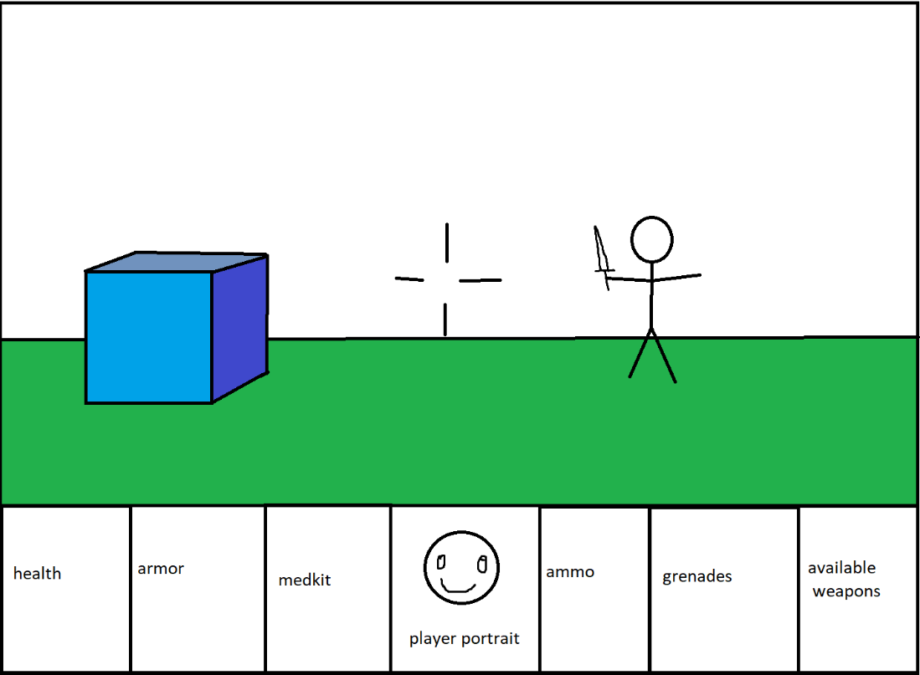

# 7.0 Screenflow

*A graphical description of how each screen is related to every other and a description of the purpose of each screen.*

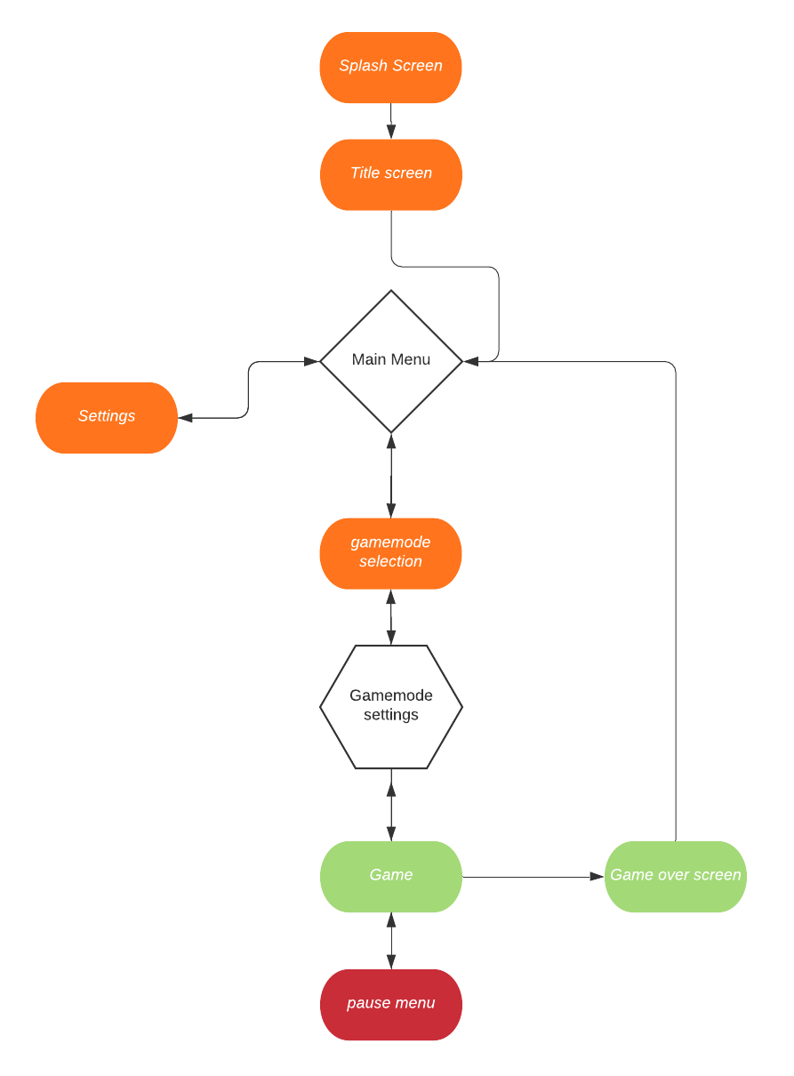

## 7.1 Control system

*In the main menu, the player will be displayed various buttons to navigate through the various other screens of the game. The player will click on these buttons and the game will update to the new screen. The options available to the player in the menu will be:*

* Select game mode
* Tutorial
* Skins
* Exit

During gameplay, the player will also be able to enter a pause menu by pressing escape. From this menu, the player will be able to exit to the main menu.

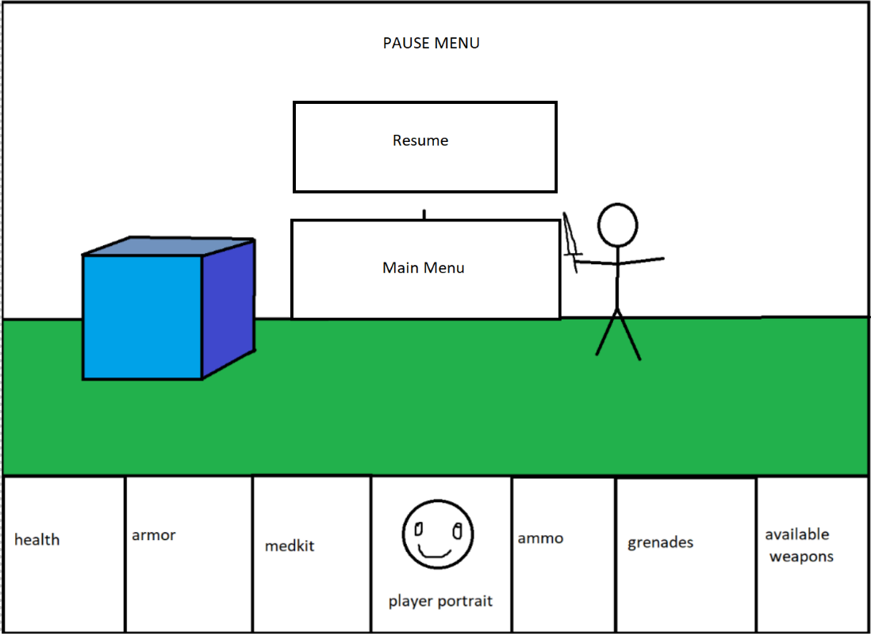

## 4.2 AI

Opponent AI:

Refer to Table on 4.2 Game World Elements, the ai types are described their.

Support AI:

No support AI in the game.

# 8. Game Art & Audio

# 8.1 Audio required:

# 

|  |  |  |
| --- | --- | --- |
| Gunshot | Menu music | Explosion |
| Player hurt | Enemy sounds | Grenade bounce |
| Background music | Level completed sound | Reload |
| Enemy Alert | Death sound | Enemy hurt |
| Player Consumable used | Coin pickup | Melee sound |

# 8.2 Art assets:

|  |  |
| --- | --- |
| **Art asset** | **Frames** |
| Tiles (12 in total) (carpet, tiles, wallpaper, plaster, brick, window, etc.) | 0 |
| Weapons (SMG, Assault rifle, crowbar, pistol, grenade, etc.) | 12 per weapon. |
| Hud (Face, Background, etc.) | 4 for players face |
| Effects (Explosion, blood) | 8 for explosion, 6 for blood |
| Pickups (health, coin, armor) | 8 for coin |
| Menu assets (background, buttons, logo, etc. | 0 |