Riverside Community Food Bank

2025 Annual Report

A Message from Our Director
Thanks to 1,200 volunteers and our partner grocers, we served more meals this year than in any year since we opened. Every number in this report is a neighbor who did not go hungry.

Our Impact
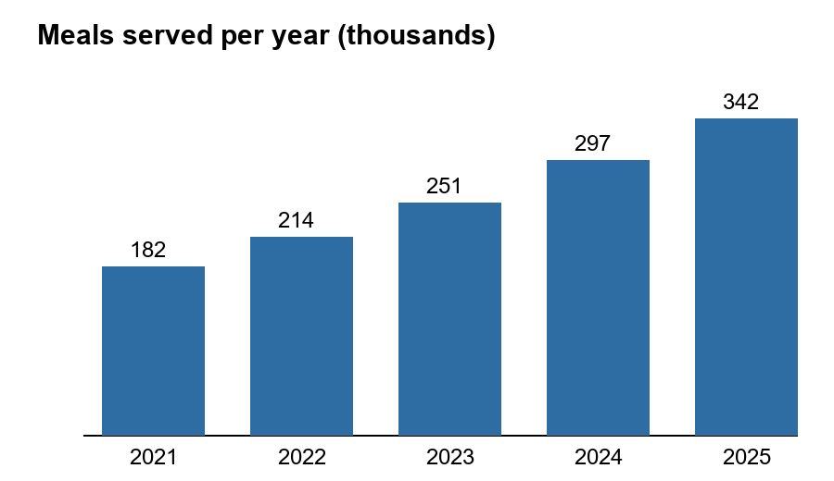
Highlights this year:
- 342,000 meals served across five counties
- Two new mobile pantries for rural areas
- A weekend backpack program for 640 students

Where the Money Goes
Program | 2025 budget | Share
Food purchasing | $1,240,000 | 62%
Mobile pantries | $480,000 | 24%
Operations | $280,000 | 14%

Get Involved
To volunteer, Volunteer (example.org).

