What is git, most common commands. Git branch, tags and commits, stash command and hooks.

<https://trailhead.salesforce.com/es/content/learn/modules/git-and-git-hub-basics>  
  
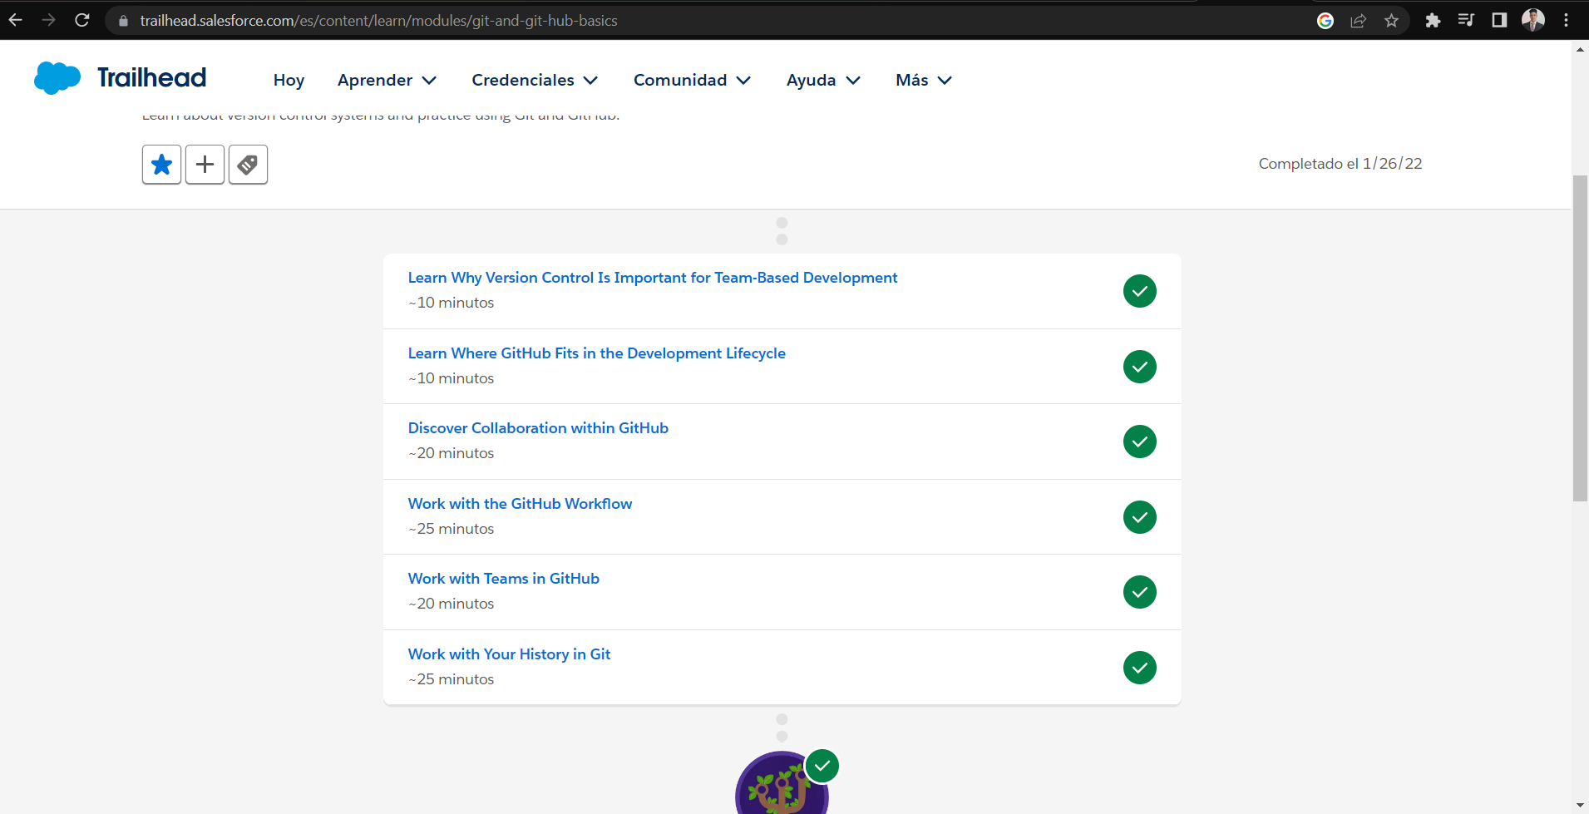

# Personal introduction I got from SalesForce:

Collaborate to Win

Modern version control systems are designed to help address problems that teams face when collaborating.

Solving the problem of working together takes more than just a great VCS like Git—it also requires you to step back and assess your approach. Breaking down silos and embracing more perspectives and conversations can enable you and your team to deliver better software. There are tools and workflows designed for the express purpose of improving communication and overall quality.

# Key terms using GitHub:

* Repositories: A collection of source files used to compile your project.
* Commits: A snapshot of your project as it existed at a specific point in time. You create commits as you work on your project to indicate points when you added and removed discrete units of work.
* Branch: A series of commits that represent the changes in your project over time. Every repository has a default branch, which contains the production-ready version of your code. Create additional branches when you’re working on new features, fixing bugs, or making other changes to your project. These branches keep your experimental code separate from your tested production code.
* Merge: The combined history of two or more branches. Most of the time, you’ll merge your feature branch into the default or deployed branch of the repository in order to move the features into production.
* Tag: A pointer to a specific commit, which provides a persistent reference to an event. Typically, tags are used with semantic versioning to represent points when your application was released.
* Issues: Have general discussions about your project, make plans for new features, and discuss bugs. An issue is only a discussion, no actual changes to code take place here.
* Pull requests: A pull request is a package of commits you’re requesting to be merged into the default branch. A pull request provides a place to discuss the changes you’re proposing and invite other team members to comment and complete code reviews. Pull requests also help you see the result of automated tests and many other cool integrations.

!IMPORTANT commands

First wee configure local:   
git config –system

git config --global

git config—local

git config --global user.name **"First Last"**

git config --global user.email [**you@email.com**](mailto:you@email.com)

git branch myfeaturebranch //CREATE BRANCH

git checkout myfeaturebranch

The local and remote repositories only interact when you run one of the four network commands in Git: git clone, git fetch, git pull, and git push.

Retrieve a full copy of the repository from GitHub: git clone <CLONE-URL>. Replace <CLONE-URL>with the clone URL you copied above. You should see something like this:

To send changes:

1. Type git push -u origin myfeaturebranch
2. When asked, enter your GitHub username and then your password.

(Best practices for of course will be allways commit -> Pull request)

Matías Charco