Trustless Bonding-Curve Covenant
Technical review brief
Version 1.0 · August 2026 · Internal

What we are asking you to do
Review one Bitcoin Script covenant that custodies user money, and tell us whether anyone can take satoshis they are not owed, or lock satoshis so that nobody can ever retrieve them.
That is the whole question. Everything else in this document exists to get you to it faster.

In scope — the covenant and the code that constructs its spends:
- packages/curve/src/contracts/merkleLedgerPool.ts — the deployed covenant (sCrypt source)
- packages/curve/src/merkleLedger.ts — the off-chain tree that must agree with the in-script fold
- packages/curve/service/merkleLedgerState.ts — successor-script and unlock construction
- packages/curve/src/covenant.ts — the pre-broadcast interpreter guard

Out of scope, and we would rather you did not spend time on them: the web application, code style, architecture preferences, and the database layer. None of them can move funds — the covenant is the sole authority, and a bug in the app produces a rejected transaction, not a loss.

What holds the money
A single covenant output holds the entire reserve of a sale. Buyers pay into it; sellers are refunded out of it; at the end its whole balance is released to one address that was fixed when the pool was deployed.

There is no operator key anywhere on this path. We cannot stop, redirect, reprice or seize a trade, and neither can the project. If a satoshi can be stolen, it is because the script permits it.

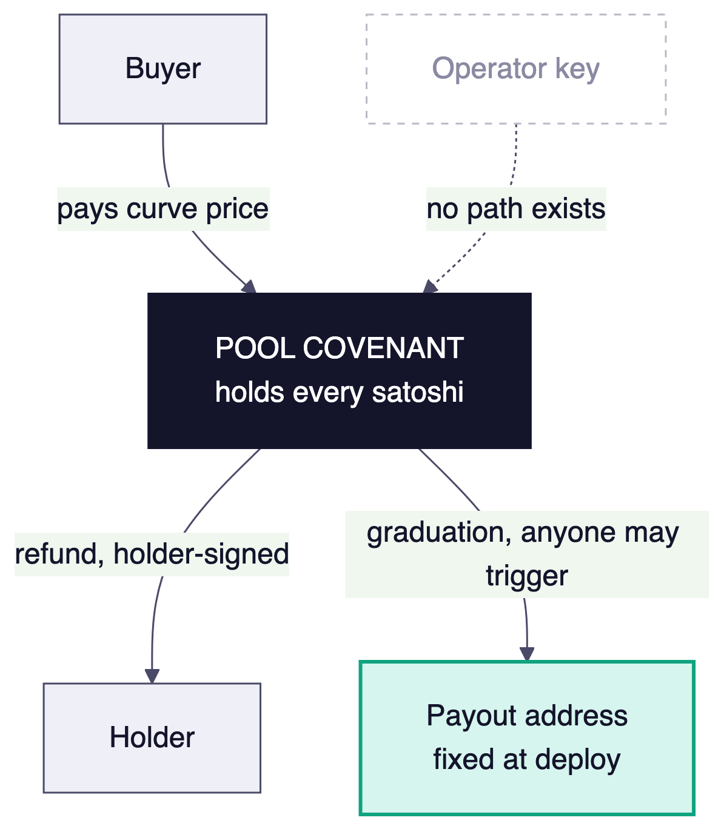
Figure 1 — Every satoshi sits in the covenant. The three arrows out are the only ways it can leave.

How it can be spent
Three public methods, each with a different sighash discipline. The flags matter as much as the logic: they decide which outputs the covenant commits to, and therefore what an attacker is free to change.
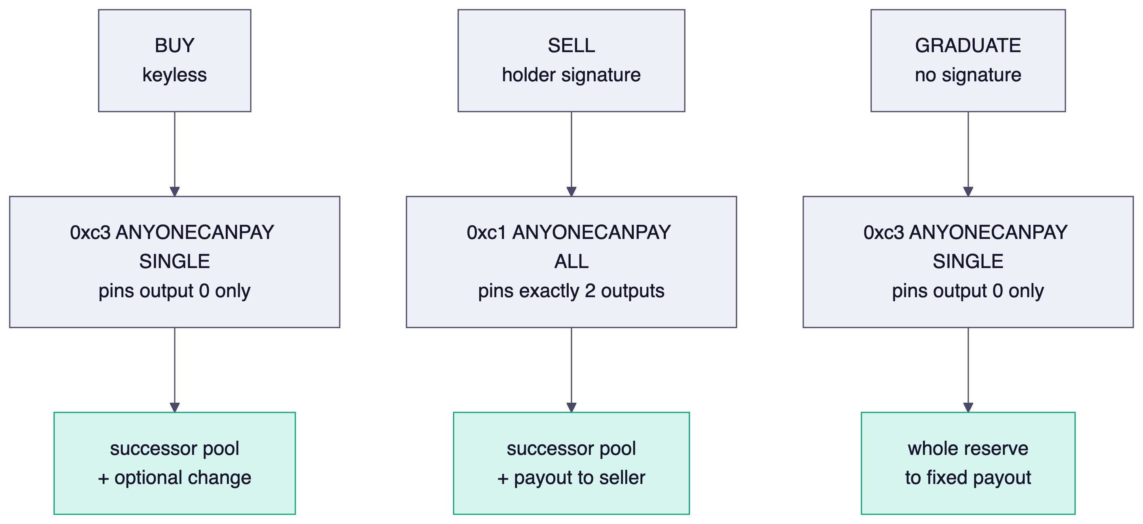
Figure 2 — The three spend paths and what each one pins.

Buy is keyless by design: nobody signs it. The covenant computes the curve price itself and requires the reserve to grow by at least that amount, so there is no authorising key to compromise. Sell is authorised by the holder's own signature over the spend — that signature is their claim to the balance. Graduation carries no signature at all; anyone may trigger it once the curve is fully sold, and the destination was fixed at deploy so a hostile caller cannot steer the money.

The mechanism most worth attacking
Holder balances live inside the covenant as a Merkle root over a fixed-depth array of slots. This is the highest-value target in the system: if a spender can prove a balance they do not hold, they can sell it and drain the reserve.
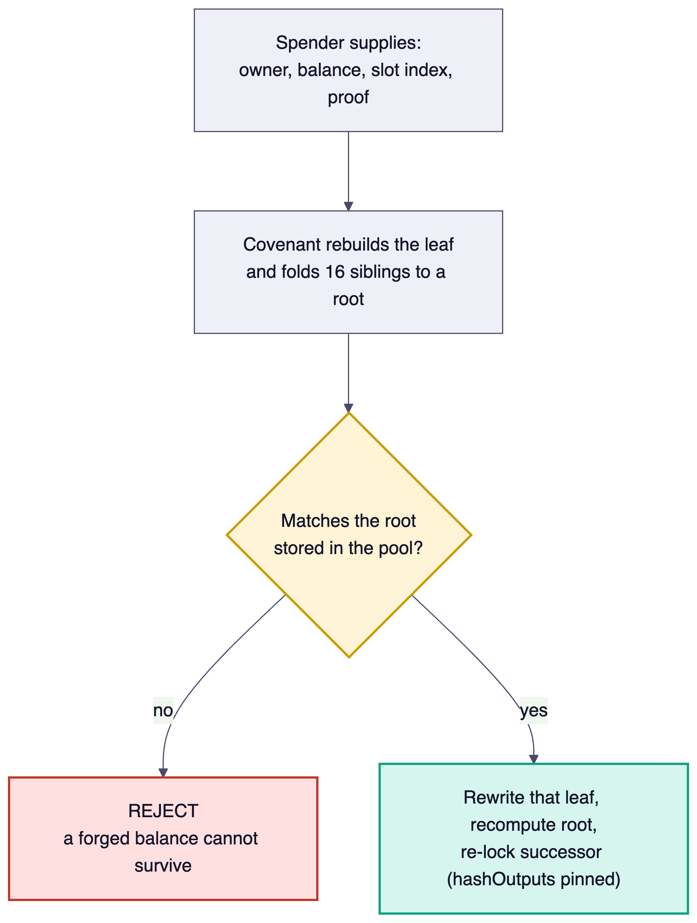
Figure 3 — Every spend proves the current value of the slot it touches.

Depth is 16, giving 65,536 slots and a 512-byte inclusion proof that does not grow with the holder count. A leaf is sha256(ownerPkh(20) || balance(8, little-endian)); both fields are fixed-width, so no two distinct pairs can serialise identically. Slots are append-only: a new holder must prove the slot at exactly holderCount is empty, and an existing one must prove the slot's current owner and balance. Nothing can be reset.

Invariants to verify
# | Invariant | Why it matters
1 | sold equals the sum of all slot balances, always | The reserve-safety invariant. Every buy adds to both; every sell subtracts from both.
2 | The curve division never truncates | d(2s+d+1) is always even, so there is no rounding in anyone's favour. Confirm, do not assume.
3 | The in-script fold equals the off-chain fold | Same sibling order, depth and hash. A disagreement means forged balances validate. Sharpest edge here.
4 | A new holder can only append onto a proven-empty slot | Otherwise a live balance is overwritten and invariant 1 breaks.
5 | An update proves the slot's current owner and balance | The leaf commits to the owner, so a slot cannot be reset or written over by another party.
6 | An empty slot and an occupied slot are distinguishable | Empty is 32 zero bytes; a real leaf is a sha256 image.
7 | hashOutputs pinning matches the flag on each method | Buy and graduate pin output 0 only; sell pins exactly two outputs.
8 | Successor scripts are byte-exact | A one-byte drift fails hashOutputs. This trap has been hit twice in this codebase.

Drain vectors, ranked
Attack these in order. The first is the reason the covenant exists.
Rank | Vector | What to try
1 | Merkle proof forgery | Wrong sibling order, an off-by-one in depth, a path-bit mismatch — anything that proves a balance not held.
2 | Append onto an occupied slot | Defeat either half of the guard independently: the index check, or the empty-leaf proof.
3 | Cross-owner slot write | Credit or debit a slot whose owner differs from the one supplied.
4 | Stale-proof replay | Reuse a proof from an earlier root.
5 | Reserve underflow on a sell | Make the refund exceed the reserve.
6 | OP_PUSH_TX preimage malleability | Verify the preimage is validated and that ctx.utxo.value cannot be spoofed.
7 | holderCount manipulation | Increment without an append, or append without an increment.

Not applicable here, unlike our other curve: there is no operator key, so no key-compromise drain, and no off-chain gate to defeat.

What is already proven on mainnet
All of the following ran on BSV mainnet with real satoshis, not on a testnet or a simulator. Transaction identifiers are given so you can inspect the bytes yourself rather than take our word for it.
What | Result | Reference
Full lifecycle | deploy, buy, sell, sell-out, graduate, mint, deliver | pool 38d331f7
Script size is constant in holder count | 11,864 bytes at every step | pool 4c6faf97
Byte-level attacks on the unlocking script | 34 of 34 repelled | verify-merkle-adversarial.ts
Ledger rebuilt from chain alone, no database | 16 of 16, holder recovered whose key no longer exists | verify-merkle-resolve.ts
Permissionless graduation by a stranger | reserve reached the committed payout; caller net negative | graduation 82e5dd53
Contention: two spenders, same tip | loser rejected by the node, then re-signed and landed | pool 31820de7
Economic invariants under random buy/sell | 54 unit tests including a 40-seed fuzz | merkle-solvency.test.mjs

What we have not tested
Stated plainly, because a review is worth less if it starts from an inflated picture of our coverage.
- The Script has been attacked but not fuzzed. Thirty-four hand-designed byte-level attacks is not randomised or mutational fuzzing. Untried: random sibling and path corruption at scale, malformed pushdata framing, out-of-range path values, and non-minimal scriptNum encodings of the numeric arguments.
- No formal argument that the off-chain and in-script folds are equivalent. They agree on every case we test. That is not a proof.
- The depth boundary is unexercised live. Slot 65,535 proves correctly off-chain, but genuine slot exhaustion would take 65,536 real appends and has never happened.
- The 8-byte balance ceiling is untested on-chain. Nothing in the covenant bounds k or supply, so a deployer could in principle choose terms a balance cannot represent. The curve cost explodes long before that binds, but it is not enforced.
- Graduation delivery is not enforced. Converting final balances into wallet-held tokens after graduation is a promise, not a covenant guarantee — see the note below.

One known and accepted weakness
Everything up to graduation is enforced by the script. The step after it is not.
When a curve sells out, the reserve goes to the project and holders are left with balances in a final ledger. Converting those into wallet-held tokens is something the project must choose to do. We cannot make the covenant do it, because a token's ownership gate is a pay-to-public-key-hash check requiring a signature, and a covenant spends by inspecting a transaction preimage rather than by holding keys. A covenant can therefore never custody these tokens, which rules out the obvious design of releasing them against an inclusion proof.
What survives is accountability rather than enforcement: the amount owed is recomputable from the deploy transaction forever, by anyone, without the project's cooperation. We surface it in the interface before a buyer commits. We would value your opinion on whether the bond mechanism we have specified to close this is worth building, or whether the disclosure is the right stopping point.

What we would like back
- A finding-by-finding response to the eight invariants and seven drain vectors above.
- Explicit coverage of the five untested areas — especially fuzzing, which we cannot credibly do on our own work.
- A go or no-go, with a maximum reserve size you would be comfortable with.
- A re-audit trigger list: which changes should send this back to you.

There is no deadline pressure and no commercial dependency on a positive answer. If the covenant is unsound we would rather learn it now, while the only money at risk is roughly ninety thousand satoshis of our own test funds.

Where to start
The full audit package, including the material summarised here, is in the repository at docs/AUDIT-PREP-MERKLE-LEDGER.md. It carries the same invariants and vectors with file-level references. The covenant itself is under two hundred lines of sCrypt and is the right place to begin.

A second, separate covenant exists for our operator-settled curve (docs/COVENANT-AUDIT-PREP.md). It has a different trust model — it does have an operator key — so findings do not transfer between the two. Review whichever is being deployed; if that is both, they are two engagements.

BSVA | Footnote text. consetetur sadipscing elitr, sed diam nonumy eirmod tempor invidunt ut labore et dolore magna aliquyam et dolore magna aliquyam erat, sed. At vero eos et accusam et justo duo dolores et stet clita diam voluptua.
Lorem ipsum dolor sit amet, consetetur sadipscing elitr, sed diam nonumy eirmod tempor invidunt sut rana dixit a folio.

