|  |
| --- |
| Peking university |
| iMashup Web OS |
| User Guide Manual |
| <https://github.com/sakinijino/iMashup> |
|  |
| **Daimeng Wang** |
| **2010/12/27** |

|  |
| --- |
|  |

Directory

Introduction 3

System Requirement 3

1. Operating System 3

2. Browser 3

3. Apache 3

Setting up 3

1. Download Source Code 3

2. Install Apache 3

3. Unpack iMashup 3

4. Configure Apache (Set Cross-domain proxy for demo) 4

User Guide 4

1. Basic Usage 4

1) Open iMashup 4

2) User Interface 5

3) Floating Panes 5

4) Docklets 6

2. Advanced Usage 8

1) Channel 8

2) Custom Methods 10

# Introduction

iMashup Web OS is an open-source project based on web technology, written in Javascript with [dojo toolkit](http://www.dojotoolkit.org/). The aim of the project is to gather services available on the Internet and combine them to achieve a more complex function.

# System Requirement

## Operating System

Since iMashup Web OS is based on web technology and written in Javascript, there is no specific requirement of operating systems.

## Browser

The dojo toolkit is not so good at compatibility. So we recommend using the 3.x version of [Mozilla Firefox](http://www.mozilla.com/) browser.

It is also recommended that you install the [Firebug](http://getfirebug.com/) plug-in in order to acquire more run-time details.

## Apache

In order to run the internet services, you will need [Apache](http://www.apache.org/) to set up a local server. We recommend you to use the latest 2.2 version of the apache.

# Setting up

The following part will introduce you the essential steps to set up iMashup Web OS on your local server.

## Download Source Code

Download the zip file containing the source code of iMashup Web OS.

Download [dojo toolkit](http://dojotoolkit.org/download) archive (version~=1.5.0).

## Install Apache

Install Apache 2.2.

## Unpack iMashup

Unpack your downloaded imashup and dojo archives.

Make the directory structure as following

- <base>

- dijit

- dojo

- dojox

- imashup

- util

## Build Releas

Enter the “util/buildscripts” directory. Executer the following command:

*build.sh action=release profileFile=../../imashup/build.profile.js*

Then put the “<base>/release” directory into your Apache “httpd” directory or set an alias path.

## Configure Apache Cross-domain Proxy (for demo)

Enter the directory where your Apache is located and open “conf/httpd.conf”.

Remove, if any, the “#” character at the front of following sentences:

*LoadModule proxy_module modules/mod_proxy.so*

*LoadModule proxy_ajp_module modules/mod_proxy_ajp.so*

*LoadModule proxy_connect_module modules/mod_proxy_connect.so*

*LoadModule proxy_ftp_module modules/mod_proxy_ftp.so*

*LoadModule proxy_http_module modules/mod_proxy_http.so*

Add the following lines at the end of the file:

*ProxyPass /tudou http://api.tudou.com/v3/*

*ProxyPass /iplocation http://api.ipinfodb.com/v3/*

*ProxyPass /googlesearch http://ajax.googleapis.com/ajax/services/search*

*ProxyPass /ebay/service http://svcs.ebay.com/services*

*ProxyPass /googleweather http://www.google.com/ig/api*

Save and exit.

## Configure iMashup Cross-domain Proxy (for demo)

Enter the directory where your IMashup is located and copy “configs/proxy.js.template” to “configs/proxy.js”.

Modify *imashup.configs.proxy.url* to your location.

Modify cross-domain URL mappings if you use different Apache ProxyPass paths

# User Guide

In this section we are going to introduce you some features of iMashup Web OS and show you how to use iMashup and its services.

## Basic Usage

### Open iMashup

Open “http://localhost/” in your browser. If your setup is correct, you will see the following interface in your browser.

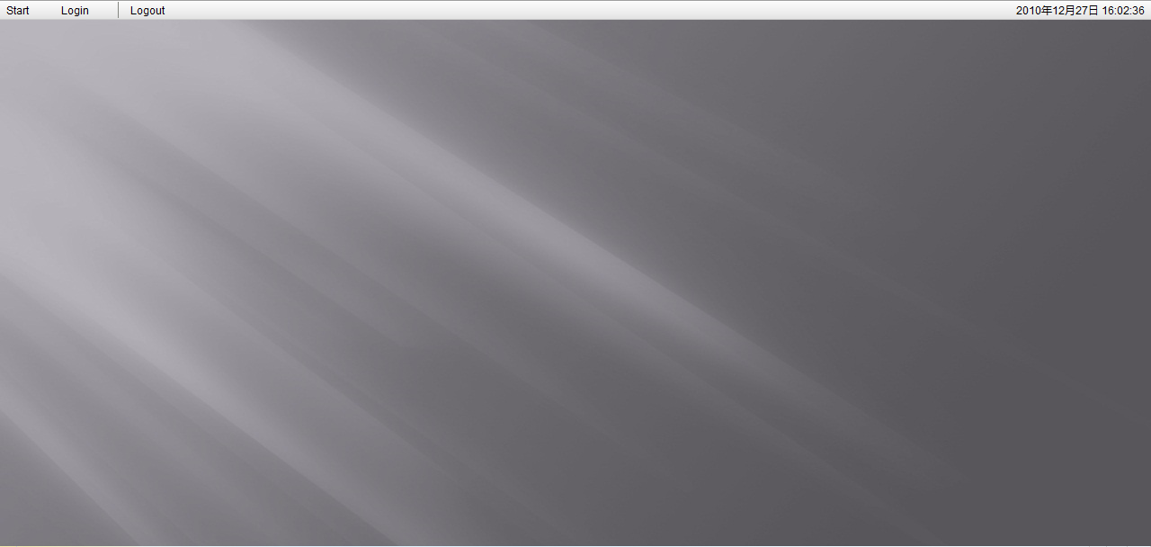

### User Interface

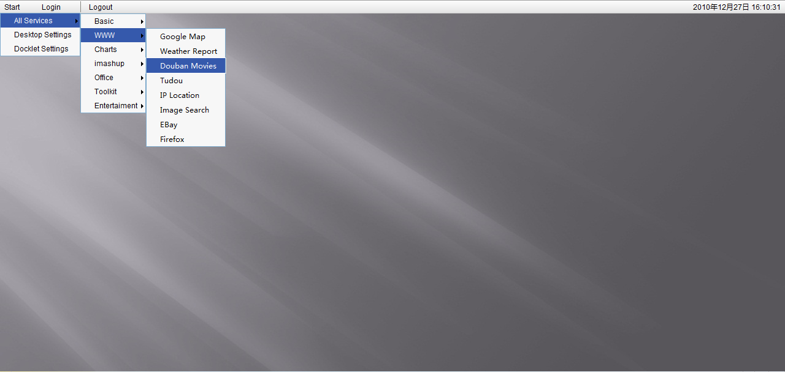

iMashup looks very similar to most of the mainstream operating systems. On the top of the desktop, you can easily find a start bar containing a start menu, a login panel and a logout button and a clock. Feel free to explore the functions provided by iMashup.

### Floating Panes

Most services provided by iMashup are shown in floating panes. When you start a new instance of a component, it is likely that you see something this:

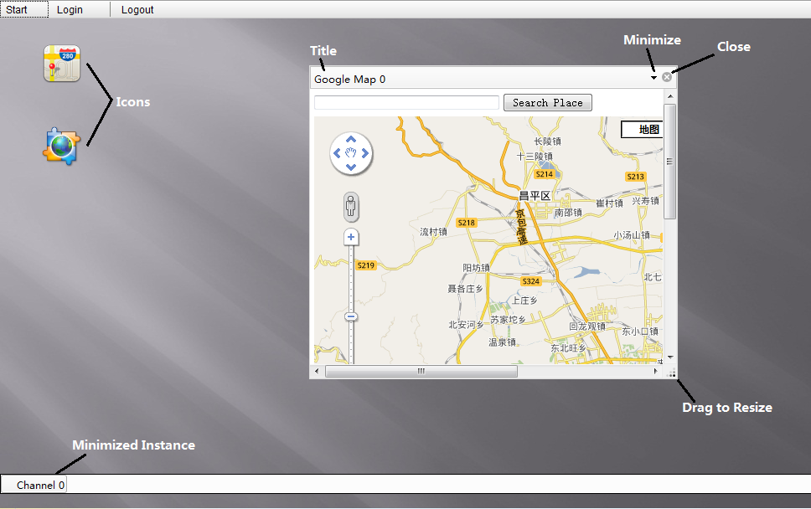

For each instance created, an icon will appear on the desktop. You can click the floating pane or the icon to activate it.

If you feel that there are too many floating panes on the desktop, you can click the minimize button on the top-right corner of the floating pane. This will remove the floating pane on the desktop and display a button on the bottom of the desktop instead. Click the button and the floating pane will be reactived.

### Docklets

If you feel that opening instances from the start menu is no convenient enough, you can use the docklet function. To setup docklets simply click the “Docklet Settings” in the start menu.

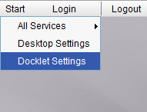

Click “More” button in the docklet setting dialog.

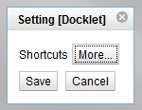

Tick the components you would like to be displayed as docklets and press “OK”.

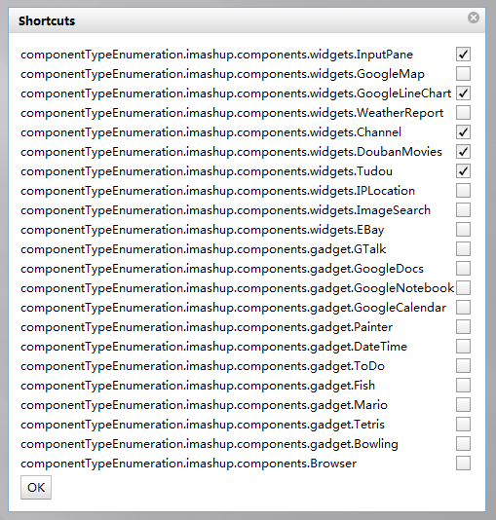

Press “Save”. Docklet will be shown at the bottom of the desktop. Click on one of the icons start a new instance of selected component.

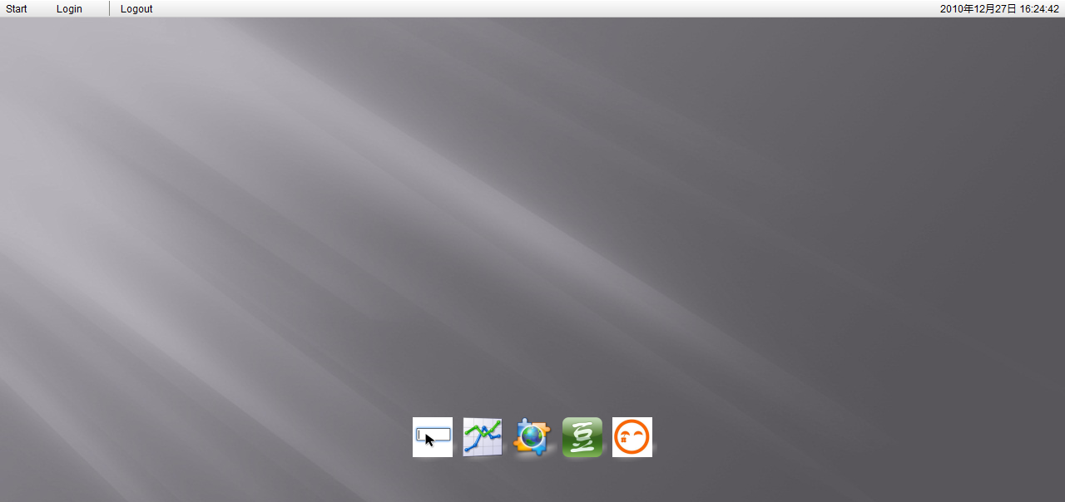

## Advanced Usage

### Channel

Channel is an important component of iMashup Web OS. It can pass arguments from functions of one instance to functions of another instance, thus allows the interaction between different services. Here is a brief picture about how channel works.

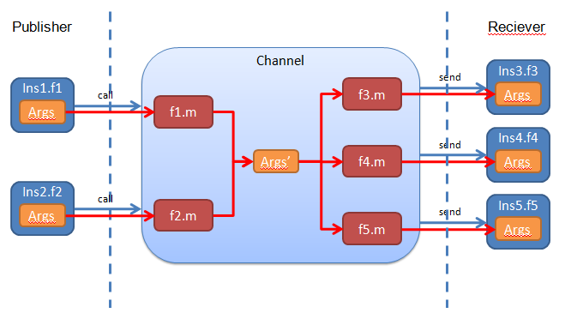

In order to learn how to use the channel, simply follow the sample below.

#### Sample 1: Advanced Movie Search

In this sample, we want to search information of a movie using “Douban Movies” component, and in the meantime search more pictures of the movie using “Google Images” component.

To start up a channel, simply click “Start -> All Services -> iMashup -> Channel”.

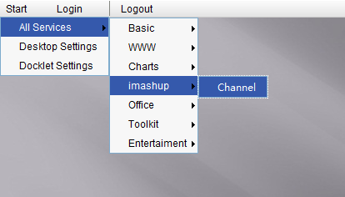

A floating pane will pop up on the desktop. You can use this floating pane to configure the publishers and receivers of the channel. Since there is no other instance present, everything in this floating pane is empty.

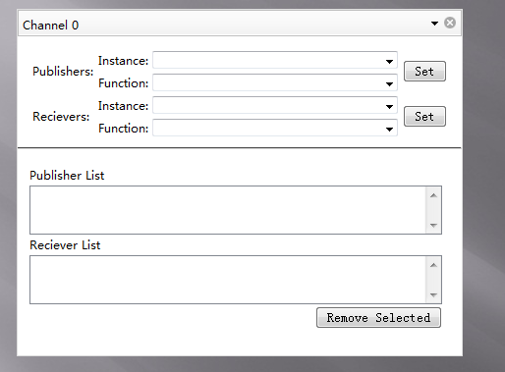

Now we start up a “Douban Movies” and a “Google Images”. Notice that the channel has detected the instances we just opened.

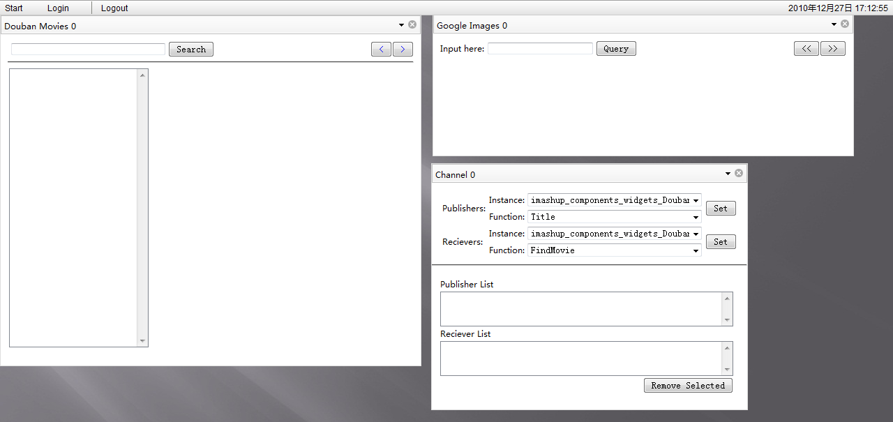

Now we choose the publisher and receiver of the channel:

Publishers:

Instance: imashup_components_widgets_DoubanMovies_0

Function: Title

Recievers:

Instance: imashup_components_widgets_ImageSearch_0

Function: searchImage

Then press the two “Set” buttons for publishers and receivers.

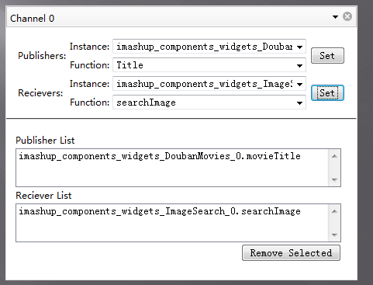

Now we have finished setting up the channel. It’s time to see the effect. Input “starwars” in the input pane of “Douban Movies” and click search. Notice that when “Douban Movies” finished searching for movie information, “Google Images” will search the images of the first movie in the search results of “Douban Movies”.

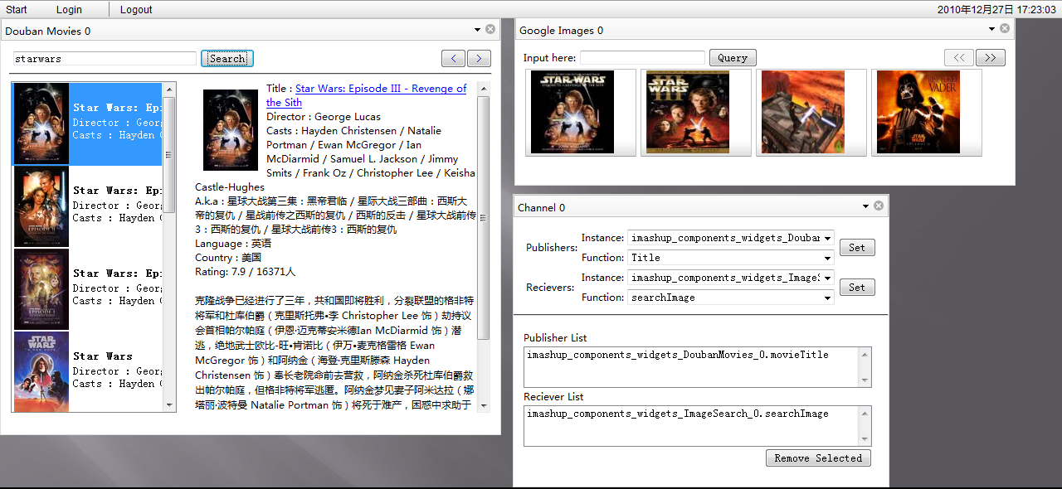

### Custom Methods

A channel passes arguments from one function to another. However, sometimes we are just not satisfied with the format of the arguments and do not want to modify the source code. Therefore, we should use the custom method function of the channel. Follow the sample and see how it’s done.

#### Sample: Locate Ebay Items on Google Map

In this sample, we will use “Ebay” to search for items and display them on “Google Map”.

First, open a channel, an “Ebay”, and a “Google Map”.

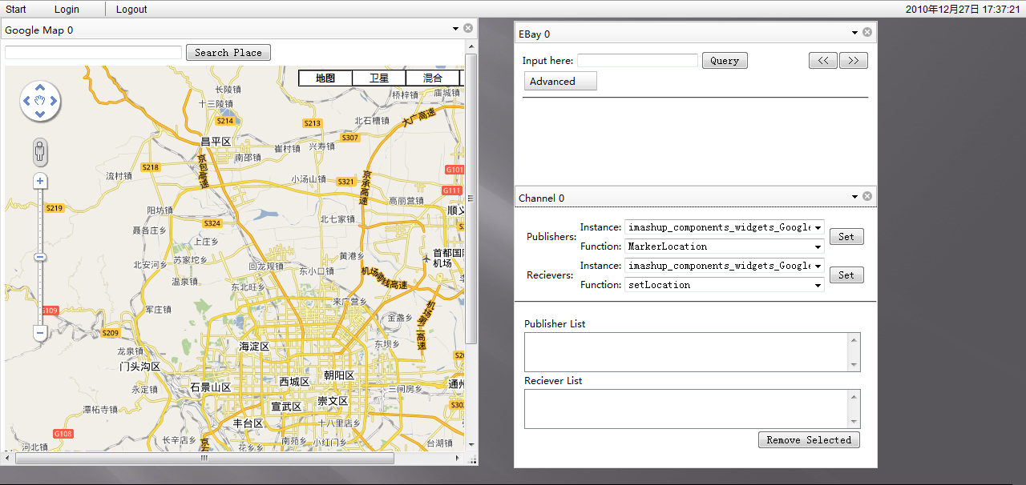

Now we choose the publisher and receiver of the channel:

Publishers:

Instance: imashup_components_widgets_Ebay_0

Function: ItemInfo

Recievers:

Instance: imashup_components_widgets_GoogleMap_0

Function: insertMarker

Then press the two “Set” buttons for publishers and receivers.

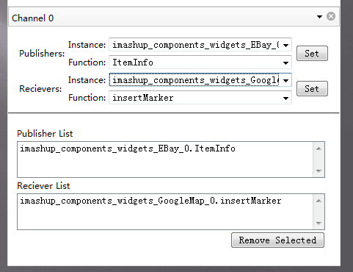

Double-click on the “imashup_components_widgets_GoogleMap_0.insertMarker” in the “Reciever List”.

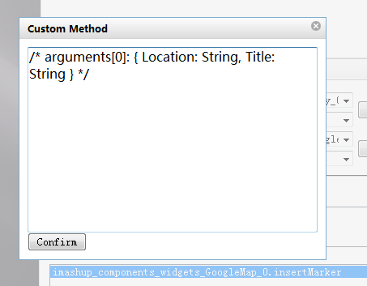

A dialog appears, with a text area and a confirm button. In the text area there is a brief description of the format of arguments. We are going to input Javascript codes in order to modify the format of the arguments. In this case, input following codes in the text area and then press “Confirm”.

*var loc = arguments[0].Location;*

*var name = arguments[0].Name;*

*arguments[0] = { Location: loc, Title: name };*

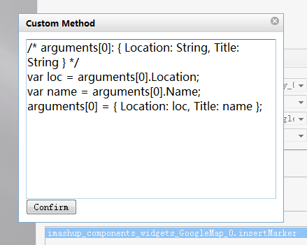

Sometimes it is necessary to check the arguments’ format of both publishers and receivers. If you have firebug installed, you can simply use “console.log” function to see the more detailed format of the arguments.

Now we input “adidas race” in the “Ebay” and click “Query”. “Ebay” will perform a search and display results.

Click the first result. Notice as a floating pane containing the item information appears, a marker is inserted on “Google Map” at the location of the item. The marker’s title is the name of the selected item.

