# Group information:

Matias Ramsland, StudID: 259150

Lukasz Pietkiewicz, StudID: 253469

Chiran Pokhrel, StudID: 259205

Jakub Mroz, StudID: 260703

Konrad Jarczyk , StudID: 242615

1. **Introduction**

The goal of the project was to create a secure banking application, resistant to OWASP TOP10 attacks.

Our application allows users to add money to their account and send it to a different user through a webpage. Visitors cannot use banking services. To become a user, a visitor must sign up for an account first.

The application is written in python with flask framework, and is using SQLAlchemy for database.

1. **Layout/Functions/Front-end**

[[pic1 Site map]]

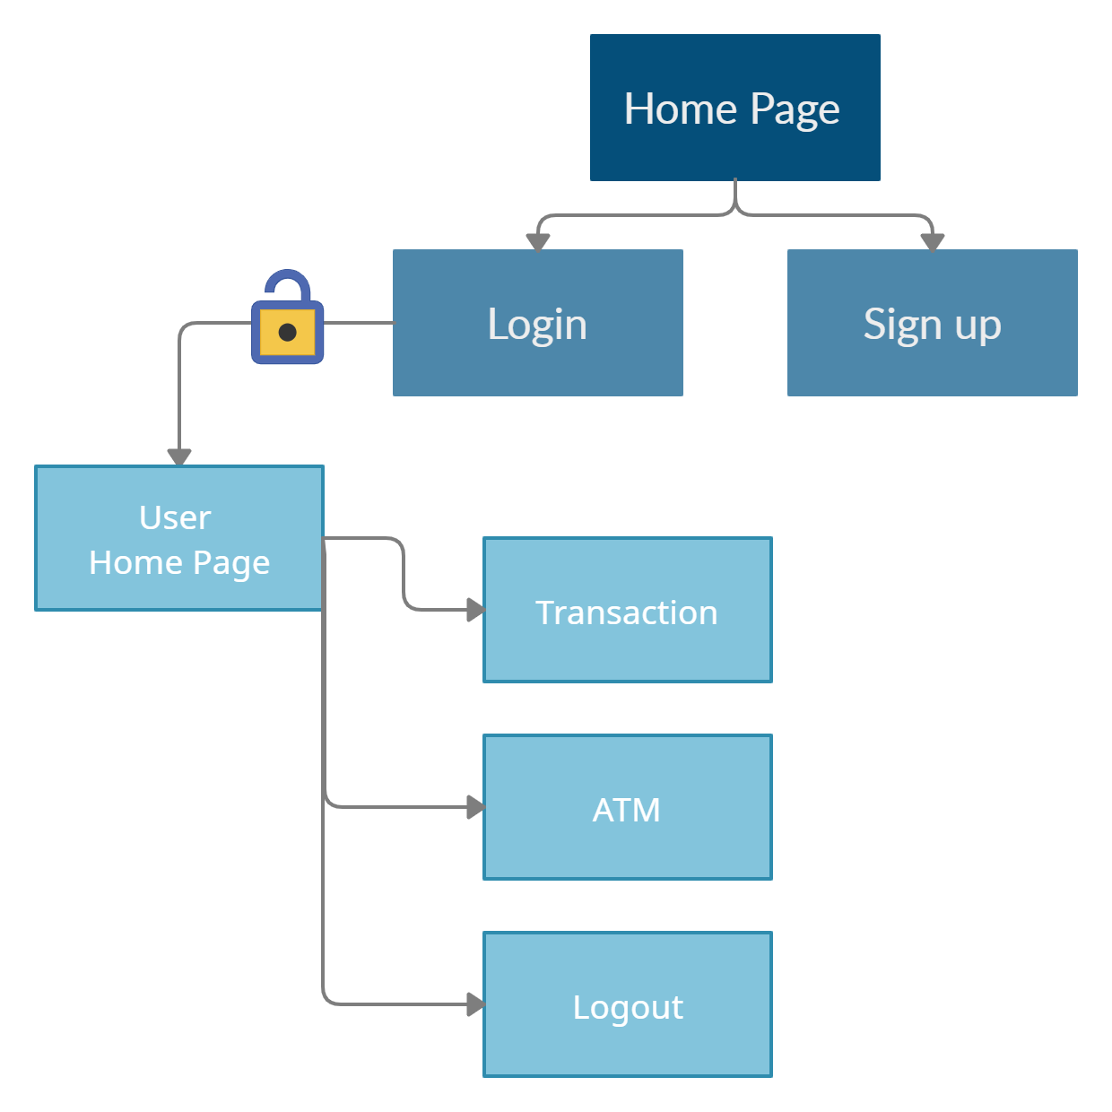

A visitor can only see login and signup pages from the homepage. When an unlogged user tries to visit the URL of any other page, he gets redirected back to the homepage.

[[pic2 what visitor sees on homepage]]

After logging in, the user gets access to ATM and Transaction pages, also homepage changes to show the user’s saldo.

[[pic3 what user sees on homepage]]

[[pic3.1 transfer]]

To transfer cash from your own bank account in the Transaction page, the user must know the username of the receiver, and in addition confirm his own.

ATM service simulates depositing cash in a local ATM to fill your account.

1. **Security and Design**

Here is a data flow diagram to help identify a flow of data and interactions between components in the application:

[[pic4 Data Flow model]]

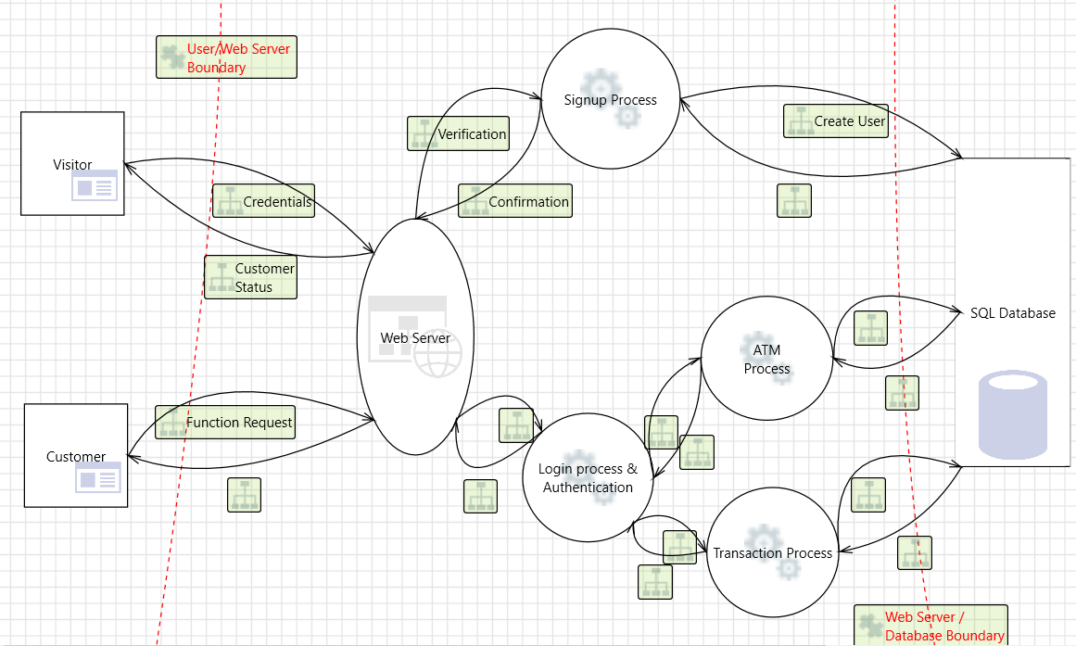

Some possible threats that we could identify by looking at the system model are:

* Spoofing:

- Credential stuffing (attacker having list of valid usernames and passwords)

- Brute force authentication

- Evading the authentication system and exploiting session management

- Cross-Site Request Forgery

- Missing session timeouts

* Tampering:

- Improper input validation

- sql injection

- xml injection

- Forcefully browsing to authenticated pages

- tampering with URL to avoid authentication checks

* Repudiation:

- lack of monitoring:

(performing unauthorized operation without ability to be traced or detected)

* Information disclosure:

- Unauthorized access to database

- Capturing non-encrypted data

- Access to weakly encrypted content

In next sections we will show what security features are implemented to mitigate some of these threats.

**3.1 How features are implemented**

# >Getting user input

WTForms extension is used to gather and validate input from users. Depending on the need, built-in or custom validators are used.

[[pic6 wtforms]] //code as jpgs for now, later as text/code in Latex

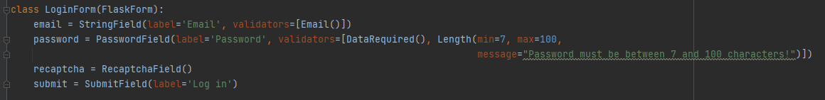

# >Creating user

When the signup form is sent, the input is validated, then a check is made to see if a user with a given name or email already exists. If not - then the given password is hashed and user data is sent to the database and saved. App then redirects to the homepage. If something goes wrong during the process, a red error message will appear.

[[pic7 auth.py signup] //code as jpgs for now, later as text/code in Latex

Argon2 function is being used to hash passwords.

# >Login process/ Session management

When the login form is sent, the input is also validated. Then the database is searched for a user with a given email and given password is compared with hashed database password. If everything is okay, the app redirects the user to his homepage. If something goes wrong during the process, a red error message will appear.

[[pic8 auth.py login] //code as jpgs for now, later as text/code in Latex

Login process includes CAPTCHA feature to make brute-forcing passwords harder. Later user can log out simply by clicking on the logout button in the navigation bar.

The application uses the Flask-Login extension for session management. It allows us to restrict some pages to be visible only for logged-in users.

[[pic9.1 auth.py @loginrequired]

[[pic9.2 no access]



When user becomes inactive for 5 minutes he gets logged out automatically

[[pic10 auth.py before request]] //code as jpgs for now, later as text/code in Latex

# >ATM & Transaction

These services first validate data, then authenticate given data to check if said username exists. If all is correct, a transaction is made. If something goes wrong during the process, a red error message will appear.

# > Database

Flask-sqlalchemy extension provides support for SQLALchemy. We use 2 database models - user and transaction.

[[pic11 db model]]

**3.2 OWASP TOP 10**

This section describes how prepared are we against common threats listed in OWASP Top 10 //TODO

3.2.1 sql injection

etc...

3.2.2 A07:2021 Identification and Authentication Failures

This security fault is known as Broken Authentication, which is about user´s identity is breached with weaknesses with the authentication in our application, for example using automated attacks. We have implemented a few things to mitigate this, as reCAPTCHA, ratelimit , two factor authentication, strong password and deleting cookies after unused.

Firstly to avoid brute forcing and automated attacks, reCAPTCHA and ratelimit has a huge impact on this. The way we implanted this is making a reCAPTCHA user on google and verifying this in our flask WTforms. <code> reCAPTCHA = recaptchaField() <code>. It is possible to bypass wtforms validators/reCAPTCHA so we also made a request limiter, which makes a response and blocks out the user, which will reset in a couple of limits. We have sat the limit to 60 POST/GET request since that should be more than enough for a normal user. Anything more than that we will block it. The code we used to implement this is:

If an attacker manages to get ahold of an users password we uses two factor authentication which is compatible with google authenticator. We uses this verification after each transaction, deposit and when we log-in. This makes the attacker not being able to access that users account without also having access to their google authenticator app. This acts like a second layer to the users security. The code we used to implement this is <code>

We have also implemented many more features to prevent this type of security breach like same message if failed log in attempt but we won´t cover this since it is not the most important.

3.2.3 A09 Security Logging and Monitoring Failures

A09 has been recently more important over the years. This security breach includes not being able to detect or log activity on the website. This includes also to securing to log functions so that no malicious attacks by the logging method can occur.

In our website we log every major request. This includes log in, sign-up, transactions, ATM deposits and if the user goes over the request limiter and the ratelimit function is called. We log both successes and failures. The way we store the data is in a separate table in the database. We simple store a string of text that is set by the request the user makes. So a typical string will contain the request (log-in/sign-up etc.) username (if exists), failed or passed and then lastly the time it happened. The way we implemented this is: <code>

We also verifies that the input doesn’t contain any illegal character, so the way we log things doesn’t become a security breach, for example injection in to the database. This is because so that it is harder to breach the log and loads of information about users becomes available to the attacker. The code for this check is:

Another logging information we have is ReCAPTCHA. As you can see from picture below is that we can see the statistic of the uses of it and if it have detected any unusual activity. It will also send us an email if detected anything unusual. The negativity with this is that reCAPTCHA uses a long time to update. It uses a couple of days usually, therefore we cannot solely trust this.

3.2.4 A05 Security Misconfiguration

This security flaw is about misconfiguration of the website, for example available administrative interfaces, not good error handling and still being in debug mode etc.

For example when we are in development face we often use debug mode, which makes it easier to debug error in the website but also it automatically update your code changes (atleast in flask). This can be harmful if not reverted back on deployment. This is because an attacker loves to get error messages and can easily understand how your website is flawed and in which way. This is simply to remember to disable debug mode which is this line of code: <code>

Another thing we need to is have an error handler for flask, so that the attacker won´t really know what error happened if it manages to create one. In our application we simply check for any errors and if detected we flash a red error message and redirects you do the home page. This also acts as a protective layer against crashing the website. The code used is: <code>

Since we don´t use any administrative access because of the potential of being a security risk, all the admin access must have access to the deployment website and can make changes there, not directly on the website. Therefor all users have the same access when using the website.

3.2.5 A04 Insecure Design

This new category in Owasp Top 10 is about flaws in design and system architecture. Some weaknesses and technical requirements need to be thought about before starting the implementation. An example of that could be risk profiling and resource management.

While creating this application we have researched secure way to design systems and created threat model to help us recognize and evaluate possible vulnerabilities. We have also prepared for some known attack methods and evaluated which external packages will be used based on security.

3.2.5 A06 Vulnerable and Outdated Components

This Owasp category is about use of unmaintained or out-of-date components with known vulnerabilities. It may become hard to track all dependencies together with nested dependencies.

To work against this we remove all unused dependencies and we check those which are being used, so we would know when one becomes unmaintained. All dependencies are kept on a list together with version used so the process becomes semi-automated.

3.2.6 A01 Broken Access Control

The number one of security breaches is Broken Access Control and therefore very important for our development team. This breach is about being able to acts outside of their intendent permissions. For example if a user is not logged in it can’t view pages on the website that they are not authorized to see or make requests.

A way to mitigate this flaw is by using flask-login. When a user login we use the login(user) code. This logs the user inn and can access routes in our website that requires a user to log-in. We use the “@login required” parameter for the implemented route. The code makes it so that the user that tries to access the page/route must be logged in. When a user logs out we call the code logout(user). This removes the flag that the user is logged in and has now not access to the pages it had when logged in. The code snippets below demonstrate this.

Lastly to mitigate this security fault is checking if the user has been inactive for more than 5 minutes. This is important if a user forgets to exit the website or logging out, because then the session cookie will still be available. The implementation looks like this:

There are a few more things we implement to mitigate broken access control but it overlaps with the other OWASP breaches and we will cover more about it in those.

//TODO make better subsection names