# Documentation

## Architecture

## Turn-on the server

### Requeriments:

Docker.

### Steps:

1. Download the repository (<https://github.com/MatiiTomaino/ChallengeTecnicoMeli-MatiasTomaino>)
2. Move to ChallengeTecnicoMeli-MatiasTomaino/Backend/TraceIp

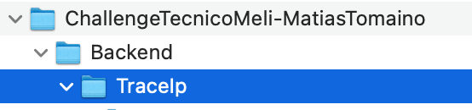

1. Open a terminal in this path
2. Execute **sudo ./trace_ip_linux.sh,** here, the docker container is created and the server and redis instance will be running when the process finished.
   1. **Note: if command doesn’t work, run chmod +x trace_ip_linux.sh.**
3. Check that server and redis instance are running.

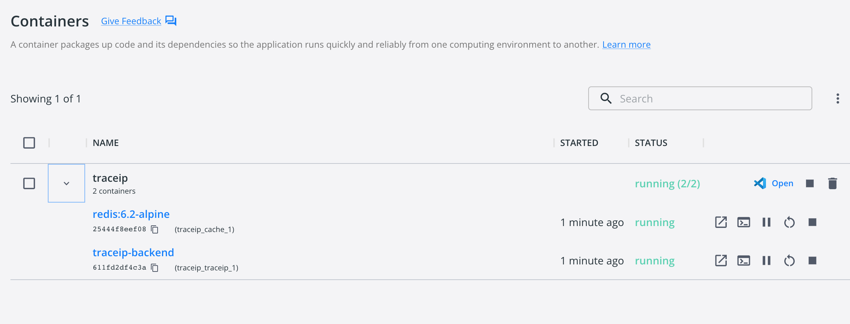

## Test API

APIs Available

* TraceIp
  + Required param: Ip
* GetFurthestDistance
* GetClosestDistance
* GetAverageDistance

### Postman:

TraceIp : http://localhost:5000/Ip/traceip?ip=83.44.196.93

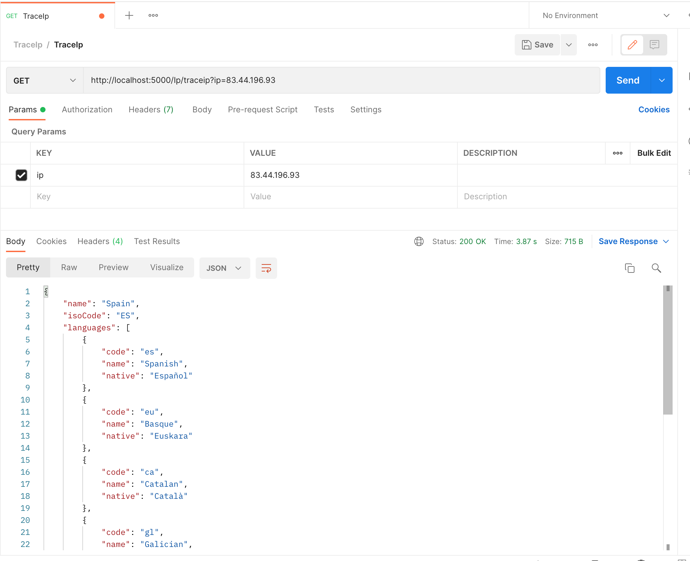

GetFurthestDistance: http://localhost:5000/Ip/GetFurthestDistance

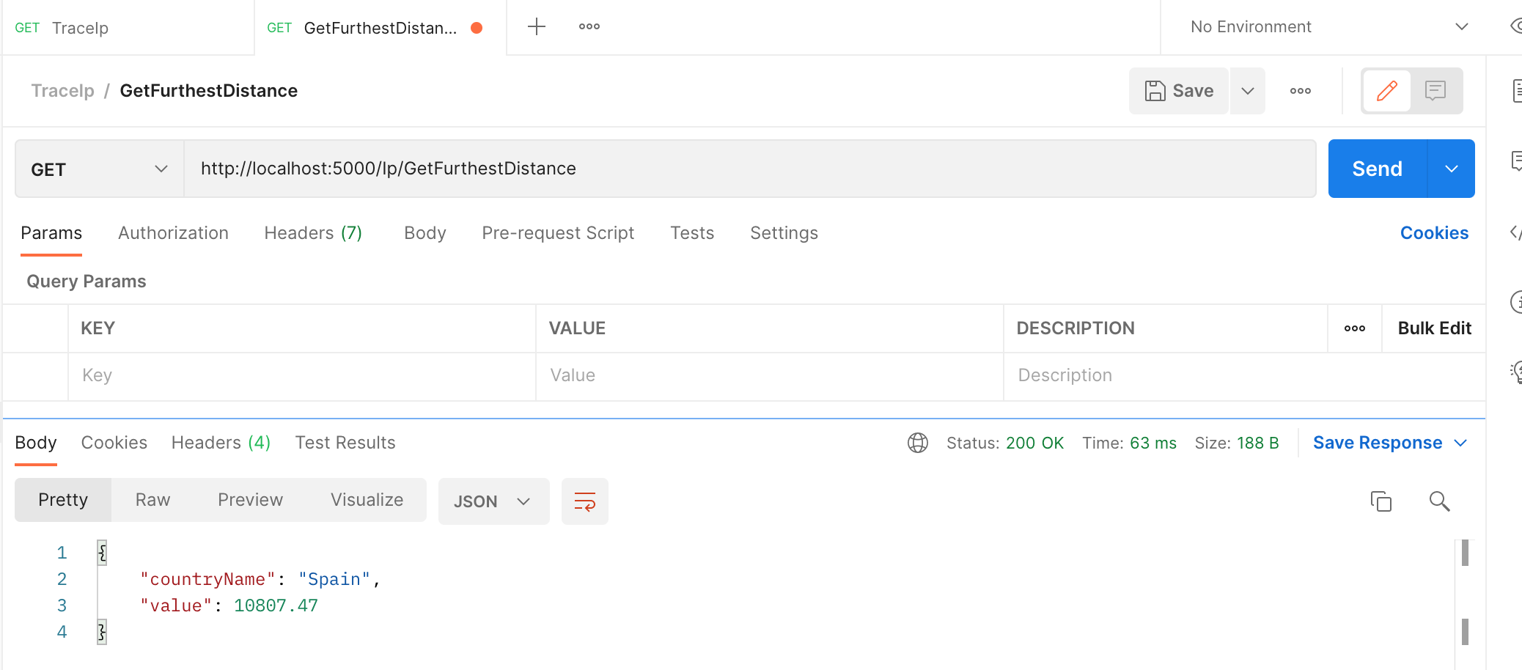

GetClosestDistance: http://localhost:5000/Ip/GetClosestDistance

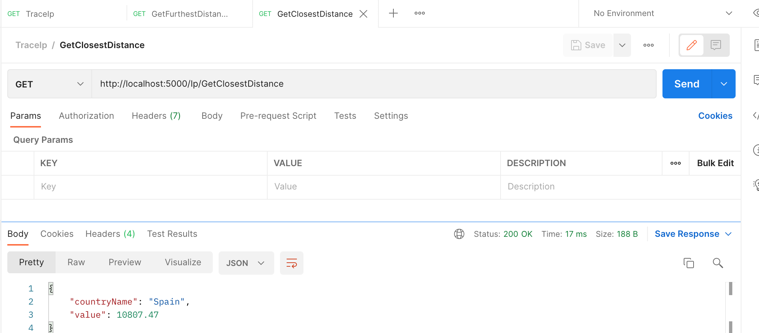

GetAverageDistance: http://localhost:5000/Ip/GetAverageDistance

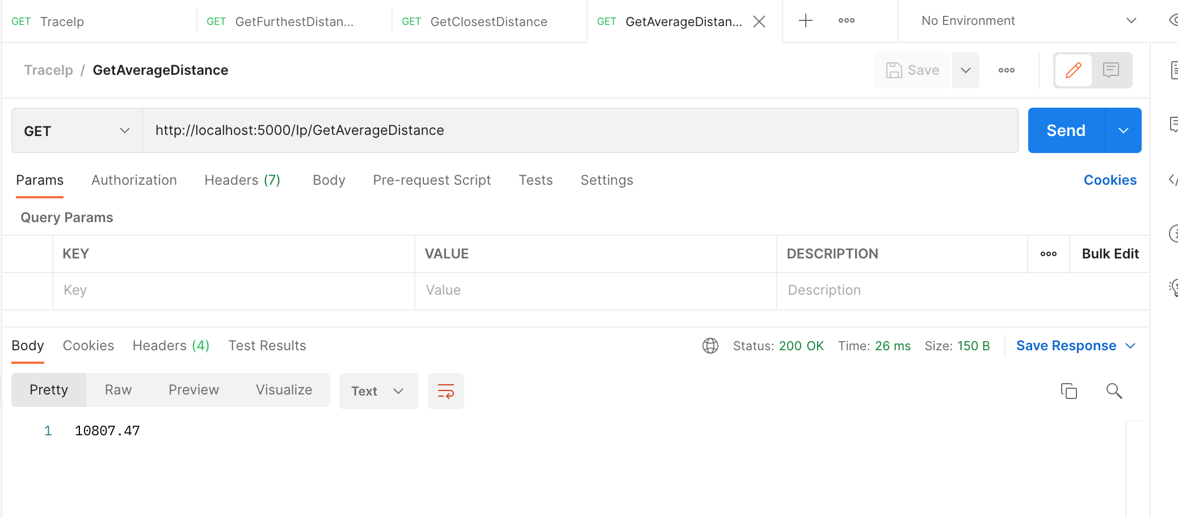

There is available a collection example in repository to import in another computer:

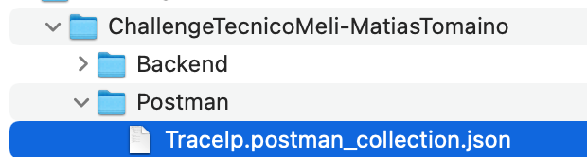

### Curl

In a terminal execute:

curl --location --request GET 'http://localhost:5000/Ip/traceip?ip=128.201.132.0'

curl --location --request GET 'http://localhost:5000/Ip/GetFurthestDistance'

curl --location --request GET 'http://localhost:5000/Ip/GetClosestDistance'

curl --location --request GET 'http://localhost:5000/Ip/GetAverageDistance'



### Swagger

Swagger was enabled only for the challenge. Generally Swagger is available only for development environment, but I made an exception so that it can be tested more easily

Access : <http://localhost:5000/swagger/index.html>

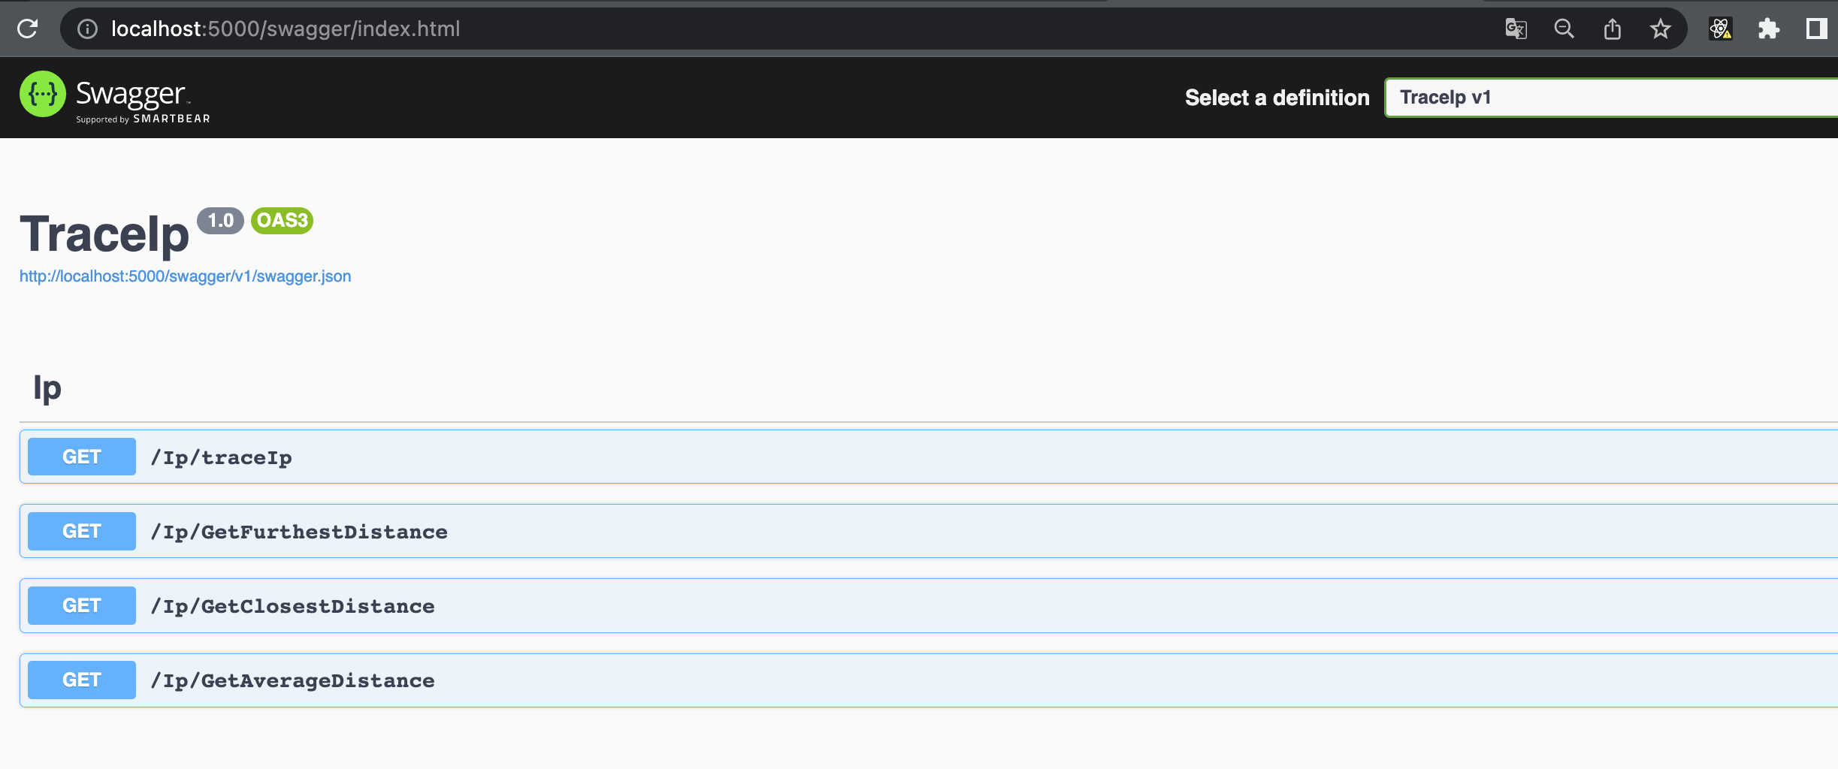

Test:

1. Enter to <http://localhost:5000/swagger/index.html>
2. Choice any Endpoint and click try it out

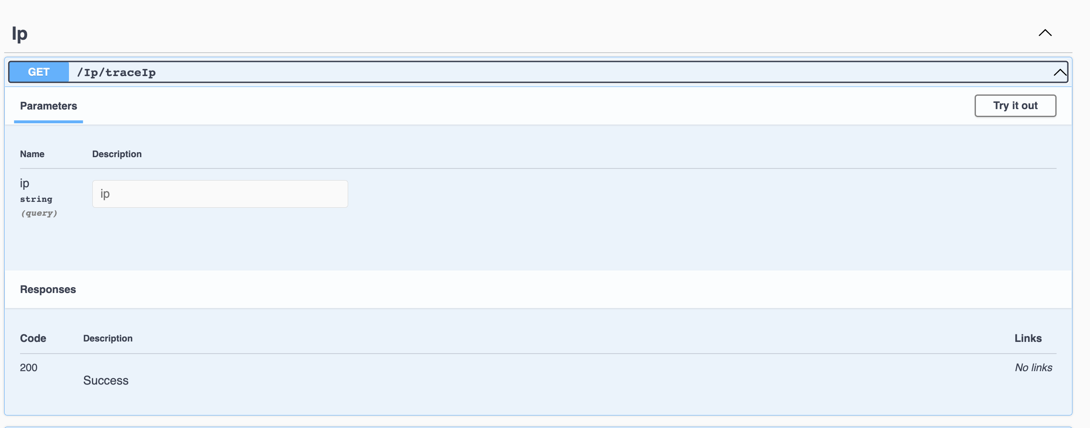

1. If is necessary, enter the params and press Execute

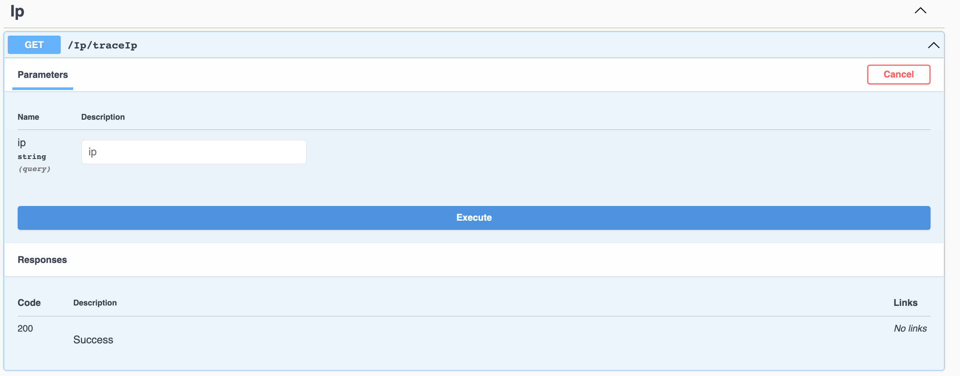

Press Execute

Enter ip value

1. View Result

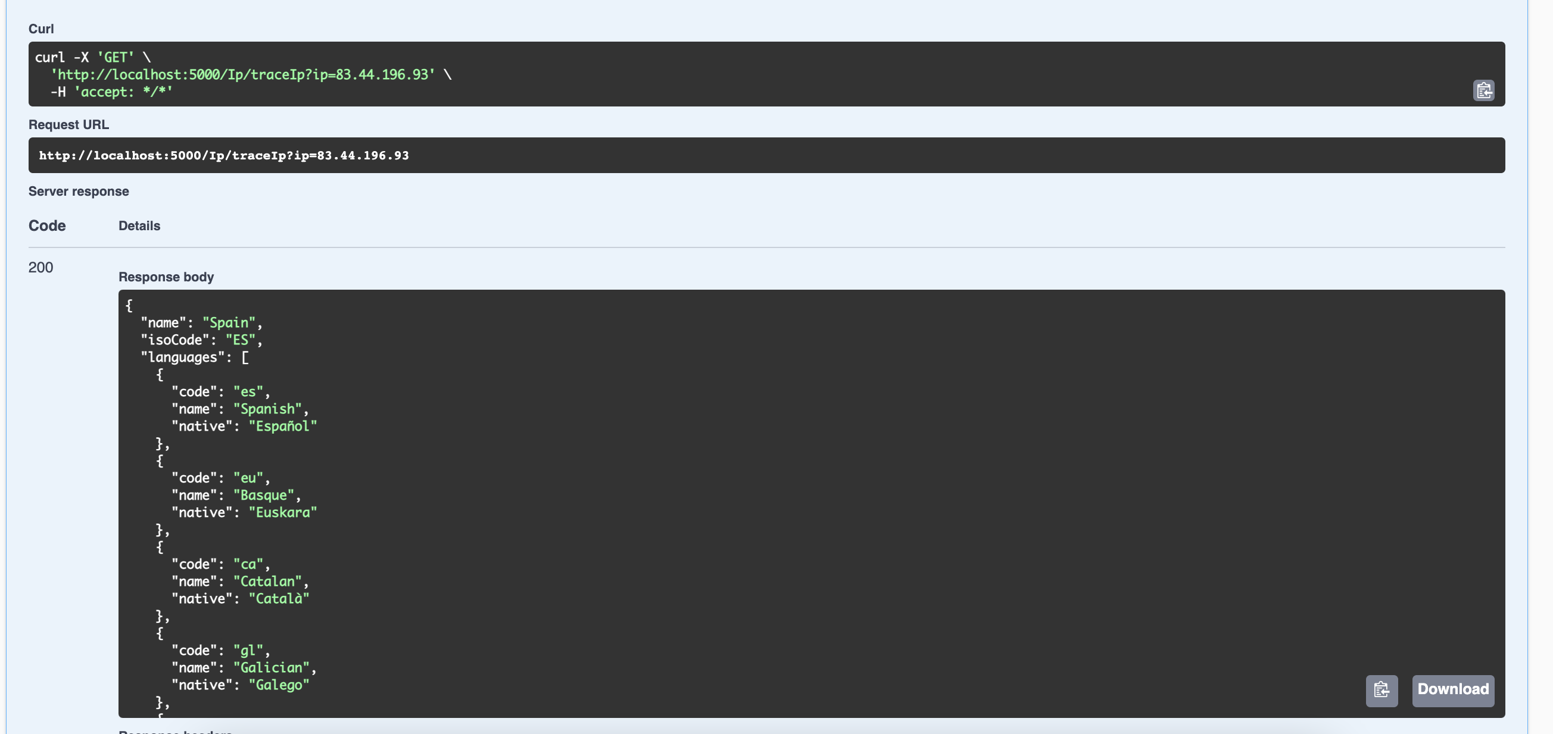

### HTML

The last mode to test the apis is with a HTML file, it’s in [Repository]/Frontend/index.html

Open the file:

Press buttons:

