**C4 MODEL DIAGRAMS**

**CONTEXT MODEL**

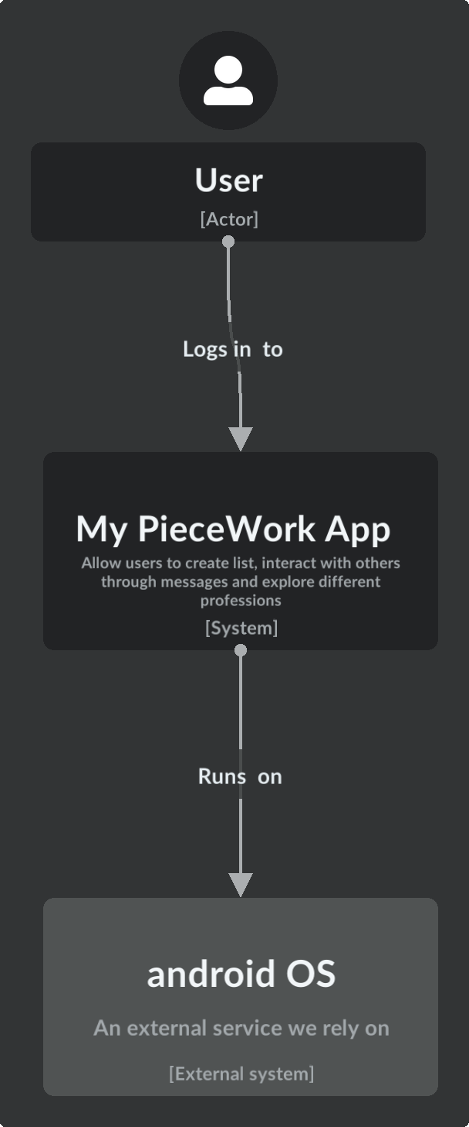

**CONTAINER MODEL**

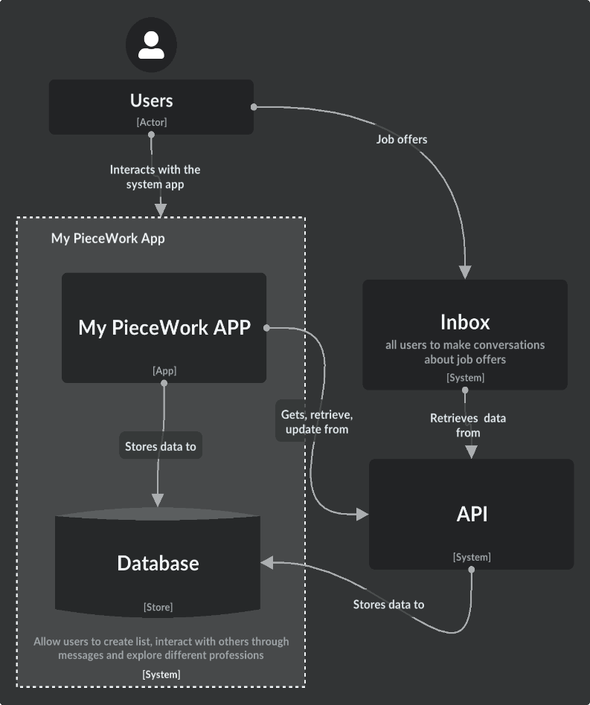

**COMPONENT DIAGRAM**

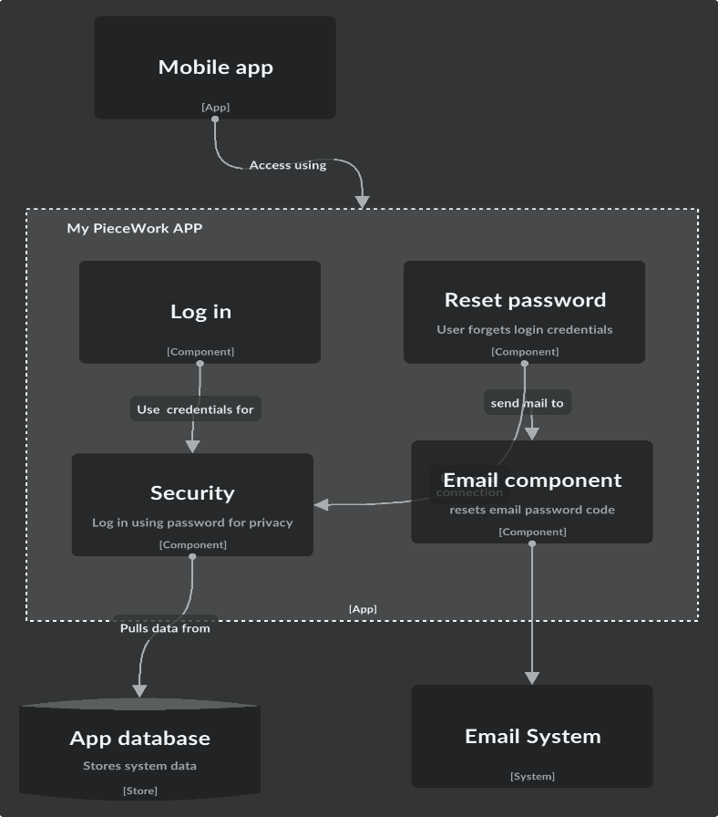

**CLASS DIAGRAM**

users List categories

Categories Inbox