Student ID: 101889190

Name: Matilda Goodison

# Setup Screenshot

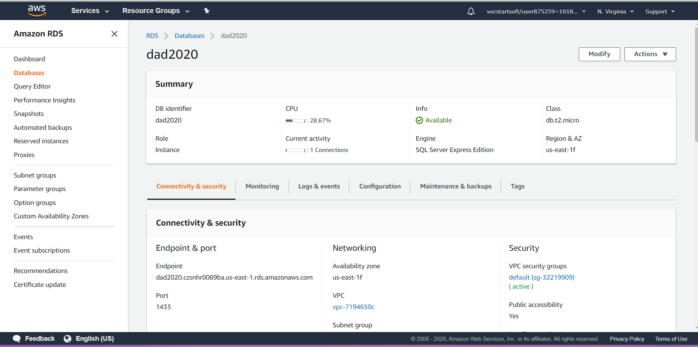

# Task 2 Screenshot

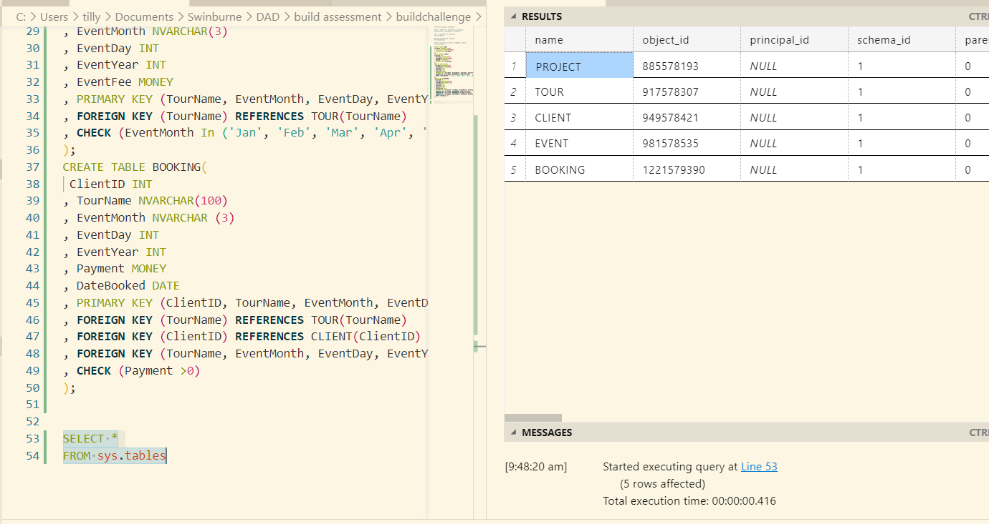

# Task 3 Screenshot

