ChatGPT for Beginners
Updated October 2026 | A step by step guide with current screenshots
ChatGPT is a tool you talk to in everyday language. It can help you understand a topic, draft a message, plan a task, and work with information you provide. This guide walks through your first conversation, shows what to click, and explains how to check the answer before you use it.
Screenshots were captured from ChatGPT on the web on October 6, 2026. Your screen may look different because features, plans, devices, and workspace settings vary.

1 Find your way around
Go to chatgpt.com and sign in. You can start with a free account. On the home screen, the message box is where you type a question or task. The plus button opens options for adding files and other tools. You can continue the same conversation with follow-up messages.
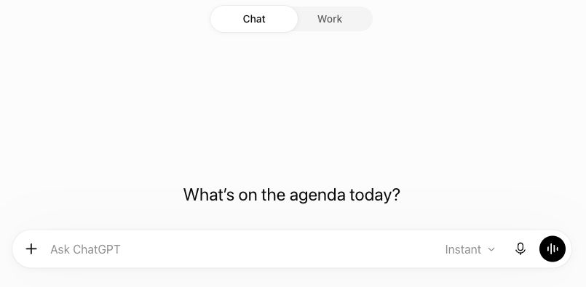
Figure 1. The Chat home screen. Type in Ask ChatGPT; the plus button is at the left of the message box.
Choose Chat for a conversation. Use it to ask a question, learn a concept, brainstorm, or rewrite a short passage. This is the easiest place to begin.
Choose Work for a larger result. If Work appears in your account, use it when you have source files, need research, or want a finished document or other file. You still describe your goal in plain language.

Work mode at a glance
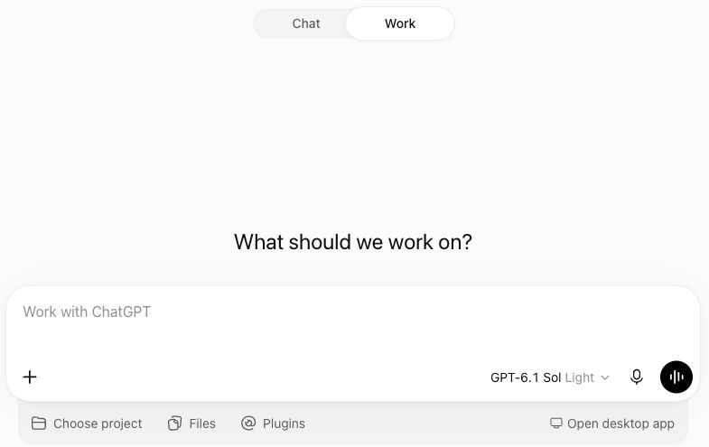
Figure 2. Work mode has a larger task box and options for projects, files, and plugins. These controls may vary by plan.

2 Have your first conversation
Start with one small request. You can ask for an explanation, a draft, or a plan. Include enough detail for a useful answer, but do not worry about writing a perfect prompt.
1. Click the message box and type what you want ChatGPT to do.
2. Read the message once, then send it with the arrow button or Enter.
3. Read the answer. If a part is unclear, ask a follow-up in the same chat.
4. Keep going until the answer fits your needs, then check important details.
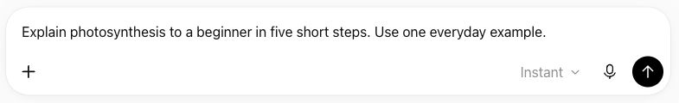
Figure 3. A clear first prompt says what to explain, who it is for, and how detailed the answer should be.
For example, after the photosynthesis answer, you could ask: “Make step 3 simpler,” “Quiz me with three questions,” or “Give another example.” ChatGPT can use the earlier messages in that conversation, so you do not need to repeat the whole request.
If you get a long answer. Ask for a short summary, a checklist, or just the first step. If you get too little detail, ask for an example or a step by step explanation.

3 Write prompts that give better results
A prompt is the instruction or question you send. The simplest way to improve one is to add the details that would change the answer. Four details often help: the goal, context, output, and boundaries. Use only what matters for your task.
Goal. Say what you want done: explain, summarize, draft, compare, plan, or revise.
Context. Name the audience, purpose, situation, and any source material ChatGPT should use.
Output. Ask for a length, format, tone, or reading level.
Boundaries. Say what to include, avoid, or verify. For example, “do not invent facts” or “keep my original meaning.”
A vague prompt: “Write an email.”
Try this: Draft a polite email to my landlord about a leaking kitchen tap. Ask for a repair visit next week, suggest two time windows, and keep it under 120 words.
The second version tells ChatGPT what the email is about and what a useful result looks like. You can still revise it afterward: “Make the opening warmer,” “Remove the last sentence,” or “Use simpler language.”

A practical prompt pattern
“Help me [goal]. Here is the context: [details]. Please give me [format and length]. Check or avoid [important boundary].”
You do not have to fill every bracket. For a quick question, one sentence may be enough. Add more context when you need a careful or personalized result.

4 Try four everyday tasks

Write and edit
Use ChatGPT to get a first draft or improve something you wrote. Paste only the text you are comfortable sharing. Tell it what must stay the same, then read the revised version before sending it to anyone.
Try this: Rewrite this note so it is friendly and direct. Keep the meaning, names, and dates unchanged. Do not add any promises: [paste note].

Learn something new
Ask for a plain explanation, a worked example, or a short quiz. You can tell ChatGPT what you already know. If an explanation feels too advanced, say exactly which sentence lost you.
Try this: Explain compound interest to someone who has never invested. Use a small number example, define the key terms, and finish with two practice questions.

Plan a task
Give real constraints such as time, budget, location, and what you want to avoid. Ask for the first action you can take today, then edit the plan if it is unrealistic.
Try this: Plan three weekday dinners for two people. Each should take under 30 minutes. Avoid peanuts, reuse ingredients, and finish with one shopping list.

Compare options
Tell ChatGPT what matters most to you. Ask it to show tradeoffs and the facts that need checking. For prices, schedules, or policies, ask for current sources and verify them.
Try this: Compare these two phone plans for one person who travels twice a year. Show the main differences in a short table and list what I should confirm on the providers’ sites: [paste plan details].

5 Add files, images, and current sources
The plus button beside the message box opens options such as adding photos and files or using web search. The exact menu depends on your account. Choose a tool only when it helps answer your question.
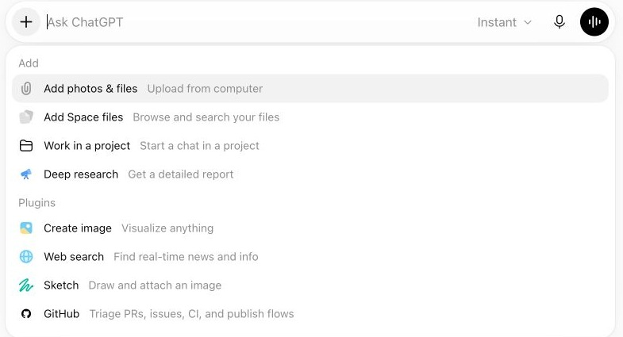
Figure 4. The add menu. Add photos & files lets you bring material into the chat; Web search is for information that may have changed.

Ask about a file
1. Choose Add photos & files and select a document or spreadsheet you are allowed to share.
2. Tell ChatGPT which part matters and what result you want.
3. Check the answer against the original file, especially numbers, dates, and names.
Try this: Summarize this document for a new employee. List the three actions they must take and name the section that supports each action.

Ask about an image
Attach a screenshot or photo when the visual details matter. Point to the relevant area and ask a specific question. Check small text and fine details yourself, since image interpretation can be imperfect.
Try this: Look at the error in the top right of this screenshot. Explain it in plain language and give me the first two things to try.

Ask for current information
Use web search when the answer depends on today’s facts, such as opening hours, prices, rules, or recent announcements. Ask for the official source and the date checked. Open the cited page before relying on the answer.
Try this: Find the current opening hours for [museum] on its official website. Include the source link, any special holiday hours, and the date you checked.

6 Check answers and protect your information
ChatGPT can sound certain even when it is mistaken. For a casual idea, a quick read may be enough. For a decision, a published message, or something you will share, use a short review routine.
1. Check names, dates, prices, quotations, and numbers against a reliable source.
2. Ask what sources were used and which statements are assumptions. Open the links yourself.
3. Read generated messages or files from beginning to end before using them.
4. For medical, legal, financial, or safety decisions, use qualified advice and authoritative sources.
Try this: Review your last answer. Separate facts you can support with a source from assumptions or suggestions. Tell me what I should verify.

A two-minute source check
Suppose ChatGPT says a museum is open until 7 p.m. on Friday. Open the official museum page, find Friday’s hours, and look for holiday or event exceptions. If ChatGPT cites a page that does not show the claim, ask it to correct the answer. This habit matters whenever a detail can change.

Share thoughtfully
Do not paste passwords, payment details, or someone else’s private information into a chat. Before uploading a sensitive file, check your account’s Data controls and sharing settings. If you only need help with wording, remove names and other identifying details first.
When you work from a file, name what ChatGPT should use. For example, “Use only the attached policy and tell me if a question is not answered there.” This makes it easier to notice unsupported claims.

When the answer is not useful
Too vague? Add your goal, audience, and one example of the result you want.
Too long? Ask for a three-sentence summary or a checklist.
Wrong direction? State what is wrong and ask for a focused revision.
May be outdated? Ask for current official sources, then open them.
Not sure what to ask? Describe the situation in your own words and ask ChatGPT what information it needs to help.

7 Copy-ready starter prompts
Replace the words in square brackets with your own details. Start with one prompt, review the answer, and follow up.
Understand a topic. Explain [topic] to a beginner. Define unfamiliar words and give one everyday example.
Learn by practice. Teach me [skill] in five small steps. After each step, ask me one question before continuing.
Improve writing. Edit this for clarity and grammar. Keep my meaning and tone. Show the revised text, then list the main changes: [text].
Draft an email. Write a [friendly/professional] email to [person] about [topic]. Include [key detail] and keep it under [word count].
Make a plan. Create a realistic plan for [goal] over [time]. My constraints are [details]. List the first three actions.
Compare choices. Compare [A] and [B] for [situation]. Show the tradeoffs and what facts I need to verify.
Summarize a file. Read the attached [file]. Give me a five-bullet summary and identify anything you could not confirm from the file.
Use current sources. Search for the latest official information on [topic]. Include links, dates, and a concise summary.
Get feedback. Here is my draft plan: [plan]. What is unclear, missing, or unrealistic? Suggest only the three most important improvements.
Simplify an answer. Explain your last answer in plain language. Keep the key facts and use one short example.

Your first 15 minutes
Try one real task today. Ask ChatGPT to explain a topic, draft a short message, or organize a simple plan. Read the answer, request one change, and verify one important detail. That small loop—ask, inspect, refine, verify—is the most useful habit to build.

Helpful words
Prompt. The question or instruction you send to ChatGPT.
Chat. A conversation that can include your first message and later follow-ups.
Source. A page, document, or other material that supports a factual claim.
File attachment. A document, spreadsheet, or image you add so ChatGPT can work with its contents.

Official sources and further reading
OpenAI guidance checked October 2026: Quickstart | Use ChatGPT | Prompting | Web | Image inputs | Web search

