Game Description  
1DV437 Introduction to Game Programming  
Matildha Sjöstedt (ms224xv@student.lnu.se)

**Tatari Quest**

I am planning to develop a 3D first person, horror genre game called Tatari Quest - tatari is Japanese for curse. Set indoors, inside a traditional Japanese house environment, the player will walk around in the dark, carrying only a lantern to light the way. In the house the player will encounter horrifying demons - whom have infested the house - and find the cursed victims of the people living there. In order to rescue the victims, the player has to find scrolls containing the cure while at the same time be wary of demons.

**Game Objectives**

**Rescue victims:** The main objective of the game is to save as many of the cursed victims as possible. But in order to do so, the player has to navigate through the corridors and rooms of the house and find the cure for the different curse types.   
**Victims:** Victims can reside in different parts of the house, each carrying a random curse. There are a fixed amount of different types of curses, which can occur none, one or several times among the victims.   
**Scrolls:** Scrolls are placed around the house, each containing a chant to cure one unique type of curse. The player can pick up scrolls, to use when encountering a victim. Reading a scroll - whether it be upon finding it or when chanting for a victim - takes a fixed amount of time and requires the lantern being lit during the duration. Rolled up scrolls placed in the player’s inventory can only be told apart by color - thus the player will need to memorize the curse cured by a specific scroll.   
**Lantern**: The player carries a lantern to light the way. The lantern can be lit and put out by the player at any time, except when reading a scroll. Lightening the lantern requires a match, of which the player only has a limited number.  
**Demons:** There are demons inside the house that can attack the player. Demons are attracted to light and the longer the player has the light lit, the bigger is the chance of demons appearing.   
**Fear-meter:** The matches and the fear-meter make up the player’s two “resources”. The fear-meter will increase when the player is attacked by a demon or when walking without having the lantern lit. Successfully rescuing a victim will slightly decrease the fear-meter. If the fear-meter reaches its maximum, the player character will flee the house - failing to rescue any remaining victims (alternatively the player him-/herself will become a victim).   
**Game-over:** The game ends when the player has either rescued all victims or had its fear-meter reached its maximum.

**Feature List**

The game will have the following features (optional features will be implemented if I have enough time to do so):

**Camera:** * The player camera will be positioned in a first person view.

**Player:** * The player can interact with its lantern, scrolls and victims that are found in the game world. The player character also interacts with collisions with demons and the environment - walls, floor etc.   
 * The player can lit and put out the lantern at any time by pressing the space-key, except when channeling a reading from a scroll.  
 * Lightening the lantern requires a match, of which the player has a limited amount.   
 * The player UI include the fear-meter and an inventory where scrolls and the number of matches will be displayed.   
 * The player can be attacked by demons, even when reading a scroll (this will however not interrupt the reading). The attack will be registered if the demon collide with the player character.  
 * The fear-meter will increase when the player is attacked by demons or when walking without having the lantern lit. Rescuing a victim decreases the meter.   
 * A score counting the number of victims rescued is displayed in the player UI.   
 * If the player walks close to a door it is given the option to move it (with for example the e-key).   
 * The game is over when the player’s fear-meter has reached its maximum or the player has rescued all victims.   
 * *Optional:* Instead of fleeing the house (described above), the player him-/herself becomes a victim if the fear-meter reaches its maximum. This will be showed by some simple cut-scene or effect in front of the player camera.

**Scrolls:** * When the player walks near a scroll laying in the game world, it is given the option to pick it up (by pressing for example the e-key). Picked up scrolls are placed in the player inventory.   
 * The player can read a scroll from the inventory at any time, by selecting it with the tab-key and then pressing the r-key for reading (the same procedure is used when chanting for a victim).   
 * The readable information displayed from the scroll will consist of a simple description of the symptoms for the specific curse the chant in the scroll can cure.   
 * Reading a scroll requires a fixed (“channel”) time, which will be represented in the player UI and also requires the lantern to be lit during the duration.   
 * Scrolls in the player inventory can only be told apart by color.  
 * Scrolls are placed at random locations in the game world at the start of the game.   
 * *Optional:* A sound effect like chanting will be played when the player is reading the scroll in front of a victim.

**Victims:** * When the player finds a victim (comes into a certain proximity of it and facing towards it) it will be prompted to press an interact button (eg. e-key). The player will then be presented with an info text-box in its UI, explaining what type of symptoms the victim has. The player will also be asked to select a scroll to chant from. This take normal reading/”channel” time and requires the lantern to be lit.   
 * The player can select to read NO scroll when encountering a victim (for example if the player knows it doesn’t have the correct scroll yet).   
 * If the player successfully selects the correct scroll for the right curse and finishes the entire reading time, the victim will be freed and it disappears with a short thank you.   
 * At the start of each game session, victims will be randomly distributed over a certain amount of fixed positions throughout the house.   
 * There can be none, one or more victims carrying the different curses. This is randomly determined at the start of the game.   
 * Victims will have a simple idle animation.   
 *Optional:* Specific animation when acknowledging the player coming near.  
 * *Optional:* The player can see the victim run away (when saved) to out of the player’s vision.

**Demons:**   
 * Demons spawn with an increasingly chance during the time the player has its lantern lit.   
 * Demons fly through the air towards the player, if they collide the player’s fear-meter is increased and the demon disappear.   
 * Demons will fly in a course, randomly selected from a few precalculated paths.  
 * *Optional:* Demons will fly in a course from a random starting point (form outside the player’s vision radius) to a random ending point, with some hit-chance being an ending point on the player.   
 * The demons will have a simple animation when flying through the air.  
 * When a demon fly towards the player a sound effect will be played.

**Environment:** * The environment will be set indoors inside a house, which design will include elements of traditional Japanese style.   
 * The house will consist of both corridors and rooms.   
 * The walls will include some doors which can be moved to reveal a room or a new path through the house (while possibly blocking another path or room).   
 * Background music and/or sound effects will be played during gameplay (eg. thunder and screams).  
 * Some walls will have windows to view an outside environment (it will not be possible to walk outside).   
 * The outside environment will consist of for example some vegetation, night sky effect with some light (moon) and a rain particle effect.  
 * When the player gets close to the windows a rain sound effect will be played together with the start of the rain particle effect.

**Game Controller:** * Information such as found scrolls, matches, victim symptoms, fear-meter etc. will be displayed in the player UI (see “Player:” above)  
 * The player can control the camera and its character by using the wasd-keys and the mouse.   
 * Before the game the player will be given a short introduction and instructions of the game and a continue/exit option.   
 * *Optional:* A short cut-scene will be played at the start of the game, for example a simple camera sweep through a corridor with sound effects playing.   
 * During gameplay the player can pause the game by pressing the esc-key. This gives the option of continuing or exiting the game.   
 * When the game ends, the player will get a review of the amount of successfully rescued victims and the option of restarting or exiting the game.

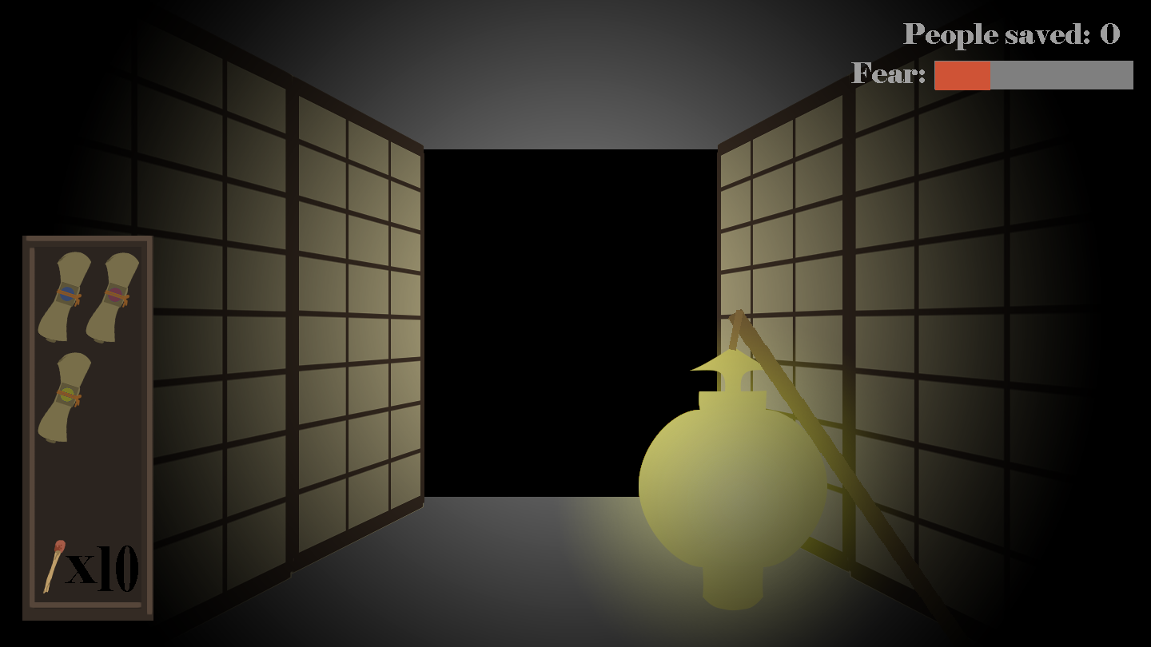**Prototype of Game View**

Picture 1: Normal game view (walking in corridor). Inventory with scrolls and matches is displayed on the left. The fear-meter and number of victims rescued are displayed on the right.

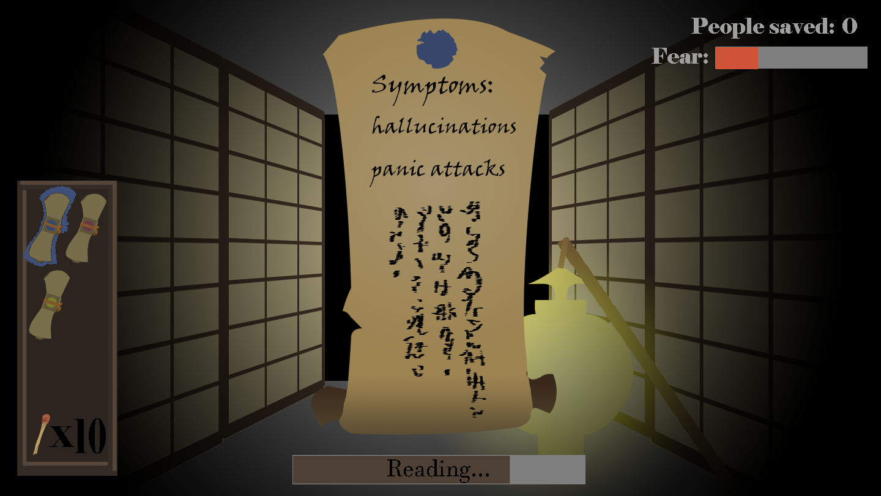

Picture 2: Reading a scroll. The scroll displays the symptoms for the curse it cures and a color used to identify the scroll. A channel-bar is placed at the bottom, indicating the time it takes for the player to read the scroll.

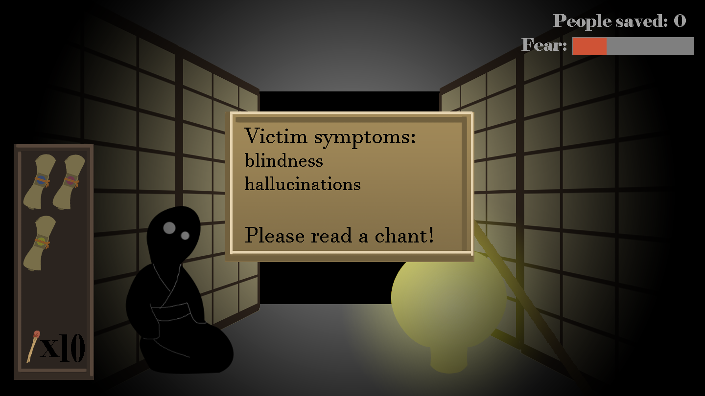

Picture 3: Encountering a victim. A text-box is displayed, prompting the player to select a scroll to chant from.

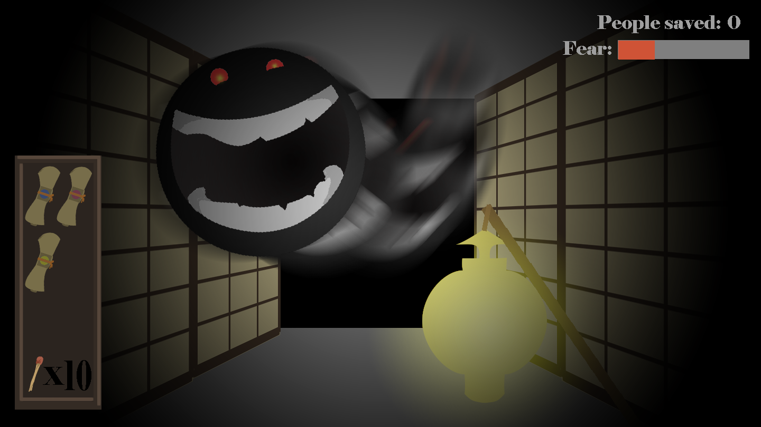

Picture 4: Encountering a demon

**Assets and other Resources**

I will use the following assets from the Unity Asset Store:

* “Korea native trees” to be used in outside environment, visible from windows. <https://www.assetstore.unity3d.com/en/#!/content/7714>  
 * I will probably use one of the following packages for indoor decoration:   
“Lowpoly Flowers” <https://www.assetstore.unity3d.com/en/#!/content/47083> , “Small Plants” <https://www.assetstore.unity3d.com/en/#!/content/6930>

Other currently unspecified resources:

* Miscellaneous textures from <https://www.textures.com> to be used for, for example wood (for floor) and paper (for walls) and something to be used for tatami-mats in some rooms.

* I will also use a grass texture for the outdoor environment.

* I will use some sound effect for demons, doors, walking and environmental sound effects such as thunder and rain.

**Optional assets/resources:**  
(used if I have time OR if I fail to create good enough variants myself)

* “Free Night Sky” to be used in outside environment, visible from windows.  
<https://www.assetstore.unity3d.com/en/#!/content/79066>

* “Free Katana and Scabbard”, for indoor decoration.

* “White Smoke Particle System”, used in outside environment and/or as an effect to bring out the demons movement (if I fail to create an good enough effect for that myself).