**Lab07-Database Application Development**

# Objective:

In this lab students learn:

* How to connect to a Oracle server from a C++ program.
* How to write and execute SQL queries in a C++ program.

***Connecting to an Oracle database from a C++ Program***

So now we will add some code to make sure we can connect we can do a simple test. In the .cpp file we created earlier, type in the following code to test your connection. It is important that you type it as to learn what is happening to make completing the project tasks much easier. (Hence why I am providing a screen shot rather than text so you cannot copy and paste)

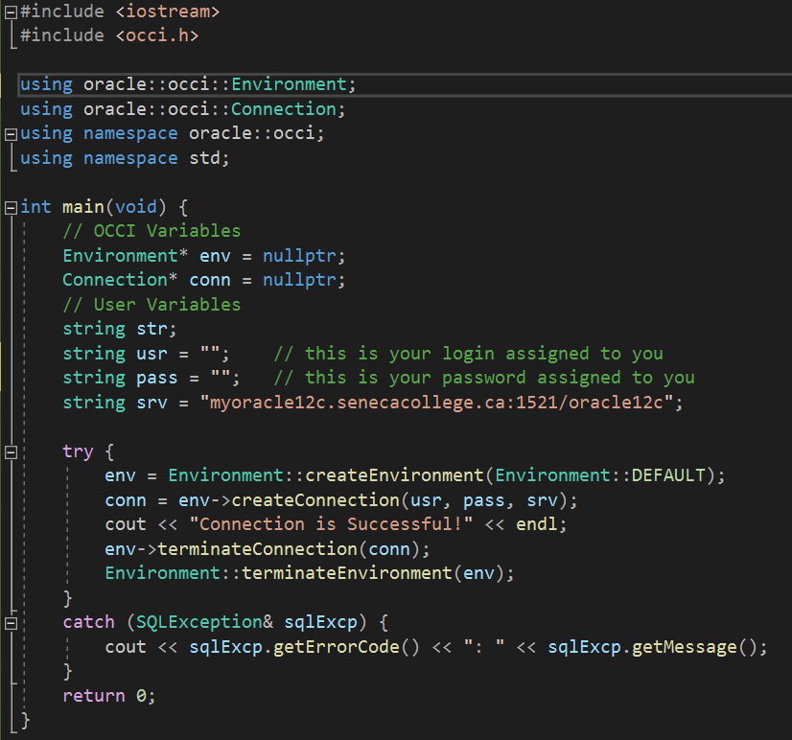

If you see the console screen come up with Connection is Successful, then you are ready to move to the next steps.

## Running a Simple SELECT query and outputting the results

So we will go through a series of steps to get some output. Type in the following code as shown within the code shown above…. (i.e. merge the two). Use the provided information in class (likely a PPT slideshow) to understand what each line is doing. Some key concepts you will want to understand include:

* Connection (conn)
* RecordSet (rs)
* next() method and how it works
* and all the terminate statements and why they are necessary.

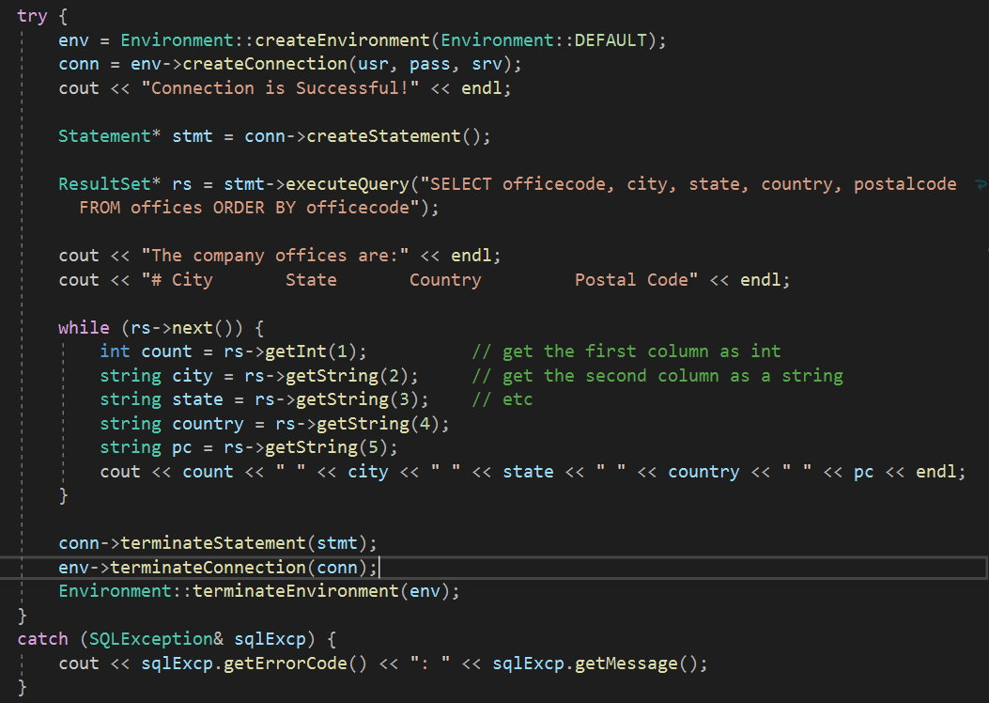

**Lab Requirements:**

In this lab, you need to write a C++ program to execute the following queries and display the result returned by each query. For the output format, see the sample output.

* 1. Display Employee Number, First Name, Last Name, Phone Number, and Extension of all Employees who work in San Francisco. See the following Sample output.
  2. Display Employee Number, Last Name, Phone Number, and Extension for all managers. (You can use column reportsto to find the managers’ employee numbers)

Sample output:

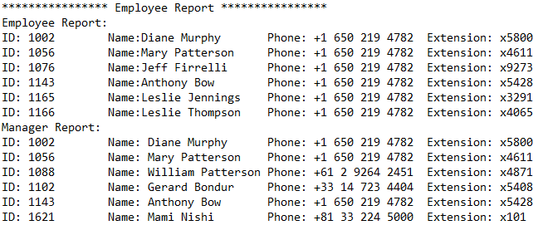

**Submission:**

***Copy Your C++ program from the Database Application lab* into text file and submit file as**

Lab07.txt

Your submission needs to be commented