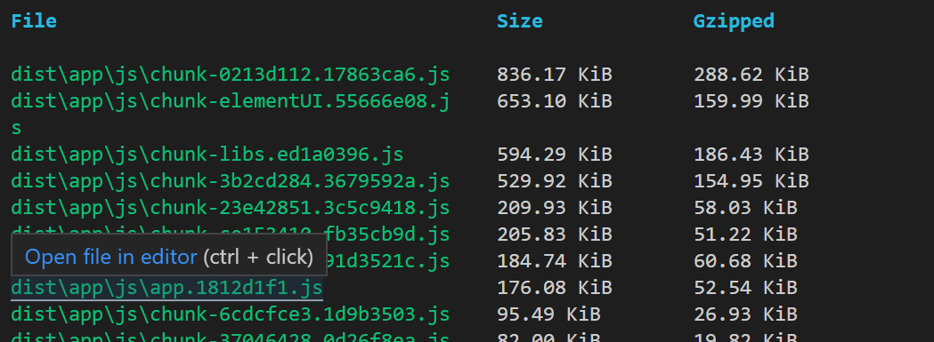

element-ui 按需加载
安装 babel-plugin-component 插件
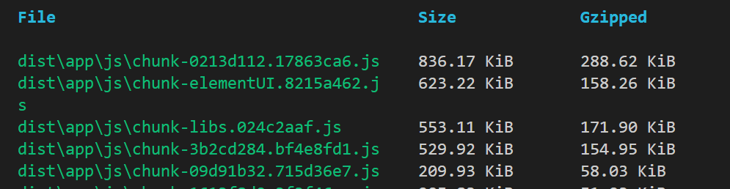

使用 cdn 加速
生产环境下 ./vue.min.js
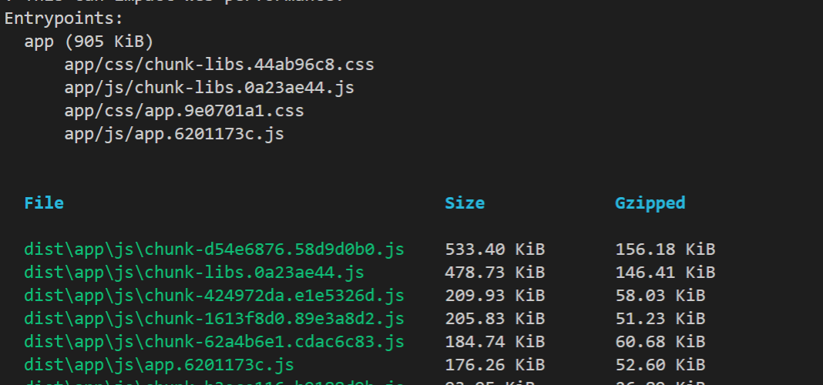
<script src="./vue.min.js"></script>
<script src="https://cdn.bootcss.com/vuex/3.0.1/vuex.min.js"></script>
<!-- <script src="https://cdn.bootcss.com/vue-router/3.0.3/vue-router.min.js"></script> -->
<script src="https://cdn.bootcss.com/element-ui/2.8.2/index.js"></script>
<script src="https://cdn.bootcss.com/echarts/4.2.0-rc.2/echarts-en.min.js"></script>
<script src="https://cdn.bootcss.com/moment.js/2.20.1/moment.min.js"></script>
<!-- <script type="module" src="https://cdn.bootcss.com/jspdf/2.0.0/jspdf.es.js"></script> -->
<!-- <script src="https://cdn.bootcss.com/html2canvas/0.5.0-beta4/html2canvas.js"></script> -->
<script src="https://cdn.bootcss.com/jspdf/1.3.4/jspdf.debug.js"></script>

configureWebpack: {
// provide the app's title in webpack's name field, so that
// it can be accessed in index.html to inject the correct title.
name: 'APP',
resolve: {
alias: {
'@': resolve('src')
}
},
//引入第三方依赖包
externals: {
'vue': 'Vue',
'vuex': 'Vuex',
'element-ui': 'ELEMENT',
'echarts': 'echarts',
'moment':'moment',
'jspdf':'jsPDF'
},
}

- VueRouter的懒加载
所有路由 懒加载
const Layout = () => import('@/components/Layout')

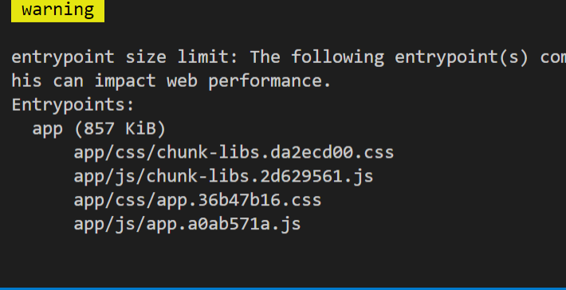
3.Gzip打包（已做）
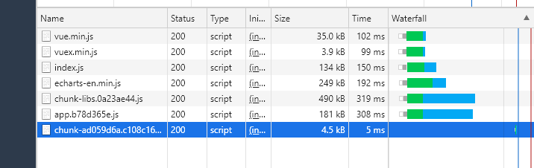

https://www.cnblogs.com/sexintercourse/p/12326937.html
在http请求的Request Headers 中能看到 Accept-Encoding:gzip

