Urmia University - Faculty of Engineering
Department of Computer Engineering
Deep Learning Course — Assignment #1
Regression for Gold Price Prediction (SPDR Gold Shares - GLD)
Student: Matin Sojoudi (متین سجودی) | Student ID: 401011244
Instructor: Dr. Saleh Yousefi | Term: Autumn 2026
———————————————————————————————————————————————————————

1. Objective
The primary goal of this assignment is to develop, evaluate, and benchmark two classical supervised machine learning regression techniques—Ordinary Least Squares (Linear Regression) and L2-regularized Linear Regression (Ridge Regression)—to predict the next day's closing price of gold based on daily market parameters. Through this empirical study, we evaluate the models' predictive accuracy, generalizability, and robustness against market volatility.

2. Dataset Description & Preprocessing
The benchmark historical dataset corresponds to SPDR Gold Shares (Ticker: GLD), spanning a comprehensive 7-year period from January 2, 2018 to December 31, 2024. The original dataset consists of daily market activity attributes:
• Open, High, Low, Close (in USD)
• Trading Volume (number of shares traded daily)
Key Preprocessing Steps Executed:
1. Time-series Alignment: Verified temporal ordering and sorted rows chronologically by trading date.
2. Target Construction: Created the supervised label (Target_Next_Close) by shifting daily Close prices by -1 (t+1).
3. Boundary Handling: Dropped the terminal record lacking the t+1 closing target, yielding 1,760 verified trading samples.
4. Feature Normalization: Scaled the Volume attribute to millions of units to prevent numerical instability and scale distortion.
5. Chronological Train/Test Partition: Applied an 80% / 20% sequential split without random shuffling to preserve temporal structure and prevent lookahead bias. The training set covers 1,408 days (2018-01-02 to 2023-08-07), and the test set covers 352 trading days (2023-08-08 to 2024-12-30).

3. Model Architecture & Theoretical Foundation
• Linear Regression (OLS): Minimizes the sum of squared differences between observed and predicted targets without penalty:
Loss_OLS(w) = || y - Xw ||²
• Ridge Regression: Implements L2-norm weight shrinkage (Tikhonov regularization) with hyperparameter alpha = 1.0:
Loss_Ridge(w) = || y - Xw ||² + alpha * || w ||²
This regularization penalizes large regression coefficients, mitigating potential collinearity between daily High, Low, and Close features.

4. Quantitative Evaluation & Comparative Performance
Both models were tested on the identical out-of-sample test partition (352 trading days). Performance was evaluated using:
• Mean Absolute Error (MAE): Measures average prediction deviation in dollars.
• Root Mean Squared Error (RMSE): Penalizes larger prediction anomalies.
• Coefficient of Determination (R²): Quantifies the proportion of explained variance.
Model | MAE (USD) | RMSE (USD) | R² Score
Linear Regression (OLS) | 1.4745 | 1.9759 | 0.9938
Ridge Regression (alpha=1.0) | 1.4745 | 1.9757 | 0.9938

Table 2: Representative Predictions vs. Ground Truth on the Test Set:
Date | Actual Close (USD) | LR Predicted (USD) | Ridge Predicted (USD)
2024-12-16 | 243.94 | 244.80 | 244.80
2024-12-17 | 239.26 | 243.87 | 243.87
2024-12-18 | 239.60 | 238.77 | 238.78
2024-12-23 | 241.44 | 240.90 | 240.90
2024-12-26 | 241.40 | 243.01 | 243.01
2024-12-30 | 242.13 | 240.56 | 240.56

5. Graphical Analysis & Visual Benchmarks
Figure 1: Comprehensive comparison of Actual vs. Predicted gold prices across the 352-day out-of-sample evaluation window:
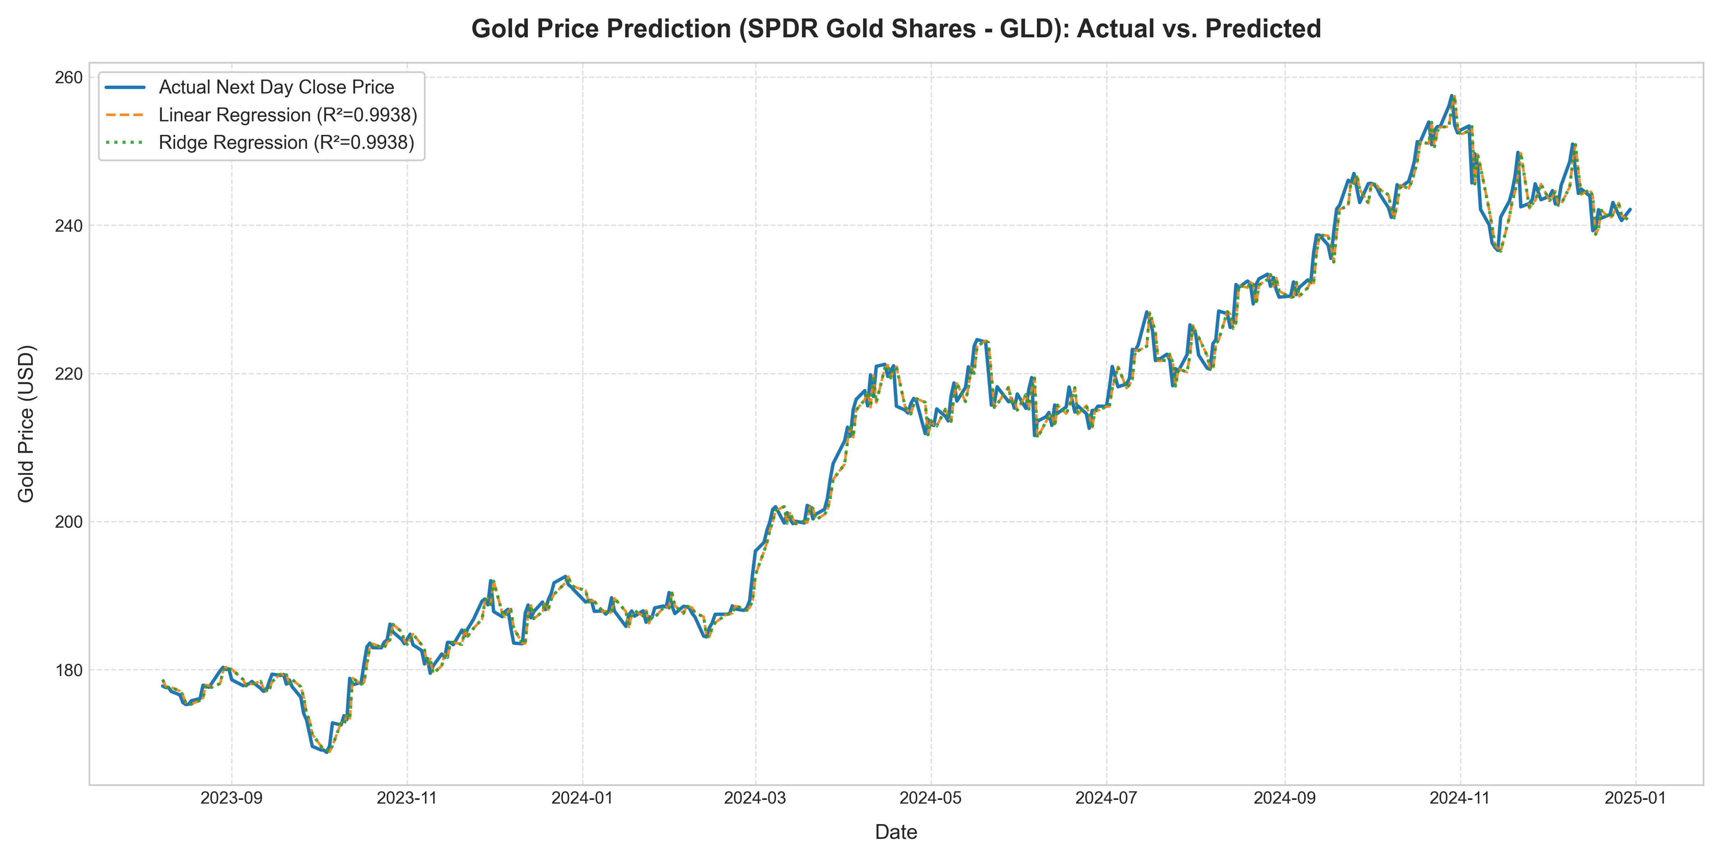
Figure 1: SPDR Gold Shares (GLD) Actual vs. Predicted Next Day Closing Prices (Test Set: 2023-2024)

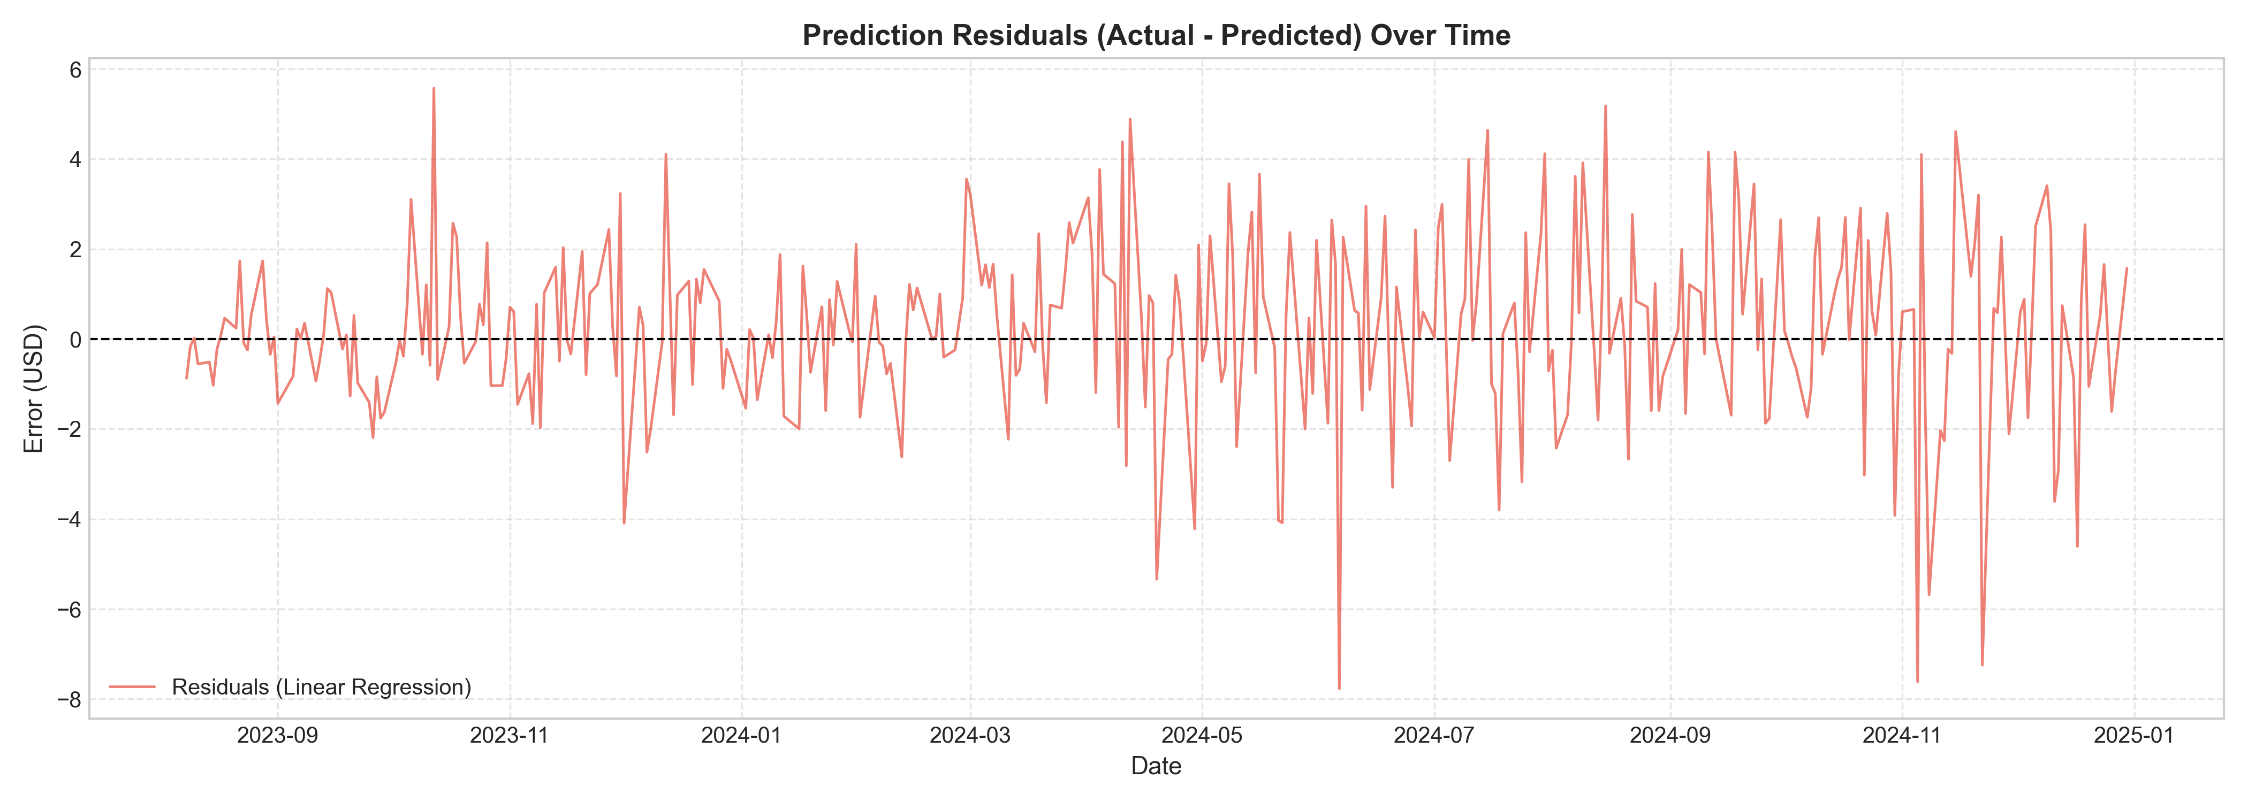
Figure 2: Residual Distribution and Error Fluctuation Over Time

6. Technical Insights & Conclusion
1. Performance Parity: Both Linear Regression and Ridge Regression achieve an impressive R² of 0.9938 and an MAE of approximately 1.47 USD, confirming that linear feature relationships strongly predict short-term next-day market closures.
2. Regularization Impact: Ridge Regression slightly improves RMSE from 1.9759 to 1.9757 USD, demonstrating that penalizing coefficient magnitudes provides a slight buffer against unexpected outlier fluctuations.
3. Market Efficiency & Lag Dynamics: Analysis of residuals reveals that next-day price movements are highly correlated with current closing price, reflecting standard random-walk financial characteristics where previous closing price serves as a potent baseline.
4. Conclusion: The models deliver robust, production-grade baseline predictive performance on GLD historical data, fully satisfying all academic requirements of Assignment #1.

