**Programming Design Paradigm AE2 - Chatbox**

UML Digrams

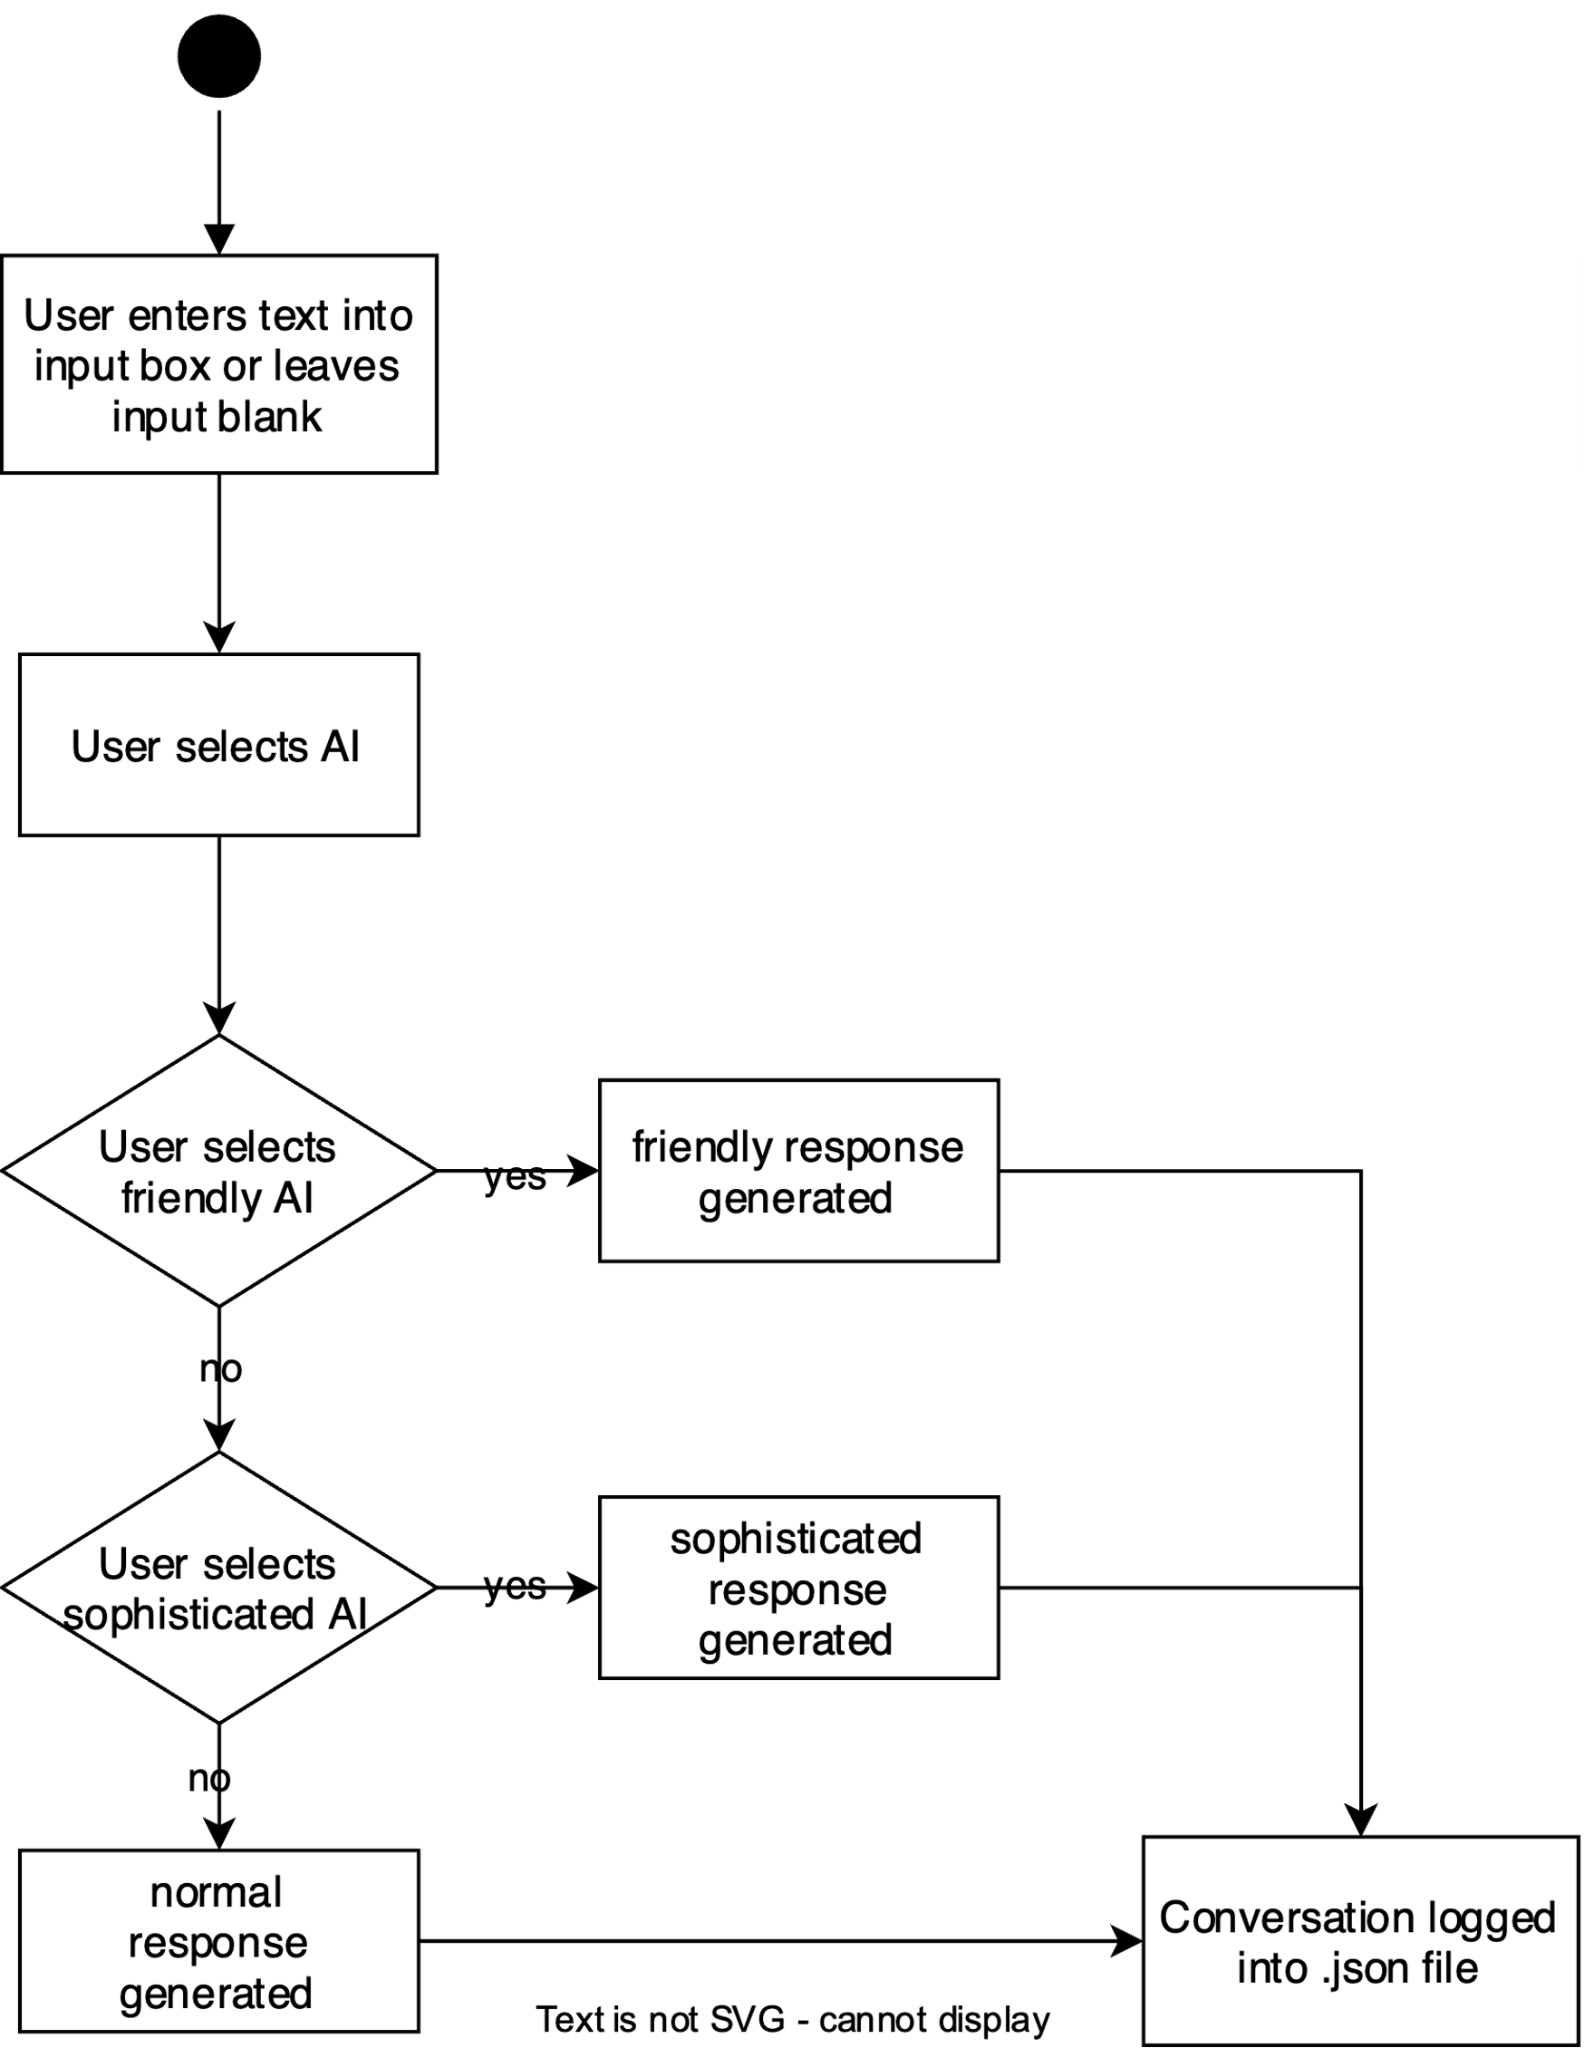

Figure 1: Activity Diagram

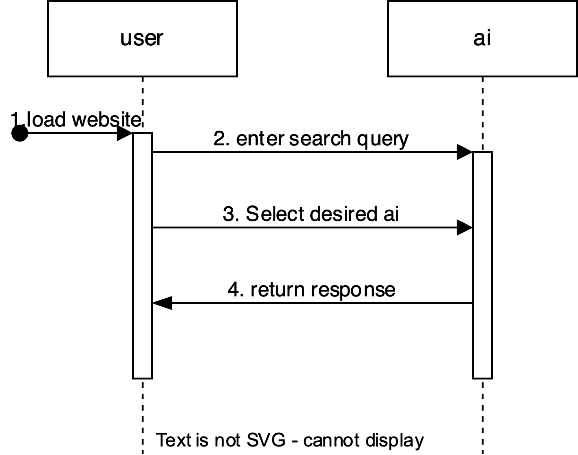

Figure 2: Sequence Diagram

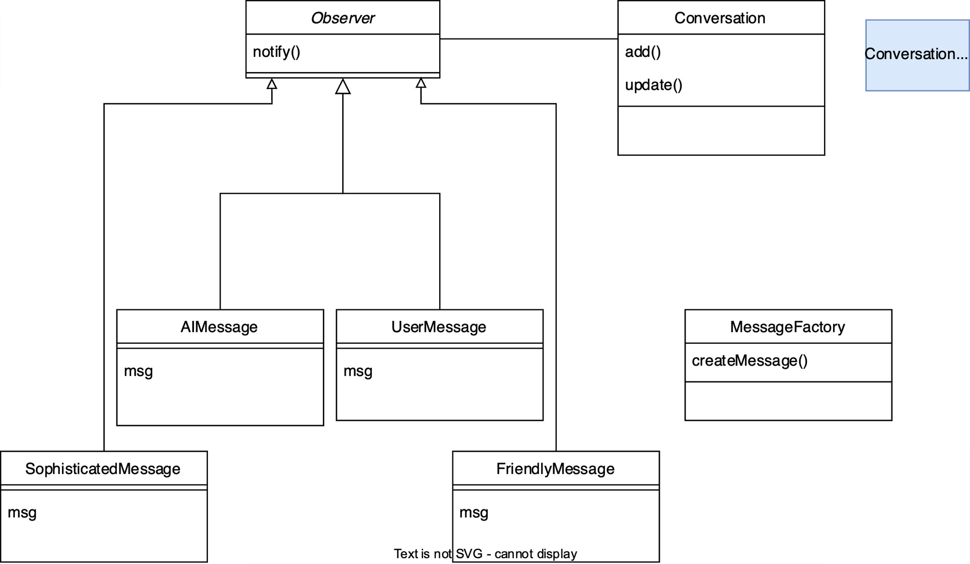

Figure 3: Class Diagram