Energy Forecasting and Dispatch Optimisation
for a Small Hydropower Utility

Master Thesis
Matis Gourdès

KTH Royal Institute of Technology
Department of Energy Technology
2026

Abstract
Let's get inspired to write an Abstract — Summarise in ~200 words: the problem
Keywords (Georgia Bold 12pt.)
energy forecasting, hydropower scheduling, battery storage, CNN-LSTM, network optimisation, linear programming, intraday market

Sammanfattning
Swedish translation of the abstract to be written here.

Nyckelord

Acknowledgments
Acknowledgments to be written here.
Prices have been converted between different currencies in April/ May of 2026:
Here are average Currency trades from this period:…

List of Abbreviations

Abbreviation | Definition
AR / ARMA / ARIMA | Autoregressive / Autoregressive Moving Average / Integrated ARMA
BESS | Battery Energy Storage System
CNN | Convolutional Neural Network
DA | Day-Ahead (electricity market)
DNN | Deep Neural Network
DSO | Distribution System Operator
ID | Intra-Day (electricity market)
KPI | Key Performance Indicator
LFP | Lithium Iron Phosphate (battery chemistry)
LP | Linear Programming
LSTM | Long Short-Term Memory (neural network)
MAE | Mean Absolute Error
MAPE | Mean Absolute Percentage Error
MILP | Mixed-Integer Linear Programming
RMSE | Root Mean Square Error
RTE | Round-Trip Efficiency
SCADA | Supervisory Control and Data Acquisition
STEF | Short-Term Energy Forecasting
SVM | Support Vector Machine

Abstract 2
Sammanfattning 3
Acknowledgments 4
List of Abbreviations 5
1 Introduction 8
1.1 Background and Motivation 8
1.2 Objectives 9
1.3 Scope and Limitations 10
1.4 Thesis Structure 11
2 Literature Review 12
2.1 Short-Term Energy Forecasting 12
2.2 Short-Term Hydropower Scheduling 14
2.3 Battery Storage for Grid Applications 15
3 System Description and Problem Context 16
3.1 AlpenEnergie — Company Overview 16
3.2 The Production Network 16
3.3 The Swiss Electricity Market 18
3.4 Problem Statement 19
4 Forecasting Model 21
4.1 Model Architecture 21
4.2 Input Features 23
4.2.1 Temporal Feature Encoding 24
4.3 Training Strategy 24
4.4 Deployment Pipeline 25
4.5 Model Drift and Retraining Strategy 25
4.6 Performance Metrics 26
5 Optimisation Model 27
5.1 Modelling Philosophy and Scope 27
5.2 Market Framework 27
5.3 Operating Modes and Priority Hierarchy 28
5.4 Capacity Tariff 29
5.5 Dispatch Strategies 29
5.5.1 Reference Model — Seasonal Reference (WATER_LEVEL) 30
5.5.1 Model 1 — Forecast-Following Model 30
5.4.2 Model 2 — Linear Programming Model 31
5.5 Physical Constraints 33
5.6 Data Preparation 34
5.6.1 Dataset 34
5.6.2 Flow–Power Correlation 34
5.6.3 Natural Inflow Derivation 34
5.6.4 Simulated Production Forecast 35
6 Battery Storage Analysis 37
6.1 Role of the Battery in This System 37
6.2 Battery Sizes and Pricing Assumptions 37
6.3 Key Performance Indicators 37
7 Results 38
7.1 Forecasting Model Results 38
7.2 Optimisation Model Results 42
7.3 Battery Results 42
7.3.1 Intraday Mode 42
7.3.2 Day-Ahead Arbitrage Mode 42
8 Discussion 44
8.1 Value of Improved Dispatch Logic 44
8.2 Battery Viability 44
8.3 Limitations 44
8.4 Future Work 44
References 46
Appendix 49
A.1 Forecast Error Quantification 49
A.2 Results 49

1 Introduction

Background and Motivation
Driven by the Paris Climate Agreement and public policies aimed at reducing emissions to mitigate the impacts of the climate crisis, the deployment of renewable energy has accelerated dramatically. Energy systems that were once designed to be centralized around large-scale production and consumption hubs must gradually adapt to decentralized production characterized by significant weather-dependent fluctuations. Global investment in clean energy technologies exceeded 2 trillion USD in 2024, with spending on renewable power, grids and storage surpassing total investment in oil, gas and coal for the first time [1]. This shift reflects both the maturity of the technology and the urgency of the transition.
This transformation of global energy flows and market structures is placing new demands on electricity markets. As the share of renewable energy increases, it becomes more difficult to maintain the balance between supply and demand in real time. The value of flexibility, the ability to adjust production or consumption very quickly, is therefore on the rise. All European countries have developed markets that finance flexibility in order to stabilize the grid and maintain electricity as a safe and reliable source of energy. Intraday electricity markets, where energy surpluses and needs are traded right up to the last moment to avoid paying penalties on reserve markets, play an increasingly important role in absorbing the short-term intermittency of renewable energy assets. Not only is the generation sector constantly evolving, but demand, driven by the electrification of new applications and more localized production, makes it harder to predict energy needs. The financial penalties associated with forecasting deviations have become real economic drivers for producers who cannot freely adjust their output [2].
Switzerland sits at the centre of this transition. The Swiss electricity system will undergo major changes with the gradual phase-out of nuclear, the accelerated electrification of heating and transport, and the need to ramp up generation from renewables to ensure the net-zero trajectory to 2050 [3]. Hydropower currently covers approximately 60% of domestic electricity production and represents Switzerland's primary source of flexible, dispatchable generation. Switzerland's system benefits from a high degree of flexibility thanks to its large installed pumped-hydro capacity, yet this flexibility comes with an operational challenge: hydropower output is driven by precipitation, snowmelt, and seasonal inflow patterns that are inherently variable and imperfectly predictable[4]. In June 2024, the Swiss public voted in favor of the Secure Electricity Supply Act, which lays the groundwork for a rapid expansion of electricity generation from renewable energy sources and introduces new regulations governing the production, consumption, storage, and transmission of energy, as well as a mandatory hydropower reserves. The act, in force since 1 January 2025, introduces flexibility as a regulated concept, requiring that the ability to control the purchase, storage or feed-in of electricity be made available by end consumers, producers and storage operators, and mandating the integration of decentralised production into local electricity grids [5],[6],[7].
At the local level, municipalities, which often manage distribution networks in Switzerland (more than 600 [8]), face a more acute version of this challenge than large producers. They must simultaneously manage a local distribution network and optimise the dispatch of generation assets, often with limited data infrastructure and without the portfolio diversification that larger operators can rely on to absorb forecast errors. For these actors, the gap between the day-ahead schedule submitted to the market and the actual real-time net consumption is not an abstract risk, it is a direct and recurring operating cost.
Small hydropower operators are particularly exposed because their output is constrained by water availability and reservoir dynamics, which limits their ability to correct forecast deviations in real time. Battery storage, by contrast, can respond instantaneously and independently of hydrological conditions, making it a natural complement rather than a competitor to hydropower dispatch. Whether this complementarity translates into an economically viable combination at the scale of a small municipal utility is, however, not self-evident. This question sits at the heart of the present work.

1.2 Objectives
The primary objective of this work is to analyse and support the transition of AlpenEnergie to a more flexible, market-oriented mode of operation. The central challenge for a small hydroelectricity producer is that costs are not generated by production itself, but by the gap between what was promised to the market and what was actually delivered. For AlpenEnergie, this challenge is further compounded by the simultaneous management of a local distribution network, which means that both the production and the consumption side of the balance must be forecast and controlled at the same time.
AlpenEnergie must submit a combined generation and consumption schedule to the day-ahead market one day in advance. Every deviation between this commitment and the real-time outcome is then settled on the intraday market, at a price that is structurally less favourable for the party in imbalance, additional fees are also charged to fund the regulatory market. The net consumption that must be forecast is the aggregate demand of all connected consumers, reduced by the output of local rooftop photovoltaic installations, which introduces weather-dependent variability through irradiance, cloud cover, temperature and snow cover for example. Getting this forecast right is therefore the first and most direct lever for reducing costs.
This work addresses the problem along two complementary tracks. The first is the development of a short-term net load forecasting model producing 48-hour predictions at 5-minute resolution, using a hybrid CNN-LSTM architecture trained on historical consumption and meteorological data. However, such a small weather dependant network is impossible to predict correctly, and some errors will remain in any case. Therefore, the second track is an economic evaluation of dispatch strategies applied to the same historical dataset, from a rule-based model to a price-aware linear programme to quantify how much of the residual imbalance cost can be recovered through smarter operational logic alone. The potential contribution of battery energy storage is assessed within this same framework, to determine whether adding physical storage creates meaningful additional value once forecasting and dispatch have already been optimised, or whether the economic case for a battery cannot be justified at the scale of a small municipal utility.

1.3 Scope and Limitations
This work focuses on the AlpenEnergie system over the 2025–2026 period, chosen to coincide with the entry into force of the new Swiss imbalance settlement mechanism in January 2026[9]. The network is modelled in simplified form: the two-reservoir cascade is represented with linearised turbine characteristics, hydraulic losses are approximated, and river donation flows are neglected. On the economic side, the model does not simulate quarterly electricity procurement blocks, or participation in the reserve markets (SRL/TRL), which are monitored as secondary KPIs but not optimised.
The forecasting model is trained on one year of historical data, which limits its ability to capture rare meteorological events and multi-year seasonal variability. Its performance is evaluated on a single network, and generalisability to other small Swiss utilities is not demonstrated. Photovoltaic generation is treated as a negative load component derived from irradiance forecasts rather than metered at individual installation level, introducing a structural approximation that grows with increasing rooftop PV penetration.
The optimisation model is deterministic and uses historical data as a perfect-foresight input; results therefore represent an upper bound on achievable performance in practice. Stochastic scheduling and long-term investment modelling are outside the scope of this study. Full availability of the turbines and battery is simulated; any rare or unusual events are not taken into account and have been excluded from the initial data. The battery analysis covers LFP technology only. All results are anchored to the specific 2025 day-ahead and intraday price distribution.

1.4 Thesis Structure
The thesis is structured to follow the natural progression from problem understanding to solution development and evaluation. The literature review in Chapter 2 establishes the methodological foundations across three domains: load forecasting, hydropower scheduling, and battery storage. Those are brought together in the subsequent chapters. Chapter 3 then grounds the work in its operational context, describing the AlpenEnergie system and the Swiss market framework that defines the financial stakes of the problem. Chapters 4, 5, and 6 form the methodological core of the thesis, developing the forecasting model, the optimisation framework, and the battery analysis respectively. Results are consolidated and compared across all configurations in Chapter 7, before Chapter 8 discusses the broader implications, limitations, and directions for future work.

2 Literature Review

2.1 Short-Term Energy Forecasting
Short-term energy forecasting (STEF) has attracted sustained research interest, driven by the increasing integration of renewable energy sources and the growing financial consequences of forecast deviations in liberalised electricity markets. A broad categorisation of existing methods distinguishes four main families: statistical models, machine learning models, deep neural networks, and hybrid architectures [10], [11].
Classical statistical approaches, including autoregressive (AR), autoregressive moving average (ARMA), and autoregressive integrated moving average (ARIMA) models, were among the first applied to electricity demand forecasting. These methods are well understood and computationally inexpensive, but they are fundamentally limited to linear relationships and struggle to generalise across the complex, nonlinear patterns that characterise modern distribution networks [10]. Machine learning approaches such as Support Vector Machines (SVM) and Exponential Smoothing partially address this limitation but remain shallow in their representational capacity [11].
Deep neural networks have consistently outperformed both earlier families across a broad range of STEF tasks [12]. Among deep learning architectures, Long Short-Term Memory (LSTM) networks have attracted particular attention for time series data. LSTMs are a specialised variant of recurrent neural networks designed to capture long-term temporal dependencies through a gated memory cell architecture governed by three gates: forget, input, and output; which collectively regulate what information is retained, updated, or discarded at each timestep [10]. This structure enables the network to learn temporal patterns spanning multiple days, such as weekly consumption cycles or heating-related demand shifts, without suffering from the vanishing gradient problem that limits standard recurrent networks. A deep multi-layer LSTM applied to short-term electricity consumption forecasting at 10-minute resolution achieved a MAPE below 1.5% on nine years of Spanish national grid data, demonstrating that multi-layer dropout regularisation combined with the Adam optimiser and an adaptive learning rate schedule produces robust results [13].
A further line of research investigates hybrid architectures combining Convolutional Neural Networks (CNNs) with LSTMs. In this configuration, the CNN acts as a local pattern extractor, scanning the input sequence with learned filters to identify recurring temporal structures before compressing this information into a compact representation passed to the LSTM for sequence modelling [14]. This combination consistently outperforms standalone LSTM, RNN, and MLP models for electricity consumption prediction, validating the expressive advantage of pairing local feature extraction with temporal sequence learning. Rather than relying solely on a sequential sliding window, a further development pairs CNN-LSTM with a similar-day selection model using Mahalanobis distance, achieving a MAPE of 4.39% on commercial building data compared to 4.96% for a standard CNN-LSTM, confirming that the selection of reference inputs has a measurable impact on forecast accuracy independently of the architecture [11].
The selection of input features is a critical dimension of model design. Incorporating meteorological variables as temperature, precipitation, and solar irradiance substantially improves forecast accuracy compared to load-only univariate models [15], a finding reinforced across multiple energy indicators where multi-feature models consistently outperform univariate baselines [16]. For networks with significant rooftop photovoltaic penetration, numerical weather predictions for irradiance carry more predictive information for solar output than recent observed values at day-ahead horizons, making forecast-based irradiance a relevant input [17].
The majority of STEF research targets gross load, the aggregate demand drawn from the grid, at hourly resolution on regional or national networks. However, the relevant forecasting target for a distribution system operator with behind-the-meter photovoltaic generation is the net load: gross consumption minus the output of rooftop PV installations. This distinction is not merely definitional. Wang et al. [18] demonstrate that net load exhibits structural properties that gross load does not, it can become negative during high-irradiance periods, its variance grows with PV penetration, and its error distribution is non-Gaussian. Using a decomposition approach on ISO New England data, they show that forecasting methods which treat net load as a single undifferentiated signal degrade significantly as PV penetration increases, with MAPE exceeding 80% at 20% penetration for naive approaches. Their preferred solution, decomposing net load into separate PV and load components forecast individually, requires metered PV generation data at sub-hourly resolution. At the scale of a small municipal operator without automated PV sub-metering, this decomposition is operationally infeasible, and the direct net load approach with irradiance as an input feature represents the appropriate practical alternative. Ratnam et al. [19] provide further grounding for this framing, formally defining net demand at the grid connection point as gross consumption minus behind-the-meter PV generation, and showing empirically that aggregated negative demand from PV surplus occurs a significant fraction of the time even in moderate-penetration networks.
Calendar and day-type effects represent an additional source of systematic variability. Public holidays present a persistent modelling challenge; a binary calendar encoding approach is tractable for Swiss networks where holiday consumption patterns are gradual rather than abrupt [18]. A broader seasonal perspective shows that no single algorithm dominates across all seasons, motivating architectures capable of learning multi-regime behaviour from a single unified model [19].
The selection of error metrics for evaluating STEF models at small network scale deserves specific attention. Standard point-wise metrics: RMSE, MAE, and MAPE are the most widely used across the literature [11], [12], [15], [16], [19] and enable cross-study comparison. However, Haben et al. [21] demonstrate that at low-voltage, high-volatility network levels, these metrics can systematically misrepresent forecast quality by applying a double penalty to forecasts that correctly predict a consumption peak but displace it slightly in time. While their adjusted error measure is not adopted in this work, the aggregated network level smooths individual household volatility sufficiently to limit this effect, their analysis motivates careful interpretation of MAPE at sub-hourly resolution and near-zero net load values. C. Menos-Aikateriniadis [22] further supports this, noting that MAPE becomes unstable when forecasting targets approach zero, which can occur overnight in small networks; RMSE and MAE are therefore reported alongside MAPE as complementary metrics.
Finally, the question of model maintenance over time is addressed by transfer learning research. Alongside LSTMs, Gated Recurrent Units (GRUs) represent a streamlined alternative recurrent architecture that consolidates the forget and input gates into a single update gate and eliminates the separate cell state, reducing the number of trainable parameters while preserving the ability to model temporal dependencies. Empirical comparisons confirm that GRUs perform comparably to LSTMs on smaller and less frequent datasets, making them a natural fit for transfer learning applications where data availability is limited [20]. In this architecture family, freezing the convolutional layers, which capture stable structural patterns, while fine-tuning only the recurrent and dense layers on new data reduces MAPE by approximately 1% compared to retraining from scratch on limited data. A warm-restart fine-tuning strategy validated across 507 real buildings reduces prediction error by 67% to 78% in scenarios with limited historical data, with no cases of negative transfer observed [23].
A key gap emerges from this review. The overwhelming majority of STEF literature addresses gross load forecasting at hourly resolution on systems with hundreds of megawatts of peak demand. Net load forecasting at 5-minute resolution for a sub-5 MW municipal network with behind-the-meter PV, without access to automated PV sub-metering, remains essentially unaddressed [22]. Haben et al. [24] confirm that contributions to short-term load forecasting remain concentrated at either system level or individual household level, with the low voltage distribution scale, and sub-hourly resolution in particular, having received very little attention, leaving the specific challenge of net load forecasting for a small municipal operator essentially unaddressed in the literature. This scale and data constraint defines the specific forecasting challenge addressed in Chapter 4.

2.2 Short-Term Hydropower Scheduling
Short-term hydropower scheduling is a well-established but technically demanding optimisation problem, primarily because hydropower systems are characterised by inherent nonlinearities: efficiency curves, reservoir routing functions, and hydraulic losses all introduce convex and non-convex elements that make exact formulations computationally expensive [25].
Linear Programming (LP) and Mixed-Integer Linear Programming (MILP) are the two most widely adopted frameworks. LP offers fast solve times and is well suited to problems where physical constraints can be reasonably linearised, while MILP handles discrete decisions, such as turbine on/off states or overflow events, more rigorously [26]. A direct comparison between MILP and Particle Swarm Optimisation (PSO) across eight power plants confirms that PSO is attractive when the problem contains nonlinearities difficult to linearise without loss of accuracy, but that LP and MILP formulations remain dominant for day-ahead planning benchmarks [27].
A recurring challenge across all formulations is forecast uncertainty. Belsnes et al. [25] distinguish between deterministic models, where future prices and inflows are assumed known, and stochastic models, which plan across probability-weighted scenario trees. The deterministic perfect-foresight assumption remains standard in day-ahead planning benchmarks, and the same study notes the flip-flop convergence issue in iterative LP, addressed through a small penalty on deviations from the previous solution round, an approach this work adopts in its terminal reservoir penalty. A further study integrates battery management into a rolling-horizon MILP for a coupled hydro-BESS system, evaluating economic viability using machine learning price forecasts and demonstrating that storage integration can be assessed within the same LP/MILP framework used for hydro-only dispatch [25].
The theoretical foundation for assigning a value to stored water is the water value method, an application of stochastic dynamic programming developed for long-term hydropower scheduling in the Nordic system [28]. Wolfgang et al. describe how water value tables, the expected marginal value of carrying water forward as a function of reservoir level, week, and price scenario are derived through backward induction and used to guide reservoir release decisions. This concept underpins the terminal reservoir penalty in the LP formulation developed in Chapter 5, which approximates the forward value of stored water through a piecewise-linear cost function on end-of-day reservoir shortfall. The full stochastic water value computation is beyond the scope of a daily deterministic LP, but the penalty structure is grounded in this established theoretical framework.
The majority of scheduling literature, however, addresses large reservoir systems with multi-day or multi-week storage capacity, Norwegian hydro systems storing up to 70% of annual inflow [28], or Iberian cascades with reservoirs measured in millions of cubic metres [27]. Anagnostopoulos and Papantonis [29] are among the few to explicitly characterise the run-of-river constraint at small scale, noting that the core difficulty arises from "the non-uniformity and seasonal variation of the natural flow rate combined with the lack of an upstream reservoir of important volume." At this scale, the standard water value approach, which derives value from inter-day and inter-seasonal storage, becomes weak when usable reservoir volume represents only a few hours of turbine output. The operational problem shifts from managing a strategic resource to tracking inflow in real time while minimising commitment deviations.
Short-term scheduling of cascade systems introduces an additional coupling constraint, discharge from the upstream reservoir directly feeds the downstream stage, which must be explicitly represented in any multi-reservoir LP or MILP formulation. A systematic review of 131 optimisation-based cascade models confirms that piecewise linear approximations of the hydraulic relationships between stages represent the dominant and computationally tractable approach to this problem [30]. At smaller scales, this coupling has been addressed through schedule-following formulations that minimise deviation from a grid commitment rather than maximising revenue [31], an objective structurally closer to the AlpenEnergie context, though the specific challenge of a two-reservoir run-of-river cascade operating as a balance-responsible party in an intraday settlement market remains unaddressed in the literature.
A second gap in the literature concerns the scheduling objective itself. The dominant framing in hydropower scheduling research is revenue maximisation against day-ahead prices [32], [33]. Aasgård et al. [33] show that stochastic programming outperforms heuristic bidding methods for day-ahead market participation, but note that gains are context-dependent and cannot be generalised. More relevantly, in a second paper, Aasgård et al. [32] survey the multi-market bidding problem for hydropower producers and explicitly identify the intraday market dimension as an underexplored research gap: "there is a lack of literature and models that address the topic in a more comprehensive manner." Their observation that multi-market participation can provide gains in flexibility and system stability despite limited profit potential is directly applicable to the AlpenEnergie context. However, neither this survey nor the broader literature addresses the specific case of a small producer whose primary objective is not revenue maximisation but imbalance cost minimisation, reducing the financial penalty for deviating from a committed day-ahead schedule on the intraday settlement market. This framing, which reflects the operational reality of small balance-responsible parties in European intraday markets, constitutes a genuine gap that the optimisation framework in Chapter 5 addresses.

2.3 Battery Storage for Grid Applications
This work focuses exclusively on lithium iron phosphate (LFP) battery technology. LFP has emerged as the dominant chemistry for stationary energy storage systems, accounting for over 90% of battery energy storage system deployments globally , a dominance driven by its superior thermal stability and better safety characteristics compared to nickel-based chemistries, alongside a longer cycle life: typically 10,000 cycles at 80% depth of discharge [34] and a lower material cost. The rapid rise of LFP in grid applications is further confirmed by its share of new battery storage reaching 80% in 2023 alone[35], reflecting both the maturity of the technology and the structural cost advantages of iron- and phosphate-based cathode materials. LFP batteries demonstrate minimal capacity degradation over extended periods and remain stable across a wide temperature range
The round-trip efficiency (RTE) is the ratio of energy retrieved from a storage system to the energy originally stored. Manufacturer specifications often present optimistic values near 92%, likely representing ideal laboratory conditions. Empirical studies of deployed grid-scale systems reveal that actual RTE averages approximately 90% at the DC level, excluding auxiliary equipment [36]. When accounting for inverter and transformer losses in grid-connected applications, system-level efficiency decreases to approximately 82%, with industry projections anticipating improvement to 85% by 2030 [36], [37].
The economic viability of battery storage depends critically on the value streams available to the system. The literature identifies three primary applications at distribution scale: energy arbitrage (charging at low prices, discharging at high prices), peak demand shaving (reducing the contracted peak power at the grid connection point), and ancillary service provision such as frequency regulation. Schmidt et al. [34] provide long-run projections for the levelised cost of storage across technologies, showing that LFP costs have declined dramatically and are projected to continue doing so. However, their analysis covers utility-scale systems, and the economics at the sub-megawatt scale of a small municipal operator differ substantially, fixed costs are spread over a smaller installed base, and the available value streams are more limited. The few studies that examine BESS economics at municipal or community scale confirm this conditional viability: a benefit-cost analysis of battery storage for three small municipal electric departments in New York, each operating with fixed hydropower allocations from a public authority, finds that BESS is cost-effective only when the firm hydro allocation is regularly exceeded, and that savings depend heavily on the specific tariff structure and wheeling charges faced by the operator[38]. This context-dependence, where the economic case for storage hinges on the precise structure of local cost penalties rather than on general market prices is directly applicable to the AlpenEnergie setting, where the relevant cost driver is intraday imbalance settlement rather than procurement above a hydro allocation.
The specific application of BESS as a tool to reduce intraday imbalance settlement costs, absorbing residual forecast error after dispatch optimisation, is almost entirely absent from the literature. Most BESS economic evaluations focus on arbitrage revenues or frequency regulation remuneration [32], neither of which captures the value proposition relevant to AlpenEnergie. Sridhar et al. [39] represent the closest analogue in the existing literature, integrating battery management into a rolling-horizon LP for a run-of-river plant in Sweden to mitigate operational environmental constraints, and demonstrating that the combined hydro-BESS system can be evaluated within a unified LP/MILP framework. Their finding that storage adds measurable value to run-of-river dispatch is directionally consistent with the analysis in Chapter 6, though their operational context, environmental flow constraints rather than intraday settlement penalties, differs from the AlpenEnergie case.
The question of whether BESS remains economically viable once forecasting and dispatch have already been optimised has received no direct attention in the literature. Most BESS studies evaluate storage against a naive baseline, without accounting for the residual error profile after a state-of-the-art forecast and price-aware LP have already eliminated the bulk of avoidable imbalance. This sequential evaluation, quantifying the marginal value of adding storage to an already-optimised system, represents the specific contribution of Chapter 6.

2.4 Synthesis and Research Gap
The three bodies of literature reviewed above have developed largely in parallel, each addressing one dimension of the problem faced by a small hydropower utility operating as a balance-responsible party in a liberalised intraday market.
Short-term energy forecasting research has produced powerful architectures, notably CNN-LSTM hybrids, validated on large systems at hourly resolution. Net load forecasting with behind-the-meter PV has begun to receive attention [18], but the combination of sub-hourly resolution, sub-5 MW network scale, and absence of automated PV sub-metering data remains unaddressed. Hydropower scheduling research has developed rigorous LP and MILP frameworks for large reservoir systems, with water value theory providing the theoretical foundation for inter-temporal trade-offs [28], but the literature is dominated by large Nordic or Iberian systems and the intraday imbalance minimisation objective is explicitly identified as an open gap [32]. Battery storage research has established LFP as the dominant technology and characterised its performance at utility scale, but the economics of sub-MW distribution-connected storage in an already-optimised dispatch context have not been examined.
No integrated framework exists that jointly addresses short-term net load forecasting, price-aware hydropower dispatch, and BESS economic evaluation at the scale of a small municipal utility operating as both DSO and balance-responsible party. This thesis addresses that gap through the joint development of a CNN-LSTM net load forecaster, a deterministic LP dispatch optimiser targeting intraday imbalance cost minimisation, and a marginal BESS economic evaluation, all applied to a real Swiss municipal operator and validated against live market data.

3 System Description and Problem Context

3.1 AlpenEnergie — Company Overview
AlpenEnergie is a municipally owned utility operating in Meiringen, Switzerland, responsible for the management of several public infrastructure services. The company acts as a local distribution system operator (DSO), generates electricity, operates a district heating network fed by a biomass plant, and maintains a cold-water network serving local heat pump installations. In addition, AlpenEnergie is responsible for the drinking water supply across several neighbouring municipalities [40].
As a vertically integrated municipal utility, AlpenEnergie benefits from strong coordination between planning and operations across its service portfolio and retains full autonomy over network design decisions. This structure makes it easier to align infrastructure investment with local development goals and positions the company well to develop flexibility services such as demand-response and storage-based dispatch. However, the integrated model creates friction with European and Swiss regulatory frameworks that favour the unbundling of network operation from generation and commercial activities, a tension that is likely to intensify as the Swiss electricity market continues to liberalise under the Mantelerlass.

3.2 The Production Network
The production network comprises multiple reservoirs and natural river intakes. For this work, the network is modelled as a two-reservoir cascade consisting of Bidmi (upstream) and Haselholz (downstream). Both reservoirs receive natural inflow; however, the water discharged from the Bidmi turbines also flows directly into the Haselholz reservoir, creating a hydraulic coupling between the two stages.
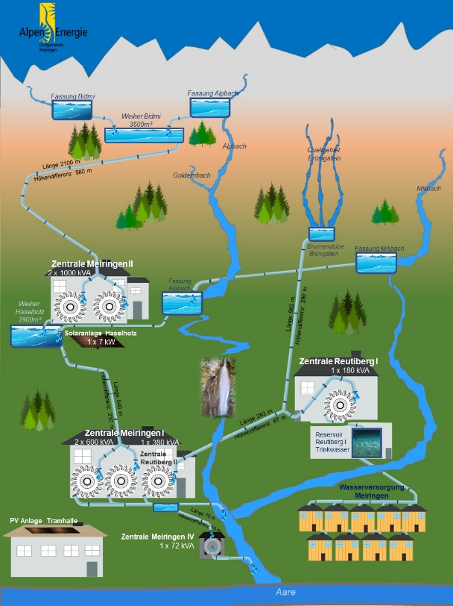
Water stored in the Bidmi reservoir is conveyed to the two turbines of the Zentrale Meiringen II power plant (2 × 1,000 kVA) via a penstock with a gross head of approximately 580 m. Following turbination, the water is collected in the Haselholz reservoir before being directed to the Zentrale Meiringen I power plant (2 × 680 kVA), where a second stage of generation takes place across a gross head of approximately 210 m.
Figure 1: Alpen Energie's energy production network [41]
The distribution network operates at 16 kV medium voltage and serves 3,800 inhabitants across a total cable and line length of approximately 154 km, with a network peak demand of 3.5 MW. Annual local generation of 20 GWh exceeds consumption of 14 GWh.
Local rooftop photovoltaic generation plays a significant role in the local network and is assumed to be fully self-consumed at the point of production. It is treated as a negative load component within the net consumption figure rather than modelled as a separate generation asset.

3.3 The Swiss Electricity Market
The Swiss electricity system is organised across several voltage levels. At the lowest level, local utilities such as AlpenEnergie operate low-voltage distribution networks serving end consumers directly. These local networks feed into regional medium-voltage grids, in the case of Meiringen, the 16 kV network operated by BKW (Bernische Kraftwerke), the cantonal utility for the Bern region [41]. BKW in turn connects to the national high-voltage transmission grid (220/380 kV), operated exclusively by Swissgrid, the Swiss TSO, which is responsible for maintaining real-time balance between generation and consumption and sustaining grid frequency at 50 Hz [5]. Switzerland is synchronously interconnected with the continental European grid via ENTSO-E, meaning that frequency deviations propagate across borders [42].

3.3.1 Day-Ahead and Intraday Markets
Wholesale electricity trading operates in two stages. The Day-Ahead (DA) market is a blind auction held the evening before delivery. Producers and consumers submit bids to buy or sell electricity for each 15-minute block. The clearing price is set by the most expensive generator needed to meet total demand, known as the marginal unit. This makes the DA price a forward-looking signal that reflects the collective forecast of supply and demand for the next day. Once DA positions are fixed, participants may adjust their commitments on the Intraday (ID) market, which operates continuously on the day of delivery itself, allowing real-time corrections of imbalances. Because Switzerland has not yet concluded an electricity agreement with the EU, Swiss participants access European intraday platforms under restricted conditions, limiting the liquidity available to correct late imbalances [9].
The ID price reflects the actual balance between supply and demand at each moment and can diverge substantially from the DA clearing price when unexpected generation shortfalls or surpluses materialise. For AlpenEnergie, this gap is the direct financial expression of forecast error: any deviation between the committed day-ahead schedule and actual net output must be purchased or sold at the prevailing ID price, which is structurally less favourable for the party in imbalance.

3.3.2 Imbalance Settlement - AusgleichsEnergie (AE)
In Switzerland, any actor participating in the electricity market must belong to a balance group and submit day-ahead schedules to Swissgrid. Electricity generation and consumption rarely match planned schedules exactly — these deviations are measured for each balance group at 15-minute resolution and financially settled with Swissgrid through a mechanism called imbalance energy, known in German as Ausgleichsenergie (AE) [43].
A balance group is called long when it has produced or injected more energy than scheduled, and short when it has consumed more than planned. Each 15-minute period is settled independently, and the direction of the imbalance determines which price applies.
Throughout the 2025 analysis period, Switzerland operated under a two-price settlement system. The AE price for a given period is derived from three components: the day-ahead spot price (Pspot), the weighted average price of activated secondary control energy, aFRR (Psek), and the weighted average price of activated tertiary control energy, mFRR (Pter) [44]. The resulting price directly reflects the real-time cost of maintaining grid balance and can diverge significantly from day-ahead prices, including turning strongly negative during periods of excess renewable generation. Crucially, under this two-price framework, a balance group is penalised for any deviation from its schedule, even when that deviation actively helps reduce Switzerland's overall grid imbalance.
As of 1 January 2026, Swissgrid replaced this mechanism with a single-price system designed to incentivise balance groups to contribute to grid stabilisation: a group whose imbalance corrects the system direction is now rewarded rather than penalised [9]. This structural shift falls outside the 2025 analysis window of this thesis but represents a meaningful change in the cost landscape that future iterations of the dispatch model should account for.

3.3.3 Reserve Markets — SRL and TRL
When imbalances persist beyond what the AE market can correct, Swissgrid activates reserve energy. Secondary reserve (Sekundärregelleistung, SRL) is the first automated response layer, activated within seconds via a continuous control signal to registered providers, primarily large hydropower plants, and sustained for up to 15 minutes. Tertiary reserve (Tertiärregelleistung, TRL) is the slower, manually dispatched layer that relieves the SRL once a sustained deviation is confirmed, with a typical response time of 15 minutes. Both products are procured through competitive weekly auctions, with providers receiving a capacity payment for availability and an energy payment upon activation. The Swiss reserve market currently operates in isolation from European balancing platforms, which limits liquidity and concentrates supply among a small number of large hydro providers. Integration with European platforms remains a stated objective of Swissgrid's Balancing Roadmap published in February 2026 [9].

3.4 Problem Statement
AlpenEnergie must submit its generation and consumption schedule to the day-ahead market one day in advance. Every deviation between the submitted commitment and the real-time outcome is financially settled ex-post by Swissgrid through the AusgleichsEnergie mechanism described in Section 3.3.2. Under the two-price system in force during 2025, this settlement penalises deviations regardless of their direction, making forecast accuracy the primary lever for cost reduction. To minimise these costs, the forecast submitted 24 hours in advance must be as close as possible to actual net consumption.
Net consumption is the aggregate load of all consumers minus local rooftop photovoltaic production, a fluctuating quantity of energy drawn from the grid that depends on factors including temperature, day of the week, and season. The penetration of rooftop solar adds weather-dependent variability through irradiance, cloud cover, and snow cover.
The first and most critical step in the overall optimisation chain is to understand the consumption load patterns and to develop a forecasting tool. A better forecast directly translates into a lower imbalance bill. This work also evaluates whether an alternative dispatch strategy, or the addition of a battery, can further reduce these costs beyond what improved forecasting alone can achieve.

4 Forecasting Model
Accurate net load forecasting is the first and most direct lever for reducing imbalance costs. Classical statistical approaches such as ARIMA are well understood but limited to linear relationships and struggle to generalise across the complex, nonlinear patterns that characterise small distribution networks [10]. Machine learning methods offer greater flexibility, but it is deep learning architectures, and hybrid combinations in particular, that have consistently demonstrated superior performance on short-term load forecasting tasks across a wide range of network types and resolutions [12], [14]. A neural network approach is therefore adopted here, chosen for its ability to simultaneously learn temporal patterns, respond to meteorological inputs, and generalise across the full seasonal cycle from a single unified model.

4.1 Model Architecture
The forecasting model produces a 48-hour prediction of net load at 5-minute resolution, chosen to match the native resolution of AlpenEnergie's SCADA system. Data are interpolated to and from 15-minute resolution where required for market submission. A variant of the model, identical in architecture, extends the prediction horizon to 96 hours and runs each Friday to ensure full weekend coverage.
The model follows an encoder–decoder architecture. The encoder processes a seven-day historical window and compresses it into a compact representation of the current consumption regime. The decoder combines this representation with three conditioning inputs: a context vector, a seasonality-aware reference profile, and an estimated PV generation curve to produce the full 576-step output sequence. The complete architecture is illustrated in Figure 2.
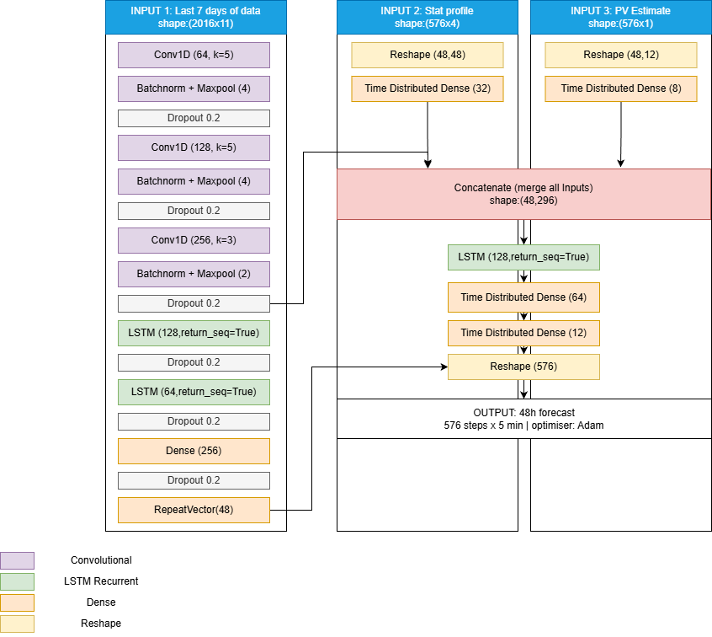
Figure 2: CNN-LSTM forecasting model architecture design

4.1.1 Encoder — CNN Feature Extraction
The encoder receives a 7-day historical window of 11 features at 5-minute resolution, representing 2,016 timesteps per input sample. The first stage of the encoder is a Convolutional Neural Network (CNN), which scans this sequence with learned filters to identify recurring temporal shapes: the morning demand ramp, the midday dip associated with solar generation, and the evening consumption peak. Rather than processing the full sequence at once, three successive Conv1D blocks with max-pooling progressively compress the 2,016-timestep input to 63 timesteps, reducing computational load while constructing a feature hierarchy in which each subsequent layer captures patterns at a coarser temporal scale. The resulting compact representation retains the dominant structural information of the week while discarding high-frequency noise, providing a cleaner and more informative signal to the subsequent sequence model.

4.1.2 Encoder — LSTM Sequence Modelling
The compressed CNN output is passed to two stacked Long Short-Term Memory (LSTM) layers of 128 and 64 units respectively. LSTMs are a specialised recurrent architecture designed to capture temporal dependencies across variable timescales through a gated memory cell, illustrated in Figure 3. Three gates govern the cell state at each timestep: the forget gate discards past states that are no longer relevant, the input gate integrates new information from the CNN feature sequence, and the output gate exposes a condensed hidden state to the next layer. In the proposed model, the input $x_{t}$at each timestep corresponds to the output of the CNN feature extractor rather than raw observations. This structure allows the network to learn dependencies spanning multiple days, for instance, that Tuesday consumption systematically exceeds Monday levels, or that a temperature drop in March shifts the heating peak earlier in the morning, without suffering from the vanishing gradient problem that limits standard recurrent networks. The final hidden state $h_{T}$of the second LSTM layer constitutes the context vector encoding the recent consumption regime, which is passed to the decoder.
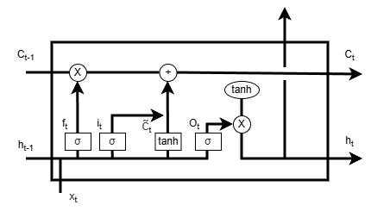
Figure 3: LSTM cell architecture [43] . f_t: forget gate, i_t: input gate, c̃_t: cell candidate, o_t: output gate, C_t: cell state, h_t: hidden state. In the proposed model, x_t corresponds to the output of the CNN feature extractor rather than raw input.

4.1.3 Decoder, Similar-Day Conditioning, and Attention Mechanism
The decoder combines three conditioning signals to produce the final forecast. The first is the encoder context vector $h_{T}$, projected through a Dense layer and repeated across the 48-hour output horizon via a RepeatVector block, providing the decoder with a summary of the current consumption regime at each output timestep. The second is a seasonality-aware reference profile, described below. The third is an estimated PV generation curve for the forecast horizon, described in Section 4.1.4. These three signals are concatenated and passed through a TimeDistributed Dense layer that independently predicts each of the 576 five-minute output steps.
Similar-day reference profile. Preliminary evaluation revealed that the baseline model failed to track seasonal transitions: forecast quality degraded progressively as the model operated further from the training period, indicating that the encoder context vector alone was insufficient to anchor the prediction to the correct seasonal demand regime. To address this, a seasonality conditioning signal is introduced in parallel to the main input sequence, inspired by Kim et al. [45], who demonstrate that supplying a CNN-LSTM with load profiles from historically similar days yields a measurable accuracy gain over standard sequential input. In the proposed implementation, a statistical load profile is derived from the most recent matching weekdays and merged at the decoder stage, anchoring the forecast to recent observed behaviour without requiring a full Mahalanobis-distance similar-day search at inference time.
Attention-weighted profile selection. The uniform averaging approach described above carries an implicit limitation: all reference days contribute equally to the profile regardless of how representative they are of current conditions. A holiday week two weeks prior, or a period affected by an exceptional weather event, is weighted identically to a normal working week from the previous day. This equal-weight assumption ignores the informational hierarchy across historical observations, in which recency and contextual similarity are not interchangeable.
To address this, a scaled dot-product attention mechanism [46] replaces the fixed uniform average. The attention layer receives two inputs: the compressed encoder representation of the past seven days, and a set of candidate same-weekday profiles. For each candidate, a similarity score is computed against the current context, normalised across all candidates into a weight distribution that sums to one, and used to produce a single reference profile as their weighted combination. A candidate week whose consumption pattern closely matches the current context receives a high weight; an atypical week caused by a holiday, an outage, or an unusual weather event is automatically down weighted. The result is a context-aware reference profile that adapts to current operational conditions rather than treating all past weeks as equally informative. Lim et al. [47] confirm that attention applied to historical same-day profiles produces interpretable patterns aligned with daily and weekly periodicities and outperforms fixed-window averaging across multiple consumption datasets. Wan et al. [48] report a 5.7–7.3% MAPE improvement over a non-attention CNN-LSTM baseline when an attention layer is introduced on the encoder outputs, the same architecture family used in this work.

4.1.4 PV Generation Sub-model
Net load at the grid connection point is defined as gross consumption minus behind-the-meter PV output. Although rooftop PV generation data could in principle be retrieved from individual sub-meters, this process is not yet automated at AlpenEnergie, making it impractical as a real-time model input for operational forecasting. An independent PV generation estimate for the forecast horizon is therefore computed separately and injected into the decoder as the third conditioning signal.
Two estimation approaches were developed and compared. The first follows the physical modelling methodology of Lorenz et al. [49], deriving a theoretical PV production potential from the Open-Meteo irradiance forecast through an empirical scaling factor calibrated on two years of historical net load observations. This approach does not attempt to predict the actual PV output directly; rather, it provides the decoder with an estimate of the maximum producible generation under the forecast irradiance conditions, leaving the residual correction to the network itself. The second approach is a dedicated neural network trained on historical PV production data, with irradiance, temperature, and calendar features as inputs, which learns to predict the actual PV offset directly from past observations. Both produce a 576-step generation estimate covering the full 48-hour forecast horizon. The two strategies differ fundamentally in their objective: the first characterises the physical production potential, while the second approximates the real injected output. Their comparative performance is evaluated in Section 7.1.

A graph like this ??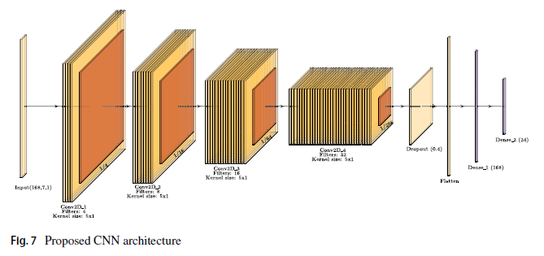

4.2 Input Features
The model takes eleven input features drawn from three data sources, as summarised in Table 1.

Table 1: Input features of the CNN-LSTM forecasting model.
Feature | Type | Source
Load_Is | Target — past values | SCADA
Load_yesterday | Target lagged by 24 h | SCADA
Load_last_week | Target lagged by 7 d | SCADA
Hour_Sin / Hour_Cos | Cyclical time encoding | Computed
Weekday_Sin / Weekday_Cos | Cyclical day encoding | Computed
PHoliday | Binary public holiday flag | Calendar
Temp_forecast | Temperature forecast | Open-Meteo API
Rain_Forecast | Precipitation forecast | Open-Meteo API
Irr_FC | Solar irradiance forecast | Open-Meteo API

The three lagged load features provide the model with direct access to the most relevant historical patterns. Time is encoded as sine-cosine pairs rather than raw integers to preserve its cyclical continuity: hour 23 and hour 0 are adjacent, not opposite ends of the scale. The public holiday flag allows the model to distinguish days with atypical consumption profiles that would otherwise be forecasted as standard working days. Meteorological inputs are obtained daily from the Open-Meteo API and cover the full 48-hour forecast horizon.
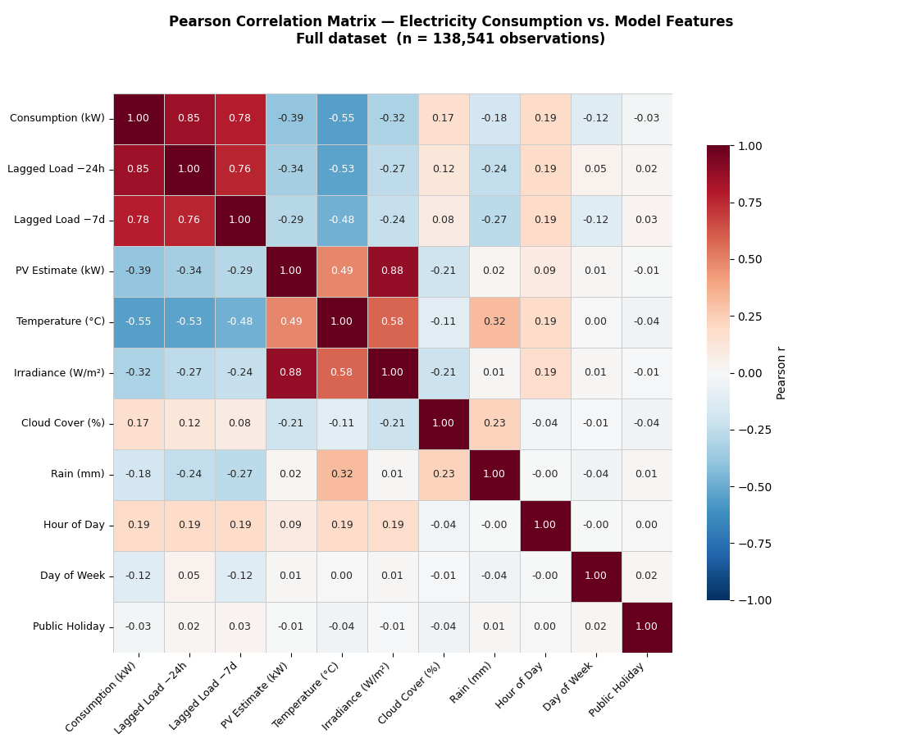
Figure 4: Pearson Correlation Matric Between Input Features and Net Consumption
To guide feature selection, Pearson correlation coefficients between all candidate features and the net consumption target were computed across the full dataset (n = 138,541 observations), as shown in Figure 4. The seasonal breakdown is provided in Appendix A2.
The two lagged load features are the strongest predictors. The 24-hour lag (r = 0.85) captures the dominant daily periodicity of consumption, while the 7-day lag (r = 0.78) contributes complementary weekly-cycle information. Both are retained despite their mutual correlation (r = 0.76), as they encode distinct temporal structures, recent demand state versus day-type patterns.
Temperature is the strongest meteorological predictor (r = −0.55), reflecting the heating-dominated character of the Meiringen network. The seasonal breakdown in Appendix A2 reveals that this relationship is highly regime-dependent, strongly negative in autumn and spring but negligible in summer, reinforcing the case for an architecture capable of learning season-specific feature weights implicitly.
The PV estimate enters as a negative load component (r = −0.39), consistent with its role in reducing net consumption at the grid connection point. Its near-perfect correlation with irradiance (r = 0.88) confirms the two features carry largely redundant information; irradiance is retained as the primary solar input given its availability from day-ahead numerical weather prediction forecasts [17]. The PV generation estimate itself is not an encoder input; it is computed separately by the sub-model described in Section 4.1.4 and injected at the decoder stage, where it acts as a direct offset correction to the gross consumption forecast.
Cloud cover, rain, hour of day, day of week, and public holiday all show weak linear correlations at the full-dataset level. Their limited Pearson coefficients do not preclude predictive value, nonlinear interactions are not captured by this analysis but confirm that lagged load and temperature are the primary information carriers in this network.

4.2.1 Temporal Feature Encoding
Temporal variables such as hour of day and day of week require careful encoding before being passed to a neural network. Two strategies are commonly considered. Categorical encoding represents each time value as an independent binary feature — 24 binary columns for hours, 7 for weekdays, allowing the model to learn a completely unconstrained behaviour for each slot. Cyclical encoding instead maps each variable onto a sine-cosine pair, preserving the circular continuity of time: hour 23 and hour 0 are represented as adjacent points on the unit circle rather than opposite ends of a linear scale.
Both strategies were evaluated on the AlpenEnergie network using a test set of 15 random days from 2026. Cyclical encoding produced an RMSE of 224.6 kW against 255.7 kW for categorical encoding, and a MAPE of 10.7% against 12.1%, representing improvements of 12.0% and 11.6% respectively. The full comparison is reported in Section 7.1. These results are consistent with the findings of [50] and [51], who report similar accuracy gains for cyclical encoding on short-term load forecasting tasks. Cyclical encoding is therefore adopted for all temporal features in the proposed model.

4.3 Training Strategy
The dataset is split chronologically into a training set and a held-out test set. The final ten days of the dataset are withheld exclusively for evaluation and are never seen during training. All preceding observations constitute the training set, from which 15% of samples are drawn randomly at each training run to form the validation set used for early stopping. This random validation draw, rather than a fixed recent window, ensures that the early stopping signal reflects performance across the full seasonal range rather than being dominated by the most recent consumption regime.
The model is trained without shuffling of the temporal sequence, preserving the ordering of the lookback windows. Each input sample consists of a seven-day historical window of 2,016 timesteps across 11 features. The training hyperparameters are summarised in Table 3.
Table 2: Training hyperparameters of the CNN-LSTM model.
Parameter | Value
Optimiser | Adam, lr = 0.001
Loss function | Huber
Maximum epochs | 100
Batch size | 32
Early stopping patience | 15 epochs
ReduceLROnPlateau | factor = 0.5, patience = 5
Dropout | 0.2

The Huber loss function is preferred over mean squared error because it is less sensitive to sudden consumption spikes: it behaves quadratically for small residuals but transitions to a linear penalty for large errors, preventing outliers from disproportionately influencing the learned weights. Early stopping halts training when validation loss ceases to improve for 15 consecutive epochs, and the learning rate scheduler reduces the step size by a factor of 0.5 when progress stalls over five epochs, together limiting overfitting without requiring manual tuning of the training duration.
In addition to the chronological test set, model performance was evaluated manually on 15 fixed random dates to mitigate the sensitivity of aggregate metrics to high-PV days. At 5-minute resolution, days with high solar generation produce very low net load values, which inflate percentage-based metrics such as MAPE independently of forecast quality. The 15-date set provides a more stable and seasonally balanced evaluation basis. It should be noted, however, that as additional data was incorporated during the development period, a fraction of the manual test dates may overlap with the training set, introducing a degree of optimistic bias in the corresponding results. This limitation is discussed further in Section 8.3.

4.4 Deployment Pipeline
The forecasting model has been integrated into an automated pipeline that runs daily without manual intervention. Each morning, the pipeline reads the latest consumption data from a designated folder, aligns it with the time calendar, retrieves the 48-hour meteorological forecast from the Open-Meteo API, and executes the net load forecast. The final output is a timestamped Excel file written automatically, containing the net load forecast and the hydro production estimate for the same horizon.
The hydro production estimate is produced by a separate two-stage model developed specifically for AlpenEnergie's network, where generation is dominated by two reservoir plants whose output depends primarily on snowmelt, precipitation, and reservoir levels. The first stage is a fully-connected neural network that predicts the daily average production from the previous 20 days of historical output and the current water levels of the Bidmi and Haselholz reservoirs. A separate weekend variant runs each Friday to cover the Saturday-to-Monday horizon. The second stage predicts the intraday production shape, outputting 96 normalised 15-minute slot values that are scaled by the Stage-1 daily average, capped at the physical installation maximum of 3,076 kW, and interpolated to 5-minute resolution. This two-stage decomposition reflects the physical reality of hydro dispatch: the total daily energy available is governed by hydrology and reservoir state, while the intraday profile reflects operational patterns.
This model is not formally evaluated in the present thesis and is reported here for completeness, as it forms an integral part of the operational pipeline delivered to AlpenEnergie.

4.5 Model Drift and Retraining Strategy
A frozen model trained on a fixed historical dataset will progressively misalign with current network conditions as consumption behaviour evolves, new loads connect, occupancy patterns shift, and the PV penetration of the network increases over time. In practice, forecast quality on the AlpenEnergie network was observed to degrade noticeably after approximately ten days without retraining, confirming that periodic model updates are necessary for sustained operational performance.
Several retraining strategies exist at varying levels of complexity. Full periodic retraining rebuilds the model from scratch on the updated dataset and is the most straightforward approach but computationally intensive. Online learning updates the model continuously after each new observation, this method is powerful but requires a purpose-built architecture and robust data pipelines. Drift detection triggers retraining only when a monitored performance indicator falls below a defined threshold, which is the most conservative approach in terms of compute but adds operational complexity.
For a CNN-LSTM architecture, a warm restart strategy is particularly well suited because the different components of the model drift at different rates. The convolutional layers encode low-level structural patterns, the daily load shape, peak and valley positions, that are relatively stable over time, while the LSTM and dense layers encode regime-specific behaviour that responds more quickly to changing conditions. A recommended protocol is therefore to perform a warm restart every 14 days for 10 epochs, freezing the CNN layers and updating only the LSTM and dense layers, complemented by a full-layer update every 90 days at a reduced learning rate to prevent catastrophic forgetting of long-term seasonal patterns [23], [49].

4.6 Performance Metrics
To evaluate forecast quality, three complementary error metrics are used. Their combined use is standard practice in the short-term load forecasting literature [11], [12], [20], [52].
Table 3: Error metrics used for forecast evaluation.
KPI | Formula | Advantage | Limitation
RMSE (kW) | √(1/N · Σ(ŷ−y)²) | Sensitive to peak deviations — relevant for grid safety | A single outlier can dominate the score
MAE (kW) | 1/N · Σ|ŷ−y| | Directly interpretable: off by X kW on average | Treats small and large errors equally
MAPE (%) | 100/N · Σ|ŷ−y|/|y| | Scale-independent, enables cross-study comparison | Numerically unstable near zero load

RMSE is the primary metric for this study, as it penalises large forecast errors disproportionately, a property that is particularly relevant in a grid context where peak deviations translate directly into costly intraday market purchases. MAE provides a complementary, easily interpretable measure of average performance, while MAPE enables comparison with published benchmarks from other grids and forecasting studies.

5 Optimisation Model
After establishing reliable consumption forecasts, the operational question that follows is how production assets should be dispatched to minimise electricity costs. Even a perfect demand forecast leaves open the question of when and how much to generate, since the financial outcome depends not only on forecast accuracy but also on the timing of generation relative to market prices and on the structure of cost penalties. This chapter presents the deterministic simulation framework developed to evaluate the economic sensitivity of AlpenEnergie’s operation to forecast uncertainty under the Swiss electricity market structure.

5.1 Modelling Philosophy and Scope
The framework developed in this chapter is a historical simulator rather than a deployable operational tool. It does not predict future consumption or generate probabilistic scenarios. Instead, it runs on historical data from 2025, using actual measurements as the ground truth against which different forecast qualities are evaluated. This deterministic approach allows the economic impact of forecast accuracy to be isolated cleanly, without conflating it with structural market uncertainty.
The central question the framework is designed to answer is: how sensitive are AlpenEnergie’s operational electricity costs to the quality of each forecast input? To answer this, multiple forecast scenarios with varying levels of accuracy are injected independently into the simulation. The resulting operational schedules are then settled economically using realised 2025 market prices and imbalance values. By varying one forecast category at a time while holding all others constant, the marginal economic value of improving each forecast type can be quantified transparently.
This framing differs from the classical optimisation literature, which typically asks how to schedule a plant to maximise revenue. The objective here is instead to quantify how much money is lost, or saved, depending on what is known in advance. The dispatch strategies implemented within the framework are therefore not presented as deployable solutions but as comparative methodologies that span the range from current operational practice to an analytical LP benchmark. The linear programme in particular is not a proposal for AlpenEnergie to adopt; it serves as a theoretical reference point against which the gains from improved forecasting can be measured.
Several simplifications are intentionally adopted throughout. Reserve market participation, stochastic inflow scenarios, transmission congestion, ancillary service revenues, energy procurement blocks, and fixed contractual costs are all outside the scope of the model. The final operational cost considered throughout this chapter is therefore defined as the sum of three terms: day-ahead market costs, imbalance settlement costs, and network capacity tariff charges. This decomposition directly maps onto the three cost levers that a small balance-responsible party such as AlpenEnergie can influence through its dispatch decisions and forecast quality.

5.2 Physical System Representation
The simulated hydropower system represents a simplified two-reservoir cascade corresponding to AlpenEnergie’s Bidmi–Haselholz network. The physical representation is not intended to reproduce the exact hydraulic behaviour of the real system, but to capture the operational constraints that govern day-ahead scheduling decisions and imbalance exposure. Figure 5 illustrates the simplified network used throughout the simulation.
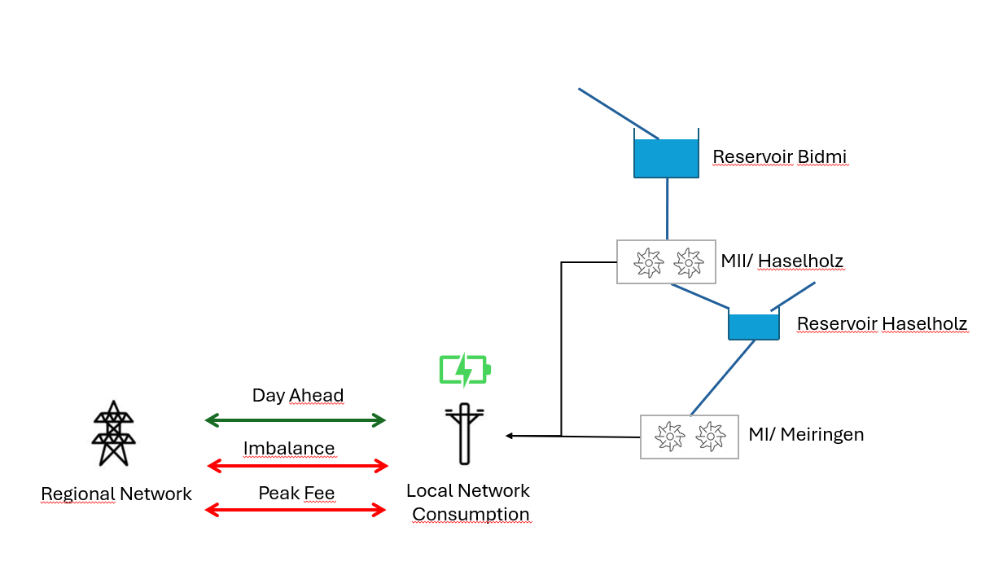
Figure 5: Network Diagram simplified [TO CHANGE]
Natural precipitation and snowmelt feed into the Bidmi reservoir. Water stored in Bidmi is conveyed through a high-head penstock to turbine M2 at Zentrale Meiringen II, which operates at a gross head of approximately 580 m. Following turbination, the discharge from M2 flows directly into the Haselholz reservoir, which also receives independent natural inflow. Water from Haselholz is then directed to turbine M1 at Zentrale Meiringen I, operating across a gross head of approximately 210 m, before being discharged into the river. This cascade structure creates a strong hydraulic coupling between the two stages: any decision to increase generation at M2 simultaneously reduces Bidmi’s storage and increases Haselholz’s inflow, constraining the downstream turbine and making the two reservoirs operationally interdependent.
The physical model adopts a linear relationship between water discharge and electrical generation, calibrated by regression on one year of SCADA measurements. The correlation between flow and power output is near-perfect for both turbines (Pearson r = 0.997), confirming that a linear representation is appropriate over the operating range observed in 2025. The resulting conversion equations are:
M1_Prod = 1.634 × M1_Flow + 24.2 [kW, l/s]
M2_Prod = 4.537 × M2_Flow + 14.0 [kW, l/s]
Hydraulic losses, nonlinear efficiency curves, evaporation, and head variation with reservoir level are neglected. Minimum turbine power is also neglected, which avoids the need for binary on/off variables and keeps the dispatch formulations as pure linear problems. Because both turbines are Pelton machines, cavitation does not impose a minimum generation threshold, making this simplification physically appropriate. The reservoir dynamics follow a discrete-time mass-balance at 5-minute resolution: the change in storage level at each timestep equals natural inflow minus turbine discharge, expressed in terms of reservoir geometry as described in Section 5.7.

5.3 Market Framework
The final electricity cost faced by AlpenEnergie combines three distinct components, each driven by a different aspect of the operational problem. Understanding their structure is essential to interpreting the sensitivity analysis that follows.

5.3.1 Day-Ahead Market
The day-ahead (DA) market is the primary planning stage, where AlpenEnergie submits a net exchange schedule for each 15-minute block of the following day, approximately 24 hours before delivery. This schedule commits the difference between expected local generation and expected local consumption. The day-ahead cost or revenue for each timestep is therefore determined by the committed net position and the DA clearing price, which is known to the operator at the time of scheduling. Because the same net load forecast is committed in all dispatch scenarios within this framework, day-ahead revenue differences across scenarios arise only from differences in the committed generation level, not from differences in the price signal.

5.3.2 Imbalance Settlement
Any deviation between the committed day-ahead schedule and actual real-time operation is financially settled ex post through the AusgleichsEnergie (AE) mechanism described in Section 3.3.2. In the simulation, imbalance costs are computed by applying the realised 2025 Swissgrid balance energy prices to the difference between scheduled and actual net exchange at each 5-minute timestep. Imbalance settlement is therefore not an active trading strategy within the framework: it is the financial consequence of forecast error and operational flexibility, applied ex post using known historical prices.
The imbalance cost is simultaneously driven by forecast accuracy, operational flexibility, and imbalance price volatility. Balance energy prices are substantially more volatile than day-ahead prices: their distribution exhibits heavy tails and frequent spikes driven by real-time system conditions that are structurally difficult to anticipate [PLACEHOLDER — Weron 2014 or equivalent imbalance-price volatility reference]. Even a relatively small forecast error can generate a disproportionate imbalance cost if it coincides with a price spike period. This asymmetry between error magnitude and financial impact is a key motivation for the sensitivity analysis carried out in Section 5.4.

5.3.3 Capacity Tariff
In addition to energy market exposure, AlpenEnergie is subject to a network capacity tariff applied by BKW, the regional grid operator. This charge is billed monthly and is determined by the single highest 15-minute average import power recorded at the grid connection point during that month, measured exclusively during the peak hours window of 07:00 to 20:00 on weekdays. The tariff rate is approximately 10 CHF per kW per month [53], meaning that a single consumption spike, even if it occurs only once and lasts only 15 minutes, sets the billing baseline for the entire month. Reducing this monthly peak by even a moderate amount therefore translates into a directly proportional reduction in the tariff charge, independent of total energy consumed.
This cost structure creates a cross-day dependency that the daily dispatch cannot ignore: once a monthly peak is established on day one, subsequent days within the same month incur no additional capacity cost unless they exceed it. The dispatch strategies described in Section 5.5 all incorporate a peak-shaving mechanism that tracks the running monthly peak and instructs the turbines to prevent import from exceeding it. Because this mechanism is active across all strategies, the capacity tariff analysis focuses on the residual peak differences that arise from different forecast qualities rather than from fundamentally different operational logics.

5.4 Operating Modes and Priority Hierarchy
AlpenEnergie’s turbines can operate under several modes, governed by a priority hierarchy illustrated in Figure 6. Reserve mode sits at the top: when AlpenEnergie registers for the SRL or TRL reserve markets, it must respond to Swissgrid’s balancing signals unconditionally, overriding all other objectives. This mode is well remunerated but operates at irregular intervals and is not amenable to deterministic simulation. It is therefore excluded from the dispatch strategies developed in this chapter, though the reservation of headroom for potential reserve activation is implicitly accounted for in the reservoir constraints.
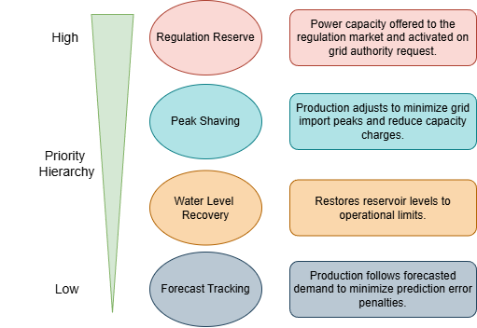
Figure 6: Operational Mode Priority Hierarchy
Below reserve mode, transfer mode manages the capacity tariff by adjusting production to prevent import peaks at the grid connection point. This objective is active in all dispatch strategies simulated and is always evaluated during the 07:00–20:00 weekday window. The primary operational mode in the simulation is forecast mode, in which turbine output is directed to match the day-ahead net load commitment as closely as possible. Finally, a water level safety programme can interrupt forecast-following if either reservoir approaches a critical threshold, briefly overriding the forecast target to protect the physical system.

5.5 Dispatch Strategies
Three dispatch strategies are implemented within the framework, spanning the range from current operational practice to a theoretical optimisation benchmark. Each strategy processes the same historical 2025 dataset and is evaluated against the same realised market prices. The differences in final cost therefore reflect the operational logic and forecast quality embedded in each strategy, not differences in the underlying market conditions.

5.5.1 Model 1 — Forecast-Following Dispatch
The forecast-following strategy introduces market awareness into the dispatch logic. The turbines are instructed to match, in aggregate, the net production target derived from the CNN-LSTM load forecast and the simulated production forecast at each 5-minute timestep. By aligning total generation with the committed day-ahead position in real time, this strategy aims to eliminate the deviation between the submitted schedule and the actual outcome and therefore minimise the intraday imbalance penalty.
In practice, the cascade architecture introduces a reservoir management constraint that a simple target-following strategy cannot resolve on its own. Because M2 discharge flows directly into the Haselholz reservoir, the split of the total production target between the two turbines must be managed carefully to prevent either reservoir from drifting toward a critical level. A rule-based state machine handles this, as illustrated in Figure 7. Under normal conditions, an analytical equalisation formula distributes the total forecast target between M1 and M2 so that both reservoirs converge toward the same normalised fill level simultaneously. If either reservoir drops below a defined safety threshold, the controller enters a protection state in which one or both turbines are reduced or stopped to allow recovery, accepting a short-term imbalance cost in exchange for protecting the physical system.
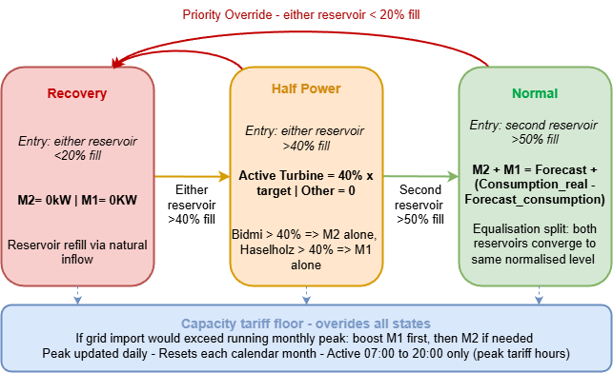
Figure 7: Rule-based state machine of the Forecast dispatch model
At every 5-minute timestep, the controller first defines a turbine target equal to the CNN-LSTM net production forecast, corrected by the real-time consumption forecast error so that the grid exchange tracks the day-ahead bid even when actual consumption drifts from the forecast. The controller then selects one of three states based on reservoir fill levels. In the NORMAL state, both turbines run with an analytical equalisation split that keeps Bidmi and Haselholz at the same normalised level while their combined output matches the target. In the HALF_POWER state, only the turbine drawing from the reservoir above the recovery threshold operates, at a reduced fraction of the target, while the other turbine idles to allow the lower reservoir to refill. In the RECOVERY state, both turbines are stopped when either reservoir drops below the minimum threshold. On top of all states, two strict physical constraints apply unconditionally: a combined ramp limit of 200 kW per 15-minute window on the M1+M2 sum, and peak-shaving during 07:00–20:00, which boosts M1 first then M2 to prevent the 15-minute average grid import from exceeding the running monthly peak. The peak-shaving override takes priority over all states, including RECOVERY.

5.5.3 Model 2 — Linear Programming Dispatch
The LP dispatch strategy replaces the rule-based state machine with a linear programme that optimises the full 24-hour dispatch in a single daily solve. Rather than tracking a target at each timestep independently, the LP weighs deviations from the forecast against the intraday price at each timestep simultaneously, choosing when to accept a small imbalance at a low-priced hour in order to preserve reservoir levels for a high-priced period later in the day. This price-aware flexibility is the key structural distinction from the forecast-following strategy, which treats all deviations as equally undesirable regardless of timing.
As noted in Section 5.1, the LP requires knowledge of the full day’s intraday prices at scheduling time, which is a perfect-foresight assumption standard in day-ahead planning benchmarks but unavailable in real operations. Its results therefore represent an upper bound on what price-aware scheduling can achieve given the current physical constraints of the system, not a deployable operational tool. The interaction between the LP and imbalance-price forecast quality is one of the sensitivity dimensions explored in Section 5.4.
[PLACEHOLDER — Full LP objective function and constraint formulation to be inserted here, including the imbalance decomposition into surplus/deficit variables, the terminal reservoir penalty structure, and the peak-shaving constraint. See Section 5.5.3 draft notes.]
Decision Variables and Imbalance Linearisation
The LP optimises the turbine outputs P_M2[t] and P_M1[t] at each 5-minute timestep t, over a horizon of N = 288 timesteps for a full day. The imbalance against the day-ahead bid cannot be directly minimised in a linear programme because it involves an absolute value. It is therefore decomposed into two non-negative auxiliary variables: δ⁺[t] representing over-production and δ⁻[t] representing under-production, linked by the equality constraint:
δ⁺[t] − δ⁻[t] = P_M2[t] + P_M1[t] − F[t] for all t
where F[t] is the CNN-LSTM net load forecast. Since both variables are penalised in the objective, the solver never assigns non-zero values to both simultaneously. As a result, their sum equals the absolute deviation at any optimal solution:
δ⁺[t] + δ⁻[t] = |P_M2[t] + P_M1[t] − F[t]|
Terminal Penalty
Left unconstrained, the LP would systematically deplete the reservoirs to minimise intraday costs on the current day, at the expense of the following days. To prevent this, any shortfall of the terminal reservoir level below a seasonally-derived target is penalised through a one-sided piecewise-linear cost function. The shortfall variables d_B and d_H are defined as:
d_B ≥ L_B* − L_B[N], d_B ≥ 0
d_H ≥ L_H* − L_H[N], d_H ≥ 0
where L_B* and L_H* are the end-of-day seasonal targets. The penalty is deliberately one-sided: exceeding the target carries no reward, since a fuller reservoir is simply carried forward into the next daily solve. The piecewise penalty slopes are defined as follows:
Table 4: Terminal penalty regarding of the shortfall from seasonal target
Zone | Shortfall range (mm) | Penalty slope
1 | 0-100 | 0 CHF/mm (free zone)
2 | 100-200 | 2 CHF/mm
3 | 200-300 | 8 CHF/mm
4 | >300 | 25 CHF/mm

The steeply increasing cost beyond the free zone creates an implicit economic value for stored water that discourages aggressive drawdown without forcing the reservoir to a fixed end-of-day level.
Objective Function
The LP minimises the total daily cost, combining the intraday imbalance penalty and the terminal reservoir shortfall:
minimise: Σ_t |p_ID[t]| · (δ⁺[t] + δ⁻[t]) · (Δt / 1000) + Σ_k c_k · (d_B,k + d_H,k)
where p_ID[t] is the intraday spot price in €/MWh, Δt = 5/60 h, and c_k are the piecewise penalty slopes from the table above. The absolute intraday price |p_ID[t]| is used deliberately: even when intraday prices turn negative, deviating from the forecast remains costly. This is consistent with the approach of M. Belsnes, who applies a similar stabilising penalty to prevent oscillatory convergence between extreme reservoir states across successive LP rounds [25]. As noted in Section 5.1, this formulation requires knowledge of the full day's intraday prices at scheduling time, which is a perfect-foresight assumption standard in day-ahead planning benchmarks.
The day-ahead revenue term is identical across all dispatch scenarios, as the same net load forecast is committed in all cases. Maximising profit therefore reduces to minimising the sum of intraday imbalance costs, peak tariff exposure, and terminal reservoir penalties, which is the form adopted here.
Capacity Tariff and Peak Shaving
The capacity tariff (Leistungsentgelt) is billed monthly at a rate of 10 €/kW, applied to the highest 15-minute average import power recorded at the grid connection point. Incorporating this into a daily LP introduces a cross-day dependency: once a monthly peak has been established, subsequent days incur no additional cost unless they exceed it.
To preserve linearity, the running monthly peak P_peak is treated as a known parameter rather than a decision variable. It is initialised to zero at the start of each calendar month, passed into each daily solve as a fixed input, and updated at the end of each day. A single scalar variable ε captures the maximum overshoot above P_peak across all 96 fifteen-minute blocks:
ε ≥ P_import_avg[b] − P_peak for all b ∈ {0, …, 95}, ε ≥ 0
The term −c_peak · ε is added to the objective. By minimising ε, the LP distributes production so that no block exceeds the running monthly peak. If an overshoot is physically unavoidable, the LP minimises its magnitude rather than failing to converge. P_peak resets to zero at the start of each new calendar month.

5.6 Physical Constraints
All dispatch strategies operate within a common set of physical constraints that reflect the operational limits of the AlpenEnergie system. These constraints are applied uniformly across the forecast-following and LP strategies, ensuring that performance differences arise from operational logic rather than from differences in the feasible space. Table 5 summarises the key constraint values.
Table 5: Physical constraints of the optimisation model.
Constraint | Value / Rule | Explanation
Bidmi reservoir bounds | 1,000 – 2,200 mm | Physical reservoir limits
Haselholz reservoir bounds | 600 – 2,800 mm | Physical reservoir limits
Ramp rate | < 200 kW per 15-min window | Both turbines combined
M2 turbine limit | ≤ 1,920 kW | Physical turbine limit
M1 turbine limit | ≤ 1,156 kW | Physical turbine limit
Water balance | Cascade coupling | Bidmi drop → M2 output → Haselholz → M1 output

5.7 Input Data and Forecast Scenario Design
The simulation relies on four categories of input data: operational measurements from AlpenEnergie’s SCADA system, electricity market prices, and multiple forecast datasets representing different accuracy levels. All inputs are aligned to a common 5-minute resolution before simulation. The year 2025 was selected as the primary analysis period because it offers the most complete and highest-quality dataset, and because it corresponds to the period for which full Swissgrid balance energy price data is available. Figure 8 illustrates the overall simulation workflow, from data ingestion through to economic evaluation.
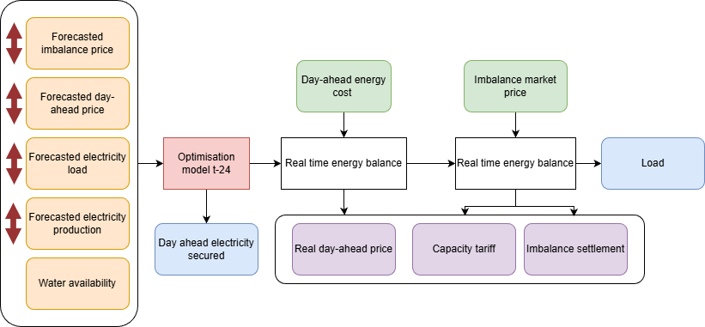
Figure 8: Optimisation workflow simulation: red arrows representing the forecast variations which will be performed

5.7.1 Flow–Power Correlation and Natural Inflow Derivation
A correlation was established between each turbine’s measured discharge flow and its power output, yielding a Pearson r of 0.997 for both M1 and M2. These linear regressions are the key physical relationships used throughout the simulation, as they enable bidirectional conversion between water flow and electrical generation. The resulting conversion equations are presented in Section 5.2. Natural inflow data are not directly measured and are therefore derived from the discrete water balance: at each 5-minute timestep, the inflow equals the measured change in reservoir level multiplied by the reservoir surface area, plus the turbine discharge. The Bidmi reservoir has a usable volume of 3,000 m³ and a surface area of 2,500 m², giving a conversion factor of 8.33 l/s per mm of level change. The equivalent factor for Haselholz is 4.39 l/s per mm.

5.7.2 Production Forecast Scenarios
Two production forecast approaches are evaluated within the framework, reflecting two fundamentally different philosophies for how day-ahead generation should be planned.
The first is a deep neural network (DeepNN) trained to replicate the historical production forecasts produced by the operator. This model was trained on the last 20 daily averages, calendar features, reservoir levels, and forecast temperature and precipitation, and operates in two stages: Stage 1 predicts the average daily production for the next day, and Stage 2 distributes this average across the 288 intraday timesteps using historical intraday patterns. Because it was calibrated on past operator behaviour, it implicitly reproduces the heuristics and seasonal practices currently used at AlpenEnergie, including the tendency to follow a seasonal production profile rather than a short-term market signal. Its performance against 2025 SCADA measurements is summarised in Table 8, with an RMSE of 115 kW, a MAE of 76 kW, and a MAPE of 5.0%.
Table 8: KPI's of the Simulated production forecast against real 2025 data.
RMSE | MAE | MAPE
115 kW | 76 kW | 5.0%

The second approach introduces an economically driven production forecast. Rather than mimicking historical operator decisions, this model estimates the production possibilities based on weather forecasts, reservoir levels, and recent historical production, and then passes this estimate to an optimisation model that constructs the intraday production pattern using the day-ahead price to reduce scheduling costs. This distinction is important: the first model reproduces what has historically been done; the second attempts to estimate what should rationally be done, given the information available 24 hours in advance. The comparison between the two within the simulation framework therefore quantifies the value of moving from heuristic to economically-informed day-ahead planning.

5.7.3 Consumption Forecast Scenarios
Four load forecast scenarios are evaluated: the CNN-LSTM model developed in Chapter 4, three degraded synthetic variants at 10%, 15%, and 20% MAPE, and a perfect-foresight reference. The CNN-LSTM model was run over the full 2025 simulation year, achieving an annual MAPE of approximately 6.5% and a simulation-year RMSE of 147 kW against a mean actual load of 1,765 kW. Eight days at the start of the year were skipped due to insufficient lookback history, leaving 357 simulated days.
Metric | Value
Days predicted | 357 / 365 (8 days skipped — first 8 Jan due to insufficient lookback)
RMSE | 147 kW
MAE | 103 kW
MAPE | 6.54 %
Mean bias (pred − actual) | −9 kW (very slight under-prediction)
Mean forecast | 1,756 kW
Mean actual | 1,765 kW

The degraded scenarios are generated using a multiplicative autoregressive noise process. Load forecasting errors are typically proportional to the load level: a 100 kW error at a 500 kW base is a far larger relative deviation than the same error at 3,000 kW. Additive noise would therefore systematically over-represent the error magnitude at low-consumption hours and under-represent it at peak hours. A multiplicative formulation, where the perturbed forecast equals the real load multiplied by a noise factor centred on one, preserves this realistic relative error structure and avoids producing negative forecast values during overnight low-load periods. The noise follows a first-order autoregressive process with an empirically estimated persistence parameter, reflecting the observed temporal correlation structure of the CNN-LSTM residuals. The noise variance for each target MAPE level is calibrated using the relationship between Gaussian standard deviation and expected absolute percentage error. This approach is consistent with established practices in forecast-value sensitivity studies [PLACEHOLDER — add reference on forecast-value methodology or stochastic load simulation].

5.7.4 Day-Ahead Price Forecast
[PLACEHOLDER — Day-ahead price forecast scenarios to be added here. The structure will follow the same R²-based variant approach as the imbalance price forecast in Section 5.7.5, with a perfect-foresight reference and a set of synthetic degraded scenarios. The day-ahead price is known to AlpenEnergie at scheduling time, so its forecast quality primarily influences the LP dispatch; the rule-based strategy does not use it explicitly.]

5.7.5 Imbalance Price Forecast Scenarios
Forecasting the balancing market price is one of the most challenging aspects of the framework. Balance energy prices reflect the real-time marginal cost of grid corrections and are driven by system conditions, activated reserve volumes, and contingency events that are structurally opaque to market participants. As shown in the analysis of Section [PLACEHOLDER — reference to correlation analysis section], even a four-week same-weekday lag explains less than 15% of variance in the Swissgrid BG-long price, confirming that simple seasonal patterns carry very limited predictive information for this market. As Weron [citation] observes in his review of electricity price forecasting, it is very unlikely that a model can predict a balancing market price with high precision: its adoption would influence the very outcome of the market, undermining the model itself.
Five imbalance price forecast variants are therefore constructed, evenly spread across the R² axis, to evaluate how incremental forecast improvements translate into operational cost reductions. These are summarised in Table X below.
Forecast Variant | Realised R² | Interpretation
REAL | 1.00 | Perfect foresight — theoretical upper bound
ROLLING_MEAN | 0.06 | Operational baseline — 7-day rolling mean, no look-ahead
R2_02 | 0.20 | Synthetic — naive statistical forecast level
R2_05 | 0.50 | Synthetic — modern ML target level
R2_08 | 0.80 | Synthetic — near-perfect, real-time state-aware forecast

The ROLLING_MEAN variant represents the current operational baseline: it is computed as the seven-day rolling mean of the realised balance energy price, shifted forward by one full day to avoid any look-ahead bias. At the start of each simulation day, the forecast uses the mean of the eight days preceding the previous day, which is the latest information that would realistically have been available at the day-ahead scheduling stage. This variant achieves an R² of only 0.06 against the realised 2025 BG prices, confirming what the literature consistently reports: that balancing prices exhibit very weak autocorrelation and are extremely difficult to predict from historical patterns alone.
The synthetic R2_02, R2_05, and R2_08 variants are constructed by blending the realised price with calibrated noise at each timestep, so that the resulting series achieves the target coefficient of determination against the actual BG price. These variants span the range from naive statistical forecasting to what would require near-perfect real-time state knowledge of the grid, providing a complete picture of the economic value that could theoretically be unlocked by progressively better imbalance price forecasting. The REAL variant applies the actual realised price directly as if the operator had perfect foresight, establishing the absolute upper bound of recoverable value from price-aware scheduling.

“It is very unlikely that a model can predict a market price with very high precision. Its likelihood and adoption would influence the very outcome of the market, which would make the same model useless. “ [Paper D23]

5.8 Sensitivity Analysis Structure
The forecast categories described in Section 5.7 are varied independently as the primary experimental structure. For each simulation run, one forecast input is modified while all others are held at their reference values, isolating the marginal economic contribution of each forecast type. The results are evaluated across three cost dimensions: day-ahead market costs, imbalance settlement costs, and capacity tariff charges. This decomposition allows the analysis to identify not only which forecast improvements reduce total cost most, but also through which cost channel the saving materialises.
Each scenario set includes a perfect-foresight reference, where the relevant forecast is replaced by the realised value, establishing the theoretical maximum achievable by improving that forecast alone. It also includes the reference operational baseline corresponding to the rule-based strategy with the DeepNN production forecast, representing the current state of operation before any forecast-driven improvement. The gap between these two anchors defines the total economic value available from forecast improvement for each cost dimension.
Beyond the independent sensitivity runs, combined scenarios integrating battery storage are evaluated in Chapter 6, where the battery interacts with the dispatch strategies developed here. The battery analysis is intentionally deferred to that chapter to preserve the clarity of the cost decomposition: Chapter 5 establishes what can be achieved through better forecasting and smarter dispatch alone, providing the baseline against which the marginal value of adding storage is measured in Chapter 6.

5.6.3 Simulated Production Forecast
To simulate the FORECAST and WATER_VALUE dispatch modes, a day-ahead production forecast is required. This data was unavailable for 2025 and was therefore replaced with simulated data generated by a feedforward deep neural network (DNN), developed for two purposes: to obtain a plausible day-ahead production prediction for 2025, and to provide a reusable production forecasting tool for future operations.
The forecast model operates in two stages. Stage 1 predicts the average power production (kW) for the next calendar day, using the last 20 daily average production values, calendar features, reservoir heights, and forecasted temperature and precipitation. Stage 2 then distributes this daily average across the 288 intraday timesteps, using 14 days of historical intraday patterns and reservoir heights as input.
The predictions intentionally contain error, as they simulate real-world day-ahead forecasting conditions. The resulting KPIs against real 2025 production data are:
Table 8: KPI's of the Simulated production forecast against real 2025 data.
RMSE | MAE | MAPE
115 kW | 76 kW | 5.0%
Day-ahead and intraday market price data were similarly incomplete. Forward fill was applied to missing price entries, as this is the most conservative and operationally realistic imputation strategy.

6 Battery Storage Analysis

6.1 Role of the Battery in This System
Within the AlpenEnergie context, a battery energy storage system (BESS) could serve two distinct functions. In intraday mode, the battery would absorb or release energy to compensate for the residual forecast error that the dispatch model cannot eliminate — reducing the magnitude of deviations that must be settled on the intraday market. In day-ahead arbitrage mode, the battery would charge during low-price overnight hours and discharge during high-price midday hours, generating revenue independently of the hydropower dispatch.
The analysis in this chapter evaluates both operating modes and determines the minimum battery size required to achieve a positive return on investment, based on the forecast error profile derived from the first two months of 2026.

6.1.1 Battery Integration in Forecast Mode

6.1.2 Battery Integration in the LP

6.2 Battery Sizes and Pricing Assumptions
[Explain battery sizing methodology based on the forecast error analysis from the Appendix. Reference the daily average amplitude of 1.45 MWh and the range 0.17 – 6.4 MWh to justify the range of sizes tested.]
[Table: battery size variants tested, with CAPEX per MWh, assumed lifetime in cycles, and annualised cost. Reference pricing papers.]

6.3 Key Performance Indicators
The following KPIs are used to evaluate each battery configuration:
- System profit (€/yr): total net revenue after CAPEX amortisation
- Return on investment (ROI): profit relative to annualised CAPEX
- Battery cycle utilisation: actual cycles per year vs. rated lifetime cycles
- Average reservoir water level
- Spilled water (MWh equivalent)
- Peak transfer power (kW)

7 Results

7.1 Forecasting Model Results
This section presents the results of the CNN-LSTM net load forecasting model in two stages. Section 7.1.1 documents the experimental comparisons that guided the final architecture choices. Section 7.1.2 reports the performance of the resulting model against external benchmarks.

7.1.1 Architecture Design Decisions
The final model configuration was determined through a series of controlled comparisons, each isolating a single architectural choice while holding all other parameters constant. The decisions are presented in the order in which they were made during development. [PLACEHOLDER- Studies cannot be compared together because they have been done at different moments with different sets of Data]
Temporal Feature Encoding
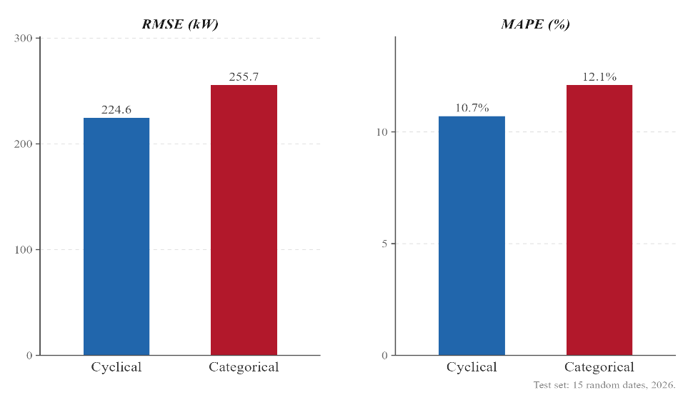
Two strategies for representing time as a model input were evaluated on an otherwise identical baseline: cyclical encoding, which maps hour of day and day of week onto sine-cosine pairs, and categorical encoding, which represents each value as an independent binary indicator. Cyclical encoding produced an RMSE of 224.6 kW against 255.7 kW for categorical encoding, and a MAPE of 10.7% against 12.1%, representing improvements of 12.0% and 1.4 percentage points respectively, as shown in Figure 7.
Figure 9: Different encoding strategy comparison (cyclical vs. categorical)

Two factors explain this gap. First, categorical encoding substantially increases input dimensionality (from a tensor of shape 2,016 × 11 to 2,016 × 39) which increases the first-layer parameter count by roughly a factor of three and raises the risk of overfitting on a dataset of limited size. Second, categorical encoding discards sub-hourly resolution: timesteps at 14:00 and 14:35 are assigned to the same hour bin, losing intra-hour information that is preserved by the continuous sinusoidal representation. Cyclical encoding is therefore both more compact and more informative at 5-minute resolution and is retained as the final temporal feature representation.
Encoder Lookback Window
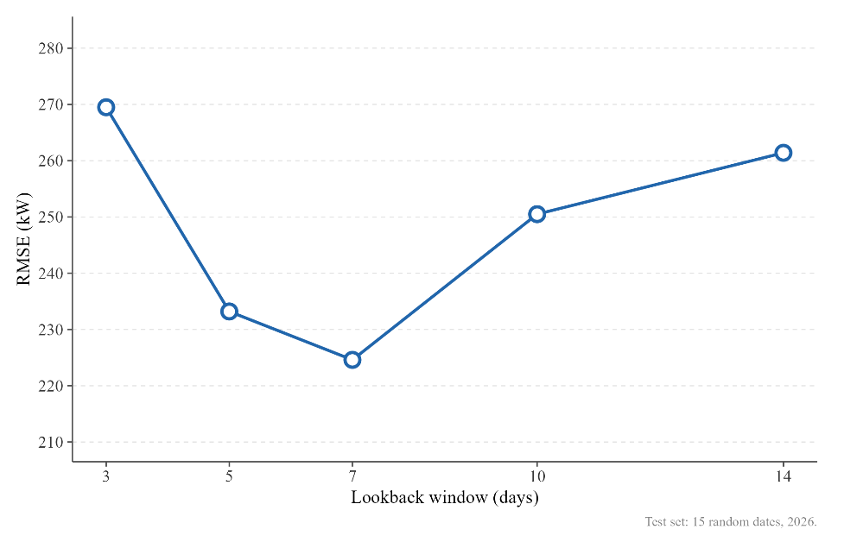
The length of the historical window fed to the CNN-LSTM encoder was evaluated across five configurations ranging from 3 to 14 days. Performance improves steadily from 3 to 7 days, indicating that the convolutional layers benefit from access to at least one full weekly cycle to identify recurring daily load shapes. Beyond 7 days, RMSE rises progressively, reaching 250.5 kW at 10 days and 261.4 kW at 14 days, as older observations introduce noise without contributing additional structural information. The 7-day window represents the optimal trade-off between temporal context and signal quality, consistent with the weekly periodicity that characterises the AlpenEnergie network and is retained for all subsequent experiments.
Figure 10: Encoder lookback window variation
Seasonal Reference Profile, Attention vs. Uniform Average
Two methods for constructing the decoder's seasonality conditioning signal were compared across three candidate pool sizes: a uniform average of the most recent matching weekdays, and a scaled dot-product attention mechanism that weights each candidate week according to its contextual similarity to the current encoder state.
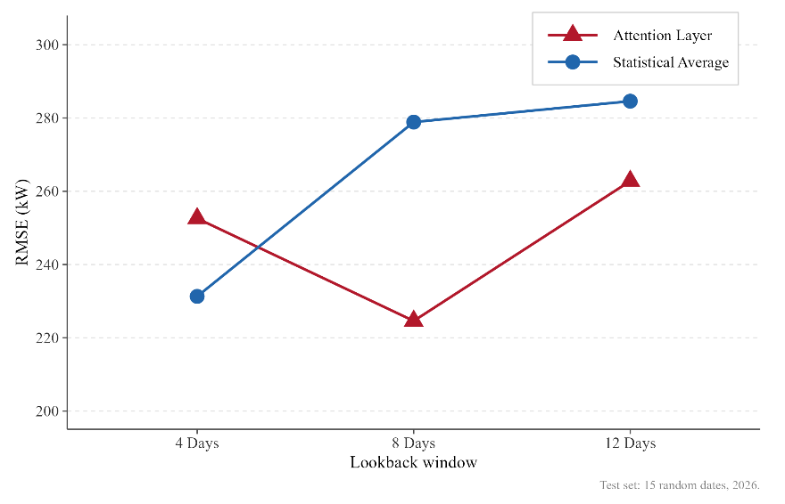
The results reveal a clear interaction between method and pool size. The uniform average performs best with the shortest pool, 4 days (RMSE = 231.3 kW), and degrades as the window extends to 8 and 12 days, as older and less representative weeks dilute the signal. The attention mechanism shows the opposite behaviour: it underperforms at 4 days, where insufficient candidate diversity limits the value of weighting, but reaches its best result at 8 days (RMSE = 224.6 kW), outperforming all other configurations. Performance then degrades again at 12 days as the candidate pool begins to include weeks from different seasonal regimes. The attention layer with an 8-day lookback is therefore selected as the final configuration, achieving a 2.9% RMSE reduction over the best uniform average baseline.
Figure 11: Comparison attention vs. uniform average of seasonal reference profile in the decoder

PV Sub-model Comparison
Two approaches for estimating the PV generation offset injected into the decoder were evaluated. The first follows the physical modelling methodology of Lorenz et al. [49], deriving a theoretical production potential from the Open-Meteo irradiance forecast through an empirical scaling factor. The second is a dedicated neural network trained directly on historical PV production data. As reported in Table 10, the Lorenz-based approach achieves a lower RMSE (78.14 kW vs. 86.70 kW) and MAPE (3.41% vs. 4.21%), but the margin is narrow and the two methods differ fundamentally in what they model, the physical potential versus the actual injected output.
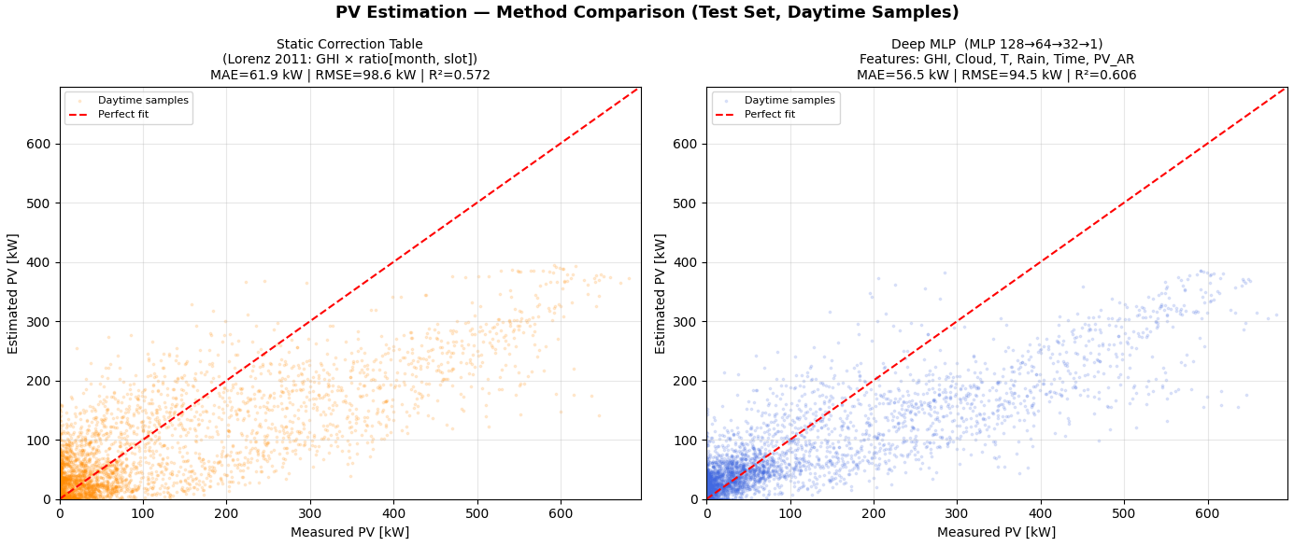
[PLACEHOLDER — Further analysis is needed: the two methods yield very similar results, and additional research is required to determine which one generalizes better under atypical weather conditions. In particular, this should include an analysis of days with strong sunshine and days with variable cloud cover.]
Hyperparameter Sensitivity
A one-factor-at-a-time sensitivity analysis was conducted to assess the influence of learning rate and dropout rate on forecast accuracy, evaluated on the 15-day held-out test set at the end of the dataset. Starting from the baseline configuration (LR = 0.001, Dropout = 0.2), the learning rate was first varied across three values while dropout was held constant; the best-performing learning rate was then fixed and dropout was varied.
As shown in Table 9, the baseline configuration achieved the best results across all three metrics (RMSE = 239 kW, MAE = 165 kW, MAPE = 22.3%). Reducing the learning rate to 0.0001 or 0.0005 degraded performance substantially, RMSE increased by 22–26%, likely because the model fails to converge within the early stopping budget at finer step sizes. Adjusting the dropout rate in either direction also worsened results, indicating that 0.2 provides the right balance between underfitting and overfitting for this dataset size. The baseline configuration is confirmed as robust within the tested parameter range.
Table 9: Hyper Parameter sensibility analysis
Config | LR | Dropout | RMSE | MAE | MAPE
Baseline | 0.001 | 0.2 | 239 | 165 | 22.3
LR-low | 0.0001 | 0.2 | 292.3 | 209.1 | 31
LR-mid | 0.0005 | 0.2 | 300.9 | 210.9 | 30.4
Best-LR + drop-low | 0.001 | 0.1 | 278.3 | 191.4 | 23.9
Best-LR + drop-high | 0.001 | 0.3 | 282.7 | 202.7 | 28.7

7.1.2 Architecture Design Decisions
The final CNN-LSTM model, incorporating cyclical temporal encoding, a 7-day encoder lookback, attention-weighted seasonal conditioning with an 8-day candidate pool, and the Lorenz-based PV sub-model, was evaluated on a sample of 15 randomly selected dates and compared against three external benchmarks: a statistical model based on the mean of the last four matching weekdays, a standalone deep neural network (DeepNN), and the forecast currently produced by an external provider.
As shown in Table 10, the CNN-LSTM achieves an RMSE of 78.14 kW and a MAPE of 3.41% on the 15-sample test set, outperforming all three benchmarks by a substantial margin. The statistical baseline, despite its simplicity, performs comparably to the external forecast in terms of MAPE (9.93% for both), but with a significantly higher RMSE (332.39 kW vs. 243.19 kW), indicating that the external model produces fewer large errors while offering no advantage on average accuracy. The standalone DeepNN underperforms all other configurations, confirming that the temporal feature extraction provided by the CNN encoder is a meaningful architectural contribution.
A 3.3 percentage point gap in MAPE is observed between the 15-sample test results and the evaluation conducted over the full 16-month training dataset, suggesting residual seasonal drift that the current warm-restart strategy has not yet fully resolved. This gap is discussed further in Section 8.3.
The current MAPE of 3.41% is competitive with published benchmarks on comparable forecasting tasks, though direct comparison is complicated by two factors specific to this study: the 48-hour prediction horizon is longer than most published benchmarks, and the model has been trained on approximately one year of data, which may be insufficient to fully capture multi-year seasonal variability.
Table 10: Comparative forecast performance, 15-sample random test on 2026 dates.
Method | RMSE (kW) | MAE (kW) | MAPE (%)
CNN-LSTM (PV_Est DeepNN) | 86.70 | 68.87 | 4.21
CNN-LSTM (PV_Est Lorentz) | 78.14 | 61.66 | 3.41
DeepNN (PV_Est DeepNN) | 229.90 | 177.98 | 10.96
Statistical (mean last 4 weeks) | 332.39 | 275.54 | 9.93
External | 243.19 | 185.80 | 9.93

7.2 Optimisation Model Results
[These are provisional results — final simulation not yet complete.]
The Water Level baseline performs worse than the reference scenario, incurring an additional cost of approximately 43,000 €/yr due to high water spillage (1,300 MWh lost) and a production MAE of 197 kW. The Forecast model recovers 87,000 € of imbalance cost, and the Water Value LP (with perfect-foresight intraday prices) recovers 94,600 € — reducing the annual imbalance cost by 51%, from −185,000 €/yr down to −91,000 €/yr.

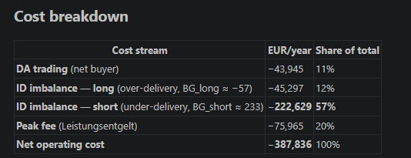

7.3 Battery Results
[These are provisional results — final battery sizing analysis not yet complete.]

7.3.1 Intraday Mode
In FORECAST mode, the battery barely activates: only 13 to 57 cycles per year for the 6 MWh unit. It generates almost no revenue, and its annualised CAPEX exceeds what it earns. The net gain decreases with every size increase — adding a 6 MWh battery reduces the net gain from 94,600 € to 79,200 €, a net loss of 15,000 €/yr compared to the no-battery case.

7.3.2 Day-Ahead Arbitrage Mode
The day-ahead arbitrage configuration runs 2,641 full cycles per year (approximately 7 per day), exhausting the battery in 4.5 years. Annualised CAPEX at this usage rate reaches approximately 933,000 €/yr for a 6 MWh unit, against a gross gain of approximately 95,000 €. This configuration destroys capital.

8 Discussion

8.1 Value of Improved Dispatch Logic
The results demonstrate that the principal source of economic value lies in the dispatch logic rather than in hardware investment. The Water Value LP reduces annual imbalance costs by 51% relative to the baseline, using the same physical assets. This finding has a direct practical implication: the priority for AlpenEnergie should be to implement the price-aware LP dispatch model before considering any capital expenditure on storage.
It is not because the quality is enhanced that the result will be more accurate. Several times when I increased the accuracy of the PV forecasting or the weather inputs the results accuracy got worse. AI models are very difficult to predict.
The choice of a 5-minute forecasting resolution, while consistent with the SCADA sampling rate, introduces a signal-to-noise challenge that deserves acknowledgment. At sub-hourly resolution and at the scale of a sub-5 MW municipal network, individual switching events — a large industrial load connecting, a heat pump cycling, a cloud passing over the rooftop PV array — produce sharp, localised spikes in net load that are structurally unpredictable from the available input features. These high-frequency fluctuations inflate point-wise error metrics such as RMSE and MAPE without necessarily reflecting a failure of the model to capture the underlying consumption regime. The 15-minute block averages used for day-ahead market commitment smooth a significant fraction of this noise, meaning that the economically relevant forecast error is systematically lower than the raw 5-minute metrics suggest. A comparison of model performance at 5-minute and 15-minute aggregation levels would be informative and is identified as a direction for future work.

8.2 Battery Viability

8.3 Limitations
The optimisation model uses perfect-foresight intraday prices, which represent an upper bound on achievable performance. Real-time ID price forecasting would reduce the LP gains. The simulated production forecast introduces an additional source of error that is not present in the pure LP benchmark. Natural inflow data are derived rather than measured, introducing uncertainty in the water balance. The model covers one year of data only; results may not generalise to drier or wetter hydrological years.
The optimisation model has been designed for simplicity and low computational cost, solving each day independently in sequence. As a result, additional constraints were necessary to ensure consistency across days and to prevent the optimiser from systematically depleting the reservoirs and the battery within each daily horizon. Furthermore, the model operates without any forward-looking vision of future intraday prices or precipitation; it has no access to price forecasts or hydrological outlooks beyond the current day. Incorporating such predictions would represent a significant improvement, enabling the model to make more informed dispatch decisions and potentially recover additional economic value over longer horizons.
- PV datas are not included in the SCADA and need a specific process so that the PV data are not always available.

8.4 Future Work
[SRL and TRL reserve market integration — assess whether AlpenEnergie can register and what remuneration would make a battery viable.]
- Implement and validate the warm-restart retraining schedule in production.
- Extend the forecasting model training dataset as further years of data become available.
- Replace perfect-foresight ID prices with a day-ahead ID price forecast to produce more realistic LP results.
- Investigate a hybrid battery operating mode combining selective intraday compensation with low-frequency DA arbitrage.
- Quantify the value of SRL/TRL market participation with a battery.
- PV prediction needs to be completely separated from load forecast

References
[1] International Energy Agency, « World Energy Investment 2024 », 2024.
[2] S. Karagiannopoulos, C. Mylonas, P. Aristidou, et G. Hug, « Active Distribution Grids Providing Voltage Support: The Swiss Case », 29 juin 2020, arXiv: arXiv:2006.16060. doi: 10.48550/arXiv.2006.16060.
[3] Tamara Grünewald, « The role of the electric grid in Switzerland’s energy future », McKinsey & Company, Power & Gas Blog, 13 mai 2021. [En ligne]. Disponible sur: https://www.mckinsey.com/industries/electric-power-and-natural-gas/our-insights/the-power-and-gas-blog/the-role-of-the-electric-grid-in-switzerlands-energy-future
[4] Swiss Federal Office of Energy, « Hydropower ». [En ligne]. Disponible sur: https://www.bfe.admin.ch/bfe/en/home/supply/renewable-energy/hydropower.html
[5] Alain Raemy, « Electricity law and regulation in Switzerland », CMS. Consulté le: 21 avril 2026. [En ligne]. Disponible sur: https://cms.law/en/int/expert-guides/cms-expert-guide-to-electricity/switzerland
[6] Swiss Federal Office of Energy, « Federal act on a secure electricity supply ». 14 mai 2025. [En ligne]. Disponible sur: https://www.bfe.admin.ch/bfe/en/home/supply/electricity-supply/federal-act-renewable-electricity-supply.html/
[7] International Energy Agency, « Switzerland 20023 Energy Policy Review ». France, septembre 2023. [En ligne]. Disponible sur: www.iea.org
[8] Elcom, « Electricty price Switzerland », Eidgenössische Elektrizitätskommission ElCom. [En ligne]. Disponible sur: https://www.strompreis.elcom.admin.ch/map?activeId=785
[9] Swissgrid, Die acht wichtigsten Punkte zum Schweizer Regelenergiemarkt. Consulté le: 21 avril 2026. [En ligne]. Disponible sur: https://www.swissgrid.ch/de/home/newsroom/blog/2026/die-acht-wichtigsten-punkte-zum-schweizer-regelenergiemarkt.html
[10] E. Demir, « Short-term electricity consumption forecasting with deep learning ».
[11] Z. Khan, T. Hussain, A. Ullah, S. Rho, M. Lee, et S. Baik, « Towards Efficient Electricity Forecasting in Residential and Commercial Buildings: A Novel Hybrid CNN with a LSTM-AE based Framework », Sensors, vol. 20, nº 5, p. 1399, mars 2020, doi: 10.3390/s20051399.
[12] S. Tsegaye, P. Sanjeevikumar, L. B. Tjernberg, et K. A. Fante, « Short‐term energy forecasting using deep neural networks: Prospects and challenges », J. Eng., vol. 2024, nº 11, p. e70022, nov. 2024, doi: 10.1049/tje2.70022.
[13] J. F. Torres, « A deep LSTM network for the Spanish electricity consumption forecasting ».
[14] J. Chung et B. Jang, « Accurate prediction of electricity consumption using a hybrid CNN-LSTM model based on multivariable data ».
[15] Y. Li, « Energy consumption forecasting with deep learning », J. Phys. Conf. Ser., vol. 2711, nº 1, p. 012012, févr. 2024, doi: 10.1088/1742-6596/2711/1/012012.
[16] J. He, Y. Li, X. Xu, et D. Wu, « Energy consumption forecasting for oil and coal in China based on hybrid deep learning », PLOS ONE, vol. 20, nº 1, p. e0313856, janv. 2025, doi: 10.1371/journal.pone.0313856.
[17] P. Bacher, H. Madsen, et H. A. Nielsen, « Online short-term solar power forecasting », Sol. Energy, vol. 83, nº 10, p. 1772‑1783, oct. 2009, doi: 10.1016/j.solener.2009.05.016.
[18] Y. Wang, N. Zhang, Q. Chen, D. S. Kirschen, P. Li, et Q. Xia, « Data-Driven Probabilistic Net Load Forecasting With High Penetration of Behind-the-Meter PV », IEEE Trans. Power Syst., vol. 33, nº 3, p. 3255‑3264, mai 2018, doi: 10.1109/TPWRS.2017.2762599.
[19] E. L. Ratnam, S. R. Weller, C. M. Kellett, et A. T. Murray, « Residential load and rooftop PV generation: an Australian distribution network dataset », Int. J. Sustain. Energy, vol. 36, nº 8, p. 787‑806, sept. 2017, doi: 10.1080/14786451.2015.1100196.
[20] H.-A. I. El-Azab, R. A. Swief, N. H. El-Amary, et H. K. Temraz, « Seasonal forecasting of the hourly electricity demand applying machine and deep learning algorithms impact analysis of different factors », Sci. Rep., vol. 15, nº 1, p. 9252, mars 2025, doi: 10.1038/s41598-025-91878-0.
[21] S. Haben, G. Giasemidis, F. Ziel, et S. Arora, « Short term load forecasting and the effect of temperature at the low voltage level », Int. J. Forecast., vol. 35, nº 4, p. 1469‑1484, oct. 2019, doi: 10.1016/j.ijforecast.2018.10.007.
[22] C. Menos-Aikateriniadis, A. Akarepis, I. Kokos, et P. S. Georgilakis, « Sub-Hourly Load Forecasting for Community-Level Flexible Appliance Management », in 2024 International Joint Conference on Neural Networks (IJCNN), Yokohama, Japan: IEEE, juin 2024, p. 1‑8. doi: 10.1109/IJCNN60899.2024.10649928.
[23] C. Li, G. Li, K. Wang, et B. Han, « A multi-energy load forecasting method based on parallel architecture CNN-GRU and transfer learning for data deficient integrated energy systems », Energy, vol. 259, p. 124967, nov. 2022, doi: 10.1016/j.energy.2022.124967.
[24] S. Haben, S. Arora, G. Giasemidis, M. Voss, et D. V. Greetham, « Review of Low Voltage Load Forecasting: Methods, Applications, and Recommendations », Appl. Energy, vol. 304, p. 117798, déc. 2021, doi: 10.1016/j.apenergy.2021.117798.
[25] M. M. Belsnes, O. Wolfgang, T. Follestad, et E. K. Aasgård, « Applying successive linear programming for stochastic short-term hydropower optimization », Electr. Power Syst. Res., vol. 130, p. 167‑180, janv. 2016, doi: 10.1016/j.epsr.2015.08.020.
[26] T. Litlabø, P. Aaslid, T. L. Riise, et D. Haugland, « Modelling overflow using mixed integer programming in short-term hydropower scheduling », Energy Syst., août 2023, doi: 10.1007/s12667-023-00602-2.
[27] R. Castro-Freibott, C. García-Castellano Gerbolés, A. García-Sánchez, et M. Ortega-Mier, « MILP and PSO approaches for solving a hydropower reservoirs intraday economic optimization problem », Cent. Eur. J. Oper. Res., vol. 33, nº 4, p. 1343‑1366, déc. 2025, doi: 10.1007/s10100-024-00934-z.
[28] O. Wolfgang, A. Haugstad, B. Mo, A. Gjelsvik, I. Wangensteen, et G. Doorman, « Hydro reservoir handling in Norway before and after deregulation », Energy, vol. 34, nº 10, p. 1642‑1651, oct. 2009, doi: 10.1016/j.energy.2009.07.025.
[29] J. S. Anagnostopoulos et D. E. Papantonis, « Optimal sizing of a run-of-river small hydropower plant », Energy Convers. Manag., vol. 48, nº 10, p. 2663‑2670, oct. 2007, doi: 10.1016/j.enconman.2007.04.016.
[30] Q. Ploussard, L. Livengood, et S. Kincic, « Modeling Gaps in Hydropower Cascading System Models: A Systematic Review of Rule-Based Formulations », 2026, arXiv. doi: 10.48550/ARXIV.2604.21062.
[31] B. Bou-Fakhreddine, S. Abou-Chakra, I. Mougharbel, A. Faye, et Y. Pollet, « Short-term hydro generation scheduling of cascade plants operating on Litani River project — Lebanon », in 2016 3rd International Conference on Renewable Energies for Developing Countries (REDEC), Zouk Mosbeh, Lebanon: IEEE, juill. 2016, p. 1‑6. doi: 10.1109/REDEC.2016.7577533.
[32] E. K. Aasgård, S.-E. Fleten, M. Kaut, K. Midthun, et G. A. Perez-Valdes, « Hydropower bidding in a multi-market setting », Energy Syst., vol. 10, nº 3, p. 543‑565, août 2019, doi: 10.1007/s12667-018-0291-y.
[33] E. K. Aasgård, H. I. Skjelbred, et F. Solbakk, « Comparing Bidding Methods for Hydropower », Energy Procedia, vol. 87, p. 181‑188, janv. 2016, doi: 10.1016/j.egypro.2015.12.349.
[34] D. Aeppli, E. Hack, et M. Held, « Aging behavior of LiFePO4-based battery cells at stack level: A Second-Life cycling study », J. Energy Storage, vol. 129, p. 117135, sept. 2025, doi: 10.1016/j.est.2025.117135.
[35] IEA, « Batteries and Secure Energy Transitions », avr. 2024.
[36] V. Viswanathan, K. Mongird, R. Franks, X. Li, et V. Sprenkle, « 2022 Grid Energy Storage Technology Cost and Performance Assessment », 2022.
[37] Lazards, « Levelised Cost of Energy analysis Version 16 ».
[38] T. H. Ortmeyer et T. Vu, « Energy Storage Peak Shaving Feasibility: Case Studies in Upstate New York », in 2021 IEEE Power & Energy Society General Meeting (PESGM), Washington, DC, USA: IEEE, juill. 2021, p. 1‑5. doi: 10.1109/PESGM46819.2021.9637895.
[39] A. Sridhar, A. G. Baskar, et J. Thakur, « Energy storage integration with run of river power plants to mitigate operational environmental constraints: Case study of Sweden », J. Energy Storage, vol. 56, p. 105899, déc. 2022, doi: 10.1016/j.est.2022.105899.
[40] « Alpen Energie », Leitbild. [En ligne]. Disponible sur: https://alpenenergie.swiss/de/Info/Dorfgemeinde#leitbild
[41] BKW, « Voltage conversion in the Meiringen region », BKW. Consulté le: 21 avril 2026. [En ligne]. Disponible sur: https://www.bkw.ch/en/voltage-conversion-in-the-meiringen-region
[42] Marie Vuillemier, « Explainer: how the Swiss electricity market works », Swissinfo. Consulté le: 21 avril 2024. [En ligne]. Disponible sur: https://www.swissinfo.ch/eng/business/explainer-how-the-swiss-electricity-market-works/47943438
[43] Swissgrid, « Balancing Roadmap ». Consulté le: 5 juin 2026. [En ligne]. Disponible sur: https://www.swissgrid.ch/en/home/operation/market/balancing-roadmap.html
[44] « Energy balancing guideline article 60 », Swissgrid, oct. 2020.
[45] Sepp Hochreiter,J ̈urgen Schmidhuber, « Long_Short-Term_Memory », Neural Comput., vol. 9, p. 1735‑1780, 1997.
[46] A. Vaswani et al., « Attention is All you Need ».
[47] B. Lim, S. Ö. Arık, N. Loeff, et T. Pfister, « Temporal Fusion Transformers for interpretable multi-horizon time series forecasting », Int. J. Forecast., vol. 37, nº 4, p. 1748‑1764, oct. 2021, doi: 10.1016/j.ijforecast.2021.03.012.
[48] A. Wan, Q. Chang, K. AL-Bukhaiti, et J. He, « Short-term power load forecasting for combined heat and power using CNN-LSTM enhanced by attention mechanism », Energy, vol. 282, p. 128274, nov. 2023, doi: 10.1016/j.energy.2023.128274.
[49] E. Lorenz, T. Scheidsteger, J. Hurka, D. Heinemann, et C. Kurz, « Regional PV power prediction for improved grid integration », 2010.
[50] T. Mahajan, G. Singh, et G. Bruns, « An Experimental Assessment of Treatments for Cyclical Data ».
[51] A. Bansal, K. Balaji, et Z. Lalani, « Temporal Encoding Strategies for Energy Time Series Prediction », 19 mars 2025, arXiv: arXiv:2503.15456. doi: 10.48550/arXiv.2503.15456.
[52] M. Qureshi, M. A. Arbab, et S. U. Rehman, « Deep learning-based forecasting of electricity consumption », Sci. Rep., vol. 14, nº 1, p. 6489, mars 2024, doi: 10.1038/s41598-024-56602-4.
[53] « Swissgrid’s tariffs for 2026 are lower, solidarised costs are increasing in line with federal requirements », Swissgrids Tarif. 2026 Are Low. Solidar. Costs Are Increasing Line Fed. Requir., mars 2025, [En ligne]. Disponible sur: https://www.swissgrid.ch/en/home/newsroom/newsfeed/20250317-01.html
[54] Olivier Tezgören, « Power Limitations at HPC Chargers », GOFAST. [En ligne]. Disponible sur: https://www.gofast.swiss/en/blog/posts/smartcharging

Appendix

A.1 Forecast Error Quantification
The goal of this appendix is to quantify the difference between what was planned to be imported or exported at the regional grid connection and the real quantity of energy actually exchanged. The hydropower production already partially compensates for forecast errors, but cannot eliminate them entirely. The analysis covers the first two months of 2026.
The net power error at each timestep is calculated as:
Net Error(t) = (Prod_actual(t) − Load_actual(t)) − (Prod_forecast(t) − Load_forecast(t))

This formula captures how well the production forecast compensates for load forecast errors. A positive net error indicates excess production relative to expectations; a negative value indicates a deficit.
The cumulative energy error over time is computed by integrating the net power error:
E_cumulative(t) = Σ Net Error(i) × Δt

where Δt is the timestep between measurements (15 minutes). This cumulative curve represents the energy that would need to be absorbed or released by a battery system to perfectly compensate for all forecast errors.
Results
Table 11: Daily forecast error amplitude statistics -January- February 2026.
Metric | Value | Interpretation
Average amplitude | 1.45 MWh | On a typical day, the battery would cycle through 1.45 MWh of energy to compensate for forecast errors
Minimum amplitude | 0.17 MWh | On the best forecasting day, only 170 kWh of storage capacity was needed
Maximum amplitude | 6.4 MWh | On the worst forecasting day, 6.4 MWh of storage capacity would be required to fully buffer all errors

A.2 Seasonal Pearson Corelation Matrix
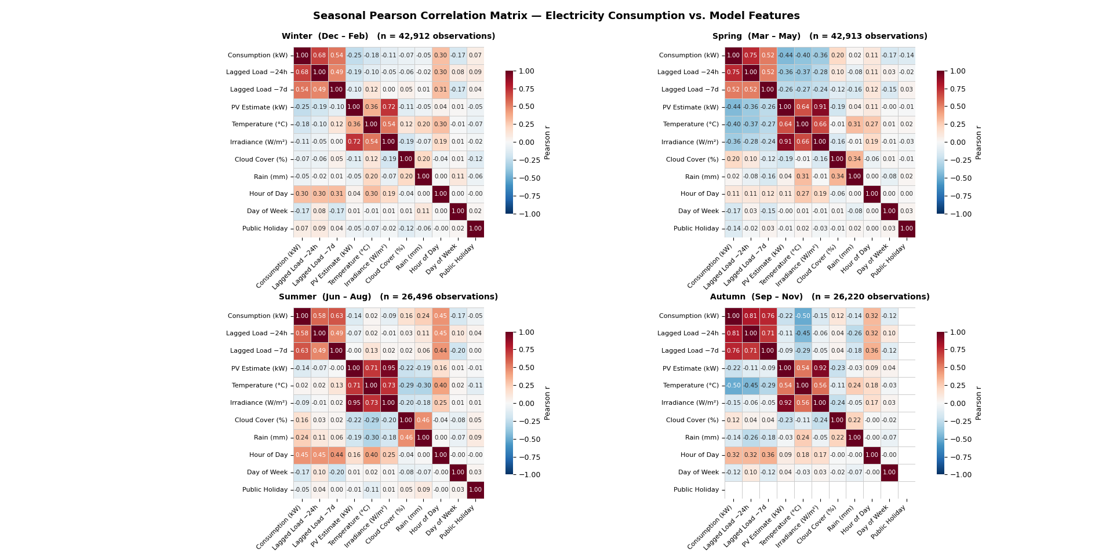
Figure 12: Seasonal Pearson Correlation Matrix - Electricity Consumption vs. Model Features

Table 12: Comparison of temporal encoding strategies.
Aspect | Cyclical (Sin/Cos) | Categorical (One-Hot)
Number of features | 2 per variable | 24 for hours — 7 for days
Continuity | Continuous | Independent
Interpretability | Low (abstract values) | High (direct mapping)
Overfitting risk | Lower (fewer parameters) | Higher (more parameters)
Training speed | Faster | Slower

Table 7: Reservoir geometry parameters used in the water balance.
 | Bidmi (M2) | Haselholz (M1)
Usable volume | 3,000 m³ | 2,900 m³
Usable depth | 1.2 m | 2.2 m
Surface area A | 2,500 m² | 1,318 m²
1 mm = X l/s | 8.33 l/s | 4.39 l/s

Industrielle Werke Basel (IWB)
IWB (Industrielle Werke Basel) is the largest energy utility in north-western Switzerland, supplying the canton of Basel-Stadt and surrounding municipalities with electricity, natural gas, district heating, drinking water, and telecommunications services. Like AlpenEnergie, IWB operates as a vertically integrated municipal utility under public law, combining network operation with generation and commercial energy activities. With a strong focus on sustainability, IWB positions itself as a leader in renewable energy integration and optimised energy efficiency in the Basel region.
In the context of this work, IWB acts as a technical partner and industry advisor. Its experience operating a large distribution network in a liberalised market environment provides valuable practical insight into the Swiss electricity market mechanisms particularly the intraday settlement rules, the capacity tariff structure, and the implications of the Swissgrid balancing reform for small balance group members. The technical exchanges with IWB have informed several modelling choices made in this work and contributed to grounding the economic analysis in operationally realistic assumptions.

 | DC–DC RTE | AC–AC RTE (inverter level) | AC–AC RTE (transformer level)
2021 | 89.55% | 86.00% | 82.59%
2030 | 91.63% | 88.00% | 84.52%
[Table caption: LFP round-trip efficiency values — DC and AC levels, 2021 vs 2030 projections. Source: PAPER C6]
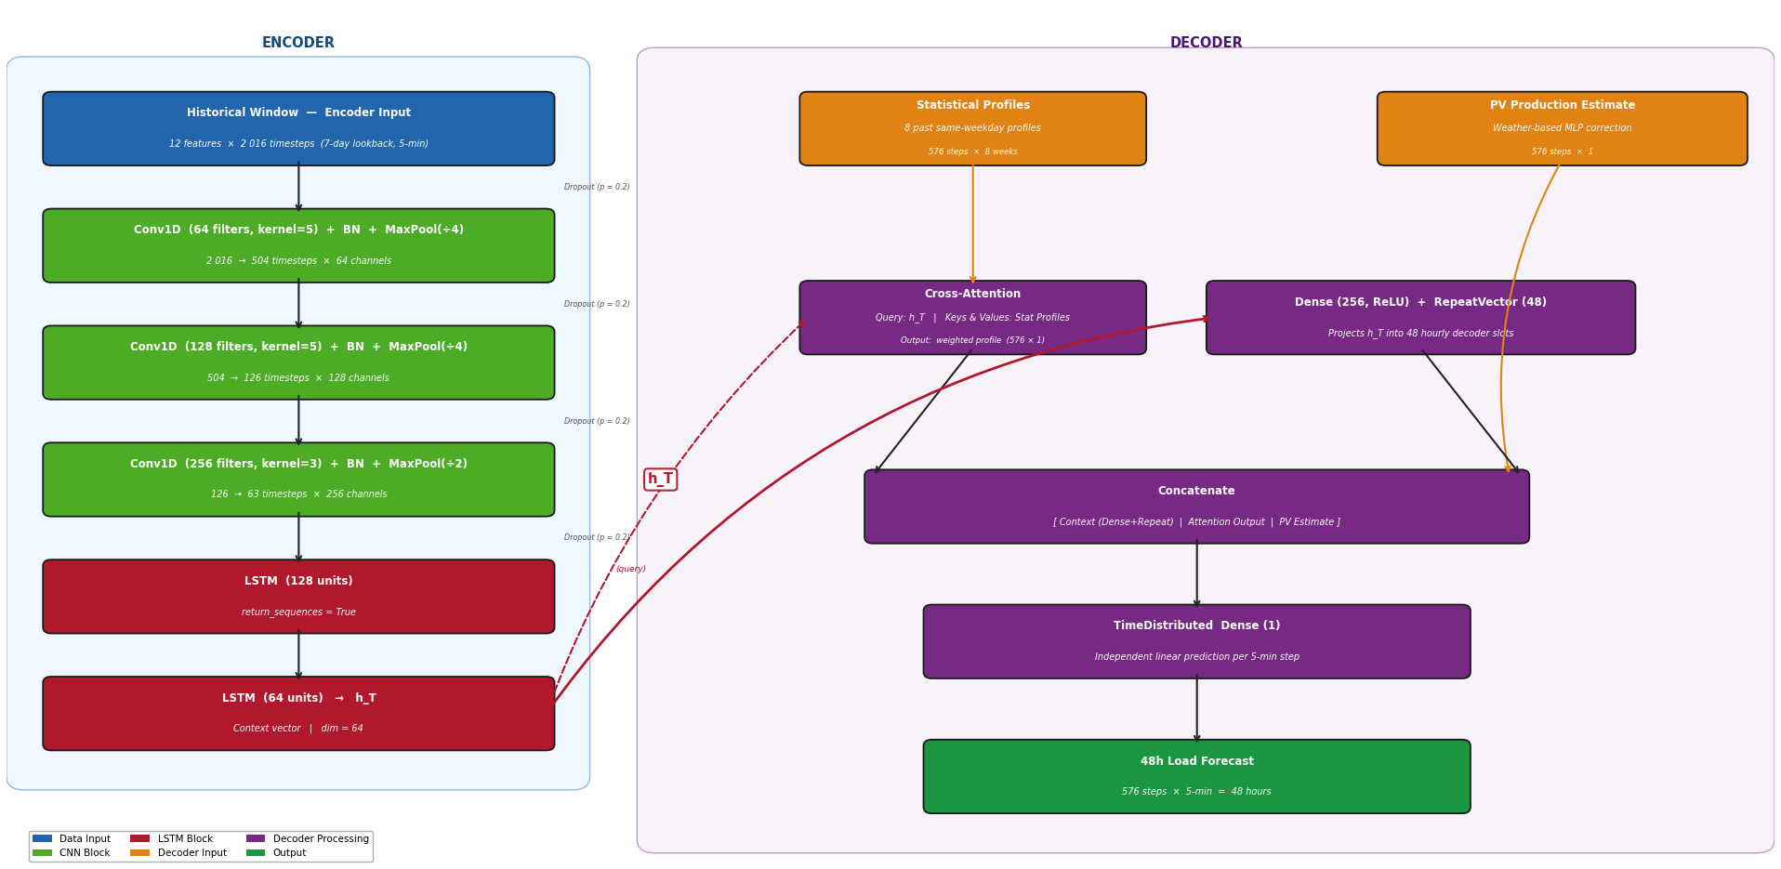

The Mantelerlass (lit. "Umbrella Decree") is the colloquial name for the Federal Act on a Secure Electricity Supply from Renewable Energy Sources, approved by Swiss voters on 9 June 2024 and in force since 1 January 2025.[6]

