

Managix – AI-Assisted Project Management And Resource Allocation Tool

Matiullah Yousfani (14747)
Huzaifa Bin Ahmed (14781)
Rana Daniyal Nisar (14735)
Syed Meesam Ali (14920)

Under the Supervision of
Muhammad Shahzad
2026

College of Computing & Information Sciences, KIET Main Campus, Karachi, Pakistan

ABSTRACT

Effective project management in modern organizations requires coordination among teams, timely task allocation, and data-driven decision-making. Traditional project management approaches often rely heavily on manual planning and oversight, which can be inefficient and prone to errors.(Diván 2017) To address these challenges, this project presents MANAGIX: An AI-Powered Project Management System, an intelligent platform designed to optimize project planning, task allocation, and employee performance monitoring while reducing manual workload.(Chinta 2021)
MANAGIX enables seamless project creation, team formation, and task and subtask management.(Jyothi and Parkavi 2016) The system incorporates AI-driven suggestions for team allocation, recommending which employees are best suited for specific tasks based on their skills, past performance, and workload. Additionally, the AI assists in budget allocation, ensuring resources are optimally distributed across projects. The backend of MANAGIX is developed using .NET Azure Functions, offering scalable and secure API-driven services, while the frontend is built with React, providing a responsive and intuitive user interface for project managers and team members.
The AI capabilities extend further into project management. For ongoing projects, MANAGIX can analyse meeting transcripts to automatically generate new tasks or subtasks, ensuring that actionable items discussed in meetings are captured and added to the project workflow. It continuously monitors employee performance, tracking metrics such as task completion rates, approval rates, and skill growth, which supports data-driven decision-making and automatic performance improvement suggestions. Furthermore, the system aggregates project data to provide insights and predictive analytics, helping managers understand team dynamics, project progress, and potential bottlenecks. (Kumar, Mohan et al. 2024)
MANAGIX integrates AI intelligently while maintaining a flexible architecture that supports future enhancements, such as advanced predictive analytics, deeper skill-based recommendations, and more comprehensive project insights. By combining AI-driven recommendations, automated task generation, and performance monitoring, MANAGIX provides a comprehensive, efficient, and future-ready project management solution that enhances productivity and decision-making within organizations. (Agunuru 2025)

ACKNOWLEDGEMENT
In the name of Allah, the most Gracious and the Most Merciful.
Peace and blessing of Allah be upon Prophet Muhammad ﷺ
First, praise of Allah, for giving us this opportunity, the strength and the patience to complete our FYP finally, after the challenges and difficulties. We would like to thank our supervisor Muhammad Shahzad for his guidance, motivation and most his significant contribution in this project, expert Sir Usman Khan for giving us the opportunity to work on this project. We would also like to thanks our parents for financial and moral support and our friends who have helped and motivated us throughout. May Allah reward them all abundantly. Ameen

DEDICATION
This report is dedicated to KIET University, our Teacher, our Supervisor, our Parents, our fellow colleagues and the hard-working students of KIET, with a hope that they will succeed in every aspect of their Academic Career and this project may help them in any aspect of their life.

Table of Contents
ABSTRACT 2
ACKNOWLEDGEMENT 3
DEDICATION 4
CHAPTER 1 7
1. Introduction 7
1.1 Motivation 7
1.2 Problem Statement 8
1.3 Objectives and Contributions 8
1.4 Project Scope 9
1.5 Organization of the Report 9
CHAPTER 2 10
2 LITERATURE REVIEW 10
2.1 Introduction 10
2.2 Literature Review: 10
2.3 Functional and Non-Functional Requirements 10
2.3.1 Functional Requirements 10
2.3.2 Non-Functional Requirements 11
2.4 Project Significance 11
2.5 Software Platform 11
2.6 Scalability 11
2.7 Services 11
CHAPTER 3 13
3 SYSTEM DESIGN AND METHODOLOGY 13
3.1 System Overview 13
3.2 Project Diagrams 14
3.3 System Design Diagrams 14
3.3.1 USE CASE DIAGRAM 14
3.3.2 ACTIVITY DIAGRAM 16
3.3.3 SEQUENCE DIAGRAM 18
3.3.4 ARCHITECTURE DIAGRAM 19
3.3.5 ER DIAGRAM 20
3.3.6 System Block Diagram 20
3.3.7 Class Diagram 21
3.3.8 Flow Chart 22
3.3.9 Swim Lane Diagram 23
3.3.10 Collaboration Diagram 23
3.3.11 Deployment Diagram 24
3.4 Technologies & Tools Used 24
REFERENCES: 25

LIST OF FIGURES

Figure | Title | Page NO
3.3.1 | USE CASE DIAGRAM | 13
3.3.2 | ACTIVITY DIAGRAM | 15
3.3.3 | SEQUENCE DIAGRAM | 17
3.3.4 | ARCHITECTURE DIAGRAM | 18
3.3.5 | ER DIAGRAM | 19

CHAPTER 1

Introduction
Efficient project management is essential for organizations to achieve goals, optimize resource allocation, and ensure timely task completion.(Ahsun and Elly 2024) Traditional project management practices often rely on manual planning, task assignment, team coordination, and performance monitoring.(Chinta 2021) These manual processes are prone to human error, time-consuming, and may not fully utilize employee potential, leading to delays, resource mismanagement, and reduced productivity.(Atkinson 1998)
To address these challenges, MANAGIX: An AI-Powered Project Management System has been developed. The system combines manual project management features with AI-assisted capabilities to optimize team formation, task allocation, budget distribution, and employee performance evaluation.(Shoushtari, Daghighi et al. 2024) In the current FYP1 version, MANAGIX primarily provides manual project management features, including user authentication with role-based access, project creation with deadlines and budgets, team creation and employee assignment, task and subtask creation, task submission with file uploads, QA review for task approvals, Kanban-based task visualization, and budget tracking. Additionally, AI-driven resume parsing is included to automatically extract skills and other relevant information from uploaded resumes, helping managers make informed hiring and team allocation decisions.(Gudipati 2025)
The future FYP2 version of MANAGIX will extend the AI capabilities to dynamically assist in project management. The AI will provide team formation suggestions, recommend which employee is suitable for a particular task, allocate project budgets optimally,(Zheng 2025) and generate new tasks from ongoing project meeting transcripts. Moreover, the system will continuously monitor employee performance metrics, such as task completion rates and approval rates, to support performance improvement suggestions. AI will also aggregate project insights and provide predictive analytics to help managers anticipate potential bottlenecks, evaluate project progress, and forecast team efficiency.(Karri 2024)
MANAGIX is developed as a web-based application, with a backend built using .NET Azure Functions for scalable, secure, and serverless API management,(Perumal 2024) and a frontend built in React, providing a responsive and user-friendly interface for project managers and employees. This architecture ensures flexibility, maintainability, and future integration of additional AI features.

Motivation
The primary motivation for developing MANAGIX stems from the inefficiencies of manual project management in modern organizational environments.(Tolvanen 2023) Traditional task allocation, performance monitoring, and team coordination require significant managerial effort and are prone to delays or mismanagement. The adoption of intelligent project management systems inspired the development of MANAGIX, aiming to enhance decision-making, reduce human workload, and improve overall project efficiency.
Interest in artificial intelligence and data-driven automation motivated the integration of AI into MANAGIX. Resume parsing was selected as the first AI feature in FYP1 to provide immediate practical benefits in team formation and skill assessment.(Gangoda, Yasantha et al. 2024) Future FYP2 enhancements will expand AI’s role to dynamic task generation, performance monitoring, and predictive project insights, offering a comprehensive solution for intelligent project management.

Problem Statement
Manual project management in most organizations faces several critical limitations:
Time-consuming task allocation and team formation: Managers spend significant time analyzing employee skills, workloads, and project requirements to assign tasks and form teams.(Juárez, Santos et al. 2021)
Limited decision support: Without AI, decisions about who should handle a task or which employee is best suited are based on intuition or incomplete data, which may not be optimal.(Buschmeyer, Hatfield et al. 2023)
Inefficient employee onboarding and skill tracking: Employees must manually enter all their details and skills, which is time-consuming and prone to missing information.(McGinty and Lylova 2020)
Limited performance insights: Monitoring task progress and employee productivity manually is slow and often reactive rather than proactive.(Dilaksha, Ranadewa et al. 2024)
AI-assisted features, such as resume parsing, address these challenges by extracting employee skills and relevant information directly from uploaded resumes, reducing manual data entry and onboarding time.(Deepa, Sindhu et al. 2025) In future enhancements (FYP2), AI will provide intelligent task and team allocation suggestions based on employee skills, availability, and performance metrics, helping managers make faster and more informed decisions while saving significant time.

Objectives and Contributions
- To provide a web-based platform for project creation, team management, task allocation, and performance tracking.(Hambali, Anisyah et al. 2024)
- To implement AI-driven resume parsing so that employees can upload their resumes (PDF/DOCX) and automatically populate their profiles, reducing manual data entry.(Säkkinen 2020)
- To provide managers with AI-assisted suggestions for team formation and task allocation, reducing decision-making time while improving efficiency.(Patil 2020)
- To offer a Kanban board and dashboard for visualizing project progress, task status, and employee workload.(Damij and Damij 2021)
- To lay the foundation for future AI features, such as task generation from meeting transcripts, performance monitoring, and predictive analytics.(Banerjee, Mitra et al. 2015)
- Development of a manual project management system covering projects, teams, tasks, and performance tracking.(Putra, Amalia et al. 2019)
- Implementation of AI-based resume parsing, allowing automatic extraction of employee details, skills, and experience from resumes.
- AI suggestions reduce decision-making time for managers by recommending suitable employees for tasks and optimal team formation.(Shah and White 2022)
- Web-based user interface with React for responsive project management and visualization.(Nalbantov, Angulo et al. 2023)
- Backend implementation with .NET Azure Functions, ensuring scalable, secure, and maintainable API services.(Manukonda 2024)
- Provides a foundation for future AI enhancements, including dynamic task generation and predictive project insights.(Bhargava, Poonia et al. 2016)

Project Scope
MANAGIX focuses on providing an integrated project management platform that combines manual management features with AI-assisted enhancements (Brlečić Valčić, Dimitrić et al. 2016; Saiyad 2024). In FYP-1, the system includes role-based user authentication for Manager, Employee, QA, and Admin, project creation with defined titles, descriptions, and deadlines, team creation and employee assignment, task assignment with submission and QA approval workflows, Kanban-based task visualization for project tracking, meeting handling with transcript generation, and AI-driven resume parsing to automatically extract employee details, skills, and experience for accurate profile creation and improved team formation. In FYP-2, the platform will be extended with advanced AI features such as intelligent team formation based on skills and availability, AI-assisted task allocation, automatic task generation from meeting transcripts, continuous performance monitoring with improvement recommendations, and predictive project analytics for better planning and risk mitigation, while maintaining a scalable, flexible, and modular system architecture.

Organization of the Report
This report is organized to present a comprehensive overview of the MANAGIX project and its development process. Chapter 1 introduces the project background, problem statement, objectives, and scope of the system. Chapter 2 reviews related work and existing project management systems to highlight research gaps. Chapter 3 describes the proposed system architecture, system modules, and overall workflow. Chapter 4 explains the implementation details, including role-based authentication, project management features, and AI-assisted components. Chapter 5 discusses system testing, results, and evaluation, while the final chapter concludes the report and outlines future enhancements planned for FYP-2.

CHAPTER 2

LITERATURE REVIEW

2.1 Introduction
This chapter reviews existing literature and systems related to project management platforms, AI-assisted task allocation, performance monitoring, and intelligent decision-support systems.(Kurniawan 2018) The purpose of this review is to analyse how modern organizations manage projects, allocate resources, and evaluate employee performance using digital tools, and to identify limitations in current approaches. The literature highlights the growing adoption of web-based project management systems and the increasing role of artificial intelligence in automating decision-making and reducing managerial workload.(Rasheed and Adebiyi 2020) By examining both traditional and AI-driven project management solutions, this chapter establishes the research gap that MANAGIX aims to address.(Yusuf and Bello 2021)

2.2 Literature Review:
Project management has evolved significantly over the past decades, with traditional tools like Microsoft Project and Jira providing structured task tracking, scheduling, and reporting functionalities. However, these systems largely rely on manual input for project planning, task allocation, and performance evaluation, which often leads to inefficiencies, delays, and errors (Brlečić Valčić, Dimitrić et al. 2016). Recent studies emphasize the integration of AI-driven solutions to enhance project management processes, such as automated task assignment, predictive analytics for risk mitigation, and performance evaluation based on objective metrics (Saiyad 2024). AI-based resume parsing and skill extraction have been explored to optimize team formation, reduce manual workload, and improve employee profiling accuracy. Combining traditional project management features with AI-assisted enhancements creates a more efficient, transparent, and collaborative environment, addressing the limitations of conventional systems and enabling organizations to make data-driven decisions while streamlining workflows. MANAGIX builds on this foundation by incorporating role-based access, automated task workflows, QA validation, and AI-driven profile management, positioning itself as a comprehensive and intelligent project management platform.

Functional and Non-Functional Requirements

Functional Requirements
- Role-based user authentication: Admin, Manager, Employee, QA.
- Admin can create, update, and delete roles.
- Admin can approve or reject new users.
- Admin can manage user profiles and remove users.
- Manager can create projects with title, description, deadline, and budget.
- Manager can create teams and assign employees to projects and tasks.
- Manager can create milestones and track project progress via dashboards and Kanban boards.
- Employee can view assigned tasks and task details.
- Employee can submit completed tasks with files and comments.
- Employee can update personal profile and upload resumes for AI-based parsing.
- QA can review submitted tasks, approve or reject them, and provide feedback.
- System generates meeting transcripts.
- AI-assisted resume parsing for automatic extraction of employee skills, experience, and profile updates.

Non-Functional Requirements
- Secure JWT-based authentication and role-based access control.
- Scalable and modular architecture for future AI feature integration.
- Responsive and user-friendly interface for all roles.
- Optimized performance to handle multiple concurrent users and projects.
- Data integrity and accuracy for task tracking and AI-parsed employee profiles.
- Reliable, maintainable, and compatible with modern web browsers.

Project Significance
The MANAGIX project is significant because it addresses the limitations of traditional project management systems by combining automation, AI-assisted features, and role-based workflows. It enhances organizational efficiency by streamlining project creation, task assignment, team formation, and progress tracking, reducing delays and manual errors. AI-driven resume parsing and performance evaluation provide accurate employee profiling and objective productivity insights, enabling managers to make informed decisions. By integrating quality assurance workflows, real-time project visibility, and intelligent task management, MANAGIX fosters transparency, collaboration, and accountability across all roles, ultimately improving overall project success and organizational productivity.

Software Platform
Web Application

Scalability
The MANAGIX system is designed to be highly scalable, ensuring it can handle increasing numbers of users, projects, teams, and tasks without performance degradation. Its modular architecture allows the seamless addition of new features, including advanced AI functionalities, without requiring major system redesigns. The backend and database are optimized to support concurrent access by multiple roles, while the frontend is built to maintain responsive performance as the number of tasks, projects, and team members grows. This scalability ensures that MANAGIX can be effectively used by small teams as well as large organizations, making it a long-term, flexible solution for project management.

Services
The MANAGIX project offers a range of services to streamline project management and enhance organizational efficiency:
- User Management Service: Handles registration, role-based authentication, profile updates, and admin approval or rejection of users.
- Project Management Service: Enables managers to create, update, view, and close projects, including defining project details, deadlines, and budgets.
- Team Management Service: Supports creation of teams, assignment and removal of employees, and linking teams to specific projects for structured collaboration.
- Task Management Service: Allows managers to create, assign, update, and delete tasks; employees can view and submit tasks, while tasks are visually tracked on a Kanban board.
- Milestone and Progress Tracking Service: Divides projects into milestones, tracks completion status, updates progress, and generates project dashboards for overview.
- QA and Approval Service: Manages task submission, review, approval, or rejection by QA with feedback to ensure quality control.
- AI Resume Parsing Service: Automatically extracts employee details, skills, and experience from uploaded resumes to update profiles and assist in team formation.
- Performance Evaluation Service: Monitors and calculates employee performance based on task completion and approvals, providing actionable insights to managers.
- Meeting and Transcript Service: Captures meeting details and generates transcripts that can later be used for task generation or project tracking.

CHAPTER 3

SYSTEM DESIGN AND METHODOLOGY

System Overview
MANAGIX is a web-based Project Resource Allocation and Management Tool designed to support organizations in planning, executing, and monitoring projects more effectively. The proposed system focuses on reducing the limitations of traditional manual project management approaches by providing a centralized platform that integrates structured project management workflows with intelligent, AI-assisted support. (Sravanthi, Sobti et al. 2023)
In its current implementation (FYP1), MANAGIX primarily delivers core project management functionalities that allow managers and employees to collaborate efficiently. The system includes secure user authentication with role-based access control, ensuring that managers, quality assurance (QA) staff, and employees can access features relevant to their responsibilities.(Olanrewaju, Khan et al. 2021) Project managers can create projects by defining objectives, deadlines, and budgets, and form teams by assigning employees based on project requirements. Tasks can be created and linked to projects, enabling clear task ownership and progress tracking. (Yoshimura, Kurumadani et al. 2025)
To enhance task monitoring and transparency, MANAGIX provides a Kanban-based task visualization system that allows users to view task status transitions such as pending, in progress, submitted, and approved. Employees can submit completed tasks along with relevant files, which are then reviewed by QA personnel for approval.(Damij and Damij 2021) Budget tracking features allow managers to monitor project expenditures and maintain financial control throughout the project lifecycle. (Dare, Ajayi et al. 2022)
A key intelligent component introduced in the current version is AI-driven resume parsing. When resumes are uploaded, the system automatically extracts skills and relevant professional information, helping managers make informed decisions during employee selection and team formation. This feature reduces manual effort and improves accuracy in identifying suitable candidates for project roles. (Deepa, Sindhu et al. 2025)
In the FYP-1 phase, MANAGIX also supports project meetings with automatic transcript generation. Meetings can be conducted within the system, and spoken discussions are converted into text using speech-to-text technology. These transcripts help team members review decisions, understand requirements, and avoid miscommunication. This feature also prepares the system for future AI-based task extraction and analysis.
The future extension of MANAGIX (FYP2) aims to enhance the system with advanced AI capabilities. These include intelligent team formation recommendations, automated task-to-employee matching, optimized budget allocation, and task generation from project meeting transcripts. Additionally, the system will analyse employee performance metrics such as task completion rates and approval trends to provide performance insights and improvement suggestions. Predictive analytics will further assist managers in identifying potential risks, bottlenecks, and efficiency issues before they impact project outcomes.
Overall, MANAGIX offers a scalable and flexible solution built using .NET Azure Functions for backend services and React for the frontend, ensuring maintainability, responsiveness, and future expansion toward fully AI-assisted project management. (Rahman 2025)

Project Diagrams
In this chapter, we give diagrams that show how our project or system may achieve the intended results as specified in the earlier mentioned literature review and project scope.

System Design Diagrams

USE CASE DIAGRAM
ADMIN EMPLOYEE
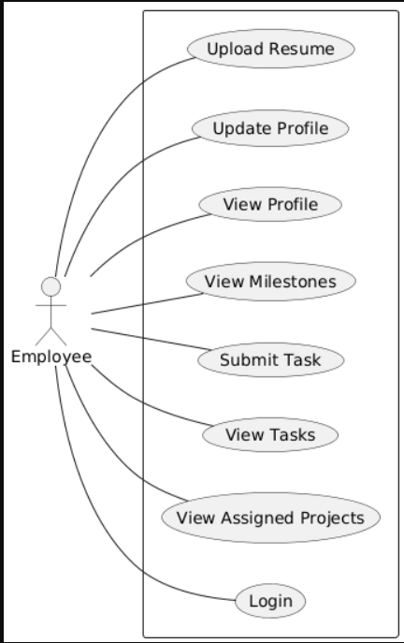
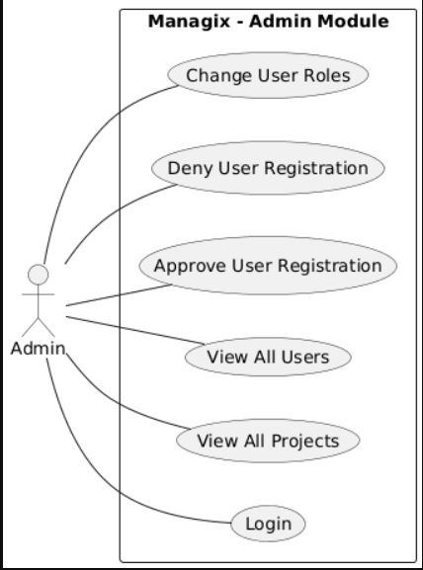
Figure 3.2.1Admin Use case Diagram | Figure 3.2.2Employee Use case Diagram

MANAGER QA
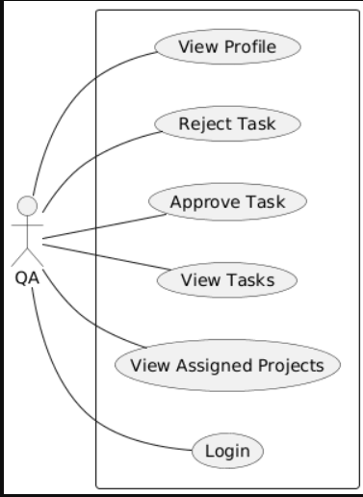
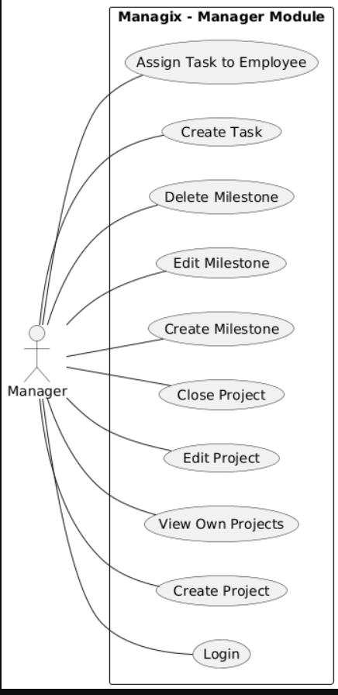
Figure 3.2.3Manager Use case Diagram | Figure 3.2.4QA Use case Diagram

ACTIVITY DIAGRAM
ADMIN EMPLOYEE
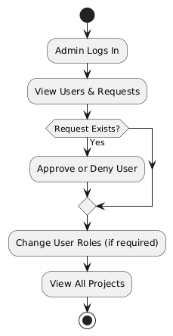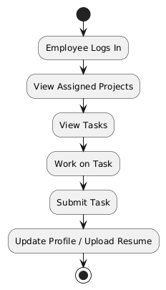
Figure 3.2.5 Admin Activity Diagram | Figure 3.2.6Employee Activity Diagram

MANAGER QA
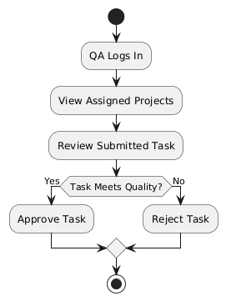
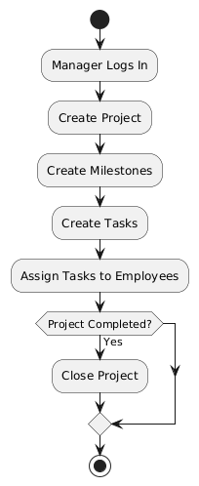
Figure 3.2.7Manager Activity Diagram | Figure 3.2.8QA Activity Diagram

SEQUENCE DIAGRAM
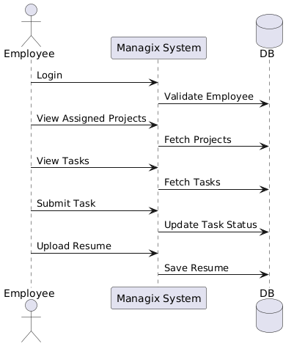
ADMIN EMPLOYEE
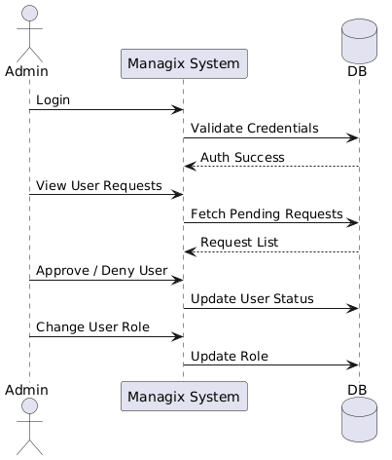
Figure 3.2.9Admin Sequence diagram | Figure 3.2.10Employee Sequence diagram

MANAGER QA
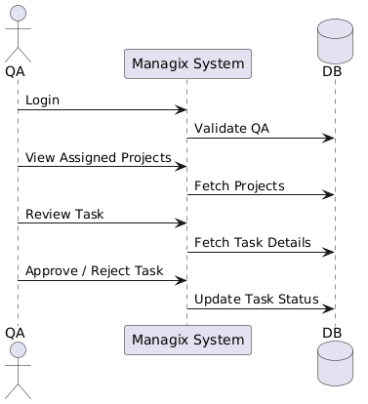
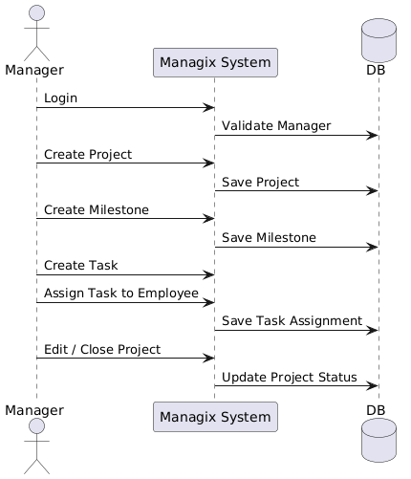
Figure 3.2.11Manager Sequence diagram | Figure 3.2.12QA Sequence Diagram

ARCHITECTURE DIAGRAM
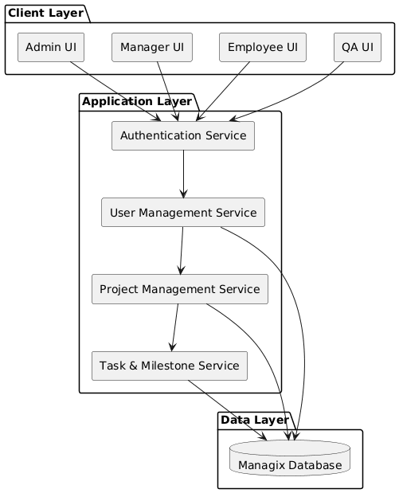

ER DIAGRAM
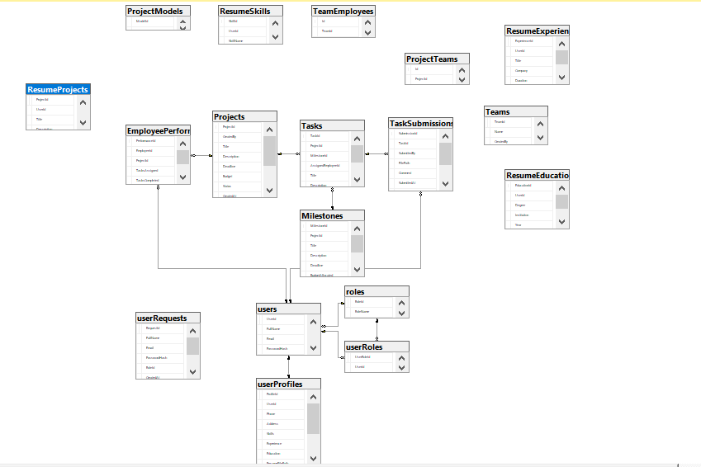

System Block Diagram

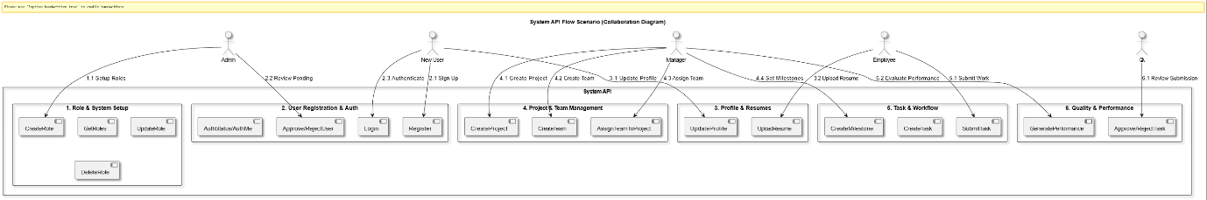

Class Diagram
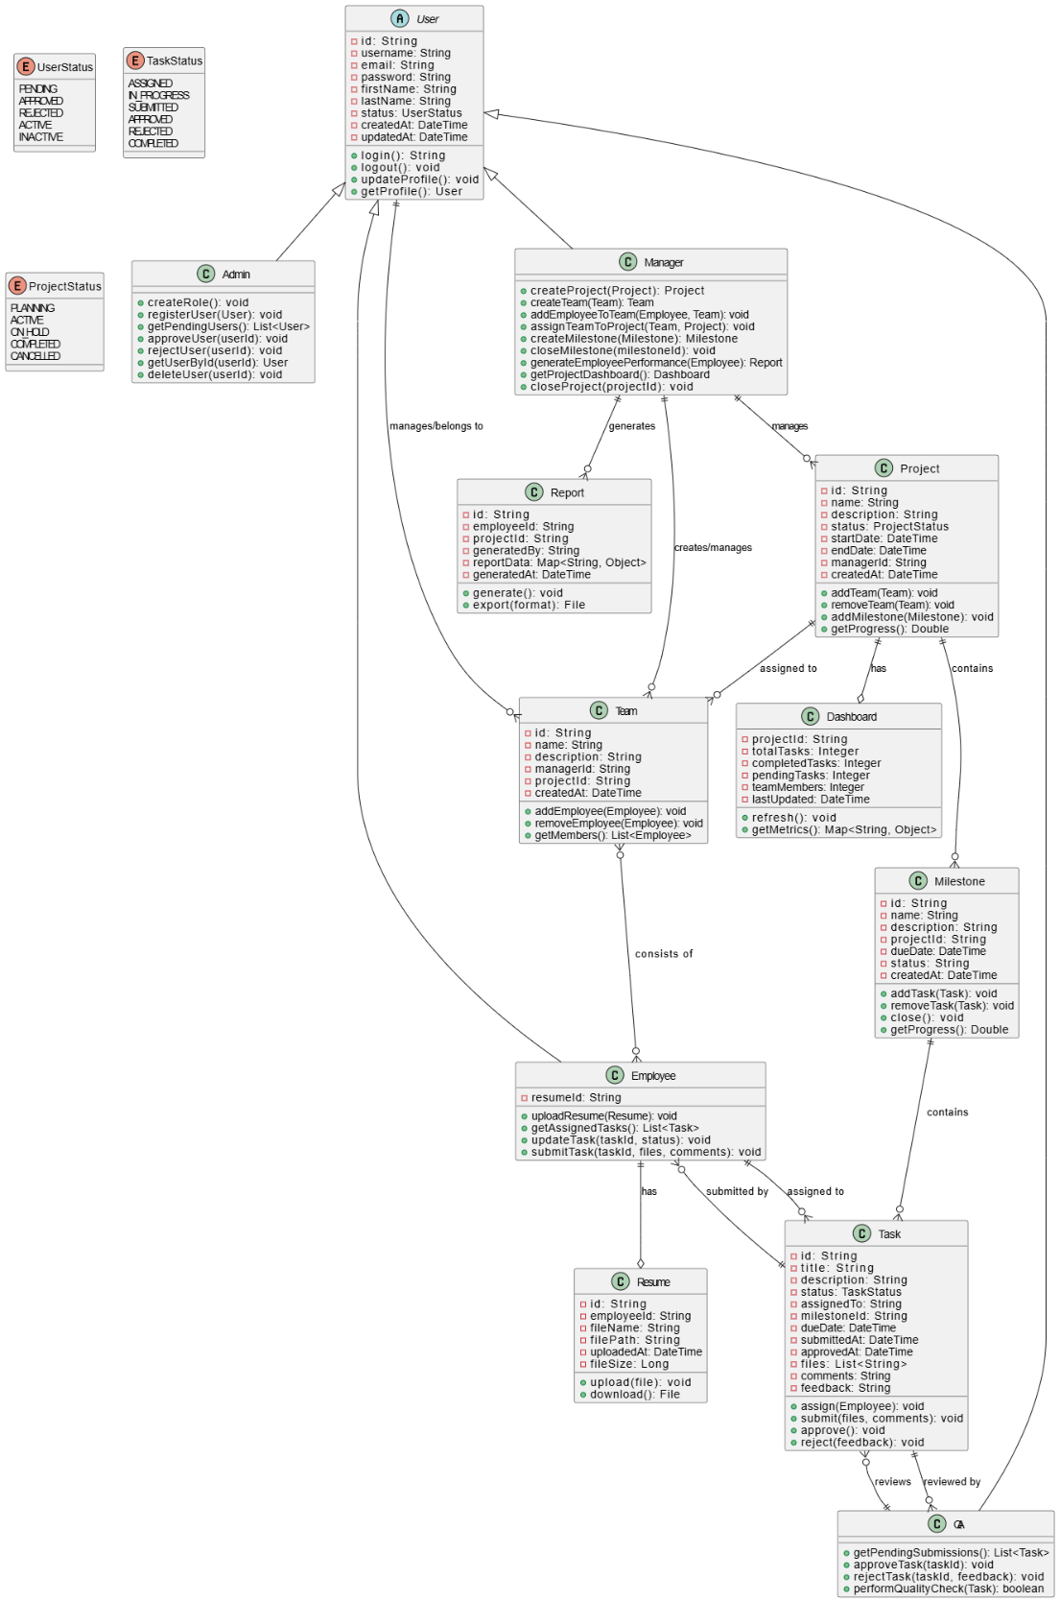

Flow Chart
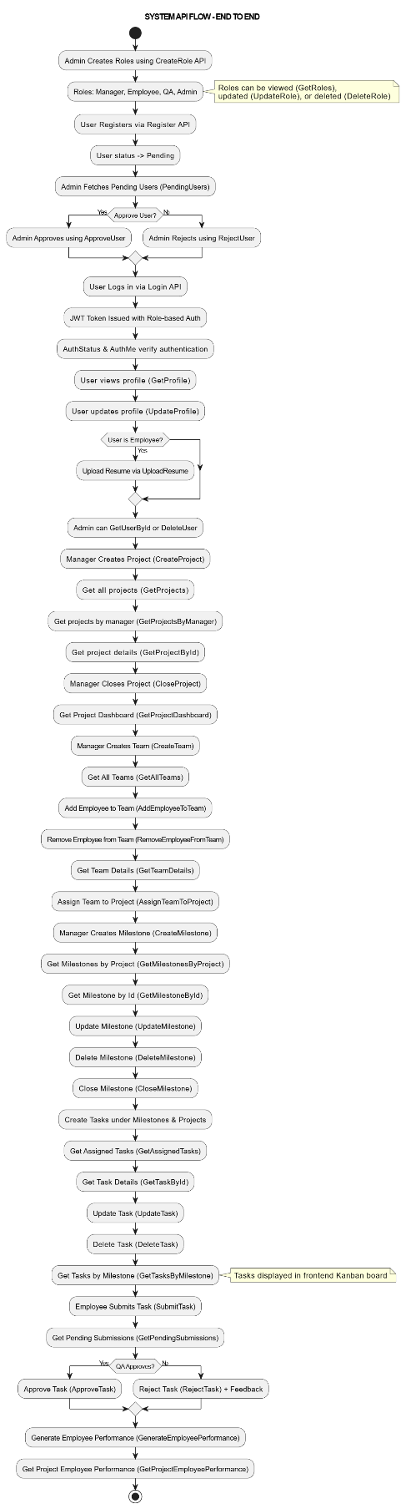

Swim Lane Diagram
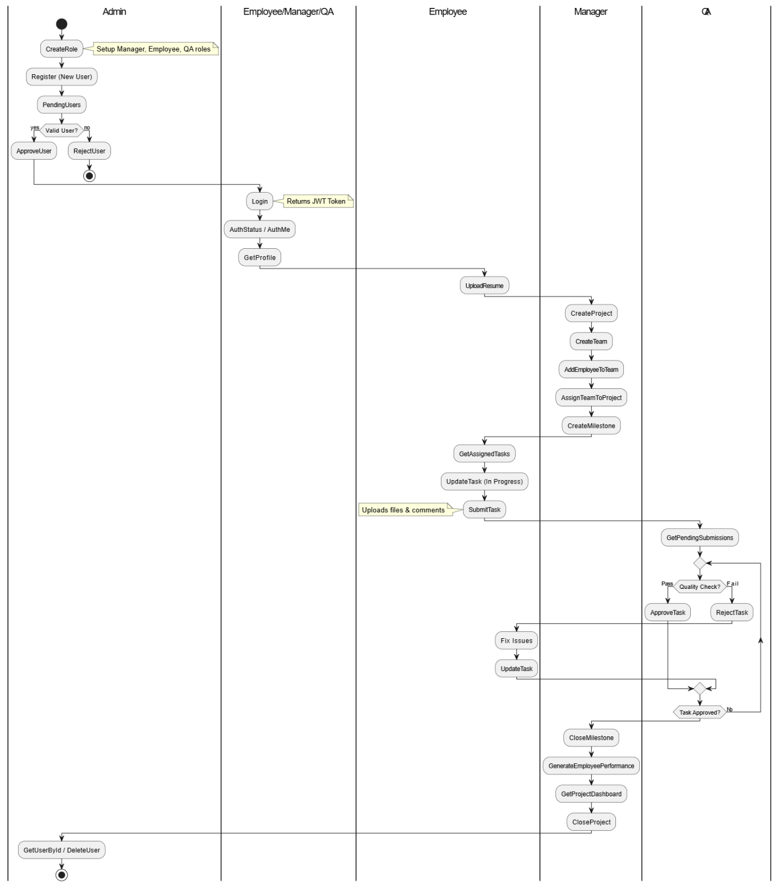

Collaboration Diagram

Deployment Diagram
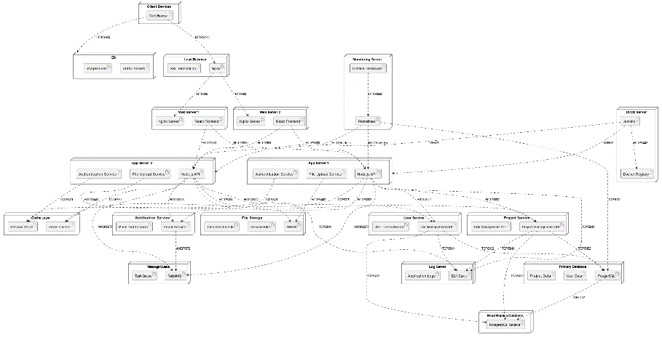

3.4 Technologies & Tools Used
MANAGIX is developed using a combination of modern web and cloud technologies to ensure scalability, performance, and ease of maintenance. The backend of the system is built using ASP.NET and Python-based Azure Functions, enabling a serverless architecture that efficiently handles API requests and AI-related processing. Entity Framework Core is used for database interaction, providing a structured and secure way to manage data, while SQL Server is used as the primary database to store project, task, user, and performance-related information. For AI capabilities such as resume parsing and transcript processing, the Groq API is integrated to support fast and reliable large language model interactions.
The frontend of MANAGIX is developed using React with TypeScript to ensure a robust and maintainable user interface. Tailwind CSS is used for responsive and consistent styling, while Redux is implemented for centralized state management across the application. The system is entirely software-based and does not require any specialized hardware; it can run on standard computers with an internet connection and a modern web browser. Azure cloud services provide scalability and availability without the need for physical servers, making the solution cost-effective and easy to deploy. This technology stack was chosen to support rapid development, future AI enhancements, and reliable project management functionality.

REFERENCES:

Agunuru, A. K. R. (2025). "AI Tools for Data Performance Enhancement: A Comprehensive Review." Journal of Computer Science and Technology Studies 7(6): 639-648.

Ahsun, A. and B. Elly (2024). "Optimizing Resource Allocation for Enhanced Project Efficiency."

Antadin, N. (2022). "Project Budgeting at a Company." Best Journal of Administration and Management 1(2): 85-88.

Atkinson, A. (1998). "Human error in the management of building projects." Construction Management & Economics 16(3): 339-349.

Bader, W. I. and A. I. Hammouri (2016). "Responsive web design techniques." International Journal of Computer Applications 150(2): 18-27.

Bah Esseme, A., et al. (2025). "AI in Project Management: Enhancing Efficiency." Decis. Mak. Risk Manag. J. Artif. Intell. Mach. Learn. Data Sci 3: 2107-2114.

Banerjee, S., et al. (2015). Generating abstractive summaries from meeting transcripts. Proceedings of the 2015 ACM Symposium on Document Engineering.

Bhargava, D., et al. (2016). Design and development of an intelligent agent based framework for predictive analytics. 2016 3rd International Conference on Computing for Sustainable Global Development (INDIACom), IEEE.

Brlečić Valčić, S., et al. (2016). "Effective project management tools for modern organizational structures." Pomorski zbornik 51(1): 131-145.

Buschmeyer, K., et al. (2023). "Psychological assessment of AI-based decision support systems: tool development and expected benefits." Frontiers in Artificial Intelligence 6: 1249322.

Carolina, S. Y., et al. (2025). "Improving Recruitment Efficiency And Effectiveness Through AI And Automation: A Literature Review." Jurnal Akuntansi, Manajemen dan Bisnis Digital 4(1): 11–18-11–18.

Chinta, S. (2021). "The impact of AI-powered automation on agile project management: transforming traditional practices." International Research Journal of Engineering and Technology (IRJET) 8(10): 2025-2036.

Clements, A. L., et al. (2017). "Low-cost air quality monitoring tools: from research to practice (a workshop summary)." Sensors 17(11): 2478.

Dakulagi, V., et al. (2025). "An overview of techniques and best practices to create intuitive and user-friendly human-machine interfaces." Artificial Intelligence and Multimodal Signal Processing in Human-Machine Interaction: 63-77.

Damij, N. and T. Damij (2021). "An approach to optimizing Kanban board workflow and shortening the project management plan." IEEE transactions on engineering management 71: 13266-13273.

Dare, S. O., et al. (2022). "An expenditure monitoring model for capital project efficiency in governmental and large-scale private sector institutions."

Deepa, Y. G., et al. (2025). "Automated Resume Parsing: A Review of Techniques, Challenges and Future Directions."

Dilaksha, S., et al. (2024). COMPARATIVE ANALYSIS OF CHALLENGES IN MANUAL AND AUTOMATED CONSTRUCTION PROGRESS MONITORING IN SRI LANKA. Proceedings The 12th World Construction Symposium| August.

Diván, M. J. (2017). Data-driven decision making. 2017 international conference on Infocom technologies and unmanned systems (trends and future directions)(ICTUS), IEEE.

DRĂGHICI, R.-V., et al. (2022). "QUANTIFYING THE EFFECTS OF MONITORING SOFTWARE ON EMPLOYEE PRODUCTIVITY AND SATISFACTION." Journal of Information Systems & Operations Management 16(1).

Gangoda, N., et al. (2024). Resume ranker: Ai-based skill analysis and skill matching system. 2024 Sixth International Conference on Intelligent Computing in Data Sciences (ICDS), IEEE.

Gudipati, P. K. (2025). AI Based Resume Parser and Job Matcher, CALIFORNIA STATE UNIVERSITY, NORTHRIDGE.

Gupta, A., et al. (2017). "Scalability in internet of things: features, techniques and research challenges." Int. J. Comput. Intell. Res 13(7): 1617-1627.

Hambali, Y. A., et al. (2024). "Analysis and design of web-based project management system." Journal of Engineering Science and Technology 19(3): 996-1009.

Jangam, S. K. and P. S. R. P. Muntala (2023). "Challenges and Solutions for Managing Errors in Distributed Batch Processing Systems and Data Pipelines." International Journal of Emerging Research in Engineering and Technology 4(4): 65-79.

Jradi, M., et al. (2018). "ObepME: An online building energy performance monitoring and evaluation tool to reduce energy performance gaps." Energy and Buildings 166: 196-209.

Juárez, J., et al. (2021). "A comprehensive review and a taxonomy proposal of team formation problems." ACM Computing Surveys (CSUR) 54(7): 1-33.

Jyothi, N. and A. Parkavi (2016). A study on task management system. 2016 International Conference on Research Advances in Integrated Navigation Systems (RAINS), IEEE.

Kabashkin, I., et al. (2025). "AI-Driven Fault Detection and Maintenance Optimization for Aviation Technical Support Systems." Processes 13(3): 666.

Karri, N. (2024). "Real-Time Performance Monitoring with AI." International Journal of Emerging Trends in Computer Science and Information Technology 5(1): 102-111.

Koufos, K., et al. (2021). "Trends in intelligent communication systems: Review of standards, major research projects, and identification of research gaps." Journal of Sensor and Actuator Networks 10(4): 60.

Kumar, P. N., et al. (2024). "Enhancing quality circle effectiveness: Leveraging AI-driven employee performance analytics." International Journal of Innovation Studies 8(1): 600-616.

Kurniawan, N. B. (2018). A Systematic Literature Review and Meta-analysis on Project Management Platform. 2018 International Conference on Information Technology Systems and Innovation (ICITSI), IEEE.

Lambertsson, K. (2025). Designing a Developer Dashboard Admin Interface: A User-Centered Approach to Collaboration and Usability.

Manukonda, A. K. (2024). "Designing Highly Available and Scalable Web Applications Using Azure App Services and Azure Functions." IJSAT-International Journal on Science and Technology 15(3).

McGinty, N. A. and E. V. Lylova (2020). Transformation of the HR management in modern organizations. 1st International Conference on Emerging Trends and Challenges in the Management Theory and Practice (ETCMTP 2019), Atlantis Press.

Nalbantov, D., et al. (2023). "Design And Implementation Of Project Management Application In React. Js." Innovative Information Technologies for Economy Digitalization (IITED)(1): 120-124.

Olanrewaju, R. F., et al. (2021). "A frictionless and secure user authentication in web-based premium applications." Ieee Access 9: 129240-129255.

Patil, S. (2020). "Team formation using recommendation systems."

Perumal, R. A. (2024). "Optimizing cloud scalability: Advanced architectures in Azure for high-performance applications." International Journal for Multidisciplinary Research (IJFMR) 7(1): 1-15.

Putra, I., et al. (2019). "Framework of construction procedure manual of the project management unit and other stakeholders in the Surabaya City Government." International Journal of Advanced Research in Engineering and Technology 10(6): 175.

Rahman, S. (2025). "Development of an IoT backend service with Azure."

Rasheed, A. S. and R. T. Adebiyi (2020). "Adoption of Web-Based Project Management System for Construction Project Delivery."

Reiff, J. and D. Schlegel (2022). "Hybrid project management–a systematic literature review." International journal of information systems and project management 10(2): 45-63.

Saiyad, S. (2024). "Project Management and Jira with Agile Scrum Methodology."

Säkkinen, H. (2020). "Employee Profiles in Automated Access Management."

Shah, C. and R. W. White (2022). Task intelligence for search and recommendation, Springer Nature.

Shoushtari, F., et al. (2024). "Application of artificial intelligence in project management." International journal of industrial engineering and operational research 6(2): 49-63.

Souza Valadares, F., et al. (2024). "Identification of the Main Traditional Project Management Methods Through a Systematic Literature Review." International Journal of Advanced Computer Science & Applications 15(6).

Sravanthi, J., et al. (2023). AI-assisted resource allocation in project management. 2023 3rd International Conference on Advance Computing and Innovative Technologies in Engineering (ICACITE), IEEE.

Sutrisno, S. (2022). "Determinants of employee performance: Overview of aspects of communication, work stress and compensation." Budapest International Research and Critics Institute-Journal (BIRCI-Journal) 5(3): 19259-19270.

Tolvanen, E. (2023). "Identifying and Overcoming Inefficiencies in Substation Integration Project Execution."

Udayakumar, P. and R. Anandan "Design and Deploy IoT Network & Security with Microsoft Azure."

Valizadeh, J., et al. (2025). Autonomy with Structural Task Allocation Games: From Inefficiency to Optimality. International Conference on Principles and Practice of Multi-Agent Systems, Springer.

Wang, X., et al. (2025). Progress Reporting: Conceptualization, Measure Development, and Impact on Employee Job Performance. Academy of Management Proceedings, Academy of Management Valhalla, NY 10595.

Weber, M., et al. (2023). "Organizational capabilities for ai implementation—coping with inscrutability and data dependency in ai." Information Systems Frontiers 25(4): 1549-1569.

Yoshimura, M., et al. (2025). "Gaze strategy and sense of ownership in learning prosthetic control: a comparative study using wearable eye tracking." Journal of NeuroEngineering and Rehabilitation.

Yusuf, J. and S. Bello (2021). "Comparative Analysis of Traditional vs AI-Driven Project Risk Management Models."

Zheng, H. (2025). "Research on the Application of Artificial Intelligence Technology in Instructional Budget Management." Journal of Modern Education and Culture 2(8).

