

STATS AND PROBABILITY PROJECT
Name: Qambar Lashari
SID: 14586

Frequency Distribution

Introduction
Organizes raw data into intervals to summarize frequency and distribution patterns.

Method
Dataset: [15, 22, 18, 30, 25, 28, 35, 40, 32, 20, 27, 19, 24, 31, 29, 33, 21, 23, 26, 34]
Steps: Determine number of classes, class width, create intervals and calculate frequencies.

Assumptions
- Data is quantitative and continuous.
- Classes are mutually exclusive.
- Random sampling.
- Uniform class widths.

Result Explanation
- Frequency table summarizes observations.
- Relative and percentage frequency show proportions.
- Cumulative frequency shows counts below intervals.
- Identify modal class.

Code / Output
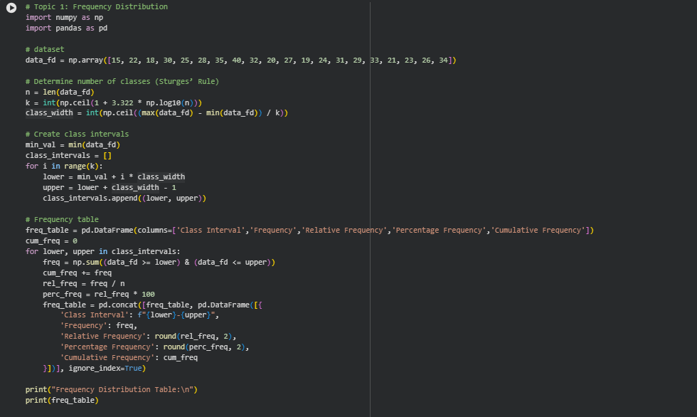
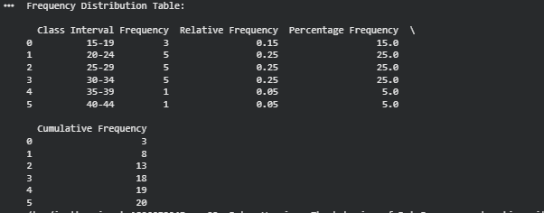

Measure of Central Tendency & Dispersion

Introduction
Describes central point of data and spread using mean, median, mode, variance, SD, skewness, and CV.

Method
Dataset: [5, 8, 7, 10, 6, 9, 7, 8, 6, 9, 7, 8, 6, 10, 7]
Calculate mean, median, mode, variance, SD, skewness, CV, and plot histogram, frequency polygon, boxplot.

Assumptions
- Data is numeric.
- No extreme outliers.
- Assumes equally spaced intervals for frequency polygon.

Result Explanation
- Mean, median, mode show center.
- Variance, SD show spread.
- Skewness shows asymmetry.
- CV shows relative variability.
- Graphs represent distribution.

Code / Output
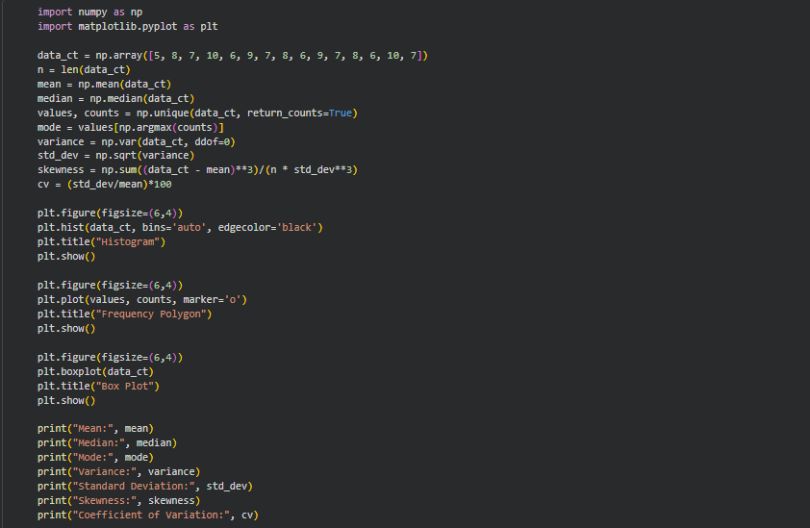
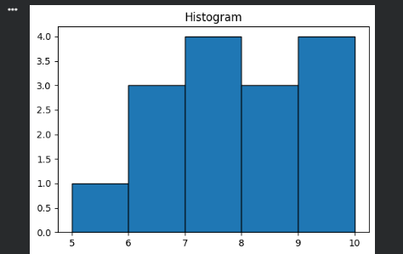
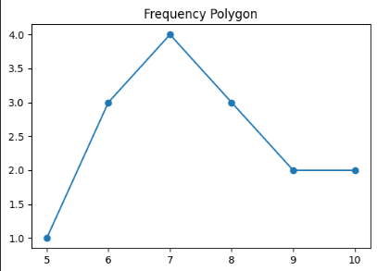
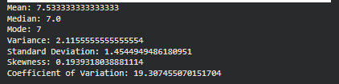

Classical Probability

Introduction
Calculates probability of events assuming equally likely outcomes; includes empirical and subjective probabilities.

Method
Simulate 20 dice rolls.
Calculate P(A), P(A'), P(B), P(A and B), P(A or B), P(A|B).

Assumptions
- Outcomes equally likely.
- Events independent for multiplicative rule.
- Empirical probability based on observations.
- Subjective probability based on informed judgment.

Result Explanation
- Each probability calculated for events.
- Conditional probability accounts for dependencies.
- Additive/multiplicative rules for combined events.

Code / Output
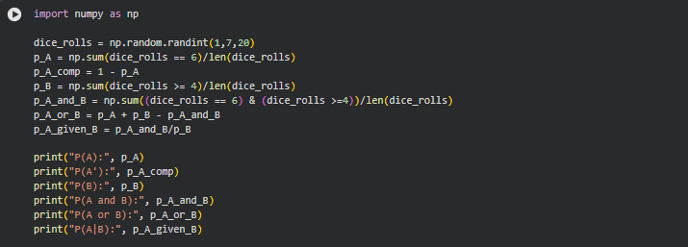
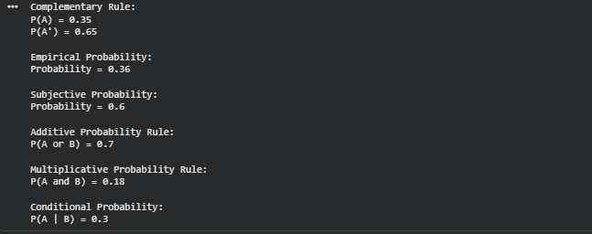

Bayes' Theorem

Introduction
Updates probability of an event based on new evidence using conditional probabilities.

Method
Given P(A), P(A'), P(B|A), P(B|A'), calculate P(B) and P(A|B) using Bayes' formula.

Assumptions
- Events A and B well-defined.
- Probabilities known or estimated.
- Events may/may not be independent.

Result Explanation
- Calculates updated probability given evidence.
- Helps in decision making under uncertainty.

Code / Output
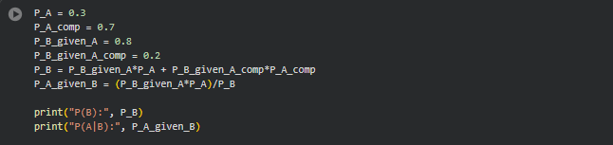

Binomial Distribution

Introduction
Models number of successes in fixed independent trials with constant success probability.

Method
Parameters: n=10, p=0.4, x=0..10
Calculate P(X=x) using binomial formula.

Assumptions
- Fixed number of trials.
- Each trial independent.
- Only two outcomes per trial.
- Constant success probability.

Result Explanation
- Probability for exact successes in n trials.
- Useful for discrete binary outcomes.

Code / Output
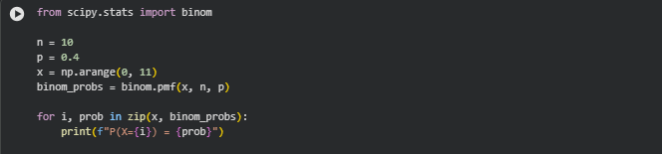

Poisson Distribution

Introduction
Models probability of events in a fixed interval when events occur independently at a constant rate.

Method
Parameters: λ=3, x=0..6
Calculate P(X=x) using Poisson formula.

Assumptions
- Events occur independently.
- Constant average rate.
- Events cannot occur simultaneously.

Result Explanation
- Probability for exact events in interval.
- Models rare events.

Code / Output

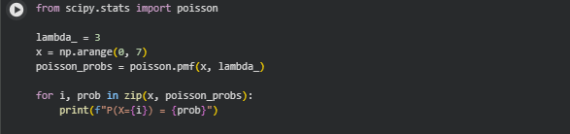

Normal Distribution

Introduction
Continuous symmetric distribution around mean; used in natural phenomena and probability calculations.

Method
Generate 50 random values with μ=50, σ=10
Calculate PDF and plot normal curve, histogram, boxplot.

Assumptions
- Data continuous.
- Bell-shaped distribution.
- Mean=Median=Mode.

Result Explanation
- PDF values calculated.
- Curves show spread and center.
- Graphs represent probability ranges.

Code / Output
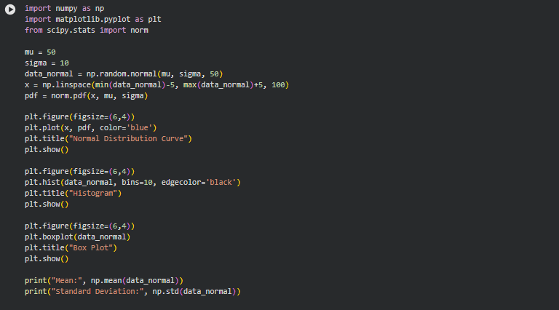
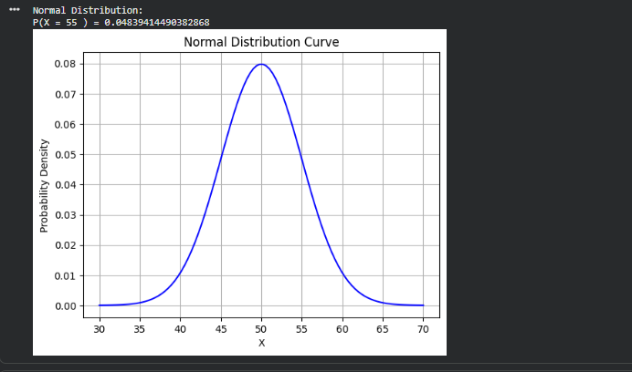

Sampling

Introduction
Selects subset from population to estimate population characteristics.

Method
Population 1-100
Simple random sample, systematic sample, stratified sample.

Assumptions
- Population well-defined.
- Random selection.
- Strata mutually exclusive and exhaustive (stratified).

Result Explanation
- Samples represent population.
- Different techniques ensure fairness.
- Estimates population parameters.

Code / Output
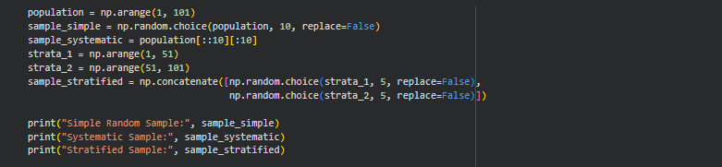
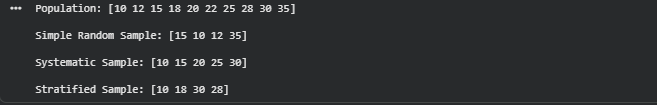

Estimation

Introduction
Infers population parameters from sample data using point and interval estimates.

Method
Dataset of 20 values
Compute sample mean, std, and confidence interval (CI) at 95%).

Assumptions
- Random sampling.
- Sample distribution approximately normal.
- Observations independent.

Result Explanation
- Point estimates give best value.
- CI shows likely range for parameters.
- Wider CI for higher confidence.

Code / Output
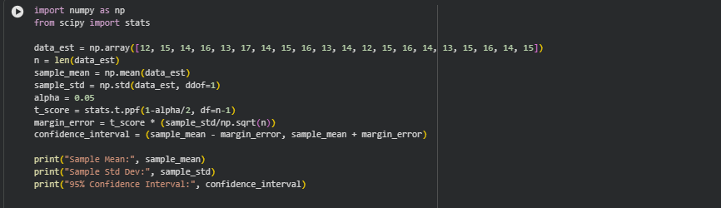
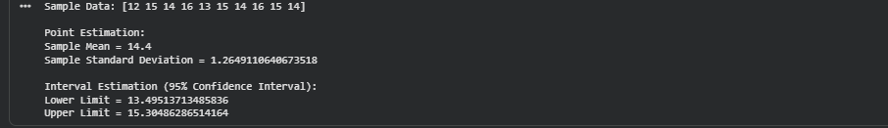

Hypothesis Testing

Introduction
Evaluates claims about population parameters using sample data.

Method
Formulate H0, H1
Calculate test statistic (Z or T)
Compare p-value with α=0.05
Determine one-tailed or two-tailed test.

Assumptions
- Random sampling.
- Normality for small samples.
- Known population SD for Z-test.
- Independence of observations.

Result Explanation
- Test statistic measures deviation from H0.
- P-value shows significance.
- One-tailed checks direction; two-tailed checks difference.
- Decide reject/fail to reject H0.

Code / Output
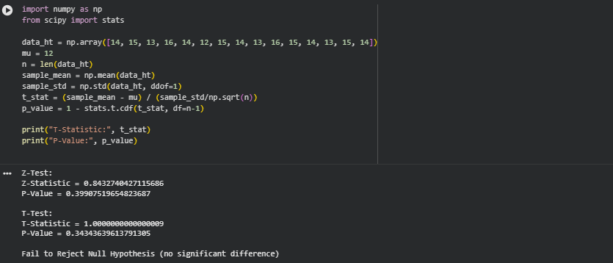

One-Tailed Hypothesis Testing

Introduction
Tests if population mean is greater or less than hypothesized value (right or left-tailed).

Method
Dataset of 10 values
Compute sample mean, SD
Perform T-test
Compare p-value to α=0.05

Assumptions
- Random sample.
- Observations independent.
- Data approximately normal.
- Population SD may be unknown.

Result Explanation
- T-statistic and p-value indicate significance.
- Reject H0 if p-value < 0.05.
- Determines whether mean exceeds hypothesized value.

Code / Output
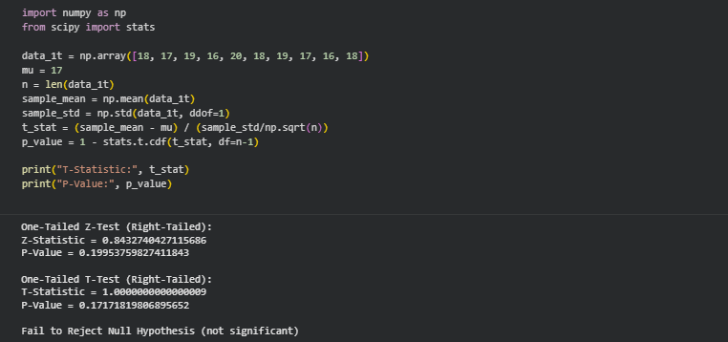

Two-Tailed Hypothesis Testing

Introduction
Tests if population mean significantly differs (higher or lower) from hypothesized value.

Method
Dataset of 10 values
Compute sample mean, SD
Perform two-tailed T-test
Compare p-value to α=0.05

Assumptions
- Random sample.
- Observations independent.
- Data approximately normal.
- Population SD may be unknown.

Result Explanation
- T-statistic and p-value indicate deviation from H0.
- Reject H0 if p-value < 0.05.
- Confirms if mean differs significantly.

Code / Output
