

Managix – AI-Assisted Project Management And Resource Allocation Tool

Matiullah Yousfani (14747)
Huzaifa Bin Ahmed (14781)
Rana Daniyal Nisar (14735)
Syed Meesam Ali (14920)

Under the Supervision of
Muhammad Shahzad
2026

College of Computing & Information Sciences, KIET Main Campus, Karachi, Pakistan

ABSTRACT

Effective project management in modern organizations requires coordination among teams, timely task allocation, and data-driven decision-making. Traditional project management approaches often rely heavily on manual planning and oversight, which can be inefficient and prone to errors.(Diván 2017) To address these challenges, this project presents MANAGIX: An AI-Powered Project Management System, an intelligent platform designed to optimize project planning, task allocation, and employee performance monitoring while reducing manual workload.(Chinta 2021)

MANAGIX enables seamless project creation, team formation, and task and subtask management.(Jyothi and Parkavi 2016) The system incorporates AI-driven suggestions for team allocation, recommending which employees are best suited for specific tasks based on their skills, past performance, and workload. Additionally, the AI assists in budget allocation, ensuring resources are optimally distributed across projects. The backend of MANAGIX is developed using .NET Azure Functions, offering scalable and secure API-driven services, while the frontend is built with React, providing a responsive and intuitive user interface for project managers and team members.

The AI capabilities extend further into project management. For ongoing projects, MANAGIX can analyse meeting transcripts to automatically generate new tasks or subtasks, ensuring that actionable items discussed in meetings are captured and added to the project workflow. It continuously monitors employee performance, tracking metrics such as task completion rates, approval rates, and skill growth, which supports data-driven decision-making and automatic performance improvement suggestions. Furthermore, the system aggregates project data to provide insights and predictive analytics, helping managers understand team dynamics, project progress, and potential bottlenecks. (Kumar, Mohan et al. 2024)

MANAGIX integrates AI intelligently while maintaining a flexible architecture that supports future enhancements, such as advanced predictive analytics, deeper skill-based recommendations, and more comprehensive project insights. By combining AI-driven recommendations, automated task generation, and performance monitoring, MANAGIX provides a comprehensive, efficient, and future-ready project management solution that enhances productivity and decision-making within organizations. (Agunuru 2025)

ACKNOWLEDGEMENT
In the name of Allah, the most Gracious and the Most Merciful.
Peace and blessing of Allah be upon Prophet Muhammad ﷺ

First, praise of Allah, for giving us this opportunity, the strength and the patience to complete our FYP finally, after the challenges and difficulties. We would like to thank our supervisor Muhammad Shahzad for his guidance, motivation and most his significant contribution in this project, expert Sir Usman Khan for giving us the opportunity to work on this project. We would also like to thanks our parents for financial and moral support and our friends who have helped and motivated us throughout. May Allah reward them all abundantly. Ameen

DEDICATION
This report is dedicated to KIET University, our Teacher, our Supervisor, our Parents, our fellow colleagues and the hard-working students of KIET, with a hope that they will succeed in every aspect of their Academic Career and this project may help them in any aspect of their life.

ACKNOWLEDGEMENT 3
DEDICATION 4
CHAPTER 1 6
INTRODUCTION 6
1.1 Introduction 6
1.2 Motivations 7
1.3 Problem Statement 7
1.4 Objectives and Contributions 8
1.5 Project Scope 9
1.6 Organization Of The Report 9
CHAPTER 2 11
LITERATURE REVIEW 11
2.1 Introduction 11
2.2 Related Work 11
2.2.1 Traditional Project Management Systems 11
2.2.2 AI-Based Project Management Tools 11
2.2.3 Resusme Parsing and Skill Extraction Systems 12
2.2.4 Performance Monitoring And Analytics Systems 12
2.3 Comparative Analysis 12
2.4 Summary Of Research Gap 13
CHAPTER 3 14
SYSTEM DESIGN AND METHODOLOGY 14
3.1 System Overview 14
3.2 Requirement Analysis 15
3.3 System Design Diagrams 18
3.4 Technologies & Tools Used 22
REFERENCES: 23

CHAPTER 1

INTRODUCTION

1.1 Introduction
Efficient project management is essential for organizations to achieve goals, optimize resource allocation, and ensure timely task completion.(Ahsun and Elly 2024) Traditional project management practices often rely on manual planning, task assignment, team coordination, and performance monitoring.(Chinta 2021) These manual processes are prone to human error, time-consuming, and may not fully utilize employee potential, leading to delays, resource mismanagement, and reduced productivity.(Atkinson 1998)

To address these challenges, MANAGIX: An AI-Powered Project Management System has been developed. The system combines manual project management features with AI-assisted capabilities to optimize team formation, task allocation, budget distribution, and employee performance evaluation.(Shoushtari, Daghighi et al. 2024) In the current FYP1 version, MANAGIX primarily provides manual project management features, including user authentication with role-based access, project creation with deadlines and budgets, team creation and employee assignment, task and subtask creation, task submission with file uploads, QA review for task approvals, Kanban-based task visualization, and budget tracking. Additionally, AI-driven resume parsing is included to automatically extract skills and other relevant information from uploaded resumes, helping managers make informed hiring and team allocation decisions.(Gudipati 2025)

The future FYP2 version of MANAGIX will extend the AI capabilities to dynamically assist in project management. The AI will provide team formation suggestions, recommend which employee is suitable for a particular task, allocate project budgets optimally,(Zheng 2025) and generate new tasks from ongoing project meeting transcripts. Moreover, the system will continuously monitor employee performance metrics, such as task completion rates and approval rates, to support performance improvement suggestions. AI will also aggregate project insights and provide predictive analytics to help managers anticipate potential bottlenecks, evaluate project progress, and forecast team efficiency.(Karri 2024)

MANAGIX is developed as a web-based application, with a backend built using .NET Azure Functions for scalable, secure, and serverless API management,(Perumal 2024) and a frontend built in React, providing a responsive and user-friendly interface for project managers and employees. This architecture ensures flexibility, maintainability, and future integration of additional AI features.

1.2 Motivations
The primary motivation for developing MANAGIX stems from the inefficiencies of manual project management in modern organizational environments.(Tolvanen 2023) Traditional task allocation, performance monitoring, and team coordination require significant managerial effort and are prone to delays or mismanagement. The adoption of intelligent project management systems inspired the development of MANAGIX, aiming to enhance decision-making, reduce human workload, and improve overall project efficiency.

Interest in artificial intelligence and data-driven automation motivated the integration of AI into MANAGIX. Resume parsing was selected as the first AI feature in FYP1 to provide immediate practical benefits in team formation and skill assessment.(Gangoda, Yasantha et al. 2024) Future FYP2 enhancements will expand AI’s role to dynamic task generation, performance monitoring, and predictive project insights, offering a comprehensive solution for intelligent project management.

1.3 Problem Statement

Manual project management in most organizations faces several critical limitations:
Time-consuming task allocation and team formation: Managers spend significant time analyzing employee skills, workloads, and project requirements to assign tasks and form teams.(Juárez, Santos et al. 2021)
Limited decision support: Without AI, decisions about who should handle a task or which employee is best suited are based on intuition or incomplete data, which may not be optimal.(Buschmeyer, Hatfield et al. 2023)
Inefficient employee onboarding and skill tracking: Employees must manually enter all their details and skills, which is time-consuming and prone to missing information.(McGinty and Lylova 2020)
Limited performance insights: Monitoring task progress and employee productivity manually is slow and often reactive rather than proactive.(Dilaksha, Ranadewa et al. 2024)
AI-assisted features, such as resume parsing, address these challenges by extracting employee skills and relevant information directly from uploaded resumes, reducing manual data entry and onboarding time.(Deepa, Sindhu et al. 2025) In future enhancements (FYP2), AI will provide intelligent task and team allocation suggestions based on employee skills, availability, and performance metrics, helping managers make faster and more informed decisions while saving significant time.

1.4 Objectives and Contributions
Objectives:
The main objective of this project is:
- To provide a web-based platform for project creation, team management, task allocation, and performance tracking.(Hambali, Anisyah et al. 2024)
- To implement AI-driven resume parsing so that employees can upload their resumes (PDF/DOCX) and automatically populate their profiles, reducing manual data entry.(Säkkinen 2020)
- To provide managers with AI-assisted suggestions for team formation and task allocation, reducing decision-making time while improving efficiency.(Patil 2020)
- To offer a Kanban board and dashboard for visualizing project progress, task status, and employee workload.(Damij and Damij 2021)
- To lay the foundation for future AI features, such as task generation from meeting transcripts, performance monitoring, and predictive analytics.(Banerjee, Mitra et al. 2015)

Contributions:
The key contributions of this project includes:
- Development of a manual project management system covering projects, teams, tasks, and performance tracking.(Putra, Amalia et al. 2019)
- Implementation of AI-based resume parsing, allowing automatic extraction of employee details, skills, and experience from resumes.
- AI suggestions reduce decision-making time for managers by recommending suitable employees for tasks and optimal team formation.(Shah and White 2022)
- Web-based user interface with React for responsive project management and visualization.(Nalbantov, Angulo et al. 2023)
- Backend implementation with .NET Azure Functions, ensuring scalable, secure, and maintainable API services.(Manukonda 2024)
- Provides a foundation for future AI enhancements, including dynamic task generation and predictive project insights.(Bhargava, Poonia et al. 2016)

1.5 Project Scope
MANAGIX focuses on providing an integrated project management platform combining manual management features with AI-assisted enhancements. (Brlečić Valčić, Dimitrić et al. 2016) (Saiyad 2024)
FYP1 Scope (current):
User authentication with roles: Manager, Employee, QA, Admin.
Project creation with title, description, and deadlines.
Team creation and employee assignment.
Assignment, submission, and QA approval.
Kanban board for task visualization and project tracking.
Meeting and transcript generation.
AI-driven resume parsing for automatically extracting employee details, skills, and experience from resumes, reducing manual data entry and assisting in team formation.

FYP2 Scope (future AI features):
AI-driven team formation suggestions based on employee skills and availability.
AI-assisted task allocation suggestions, helping managers assign tasks to the most suitable employee efficiently.
Generation of tasks from ongoing project meeting transcripts.
Continuous monitoring and evaluation of employee performance metrics, supporting performance improvement suggestions.
Aggregation of project insights and predictive analytics for better project planning and risk mitigation.
The system is designed to be scalable, flexible, and modular, enabling integration of additional AI features without major architectural changes.

1.6 Organization Of The Report
This report is organized into six chapters:

Chapter 1: Introduction – includes project context, motivation, problem statement, objectives, contributions, and scope.
Chapter 2: Literature Review – discusses related work in project management systems and AI applications.
Chapter 3: Methodology – explains system architecture, workflow, and technologies used.
Chapter 4: System Design and Implementation – details modules, backend, frontend, database design, and API functionalities.
Chapter 5: Results and Evaluation – presents system testing, performance, and analysis of implemented features.
Chapter 6: Conclusion and Future Work – summarizes achievements and outlines potential enhancements for AI features and project scalability.

CHAPTER 2

LITERATURE REVIEW

2.1 Introduction
This chapter reviews existing literature and systems related to project management platforms, AI-assisted task allocation, performance monitoring, and intelligent decision-support systems.(Kurniawan 2018) The purpose of this review is to analyse how modern organizations manage projects, allocate resources, and evaluate employee performance using digital tools, and to identify limitations in current approaches. The literature highlights the growing adoption of web-based project management systems and the increasing role of artificial intelligence in automating decision-making and reducing managerial workload.(Rasheed and Adebiyi 2020) By examining both traditional and AI-driven project management solutions, this chapter establishes the research gap that MANAGIX aims to address.(Yusuf and Bello 2021)

2.2 Related Work

2.2.1 Traditional Project Management Systems
This chapter reviews existing literature and systems related to project management platforms, AI-assisted task allocation, performance monitoring, and intelligent decision-support systems. The purpose of this review is to analyse how modern organizations manage projects, allocate resources, and evaluate employee performance using digital tools, and to identify limitations in current approaches. The literature highlights the growing adoption of web-based project management systems and the increasing role of artificial intelligence in automating decision-making and reducing managerial workload. By examining both traditional and AI-driven project management solutions, this chapter establishes the research gap that MANAGIX aims to address. (Koufos, EI Haloui et al. 2021)

2.2.2 AI-Based Project Management Tools
Recent research highlights the integration of artificial intelligence into project management tools to enhance automation and decision support. AI-powered systems are increasingly used to analyze historical project data, predict task completion times, and recommend resource allocations. Some commercial platforms incorporate machine learning models to estimate project risks and identify potential delays based on past performance trends.
Studies indicate that AI-driven task recommendation systems can improve efficiency by matching tasks with employees based on skill sets, workload, and historical performance. These systems reduce the cognitive burden on managers and enable faster, more consistent decision-making. However, many existing solutions offer limited transparency in their recommendations and often require extensive historical data, which may not be available in smaller organizations or early project stages. (Weber, Engert et al. 2023)

2.2.3 Resusme Parsing and Skill Extraction Systems
Resume parsing is a well-established AI application that uses natural language processing (NLP) techniques to extract structured information from unstructured resume documents. Research shows that automated resume parsing can significantly reduce recruitment and onboarding time by extracting skills, education, experience, and certifications with high accuracy. Organizations increasingly use such systems to build skill databases and support workforce planning.
In the context of project management, resume parsing enables automatic population of employee profiles, reducing manual data entry and ensuring more accurate skill representation. However, most resume parsing systems are used in isolation for recruitment purposes and are not directly integrated into project management workflows for task allocation and performance analysis. (Carolina, Putri et al. 2025)

2.2.4 Performance Monitoring And Analytics Systems
Employee performance monitoring systems focus on tracking productivity metrics such as task completion rates, quality scores, and adherence to deadlines. Research in performance analytics emphasizes the importance of continuous monitoring and feedback to support employee growth and organizational efficiency. Advanced systems aggregate performance data across projects to generate insights and identify trends.
Despite these advancements, many performance monitoring tools remain reactive rather than predictive. They often provide historical reports without offering actionable recommendations for improvement. Additionally, performance data is frequently siloed from project planning tools, limiting its usefulness in real-time decision-making. (DRĂGHICI, Mosessohn et al. 2022)

2.3 Comparative Analysis
A comparison between MANAGIX and existing project management systems highlights several distinguishing factors. Traditional tools emphasize task tracking and collaboration but lack intelligent automation. AI-enabled platforms provide predictive insights but often focus on limited aspects of project management, such as scheduling or risk analysis. (Souza Valadares, Souza Moura et al. 2024)
MANAGIX integrates manual project management features with AI-assisted capabilities in a unified platform. (Reiff and Schlegel 2022) Unlike conventional systems, it combines resume parsing, skill-based task recommendations, budget allocation assistance, and performance monitoring within the same workflow. This holistic integration enables managers to make informed decisions based on real-time data rather than intuition alone.

2.4 Summary Of Research Gap
The literature reveals several gaps in current project management solutions. First, most systems rely heavily on manual decision-making for team formation and task allocation, leading to inefficiencies and inconsistent outcomes.(Valizadeh, Zhang et al. 2025) Second, AI-driven features are often fragmented, addressing isolated problems without full integration into project workflows.(Bah Esseme, Faniyan et al. 2025) Third, resume parsing and performance monitoring tools are typically disconnected from task assignment and project planning.(Jradi, Arendt et al. 2018)
MANAGIX addresses these gaps by providing an integrated, AI-powered project management system that combines resume parsing, intelligent recommendations, performance monitoring, and predictive insights. By embedding AI directly into core project management processes, MANAGIX aims to reduce managerial workload, improve resource utilization, and support data-driven decision-making in modern organizations.

CHAPTER 3

SYSTEM DESIGN AND METHODOLOGY

3.1 System Overview
MANAGIX is a web-based Project Resource Allocation and Management Tool designed to support organizations in planning, executing, and monitoring projects more effectively. The proposed system focuses on reducing the limitations of traditional manual project management approaches by providing a centralized platform that integrates structured project management workflows with intelligent, AI-assisted support. (Sravanthi, Sobti et al. 2023)
In its current implementation (FYP1), MANAGIX primarily delivers core project management functionalities that allow managers and employees to collaborate efficiently. The system includes secure user authentication with role-based access control, ensuring that managers, quality assurance (QA) staff, and employees can access features relevant to their responsibilities.(Olanrewaju, Khan et al. 2021) Project managers can create projects by defining objectives, deadlines, and budgets, and form teams by assigning employees based on project requirements. Tasks can be created and linked to projects, enabling clear task ownership and progress tracking. (Yoshimura, Kurumadani et al. 2025)
To enhance task monitoring and transparency, MANAGIX provides a Kanban-based task visualization system that allows users to view task status transitions such as pending, in progress, submitted, and approved. Employees can submit completed tasks along with relevant files, which are then reviewed by QA personnel for approval.(Damij and Damij 2021) Budget tracking features allow managers to monitor project expenditures and maintain financial control throughout the project lifecycle. (Dare, Ajayi et al. 2022)
A key intelligent component introduced in the current version is AI-driven resume parsing. When resumes are uploaded, the system automatically extracts skills and relevant professional information, helping managers make informed decisions during employee selection and team formation. This feature reduces manual effort and improves accuracy in identifying suitable candidates for project roles. (Deepa, Sindhu et al. 2025)
In the FYP-1 phase, MANAGIX also supports project meetings with automatic transcript generation. Meetings can be conducted within the system, and spoken discussions are converted into text using speech-to-text technology. These transcripts help team members review decisions, understand requirements, and avoid miscommunication. This feature also prepares the system for future AI-based task extraction and analysis.
The future extension of MANAGIX (FYP2) aims to enhance the system with advanced AI capabilities. These include intelligent team formation recommendations, automated task-to-employee matching, optimized budget allocation, and task generation from project meeting transcripts. Additionally, the system will analyse employee performance metrics such as task completion rates and approval trends to provide performance insights and improvement suggestions. Predictive analytics will further assist managers in identifying potential risks, bottlenecks, and efficiency issues before they impact project outcomes.
Overall, MANAGIX offers a scalable and flexible solution built using .NET Azure Functions for backend services and React for the frontend, ensuring maintainability, responsiveness, and future expansion toward fully AI-assisted project management. (Rahman 2025)

3.2 Requirement Analysis
- List Functional Requirements
ADMIN PANEL:-
- The system shall allow the admin to manage user accounts, including viewing, activating, and deactivating users.
- The system shall allow the admin to assign roles such as manager, employee, and QA to registered users.
- The system shall allow the admin to view all projects, teams, and system-wide activities.
- The system shall allow the admin to manage organizational data and ensure system integrity.
- The system shall allow the admin to monitor overall system usage and performance logs.
- The system shall allow the admin to manage access control and enforce security policies.
(Lambertsson 2025)
MANAGER PANEL:-
- The system shall allow managers to create, update, and delete projects with defined deadlines and budgets.
- The system shall allow managers to create teams and assign employees to specific projects.
- The system shall allow managers to create, assign, and modify tasks and subtasks.
- The system shall provide managers with a Kanban board to track task progress.
- The system shall allow managers to review project budgets and monitor expenditures.
- The system shall allow managers to upload and analyze employee resumes using AI-based resume parsing.
- The system shall allow managers to view employee performance data based on task completion and approvals.
- The system shall allow managers to receive notifications regarding task updates and project progress.
(Antadin 2022)
EMPLOYEE PANEL:-
- The system shall allow employees to view assigned projects, tasks, and deadlines.
- The system shall allow employees to update task status on the Kanban board.
- The system shall allow employees to submit completed tasks along with supporting files.
- The system shall allow employees to view feedback or revision requests from QA or managers.
- The system shall allow employees to track their task history and progress.
- The system shall allow employees to receive notifications related to task assignments and updates.
(Wang, Meng et al. 2025)
QA PANEL:-
- The system shall allow QA personnel to view submitted tasks assigned for review.
- The system shall allow QA personnel to approve tasks that meet quality standards.
- The system shall allow QA personnel to reject tasks and request revisions with feedback.
- The system shall allow QA personnel to monitor task quality and approval trends.
- The system shall allow QA personnel to track submission and approval history.
- The system shall allow QA personnel to receive notifications for pending task reviews.
(Clements, Griswold et al. 2017)
- List Non-Functional Requirements
SECURITY:-
- The system shall implement secure authentication and role-based authorization to prevent unauthorized access.
- The system shall ensure encrypted communication between client and server.
- The system shall protect sensitive user and project data from unauthorized modification or disclosure.
(Udayakumar and Anandan)
PERFORMANCE:-
- The system shall respond to user actions within acceptable time limits under normal operating conditions.
- The system shall efficiently handle multiple concurrent users without performance degradation.
- The system shall optimize database queries to ensure fast data retrieval.
(Sutrisno 2022)
SCALABILITY:-
- The system shall support an increasing number of users, projects, and tasks without requiring major architectural changes.
- The serverless backend shall allow automatic scaling based on system load.
(Gupta, Christie et al. 2017)
USABILITY:-
- The system shall provide a user-friendly and intuitive interface for admins, managers, employees, and QA personnel.
- The system shall require minimal training for users to perform basic project management tasks.
- The system shall provide clear feedback and notifications for user actions.
(Dakulagi, Yeap et al. 2025)
RELIABILITY:-
- The system shall ensure consistent operation with minimal downtime.
- The system shall handle unexpected errors gracefully without data loss.
- The system shall maintain data consistency during failures or interruptions.
(Jangam and Muntala 2023)
MAINTAINABILITY:-
- The system shall be modular and well-structured to allow easy maintenance and updates.
- The system shall support future enhancements, particularly AI-based features planned for FYP2.
(Kabashkin, Perekrestov et al. 2025)
COMPATIBILITY:-
- The system shall be compatible with modern web browsers such as Chrome, Edge, and Firefox.
- The system shall support responsive design for use on different screen sizes.
(Bader and Hammouri 2016)

3.3 System Design Diagrams
ACTIVITY DIAGRAM
ADMIN EMPLOYEE
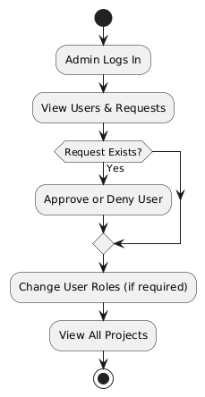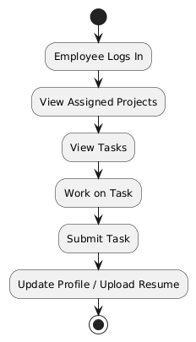
MANAGER QA
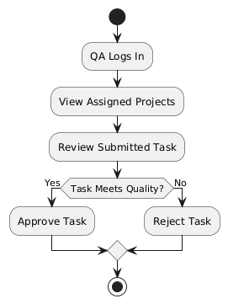
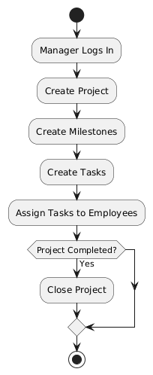

USE CASE DIAGRAM
ADMIN EMPLOYEE
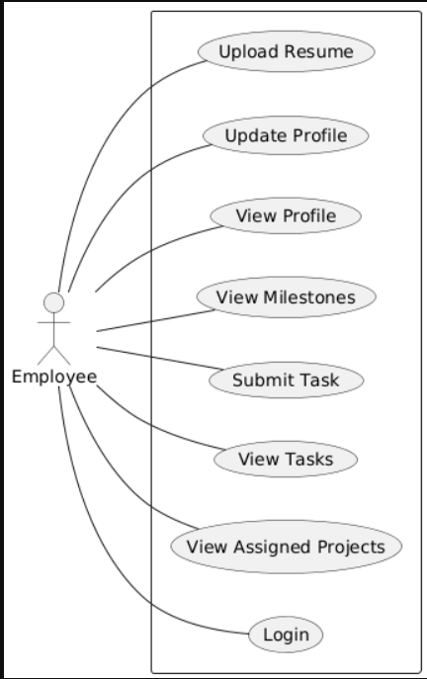
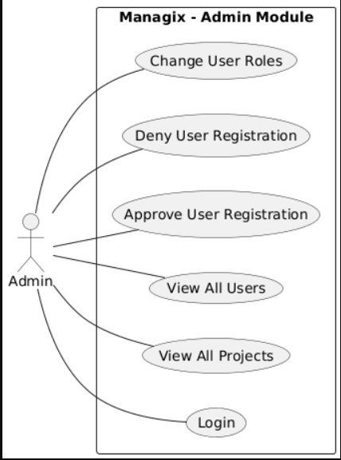
MANAGER QA
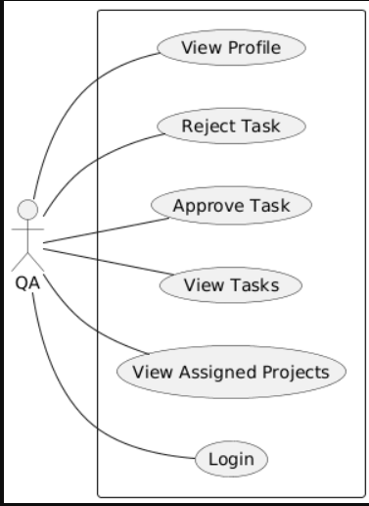
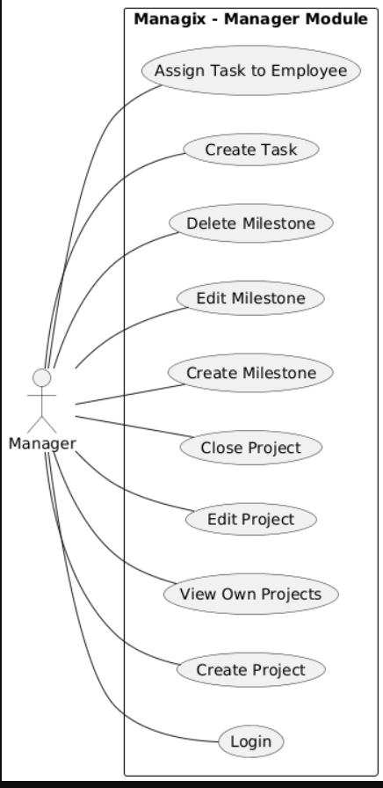

SEQUENCE DIAGRAM
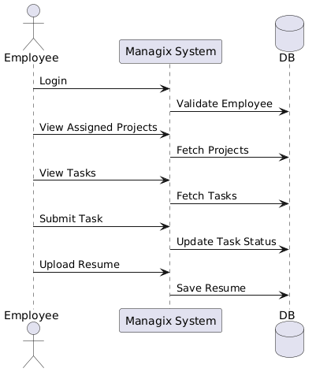
ADMIN EMPLOYEE
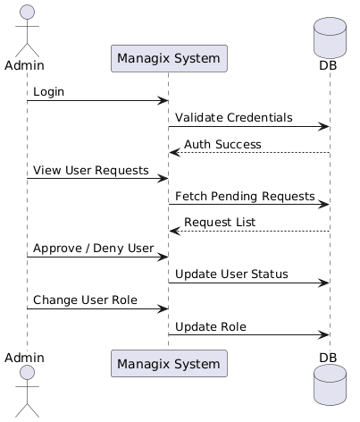

MANAGER QA
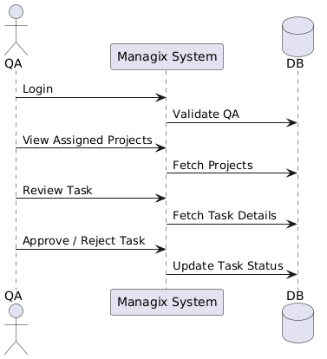
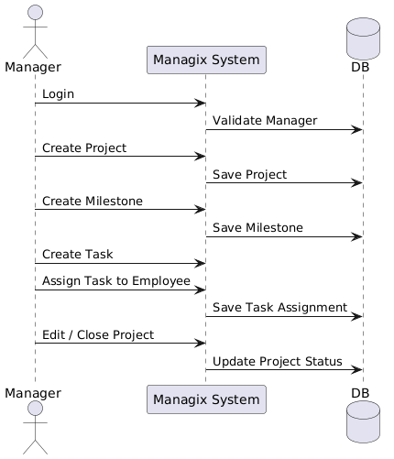

ARCHITECTURE DIAGRAM
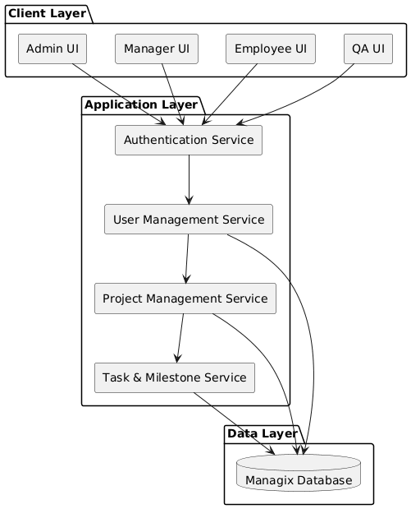

ERD DIAGRAM
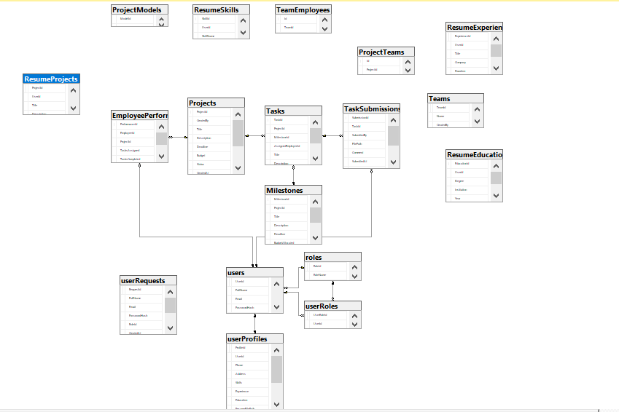

3.4 Technologies & Tools Used
MANAGIX is developed using a combination of modern web and cloud technologies to ensure scalability, performance, and ease of maintenance. The backend of the system is built using ASP.NET and Python-based Azure Functions, enabling a serverless architecture that efficiently handles API requests and AI-related processing. Entity Framework Core is used for database interaction, providing a structured and secure way to manage data, while SQL Server is used as the primary database to store project, task, user, and performance-related information. For AI capabilities such as resume parsing and transcript processing, the Groq API is integrated to support fast and reliable large language model interactions.
The frontend of MANAGIX is developed using React with TypeScript to ensure a robust and maintainable user interface. Tailwind CSS is used for responsive and consistent styling, while Redux is implemented for centralized state management across the application. The system is entirely software-based and does not require any specialized hardware; it can run on standard computers with an internet connection and a modern web browser. Azure cloud services provide scalability and availability without the need for physical servers, making the solution cost-effective and easy to deploy. This technology stack was chosen to support rapid development, future AI enhancements, and reliable project management functionality.

REFERENCES:

Agunuru, A. K. R. (2025). "AI Tools for Data Performance Enhancement: A Comprehensive Review." Journal of Computer Science and Technology Studies 7(6): 639-648.

Ahsun, A. and B. Elly (2024). "Optimizing Resource Allocation for Enhanced Project Efficiency."

Antadin, N. (2022). "Project Budgeting at a Company." Best Journal of Administration and Management 1(2): 85-88.

Atkinson, A. (1998). "Human error in the management of building projects." Construction Management & Economics 16(3): 339-349.

Bader, W. I. and A. I. Hammouri (2016). "Responsive web design techniques." International Journal of Computer Applications 150(2): 18-27.

Bah Esseme, A., et al. (2025). "AI in Project Management: Enhancing Efficiency." Decis. Mak. Risk Manag. J. Artif. Intell. Mach. Learn. Data Sci 3: 2107-2114.

Banerjee, S., et al. (2015). Generating abstractive summaries from meeting transcripts. Proceedings of the 2015 ACM Symposium on Document Engineering.

Bhargava, D., et al. (2016). Design and development of an intelligent agent based framework for predictive analytics. 2016 3rd International Conference on Computing for Sustainable Global Development (INDIACom), IEEE.

Brlečić Valčić, S., et al. (2016). "Effective project management tools for modern organizational structures." Pomorski zbornik 51(1): 131-145.

Buschmeyer, K., et al. (2023). "Psychological assessment of AI-based decision support systems: tool development and expected benefits." Frontiers in Artificial Intelligence 6: 1249322.

Carolina, S. Y., et al. (2025). "Improving Recruitment Efficiency And Effectiveness Through AI And Automation: A Literature Review." Jurnal Akuntansi, Manajemen dan Bisnis Digital 4(1): 11–18-11–18.

Chinta, S. (2021). "The impact of AI-powered automation on agile project management: transforming traditional practices." International Research Journal of Engineering and Technology (IRJET) 8(10): 2025-2036.

Clements, A. L., et al. (2017). "Low-cost air quality monitoring tools: from research to practice (a workshop summary)." Sensors 17(11): 2478.

Dakulagi, V., et al. (2025). "An overview of techniques and best practices to create intuitive and user-friendly human-machine interfaces." Artificial Intelligence and Multimodal Signal Processing in Human-Machine Interaction: 63-77.

Damij, N. and T. Damij (2021). "An approach to optimizing Kanban board workflow and shortening the project management plan." IEEE transactions on engineering management 71: 13266-13273.

Dare, S. O., et al. (2022). "An expenditure monitoring model for capital project efficiency in governmental and large-scale private sector institutions."

Deepa, Y. G., et al. (2025). "Automated Resume Parsing: A Review of Techniques, Challenges and Future Directions."

Dilaksha, S., et al. (2024). COMPARATIVE ANALYSIS OF CHALLENGES IN MANUAL AND AUTOMATED CONSTRUCTION PROGRESS MONITORING IN SRI LANKA. Proceedings The 12th World Construction Symposium| August.

Diván, M. J. (2017). Data-driven decision making. 2017 international conference on Infocom technologies and unmanned systems (trends and future directions)(ICTUS), IEEE.

DRĂGHICI, R.-V., et al. (2022). "QUANTIFYING THE EFFECTS OF MONITORING SOFTWARE ON EMPLOYEE PRODUCTIVITY AND SATISFACTION." Journal of Information Systems & Operations Management 16(1).

Gangoda, N., et al. (2024). Resume ranker: Ai-based skill analysis and skill matching system. 2024 Sixth International Conference on Intelligent Computing in Data Sciences (ICDS), IEEE.

Gudipati, P. K. (2025). AI Based Resume Parser and Job Matcher, CALIFORNIA STATE UNIVERSITY, NORTHRIDGE.

Gupta, A., et al. (2017). "Scalability in internet of things: features, techniques and research challenges." Int. J. Comput. Intell. Res 13(7): 1617-1627.

Hambali, Y. A., et al. (2024). "Analysis and design of web-based project management system." Journal of Engineering Science and Technology 19(3): 996-1009.

Jangam, S. K. and P. S. R. P. Muntala (2023). "Challenges and Solutions for Managing Errors in Distributed Batch Processing Systems and Data Pipelines." International Journal of Emerging Research in Engineering and Technology 4(4): 65-79.

Jradi, M., et al. (2018). "ObepME: An online building energy performance monitoring and evaluation tool to reduce energy performance gaps." Energy and Buildings 166: 196-209.

Juárez, J., et al. (2021). "A comprehensive review and a taxonomy proposal of team formation problems." ACM Computing Surveys (CSUR) 54(7): 1-33.

Jyothi, N. and A. Parkavi (2016). A study on task management system. 2016 International Conference on Research Advances in Integrated Navigation Systems (RAINS), IEEE.

Kabashkin, I., et al. (2025). "AI-Driven Fault Detection and Maintenance Optimization for Aviation Technical Support Systems." Processes 13(3): 666.

Karri, N. (2024). "Real-Time Performance Monitoring with AI." International Journal of Emerging Trends in Computer Science and Information Technology 5(1): 102-111.

Koufos, K., et al. (2021). "Trends in intelligent communication systems: Review of standards, major research projects, and identification of research gaps." Journal of Sensor and Actuator Networks 10(4): 60.

Kumar, P. N., et al. (2024). "Enhancing quality circle effectiveness: Leveraging AI-driven employee performance analytics." International Journal of Innovation Studies 8(1): 600-616.

Kurniawan, N. B. (2018). A Systematic Literature Review and Meta-analysis on Project Management Platform. 2018 International Conference on Information Technology Systems and Innovation (ICITSI), IEEE.

Lambertsson, K. (2025). Designing a Developer Dashboard Admin Interface: A User-Centered Approach to Collaboration and Usability.

Manukonda, A. K. (2024). "Designing Highly Available and Scalable Web Applications Using Azure App Services and Azure Functions." IJSAT-International Journal on Science and Technology 15(3).

McGinty, N. A. and E. V. Lylova (2020). Transformation of the HR management in modern organizations. 1st International Conference on Emerging Trends and Challenges in the Management Theory and Practice (ETCMTP 2019), Atlantis Press.

Nalbantov, D., et al. (2023). "Design And Implementation Of Project Management Application In React. Js." Innovative Information Technologies for Economy Digitalization (IITED)(1): 120-124.

Olanrewaju, R. F., et al. (2021). "A frictionless and secure user authentication in web-based premium applications." Ieee Access 9: 129240-129255.

Patil, S. (2020). "Team formation using recommendation systems."

Perumal, R. A. (2024). "Optimizing cloud scalability: Advanced architectures in Azure for high-performance applications." International Journal for Multidisciplinary Research (IJFMR) 7(1): 1-15.

Putra, I., et al. (2019). "Framework of construction procedure manual of the project management unit and other stakeholders in the Surabaya City Government." International Journal of Advanced Research in Engineering and Technology 10(6): 175.

Rahman, S. (2025). "Development of an IoT backend service with Azure."

Rasheed, A. S. and R. T. Adebiyi (2020). "Adoption of Web-Based Project Management System for Construction Project Delivery."

Reiff, J. and D. Schlegel (2022). "Hybrid project management–a systematic literature review." International journal of information systems and project management 10(2): 45-63.

Saiyad, S. (2024). "Project Management and Jira with Agile Scrum Methodology."

Säkkinen, H. (2020). "Employee Profiles in Automated Access Management."

Shah, C. and R. W. White (2022). Task intelligence for search and recommendation, Springer Nature.

Shoushtari, F., et al. (2024). "Application of artificial intelligence in project management." International journal of industrial engineering and operational research 6(2): 49-63.

Souza Valadares, F., et al. (2024). "Identification of the Main Traditional Project Management Methods Through a Systematic Literature Review." International Journal of Advanced Computer Science & Applications 15(6).

Sravanthi, J., et al. (2023). AI-assisted resource allocation in project management. 2023 3rd International Conference on Advance Computing and Innovative Technologies in Engineering (ICACITE), IEEE.

Sutrisno, S. (2022). "Determinants of employee performance: Overview of aspects of communication, work stress and compensation." Budapest International Research and Critics Institute-Journal (BIRCI-Journal) 5(3): 19259-19270.

Tolvanen, E. (2023). "Identifying and Overcoming Inefficiencies in Substation Integration Project Execution."

Udayakumar, P. and R. Anandan "Design and Deploy IoT Network & Security with Microsoft Azure."

Valizadeh, J., et al. (2025). Autonomy with Structural Task Allocation Games: From Inefficiency to Optimality. International Conference on Principles and Practice of Multi-Agent Systems, Springer.

Wang, X., et al. (2025). Progress Reporting: Conceptualization, Measure Development, and Impact on Employee Job Performance. Academy of Management Proceedings, Academy of Management Valhalla, NY 10595.

Weber, M., et al. (2023). "Organizational capabilities for ai implementation—coping with inscrutability and data dependency in ai." Information Systems Frontiers 25(4): 1549-1569.

Yoshimura, M., et al. (2025). "Gaze strategy and sense of ownership in learning prosthetic control: a comparative study using wearable eye tracking." Journal of NeuroEngineering and Rehabilitation.

Yusuf, J. and S. Bello (2021). "Comparative Analysis of Traditional vs AI-Driven Project Risk Management Models."

Zheng, H. (2025). "Research on the Application of Artificial Intelligence Technology in Instructional Budget Management." Journal of Modern Education and Culture 2(8).

