🌸 Iris Flower Classification: Comprehensive Project Report
CodeAlpha Data Science Internship — Task 1
1. Executive Summary
The objective of this project is to build an automated machine learning model capable of classifying Iris flower samples into one of three species: Iris-setosa, Iris-versicolor, and Iris-virginica.
Using a dataset of 150 samples with four physical features (sepal length, sepal width, petal length, and petal width), we developed a Random Forest Classifier that successfully classifies the species with 100% accuracy on the test dataset. In addition to creating the predictive model, we explored underlying correlations and patterns within the flower measurements to understand what makes each class distinct.
2. Methodology & Steps Taken
Step 1: Data Exploration & Understanding
We loaded the dataset Iris.csv using Pandas. Initial checks confirmed:
- Total Records: 150 rows.
- Total Columns: 6 columns (Id, SepalLengthCm, SepalWidthCm, PetalLengthCm, PetalWidthCm, Species).
- Missing Values: Zero null values, representing a clean and complete dataset.
Step 2: Data Preprocessing
- ID Drop: The Id column was dropped because it acts as a unique row counter and does not hold any predictive power.
- Label Encoding: The categorical target variable Species was converted into numerical categories using Scikit-learn's LabelEncoder (Setosa -> 0, Versicolor -> 1, Virginica -> 2).
Step 3: Exploratory Data Analysis (EDA)
We generated several plots to understand the target distribution, pair-wise relationships, and cross-correlations:
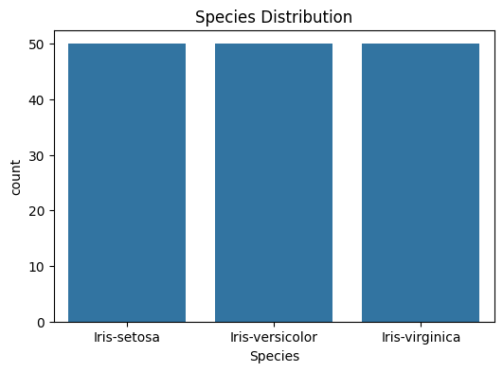
Figure: Target Species Count Distribution Plot
Observation from Species Count Plot: The dataset is perfectly balanced with exactly 50 samples for each species (Iris-setosa, Iris-versicolor, and Iris-virginica), preventing class imbalance issues in training.
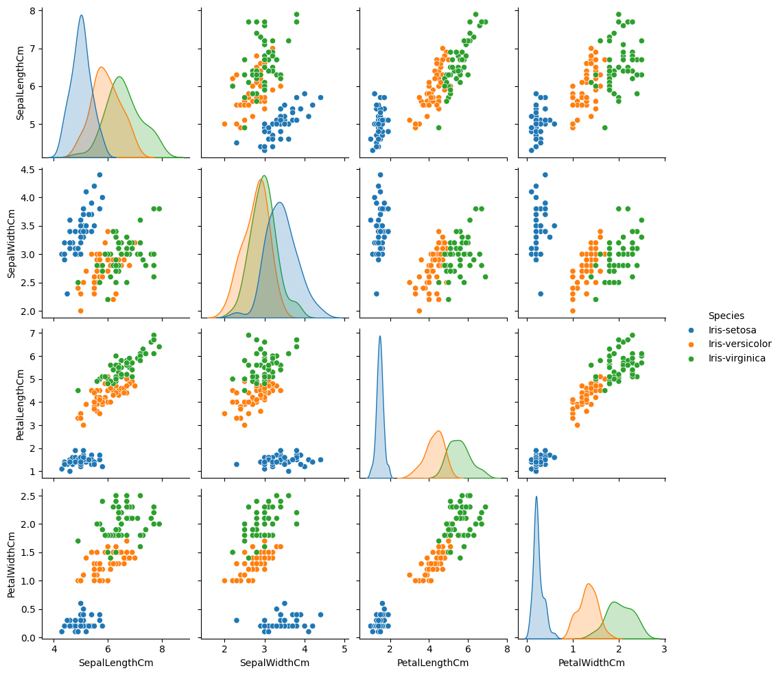
Figure: Pairwise Feature Relationships grouped by Species
Observation from Feature Pairplot: We can clearly observe that Iris-setosa (blue dots) forms an isolated cluster, meaning it is linearly separable from the other two classes using just petal length and width. Conversely, Iris-versicolor and Iris-virginica have overlapping regions, particularly in sepal measurements, demanding a non-linear classifier like Random Forest to separate them accurately.
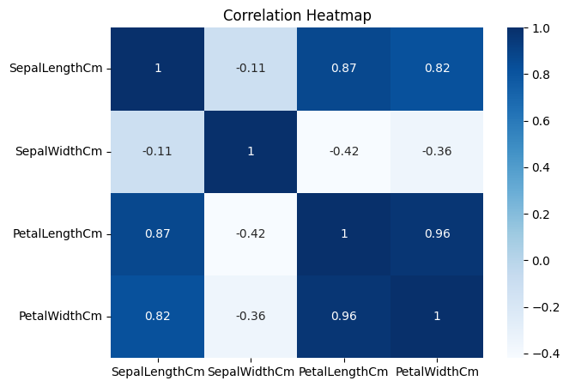
Figure: Correlation Matrix Heatmap for Numerical Features
Observation from Heatmap: There is a extremely strong positive correlation (r = 0.96) between Petal Length and Petal Width. Similarly, Sepal Length shows strong correlation with Petal measurements. In contrast, Sepal Width shows negative correlation with all other features, highlighting distinct growth ratios.
Step 4: Model Development
- Train-Test Split: The dataset was split into 80% training data (120 samples) and 20% testing data (30 samples) using a random state seed of 42 to ensure repeatability.
- Algorithm Selection: A Random Forest Classifier was chosen due to its high accuracy, stability, and resistance to overfitting on small tabular datasets.
- Model Training: The classifier was fitted onto the training features (X_train) and labels (y_train).
Step 5: Model Serialization
The trained model was serialized using the joblib library and saved as iris_model.pkl for quick inference in the future without retraining.
3. Results & Evaluation
3.1. Accuracy Score
The model was tested against the 30 unseen samples in the test set, achieving a perfect classification accuracy of 100.00%.
3.2. Detailed Classification Metrics
The precision, recall, and F1-scores for all three species were evaluated:
Species Name | Class Label | Precision | Recall | F1-Score | Test Samples (Support)
Iris-setosa | 0 | 1.00 | 1.00 | 1.00 | 10
Iris-versicolor | 1 | 1.00 | 1.00 | 1.00 | 9
Iris-virginica | 2 | 1.00 | 1.00 | 1.00 | 11
Overall Accuracy |  | 1.00 | 1.00 | 1.00 | 30

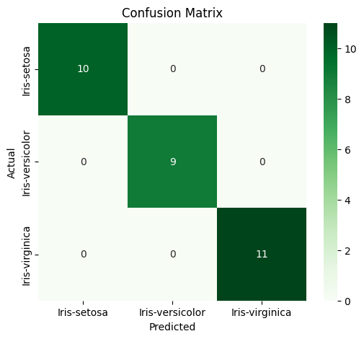
Figure: Evaluation Confusion Matrix
Observation from Confusion Matrix: All 30 test samples were classified with 100% precision. 10 out of 10 Setosa samples, 9 out of 9 Versicolor samples, and 11 out of 11 Virginica samples were predicted correctly, leaving zero misclassification errors.
4. Key Findings & Discoveries
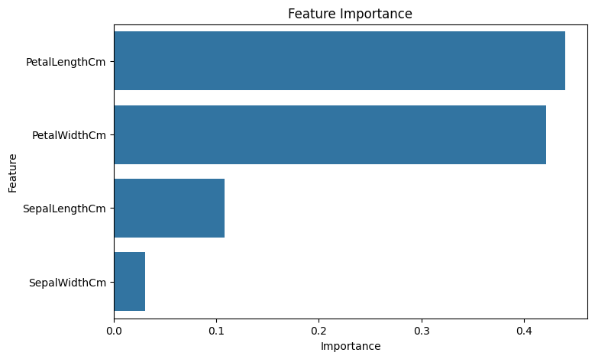
Figure: Random Forest Feature Importances Bar Chart
Observation from Feature Importance: The Random Forest model relied heavily on Petal Width and Petal Length, which represent over 80% of the total predictive weight. Sepal Length and Sepal Width had very minimal importance, indicating that petal dimensions are the defining physiological factor for distinguishing Iris species.
5. Running the Model (Inference Example)
To use the saved model to classify a new flower:
import joblib
# Load the saved model
model = joblib.load("iris_model.pkl")
# New flower data: [SepalLengthCm, SepalWidthCm, PetalLengthCm, PetalWidthCm]
new_flower = [[5.1, 3.5, 1.4, 0.2]]
# Predict
predicted_class = model.predict(new_flower)[0]
species_map = {0: "Iris-setosa", 1: "Iris-versicolor", 2: "Iris-virginica"}
print("Predicted Species:", species_map[predicted_class])
# Output: Predicted Species: Iris-setosa

