**DISD0601 Year2 Group1 PROG6221**

**Student number**: ST10437390

**Name:** Gosego Katleho Matlokwe

**Programming 2A POE Part 1**

Cybersecurity Awareness Chatbot README File

Due date: 4th April 2025

This is the README file for the Cybersecurity Awareness Chatbot C# console app.

This app was developed to assit and educate users on different cybersecurity topics. The highlighted topic on this Part of the POE are phishing, password creation and safe browsing on the internet.

When you first run the application it starts by paying a voice greeting to welcome the user. (The voice greeting should be accessible on the program files of the console app).

* The application will proceed to show the ASCII art image together with a greeting for the user, the first prompt the user will have a request for the user’s name to offer a personalized experience.

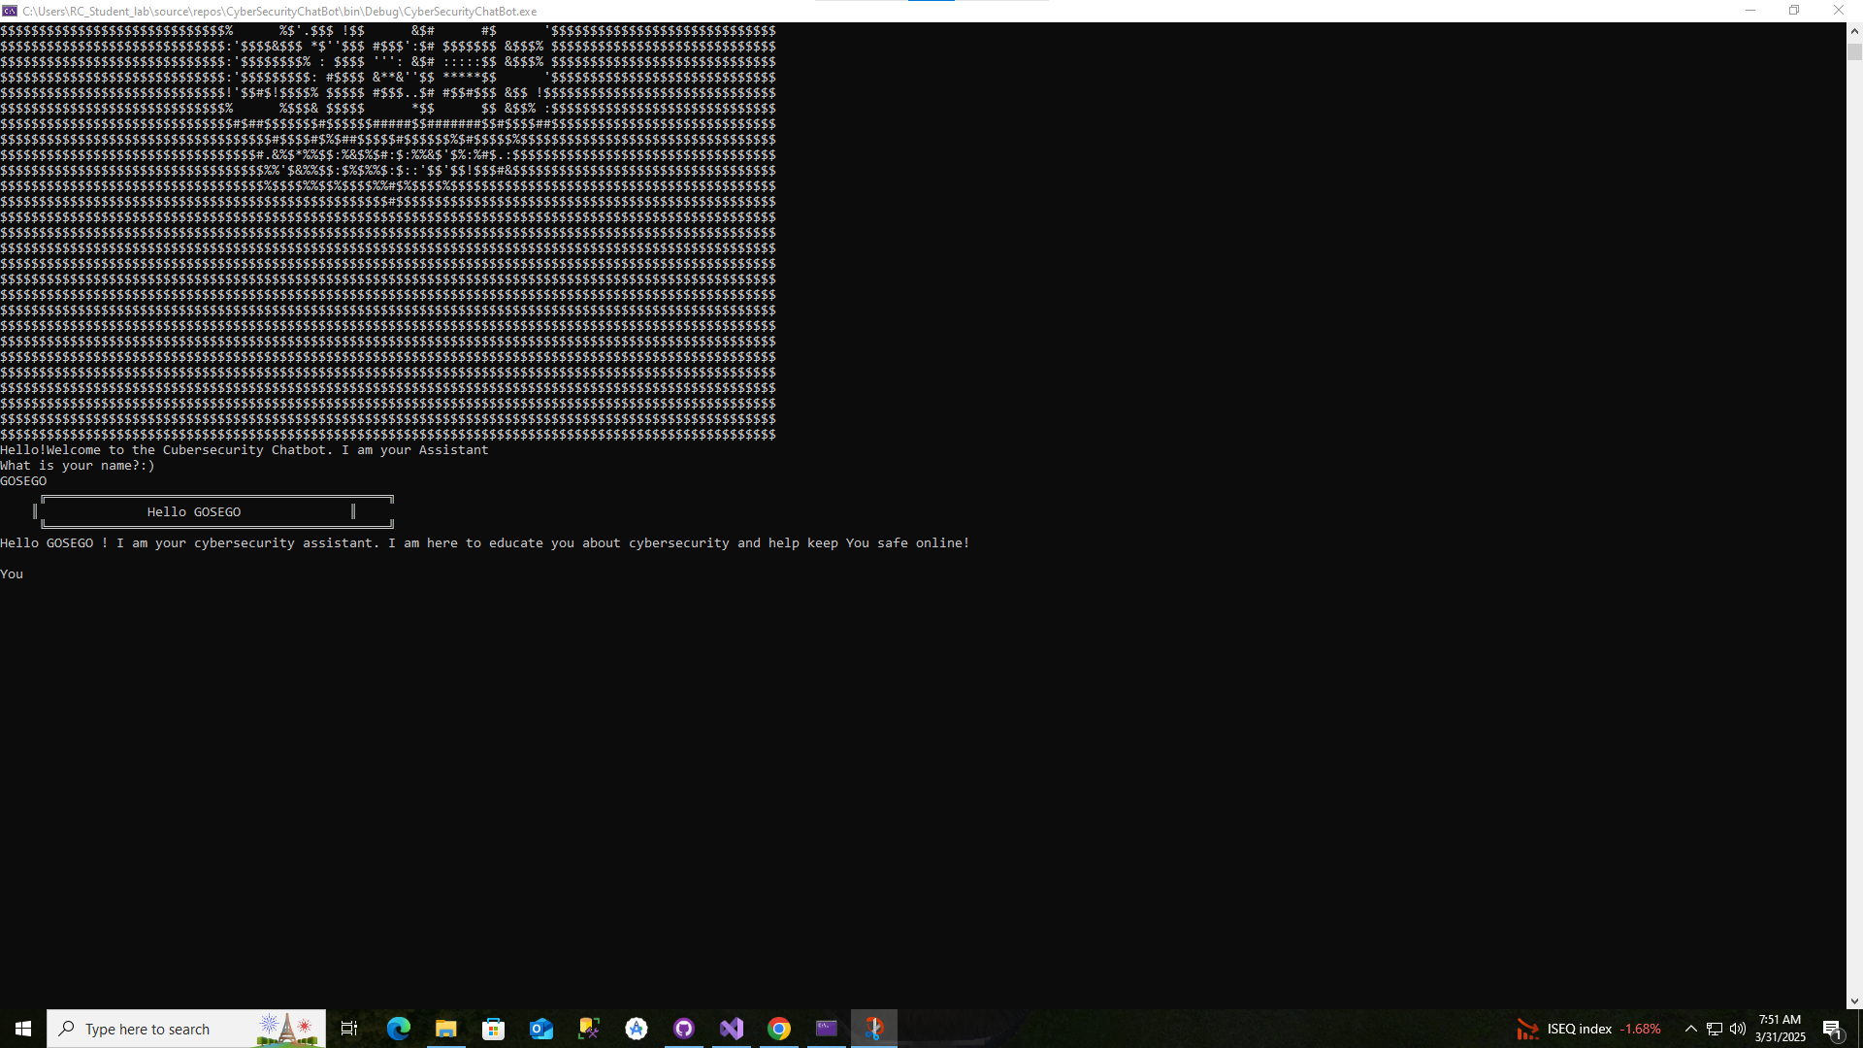

Should the user opt to not provide their name the program will assign the user as User1 as depicted below.

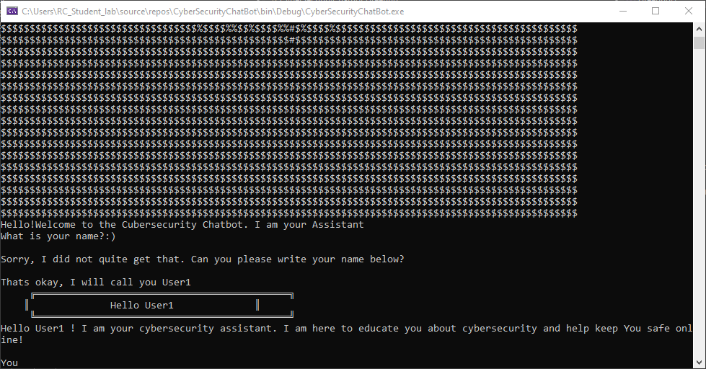

The conversation class is then initailized after the user provides their name and the greeting class ends. This is the list what the chatbot should be able to answer on.

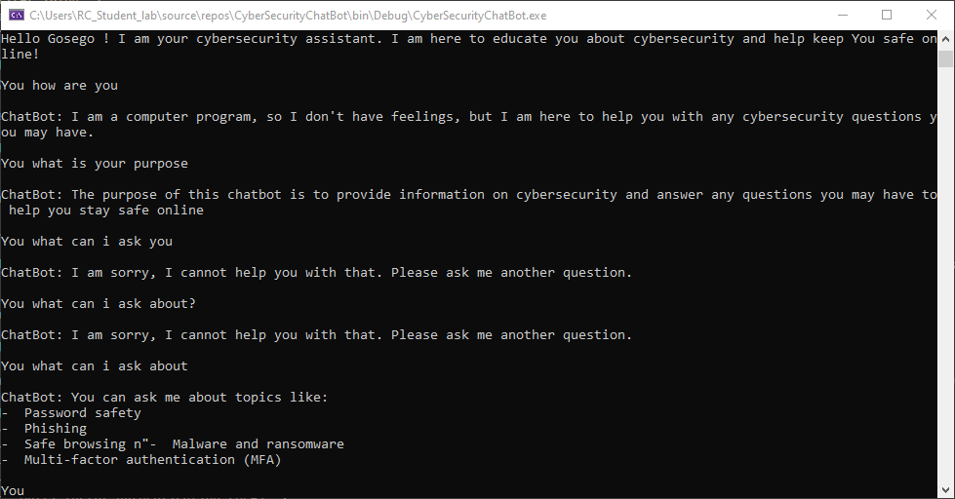

This is what the general the conversation should look like

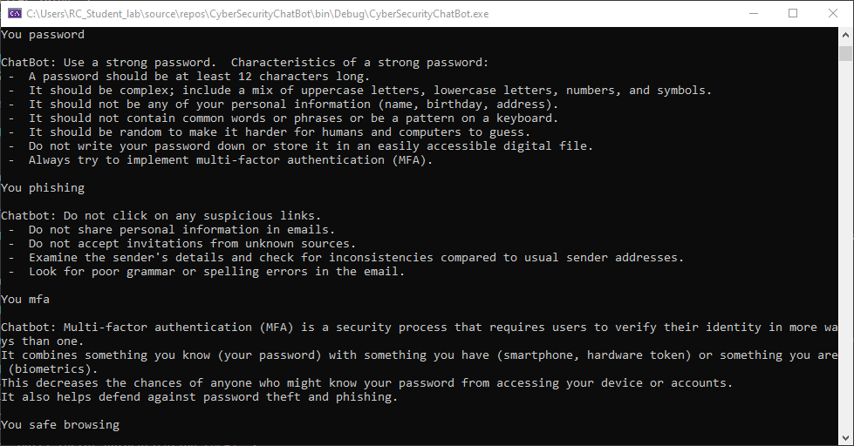

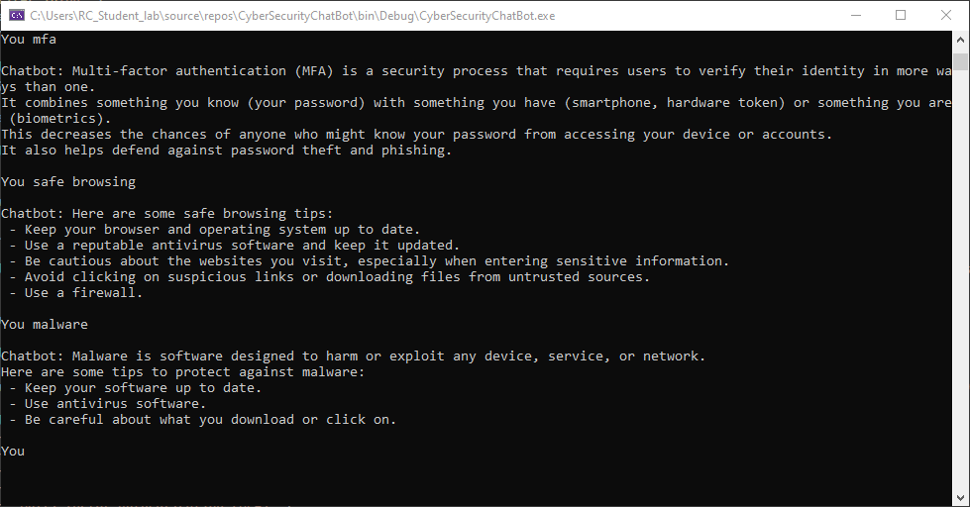

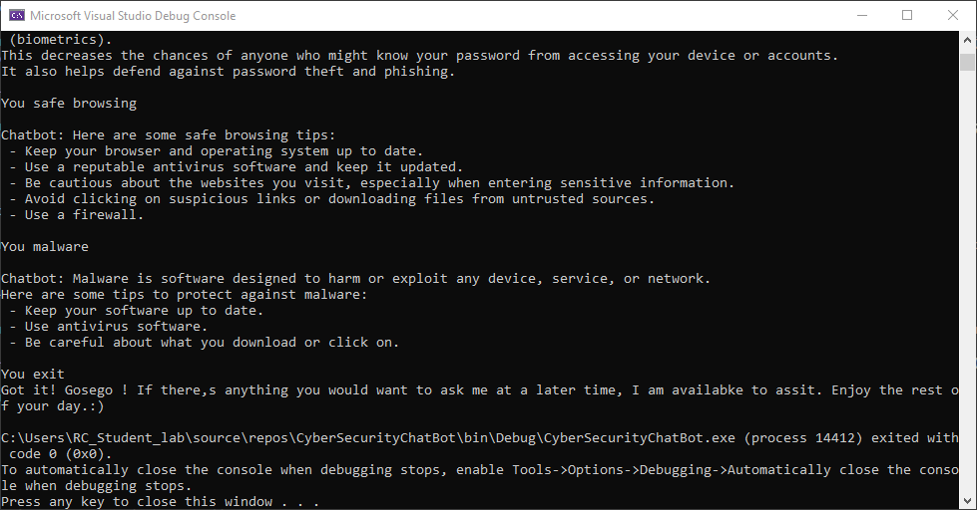

This is the CI workflow

