1. МИНОБРНАУКИ РОССИИ
2. САНКТ-ПЕТЕРБУРГСКИЙ ГОСУДАРСТВЕННЫЙ
3. ЭЛЕКТРОТЕХНИЧЕСКИЙ УНИВЕРСИТЕТ
4. «ЛЭТИ» ИМ. В.И. УЛЬЯНОВА (ЛЕНИНА)
5. Кафедра Вычислительной техники

ОТЧЁТ

по лабораторной работе №2

1. по дисциплине «Операционные системы»
2. Тема: Управление памятью

|  |  |  |
| --- | --- | --- |
| Студент гр. 9308 |  | Соболев М.С. |
| Преподаватель |  | Тимофеев А.В. |

Оглавление

1. Введение 4

2. Исследование виртуального адресного пространства процесса 6

2.1. Получение информации о вычислительной системе 6

2.2. Определение статуса виртуальной памяти 8

2.3. Определение состояния конкретного участка памяти по заданному с клавиатуры адресу 10

2.4. Резервирование региона (и передача ему физической памяти) в автоматическом режиме и в режиме ввода адреса начала региона 11

2.5. Вывод списка зарезервированных пользователем адресов 16

2.6. Запись данных в ячейки памяти по заданным с клавиатуры адресам 17

2.7. Установка защиты доступа для заданного (с клавиатуры) региона памяти и её проверку 19

2.8. Возврат физической памяти и освобождение региона адресного пространства заданного (с клавиатуры) региона памяти 21

2.9. Исходный код программы 24

2.10. Выводы по работе виртуальной памяти 101

2.11. Выводы 103

3. Использование проецируемых файлов для обмена данными между процессами 104

3.1. Создание проецируемого файла приложением-писателем 104

3.2. Открытие проецируемого файла приложением-читателем 106

3.3. Исходный код программы-писателя 108

3.4. Исходный код программы-читателя 113

3.5. Выводы по работе проецируемых файлов 117

3.6. Выводы 118

4. Список использованных источников 119

# 1. Введение

Тема работы: Управление файловой системой.

Цель работы: исследовать механизмы управления виртуальной памятью Win32.

Указания к выполнению

Задание 4.1. Исследовать виртуальное адресное пространство процесса.

1. Создайте консольное приложение с меню (каждая выполняемая функция и/или операция должна быть доступна по отдельному пункту меню), которое выполняет:

− получение информации о вычислительной системе (функция Win32 API – GetSystemInfo);

− определение статуса виртуальной памяти (функция Win32 API – GlobalMemoryStatus);

− определение состояния конкретного участка памяти по заданному с клавиатуры адресу (функция Win32 API – VirtualQuery);

− резервирование региона в автоматическом режиме и в режиме ввода адреса начала региона (функция Win32 API – VirtualAlloc);

− резервирование региона и передача ему физической памяти в автоматическом режиме и в режиме ввода адреса начала региона (функция Win32 API – VirtualAlloc);

− запись данных в ячейки памяти по заданным с клавиатуры адресам;

− установку защиты доступа для заданного (с клавиатуры) региона памяти и ее проверку (функция Win32 API – VirtualProtect);

− возврат физической памяти и освобождение региона адресного пространства заданного (с клавиатуры) региона памяти (функция Win32 API –VirtualFree).

2. Запустите приложение и проверьте его работоспособность на нескольких наборах вводимых данных. Запротоколируйте результаты в отчет. Дайте свои комментарии в отчете относительно выполнения функций Win32 API.

3. Подготовьте итоговый отчет с развернутыми выводами по заданию.

Задание 4.2. Использование проецируемых файлов для обмена данными между процессами.

1. Создайте два консольных приложения с меню (каждая выполняемая функция и/или операция должна быть доступна по отдельному пункту меню), которые выполняют:

− приложение-писатель создает проецируемый файл (функции Win32 API – CreateFile, CreateFileMapping), проецирует фрагмент файла в память (функции Win32 API – MapViewOfFile, UnmapViewOfFile), осуществляет ввод данных с клавиатуры и их запись в спроецированный файл;

− приложение-читатель открывает проецируемый файл (функция Win32 API – OpenFileMapping), проецирует фрагмент файла в память (функции Win32 API – MapViewOfFile, UnmapViewOfFile), считывает содержимое из спроецированного файла и отображает на экран.

2. Запустите приложения и проверьте обмен данных между процессами, удостоверьтесь в надлежащем выполнении задания. Запротоколируйте результаты в отчет. Дайте свои комментарии в отчете относительно выполнения функций Win32 API.

3. Подготовьте итоговый отчет с развернутыми выводами по заданию.

# 2. Исследование виртуального адресного пространства процесса

## 2.1. Получение информации о вычислительной системе

Реализация главного меню программы и вывод информации о вычислительной системе с использованием функции GetSystemInfo().

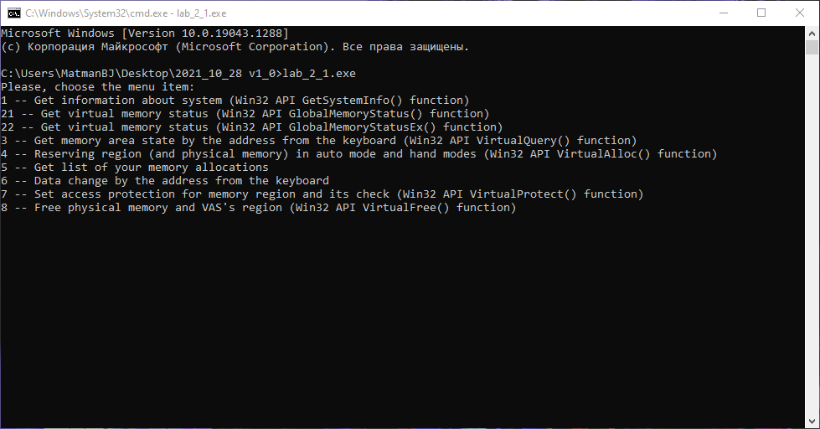

Рисунок 1: Главное меню программы

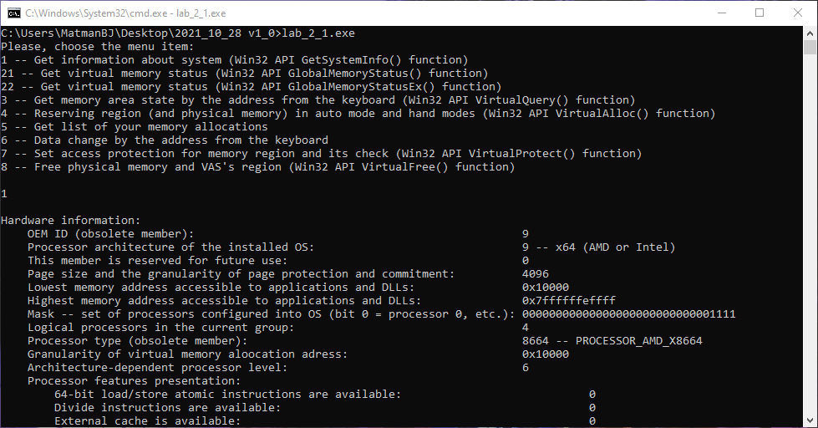

Рисунок 2: Вывод информации о системе

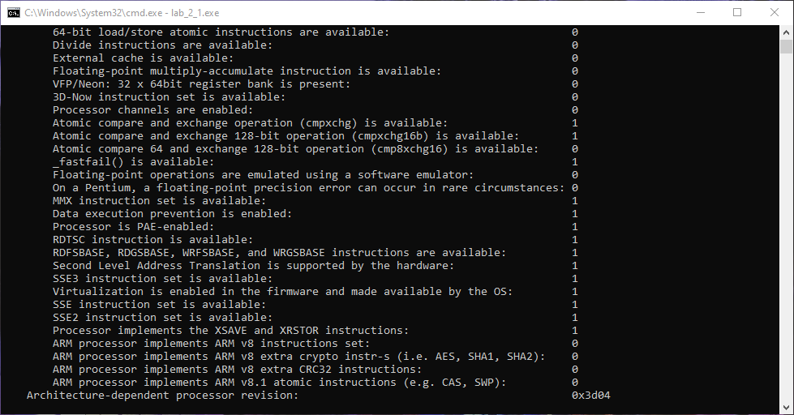

Рисунок 3: Вывод информации о системе

## 2.2. Определение статуса виртуальной памяти

Вывод основной информации о статусе виртуальной памяти с использованием функций GlobalMemoryStatus() и GlobalMemoryStatusEx(). Функция GlobalMemoryStatusEx() рекомендуема согласно документации Microsoft ввиду возможного получения ошибочных данных при использовании функции GlobalMemoryStatus(), однако различия в результатах обеих функций минимальны.

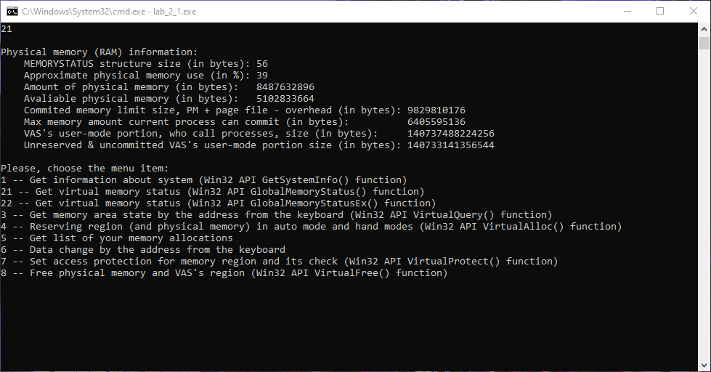

Рисунок 4: Вывод статуса виртуальной памяти

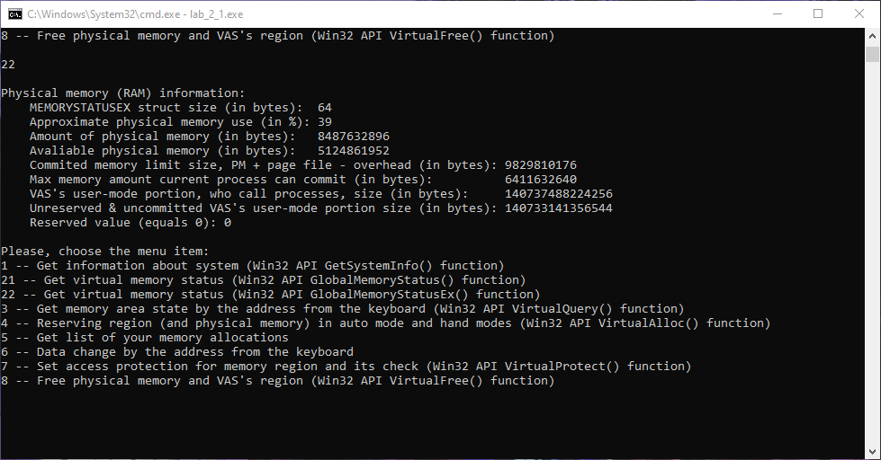

Рисунок 5: Вывод статуса виртуальной памяти

## 2.3. Определение состояния конкретного участка памяти по заданному с клавиатуры адресу

Вывод информации о состоянии конкретного участка памяти по адресу с использованием функции VirtualQuery().

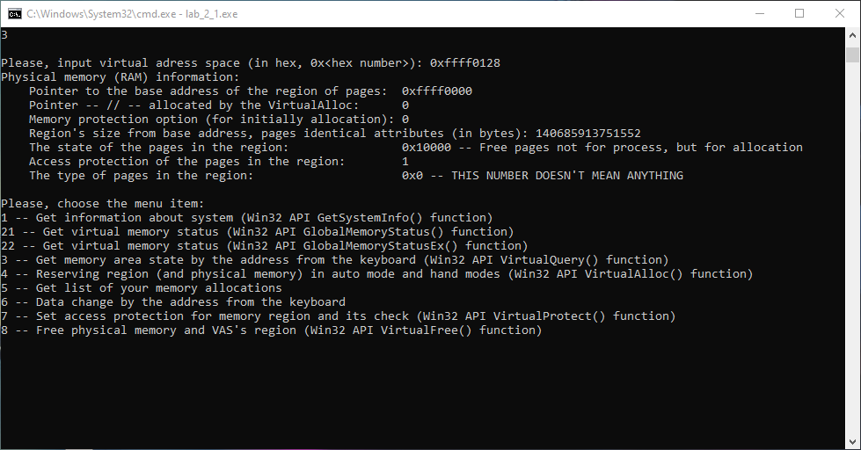

Рисунок 6: Создание каталога

## 2.4. Резервирование региона (и передача ему физической памяти) в автоматическом режиме и в режиме ввода адреса начала региона

Резервирование региона (и передача ему физической памяти) в автоматическом режиме и в режиме ввода адреса начала региона с использованием функции VirtualAlloc(). Резервирование региона, а также передача ему физической памяти реализуются с помощью соответствующих флагов, передаваемых в функцию VirtualAlloc() в качестве параметров.

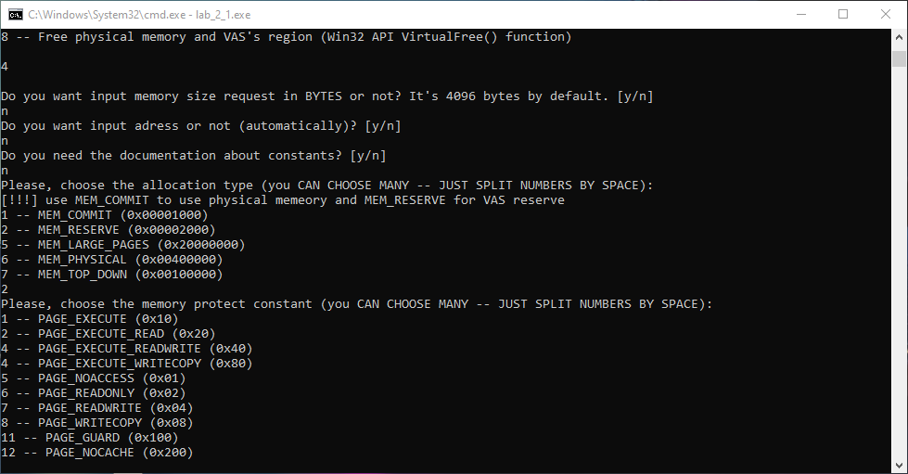

Рисунок 7: Резервирование региона в автоматическом режиме

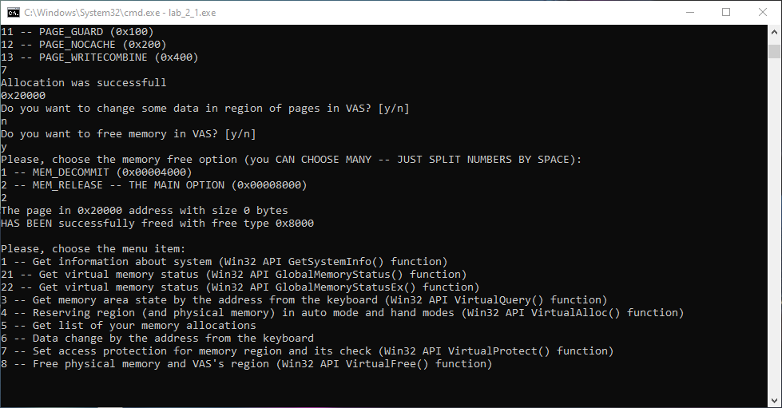

Рисунок 8: Резервирование региона в автоматическом режиме

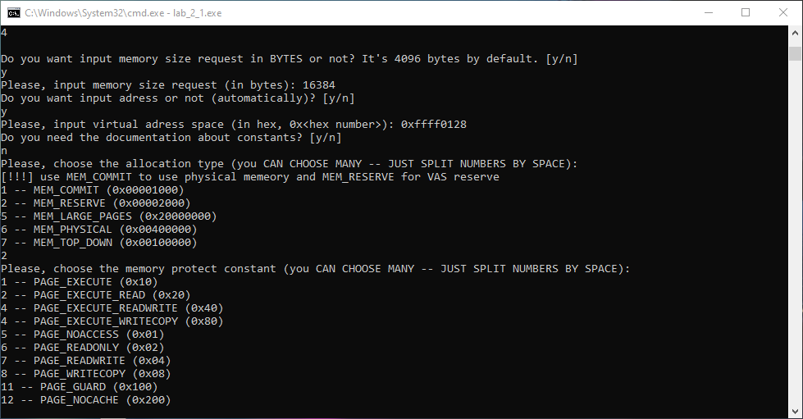

Рисунок 9: Резервирование региона в ручном режиме

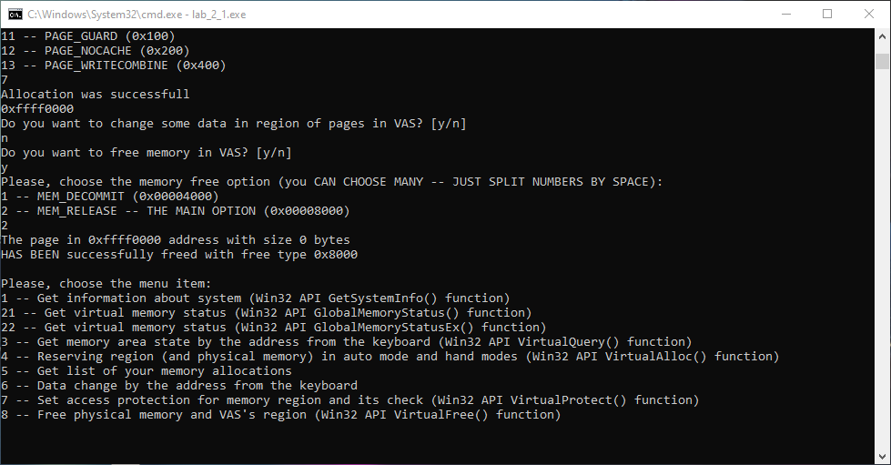

Рисунок 10: Резервирование региона в ручном режиме

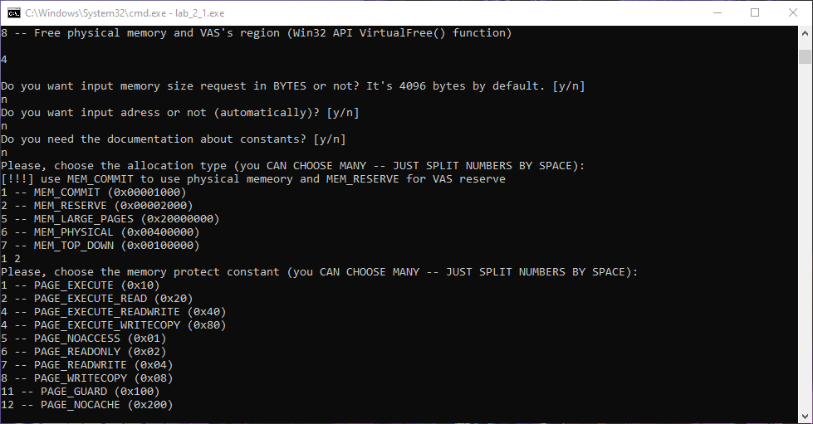

Рисунок 11: Резервирование региона и передача ему физической памяти в автоматическом режиме

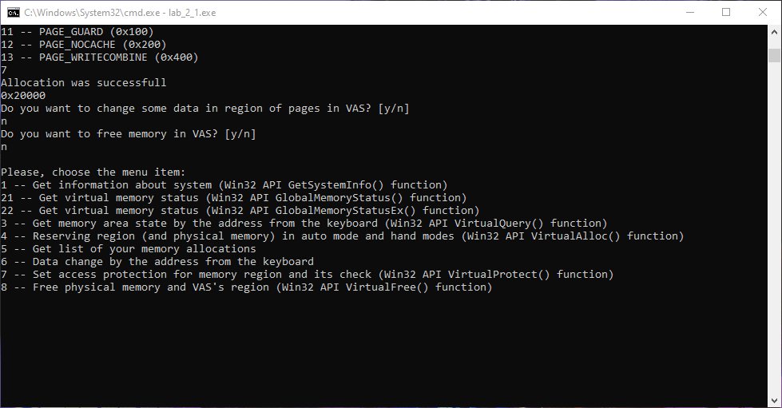

Рисунок 12: Резервирование региона и передача ему физической памяти в автоматическом режиме

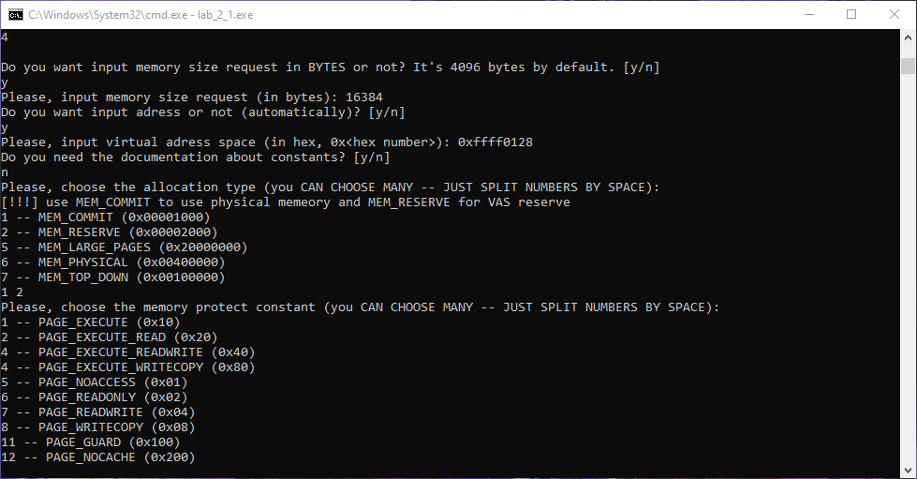

Рисунок 13: Резервирование региона и передача ему физической памяти в ручном режиме

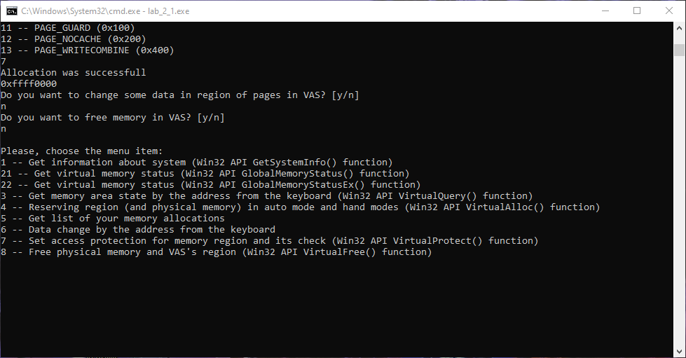

Рисунок 14: Резервирование региона и передача ему физической памяти в ручном режиме

## 2.5. Вывод списка зарезервированных пользователем адресов

Вывод списка зарезервированных пользователем адресов (в том числе и с физической памятью).

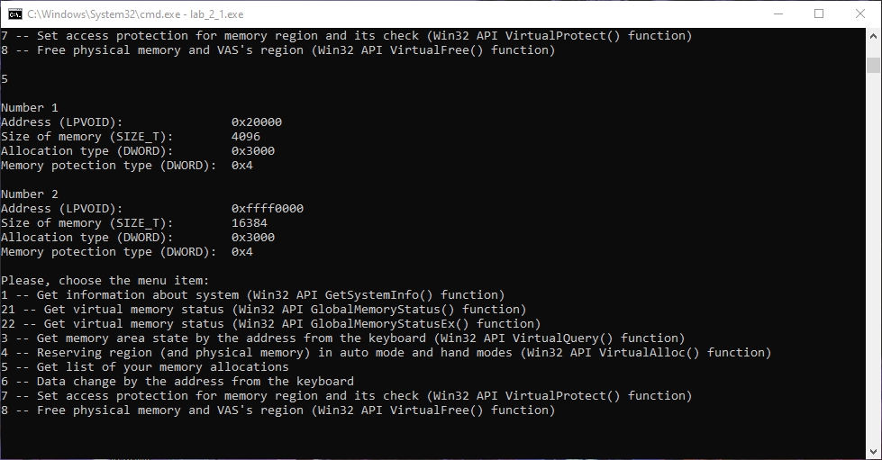

Рисунок 15: Копирование файла

## 2.6. Запись данных в ячейки памяти по заданным с клавиатуры адресам

Запись данных в ячейки памяти по заданным с клавиатуры адресам. Запись данных производится с помощью различных основных типов данных, в том числе логического, символьного, целочисленного и вещественного, которые для ввода и вывода выбирает сам пользователь. Она и просмотр данных возможны на любом участке доступного адресного пространства. В программе реализована проверка вводимого адреса. Запись данных возможна как при выборе соответствующего пункта в меню, так и при выборе соответствующего подраздела в меню выделения памяти после успешного завершения операции.

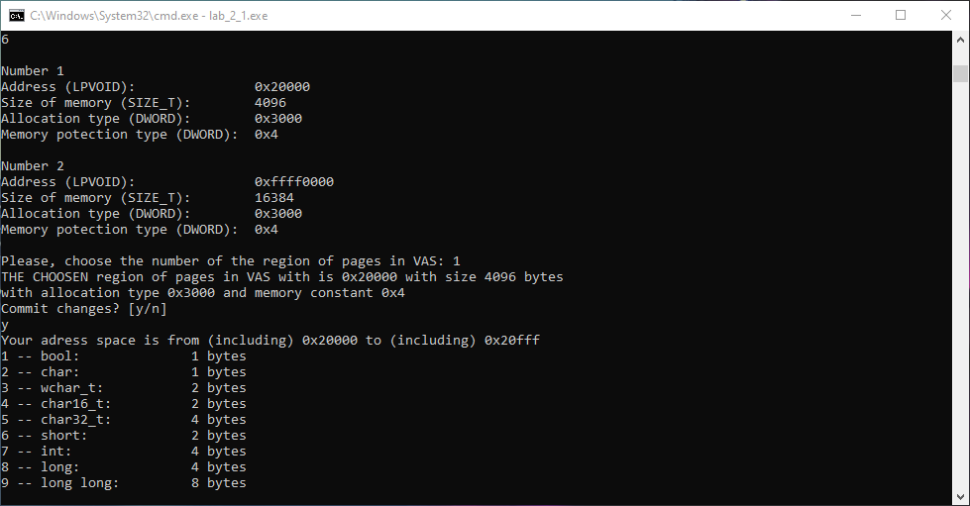

Рисунок 16: Вывод атрибутов файла

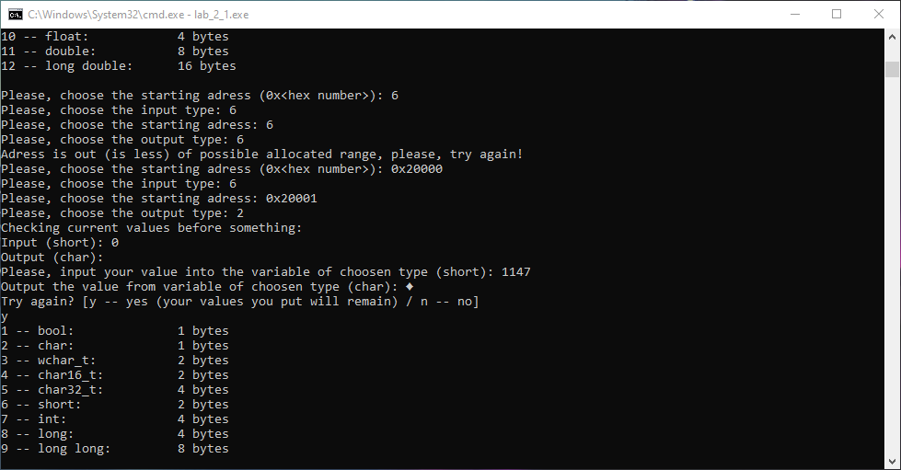

Рисунок 17: Изменение атрибутов файла

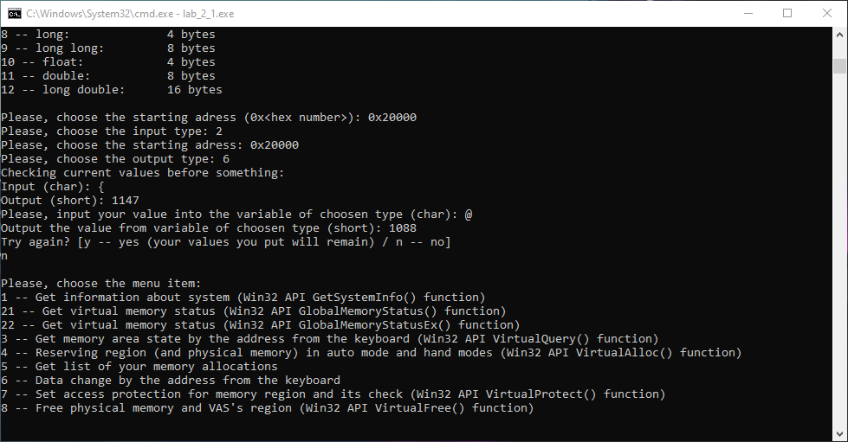

Рисунок 18: Изменённый атрибут файла в свойствах

## 2.7. Установка защиты доступа для заданного (с клавиатуры) региона памяти и её проверку

Установка константы защиты памяти для заданного (с клавиатуры) региона памяти с использованием функции VirtualProtect(). Это происходит с помощью соответствующих флагов, принимаемых функцией в качестве параметра, а в качестве проверки предыдущее и установленное значения констант выводятся. Установка константы защиты памяти производится для выделенных пользователем адресов.

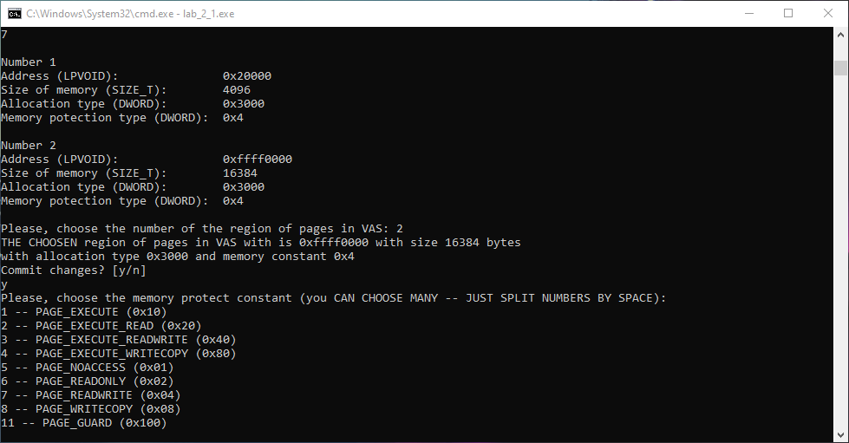

Рисунок 19: Установка константы защиты памяти

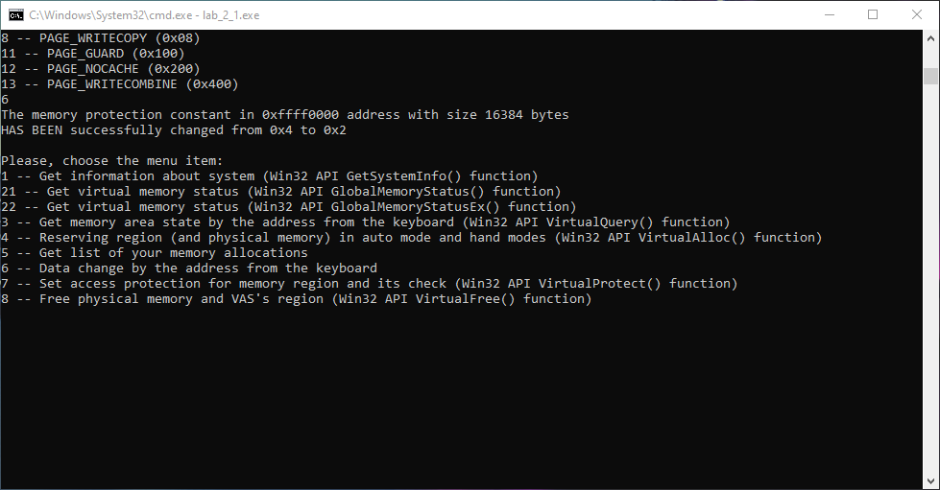

Рисунок 20: Установка константы защиты памяти

## 2.8. Возврат физической памяти и освобождение региона адресного пространства заданного (с клавиатуры) региона памяти

Возврат физической памяти и освобождение региона адресного пространства заданного (с клавиатуры) региона памяти. Это происходит с помощью соответствующих флагов, принимаемых функцией в качестве параметра. Возврат физической памяти и освобождение региона адресного пространства заданного региона памяти производится для выделенных пользователем адресов.

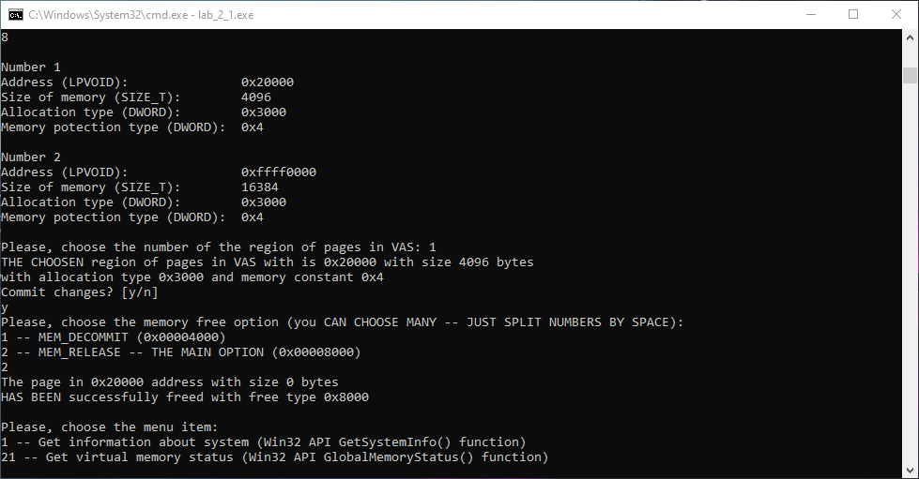

Рисунок 21: Возврат физической памяти и освобождение региона адресного пространства

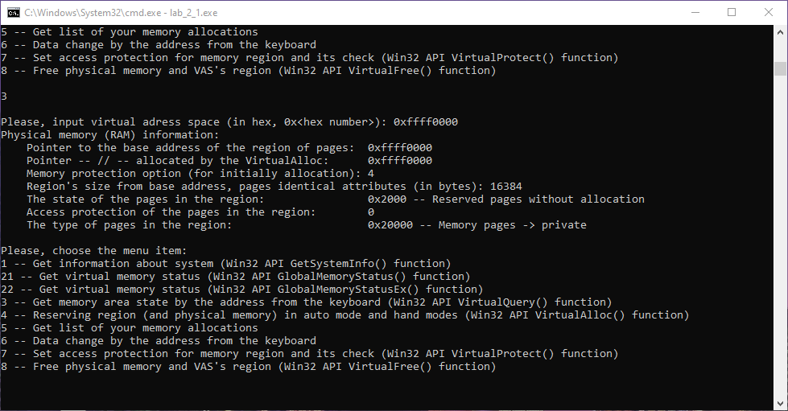

Рисунок 22: Проверка региона адресного пространства

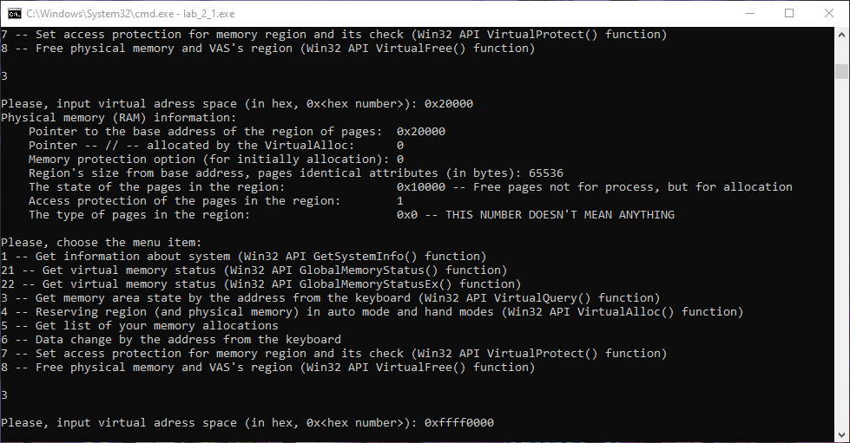

Рисунок 23: Проверка региона адресного пространства

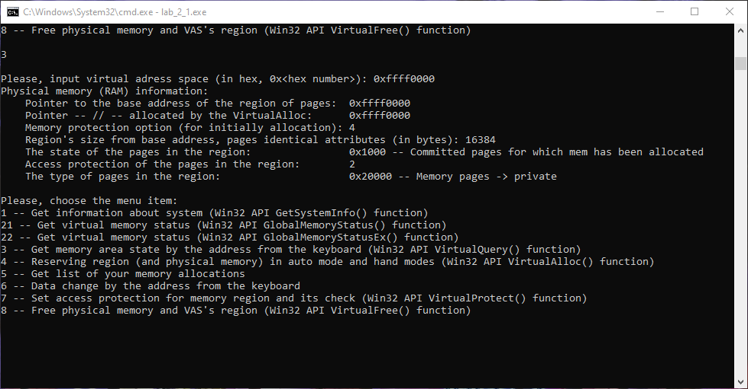

Рисунок 24: Возврат физической памяти

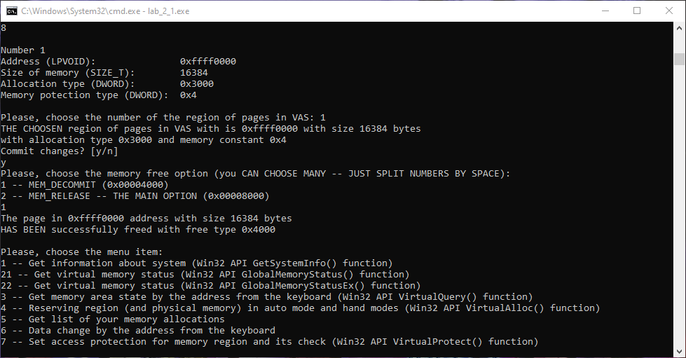

Рисунок 25: Проверка региона адресного пространства

## 2.9. Исходный код программы

/*

Win32 API (WinAPI) is a set of functions in the library <windows.h>

API means "Application Programming Interface"

*/

#include <windows.h> // for WinAPI functions

#include <bitset> // for binary output

#include <math.h> // for double making

#include <exception> // for exceptions

#include <iostream> // just for working

#include <string> // for the "string" type using

#include <vector> // for the "vector" type using

#include <tuple> // for the "tuple" type using

#include <algorithm> // for the "find" function using

using namespace std;

typedef vector<tuple<LPVOID, SIZE_T, DWORD, DWORD>> LOCALLOC; // new thing for locating all local allocations

LOCALLOC listOfAllocations;

// ---------- FUNCTION DECLARATION ----------

bool BoolSafetyInput ();

void MainMenu ();

void Info ();

void LocalGetSystemInfo ();

void LocalGlobalMemoryStatus ();

void LocalGlobalMemoryStatusEx ();

void LocalVirtualQuery ();

void LocalListOfAllocations ();

void LocalListOfAllocationsFree ();

void LocalVirtualAlloc ();

void LocalDataChangeCore (LPVOID localVirtualAlloc, SIZE_T localMemorySize);

void LocalDataChangeIndependent ();

void LocalVirtualProtect ();

void LocalVirtualFreeCore (LPVOID locallpAddress, SIZE_T localdwSize);

void LocalVirtualFreeIndependent ();

// ---------- MAIN ----------

int main (int argc, char* argv[]) // i've finally understood what it means (argc -- number of arguments, argv -- strings of arguments (including -<word> and --<word>))

{

// "GET CURRENT DIRECTORY", "SET CURRENT DIRECTORY"

int flag = -1; // "-1" for incorrect input continue the program

do

{

MainMenu();

cin >> flag;

cout << "\n";

switch (flag)

{

case 0:

cout << "Goodbye!";

break;

case 1:

LocalGetSystemInfo();

break;

case 21:

LocalGlobalMemoryStatus();

break;

case 22:

LocalGlobalMemoryStatusEx();

break;

case 3:

LocalVirtualQuery();

break;

case 4:

LocalVirtualAlloc();

break;

case 5:

LocalListOfAllocations();

break;

case 6:

LocalDataChangeIndependent();

break;

case 7:

LocalVirtualProtect ();

break;

case 8:

LocalVirtualFreeIndependent ();

break;

default:

cout << "Incorrect input! Try again.";

break;

}

}

while (flag != 0);

LocalListOfAllocationsFree ();

return 0;

}

// ---------- 0 -- Bool Safety Input ----------

bool BoolSafetyInput ()

{

string localNewVariable;

bool localNewBool = false;

bool localFlag = true;

while (localFlag == true)

{

fflush(stdin);

getline(cin, localNewVariable);

if (localNewVariable.compare("0") == 0)

{

localNewBool = false;

localFlag = false;

}

else if (localNewVariable.compare("1") == 0)

{

localNewBool = true;

localFlag = false;

}

else

{

cout << "Wrong bool number (use only 0 or 1)!\n";

}

}

return localNewBool;

}

// ---------- 0 -- MAIN MENU ----------

void MainMenu ()

{

cout << "Please, choose the menu item:\n"

<< "1 -- Get information about system (Win32 API GetSystemInfo() function)\n"

<< "21 -- Get virtual memory status (Win32 API GlobalMemoryStatus() function)\n"

<< "22 -- Get virtual memory status (Win32 API GlobalMemoryStatusEx() function)\n"

<< "3 -- Get memory area state by the address from the keyboard (Win32 API VirtualQuery() function)\n"

<< "4 -- Reserving region (and physical memory) in auto mode and hand modes (Win32 API VirtualAlloc() function)\n"

<< "5 -- Get list of your memory allocations\n"

<< "6 -- Data change by the address from the keyboard\n"

<< "7 -- Set access protection for memory region and its check (Win32 API VirtualProtect() function)\n"

<< "8 -- Free physical memory and VAS's region (Win32 API VirtualFree() function)\n"

<< "\n";

}

// ---------- 0 -- INFO ----------

void Info ()

{

cout << "Saint Petersburg Electrotechnical University \"LETI\" (ETU \"LETI\"),\n"

<< "Faculty of Computer Science and Technology \"FKTI\",\n"

<< "Department of Computer Science and Engineering,\n"

<< "Computer Systems Engineering and Informatics (09.03.01) program.\n\n"

<< "OS labortory work 2 \"Memory control\" version 1_0 dated 2021_10_28\n\n"

<< "This software is under MIT License (X11 License).\n"

<< "You can see a detailed description in \"LICENSE.md\" file.\n\n"

<< "Copyight (c) 2021 Sobolev Matvey Sergeevich\n";

}

// ---------- 1 -- LOCAL GET SYSTEM INFO ----------

/*

void GetSystemInfo(

LPSYSTEM_INFO lpSystemInfo

);

typedef struct _SYSTEM_INFO {

union {

DWORD dwOemId;

struct {

WORD wProcessorArchitecture;

WORD wReserved;

} DUMMYSTRUCTNAME;

} DUMMYUNIONNAME;

DWORD dwPageSize;

LPVOID lpMinimumApplicationAddress;

LPVOID lpMaximumApplicationAddress;

DWORD_PTR dwActiveProcessorMask;

DWORD dwNumberOfProcessors;

DWORD dwProcessorType;

DWORD dwAllocationGranularity;

WORD wProcessorLevel;

WORD wProcessorRevision;

} SYSTEM_INFO, *LPSYSTEM_INFO;

*/

void LocalGetSystemInfo()

{

SYSTEM_INFO localSystemInfo; // creating the structure

GetSystemInfo(&localSystemInfo); // sending the pointer and getting the information

cout << "Hardware information:\n"; // information output

// DWORD dwOemId output

cout << " OEM ID (obsolete member): " << localSystemInfo.dwOemId << "\n";

// WORD wProcessorArchitecture output

if (localSystemInfo.wProcessorArchitecture == PROCESSOR_ARCHITECTURE_AMD64) // number 9

{

cout << " Processor architecture of the installed OS: " << localSystemInfo.wProcessorArchitecture << " -- " << "x64 (AMD or Intel)\n";

}

else if (localSystemInfo.wProcessorArchitecture == PROCESSOR_ARCHITECTURE_ARM) // number 5

{

cout << " Processor architecture of the installed OS: " << localSystemInfo.wProcessorArchitecture << " -- " << "ARM\n";

}

else if (localSystemInfo.wProcessorArchitecture == 0x000c /*PROCESSOR_ARCHITECTURE_ARM64*/) // number 12; with "PROCESSOR_ARCHITECTURE_ARM64" it doesn't work

{

cout << " Processor architecture of the installed OS: " << localSystemInfo.wProcessorArchitecture << " -- " << "ARM64\n";

}

else if (localSystemInfo.wProcessorArchitecture == PROCESSOR_ARCHITECTURE_IA64) // number 6

{

cout << " Processor architecture of the installed OS: " << localSystemInfo.wProcessorArchitecture << " -- " << "Intel Itanium-based\n";

}

else if (localSystemInfo.wProcessorArchitecture == PROCESSOR_ARCHITECTURE_INTEL) // number 0

{

cout << " Processor architecture of the installed OS: " << localSystemInfo.wProcessorArchitecture << " -- " << "x86\n";

}

else if (localSystemInfo.wProcessorArchitecture == PROCESSOR_ARCHITECTURE_UNKNOWN) // number 0xffff

{

cout << " Processor architecture of the installed OS: " << localSystemInfo.wProcessorArchitecture << " -- " << "Unknown architecture.\n";

}

else // other number

{

cout << " Processor architecture of the installed OS: " << localSystemInfo.wProcessorArchitecture << " -- " << "THIS NUMBER DOESN'T MEAN ANYTHING\n";

}

// WORD wReserved output

cout << " This member is reserved for future use: " << localSystemInfo.wReserved << "\n";

// DWORD dwPageSize output

cout << " Page size and the granularity of page protection and commitment: " << localSystemInfo.dwPageSize << "\n";

// LPVOID lpMinimumApplicationAddress output

cout << " Lowest memory address accessible to applications and DLLs: " << localSystemInfo.lpMinimumApplicationAddress << "\n";

// LPVOID lpMaximumApplicationAddress output

cout << " Highest memory address accessible to applications and DLLs: " << localSystemInfo.lpMaximumApplicationAddress << "\n";

// DWORD_PTR dwActiveProcessorMask output

cout << " Mask -- set of processors configured into OS (bit 0 = processor 0, etc.): " << bitset<32>(localSystemInfo.dwActiveProcessorMask) << "\n";

// DWORD dwNumberOfProcessors output

cout << " Logical processors in the current group: " << localSystemInfo.dwNumberOfProcessors << "\n";

// DWORD dwProcessorType output

if (localSystemInfo.dwProcessorType == PROCESSOR_INTEL_386) // number 386

{

cout << " Processor type (obsolete member): " << localSystemInfo.dwProcessorType << " -- " << "PROCESSOR_INTEL_386\n";

}

else if (localSystemInfo.dwProcessorType == PROCESSOR_INTEL_486) // number 486

{

cout << " Processor type (obsolete member): " << localSystemInfo.dwProcessorType << " -- " << "PROCESSOR_INTEL_486\n";

}

else if (localSystemInfo.dwProcessorType == PROCESSOR_INTEL_PENTIUM) // number 586; with "PROCESSOR_ARCHITECTURE_ARM64" it doesn't work

{

cout << " Processor type (obsolete member): " << localSystemInfo.dwProcessorType << " -- " << "PROCESSOR_INTEL_PENTIUM\n";

}

else if (localSystemInfo.dwProcessorType == PROCESSOR_INTEL_IA64) // number 2200

{

cout << " Processor type (obsolete member): " << localSystemInfo.dwProcessorType << " -- " << "PROCESSOR_INTEL_IA64\n";

}

else if (localSystemInfo.dwProcessorType == PROCESSOR_AMD_X8664) // number 8664

{

cout << " Processor type (obsolete member): " << localSystemInfo.dwProcessorType << " -- " << "PROCESSOR_AMD_X8664\n";

}

/*else if (localSystemInfo.dwProcessorType == PROCESSOR_ARM) // Reserved

{

cout << " Processor type (obsolete member): " << localSystemInfo.dwProcessorType << " -- " << "PROCESSOR_ARM (Reserved)\n";

}*/

else // other number

{

cout << " Processor type (obsolete member): " << localSystemInfo.dwProcessorType << " -- " << "THIS NUMBER DOESN'T MEAN ANYTHING\n";

}

// DWORD dwAllocationGranularity output

cout << " Granularity of virtual memory aloocation adress: 0x" << hex << localSystemInfo.dwAllocationGranularity << dec << "\n";

// WORD wProcessorLevel output

/*

If wProcessorArchitecture is PROCESSOR_ARCHITECTURE_INTEL, wProcessorLevel is defined by the CPU vendor.

If wProcessorArchitecture is PROCESSOR_ARCHITECTURE_IA64, wProcessorLevel is set to 1.

*/

cout << " Architecture-dependent processor level: " << localSystemInfo.wProcessorLevel << "\n";

// Procaessor features output (it's not a part of the structure)

cout << " Processor features presentation:\n";

cout << " 64-bit load/store atomic instructions are available: " << IsProcessorFeaturePresent(PF_ARM_64BIT_LOADSTORE_ATOMIC) << "\n"; // number 25

cout << " Divide instructions are available: " << IsProcessorFeaturePresent(PF_ARM_DIVIDE_INSTRUCTION_AVAILABLE) << "\n"; // number 24

cout << " External cache is available: " << IsProcessorFeaturePresent(PF_ARM_EXTERNAL_CACHE_AVAILABLE) << "\n"; // number 26

cout << " Floating-point multiply-accumulate instruction is available: " << IsProcessorFeaturePresent(PF_ARM_FMAC_INSTRUCTIONS_AVAILABLE) << "\n"; // number 27

cout << " VFP/Neon: 32 x 64bit register bank is present: " << IsProcessorFeaturePresent(PF_ARM_VFP_32_REGISTERS_AVAILABLE) << "\n"; // number 18

//cout << " VFP/Neon: 32 x 64bit register bank is present (other flag): " << IsProcessorFeaturePresent(PF_ARM_VFP_EXTENDED_REGISTERS) << "\n";

cout << " 3D-Now instruction set is available: " << IsProcessorFeaturePresent(PF_3DNOW_INSTRUCTIONS_AVAILABLE) << "\n"; // number 7

cout << " Processor channels are enabled: " << IsProcessorFeaturePresent(PF_CHANNELS_ENABLED) << "\n"; // number 16

cout << " Atomic compare and exchange operation (cmpxchg) is available: " << IsProcessorFeaturePresent(PF_COMPARE_EXCHANGE_DOUBLE) << "\n"; // number 2

cout << " Atomic compare and exchange 128-bit operation (cmpxchg16b) is available: " << IsProcessorFeaturePresent(PF_COMPARE_EXCHANGE128) << "\n"; // number 14

cout << " Atomic compare 64 and exchange 128-bit operation (cmp8xchg16) is available: " << IsProcessorFeaturePresent(PF_COMPARE64_EXCHANGE128) << "\n"; // number 15

cout << " _fastfail() is available: " << IsProcessorFeaturePresent(PF_FASTFAIL_AVAILABLE) << "\n"; // number 23

cout << " Floating-point operations are emulated using a software emulator: " << IsProcessorFeaturePresent(PF_FLOATING_POINT_EMULATED) << "\n"; // number 1

cout << " On a Pentium, a floating-point precision error can occur in rare circumstances: " << IsProcessorFeaturePresent(PF_FLOATING_POINT_PRECISION_ERRATA) << "\n"; // number 0

cout << " MMX instruction set is available: " << IsProcessorFeaturePresent(PF_MMX_INSTRUCTIONS_AVAILABLE) << "\n"; // number 3

cout << " Data execution prevention is enabled: " << IsProcessorFeaturePresent(PF_NX_ENABLED) << "\n"; // number 12

cout << " Processor is PAE-enabled: " << IsProcessorFeaturePresent(PF_PAE_ENABLED) << "\n"; // number 9

cout << " RDTSC instruction is available: " << IsProcessorFeaturePresent(PF_RDTSC_INSTRUCTION_AVAILABLE) << "\n"; // number 8

cout << " RDFSBASE, RDGSBASE, WRFSBASE, and WRGSBASE instructions are available: " << IsProcessorFeaturePresent(PF_RDWRFSGSBASE_AVAILABLE) << "\n"; // number 22

cout << " Second Level Address Translation is supported by the hardware: " << IsProcessorFeaturePresent(PF_SECOND_LEVEL_ADDRESS_TRANSLATION) << "\n"; // number 20

cout << " SSE3 instruction set is available: " << IsProcessorFeaturePresent(PF_SSE3_INSTRUCTIONS_AVAILABLE) << "\n"; // number 13

cout << " Virtualization is enabled in the firmware and made available by the OS: " << IsProcessorFeaturePresent(PF_VIRT_FIRMWARE_ENABLED) << "\n"; // number 21

cout << " SSE instruction set is available: " << IsProcessorFeaturePresent(PF_XMMI_INSTRUCTIONS_AVAILABLE) << "\n"; // number 6

cout << " SSE2 instruction set is available: " << IsProcessorFeaturePresent(PF_XMMI64_INSTRUCTIONS_AVAILABLE) << "\n"; // number 10

cout << " Processor implements the XSAVE and XRSTOR instructions: " << IsProcessorFeaturePresent(PF_XSAVE_ENABLED) << "\n"; // number 17

//cout << " ARM processor implements the the ARM v8 instructions set: " << IsProcessorFeaturePresent(PF_ARM_V8_INSTRUCTIONS_AVAILABLE) << "\n";

//cout << " ARM processor implements the ARM v8 extra cryptographic instructions (i.e. AES, SHA1 and SHA2): " << IsProcessorFeaturePresent(PF_ARM_V8_CRYPTO_INSTRUCTIONS_AVAILABLE) << "\n";

//cout << " ARM processor implements the ARM v8 extra CRC32 instructions: " << IsProcessorFeaturePresent(PF_ARM_V8_CRC32_INSTRUCTIONS_AVAILABLE) << "\n";

//cout << " ARM processor implements the ARM v8.1 atomic instructions (e.g. CAS, SWP): " << IsProcessorFeaturePresent(PF_ARM_V81_ATOMIC_INSTRUCTIONS_AVAILABLE) << "\n";

cout << " ARM processor implements ARM v8 instructions set: " << IsProcessorFeaturePresent(29) << "\n"; // [crutch]

cout << " ARM processor implements ARM v8 extra crypto instr-s (i.e. AES, SHA1, SHA2): " << IsProcessorFeaturePresent(30) << "\n"; // [crutch]

cout << " ARM processor implements ARM v8 extra CRC32 instructions: " << IsProcessorFeaturePresent(31) << "\n"; // [crutch]

cout << " ARM processor implements ARM v8.1 atomic instructions (e.g. CAS, SWP): " << IsProcessorFeaturePresent(34) << "\n"; // [crutch]

// WORD wProcessorRevision output

/*

Intel Pentium, Cyrix, or NextGen 586:

The high byte is the model and the low byte is the stepping. For example, if the value is xxyy, the model number and stepping can be displayed as follows:

Model xx, Stepping yy

Intel 80386 or 80486:

A value of the form xxyz.

If xx is equal to 0xFF, y - 0xA is the model number, and z is the stepping identifier.

If xx is not equal to 0xFF, xx + 'A' is the stepping letter and yz is the minor stepping.

ARM:

Reserved.

*/

cout << " Architecture-dependent processor revision: 0x" << hex << localSystemInfo.wProcessorRevision << dec << "\n";

/*if (localSystemInfo.dwProcessorType == PROCESSOR_INTEL_386 || localSystemInfo.dwProcessorType == PROCESSOR_INTEL_486)

{

if ((localSystemInfo.wProcessorRevision / 256) == 0xff)

{

cout << " Model number: " << (localSystemInfo.wProcessorRevision % 256) - (localSystemInfo.wProcessorRevision % 16) - 0xa << "\n";

cout << " Stepping identifier: " << (localSystemInfo.wProcessorRevision % 16) << "\n";

}

else

{

cout << " Stepping letter: " << (localSystemInfo.wProcessorRevision / 256) + 'A' << "\n";

cout << " Minor stepping: " << (localSystemInfo.wProcessorRevision % 256) + 'A' << "\n";

}

}

else if (localSystemInfo.dwProcessorType == PROCESSOR_INTEL_PENTIUM || localSystemInfo.dwProcessorType == PROCESSOR_INTEL_IA64 || localSystemInfo.dwProcessorType == PROCESSOR_AMD_X8664)

{

cout << " Model: " << (localSystemInfo.wProcessorRevision / 256) << "\n";

cout << " Stepping: " << (localSystemInfo.wProcessorRevision % 256) << "\n";

}

else

{}*/

cout << "\n";

}

// ---------- 2 -- LOCAL GLOBAL MEMORY STATUS ----------

/*

void GlobalMemoryStatus(

LPMEMORYSTATUS lpBuffer

);

typedef struct _MEMORYSTATUS {

DWORD dwLength;

DWORD dwMemoryLoad;

SIZE_T dwTotalPhys;

SIZE_T dwAvailPhys;

SIZE_T dwTotalPageFile;

SIZE_T dwAvailPageFile;

SIZE_T dwTotalVirtual;

SIZE_T dwAvailVirtual;

} MEMORYSTATUS, *LPMEMORYSTATUS;

*/

void LocalGlobalMemoryStatus ()

{

MEMORYSTATUS localMemoryStatus; // creating structure

GlobalMemoryStatus(&localMemoryStatus); // sending the pointer and getting the information

cout << "Physical memory (RAM) information:\n"; // information output

// DWORD dwLength output

cout << " MEMORYSTATUS structure size (in bytes): " << localMemoryStatus.dwLength << "\n";

// DWORD dwMemoryLoad output

cout << " Approximate physical memory use (in %): " << localMemoryStatus.dwMemoryLoad << "\n";

// SIZE_T dwTotalPhys output

cout << " Amount of physical memory (in bytes): " << localMemoryStatus.dwTotalPhys << "\n";

// SIZE_T dwAvailPhys output

cout << " Avaliable physical memory (in bytes): " << localMemoryStatus.dwAvailPhys << "\n";

// SIZE_T dwTotalPageFile output

cout << " Commited memory limit size, PM + page file - overhead (in bytes): " << localMemoryStatus.dwTotalPageFile << "\n";

// SIZE_T dwAvailPageFile output

cout << " Max memory amount current process can commit (in bytes): " << localMemoryStatus.dwAvailPageFile << "\n";

// SIZE_T dwTotalVirtual output

cout << " VAS's user-mode portion, who call processes, size (in bytes): " << localMemoryStatus.dwTotalVirtual << "\n";

// SIZE_T dwAvailVirtual output

cout << " Unreserved & uncommitted VAS's user-mode portion size (in bytes): " << localMemoryStatus.dwAvailVirtual << "\n";

cout << "\n";

}

// ---------- 2 -- LOCAL GLOBAL MEMORY STATUS EX ----------

/*

BOOL GlobalMemoryStatusEx(

LPMEMORYSTATUSEX lpBuffer

);

typedef struct _MEMORYSTATUSEX {

DWORD dwLength;

DWORD dwMemoryLoad;

DWORDLONG ullTotalPhys;

DWORDLONG ullAvailPhys;

DWORDLONG ullTotalPageFile;

DWORDLONG ullAvailPageFile;

DWORDLONG ullTotalVirtual;

DWORDLONG ullAvailVirtual;

DWORDLONG ullAvailExtendedVirtual;

} MEMORYSTATUSEX, *LPMEMORYSTATUSEX;

*/

void LocalGlobalMemoryStatusEx ()

{

MEMORYSTATUSEX localMemoryStatusEx; // creating structure

localMemoryStatusEx.dwLength = sizeof (localMemoryStatusEx); // necessarily, without it it doesn't work!!!

bool localFlag = GlobalMemoryStatusEx(&localMemoryStatusEx); // sending the pointer and getting the information

// Physical memory refers to the actual RAM of the system

if (localFlag == true)

{

cout << "Physical memory (RAM) information:\n"; // information output

// DWORD dwLength output

cout << " MEMORYSTATUSEX struct size (in bytes): " << localMemoryStatusEx.dwLength << "\n";

// DWORD dwMemoryLoad output

cout << " Approximate physical memory use (in %): " << localMemoryStatusEx.dwMemoryLoad << "\n";

// DWORDLONG ullTotalPhys output

cout << " Amount of physical memory (in bytes): " << localMemoryStatusEx.ullTotalPhys << "\n";

// DWORDLONG ullAvailPhys output

cout << " Avaliable physical memory (in bytes): " << localMemoryStatusEx.ullAvailPhys << "\n";

// DWORDLONG ullTotalPageFile output

cout << " Commited memory limit size, PM + page file - overhead (in bytes): " << localMemoryStatusEx.ullTotalPageFile << "\n";

// DWORDLONG ullAvailPageFile output

cout << " Max memory amount current process can commit (in bytes): " << localMemoryStatusEx.ullAvailPageFile << "\n";

// DWORDLONG ullTotalVirtual output

cout << " VAS's user-mode portion, who call processes, size (in bytes): " << localMemoryStatusEx.ullTotalVirtual << "\n";

// DWORDLONG ullAvailVirtual output

cout << " Unreserved & uncommitted VAS's user-mode portion size (in bytes): " << localMemoryStatusEx.ullAvailVirtual << "\n";

// DWORDLONG ullAvailExtendedVirtual output

cout << " Reserved value (equals 0): " << localMemoryStatusEx.ullAvailExtendedVirtual << "\n";

}

else

{

cout << "Something went wrong! Last error code: " << GetLastError() << "\n";

}

cout << "\n";

}

// ---------- 3 -- LOCAL VIRTUAL QUERY ----------

/*

SIZE_T VirtualQuery(

LPCVOID lpAddress,

PMEMORY_BASIC_INFORMATION lpBuffer,

SIZE_T dwLength

);

typedef struct _MEMORY_BASIC_INFORMATION {

PVOID BaseAddress;

PVOID AllocationBase;

DWORD AllocationProtect;

WORD PartitionId;

SIZE_T RegionSize;

DWORD State;

DWORD Protect;

DWORD Type;

} MEMORY_BASIC_INFORMATION, *PMEMORY_BASIC_INFORMATION;

*/

void LocalVirtualQuery ()

{

DWORD localAdress = 0x11376077;

//DWORD localAdress = -1; // creating adress variable

MEMORY_BASIC_INFORMATION localBuffer; // creating buffer for information write

SIZE_T localLength; // creating size variable (for what?)

do

{

cout << "Please, input virtual adress space (in hex, 0x<hex number>): ";

cin >> hex >> localAdress >> dec;

} while (localAdress < 0x00000000 || localAdress > 0xffffffff);

// The return value is the actual number of bytes returned in the information buffer.

// If the function fails, the return value is zero. To get extended error information, call GetLastError. Possible error values include ERROR_INVALID_PARAMETER.

SIZE_T localVirtualQuery = VirtualQuery ((LPVOID)localAdress, &localBuffer, sizeof(localBuffer));

// LPVOID -- pointer

// LPCVOID -- pointer to constant

// Physical memory refers to the actual RAM of the system

if (localVirtualQuery != 0)

{

cout << "Physical memory (RAM) information:\n"; // information output

// PVOID BaseAddress output

cout << " Pointer to the base address of the region of pages: " << localBuffer.BaseAddress << "\n";

// PVOID AllocationBase output

cout << " Pointer -- // -- allocated by the VirtualAlloc: " << localBuffer.AllocationBase << "\n";

// DWORD AllocationProtect output

cout << " Memory protection option (for initially allocation): " << localBuffer.AllocationProtect << "\n";

// WORD PartitionId output

//cout << " Partition ID (?): " << localBuffer.PartitionId << "\n"; // compiler can't recognize that

// SIZE_T RegionSize output

cout << " Region's size from base address, pages identical attributes (in bytes): " << localBuffer.RegionSize << "\n";

// DWORD State output

if (localBuffer.State == MEM_COMMIT) // number 0x1000

{

cout << " The state of the pages in the region: 0x" << hex << localBuffer.State << dec << " -- " << "Committed pages for which mem has been allocated\n";

}

else if (localBuffer.State == MEM_FREE) // number 0x10000

{

cout << " The state of the pages in the region: 0x" << hex << localBuffer.State << dec << " -- " << "Free pages not for process, but for allocation\n";

}

else if (localBuffer.State == MEM_RESERVE) // number 0x2000

{

cout << " The state of the pages in the region: 0x" << hex << localBuffer.State << dec << " -- " << "Reserved pages without allocation\n";

}

else // another number

{

cout << " The state of the pages in the region: 0x" << hex << localBuffer.State << dec << " -- " << "THIS NUMBER DOESN'T MEAN ANYTHING\n";

}

// DWORD Protect output

cout << " Access protection of the pages in the region: " << localBuffer.Protect << "\n";

// DWORD Type output

if (localBuffer.Type == MEM_IMAGE) // number 0x1000000

{

cout << " The type of pages in the region: 0x" << hex << localBuffer.Type << dec << " -- " << "Memory pages -> image section\n";

}

else if (localBuffer.Type == MEM_MAPPED) // number 0x40000

{

cout << " The type of pages in the region: 0x" << hex << localBuffer.Type << dec << " -- " << "Memory pages -> section\n";

}

else if (localBuffer.Type == MEM_PRIVATE) // number 0x20000

{

cout << " The type of pages in the region: 0x" << hex << localBuffer.Type << dec << " -- " << "Memory pages -> private\n";

}

else // another number

{

cout << " The type of pages in the region: 0x" << hex << localBuffer.Type << dec << " -- " << "THIS NUMBER DOESN'T MEAN ANYTHING\n";

}

}

else

{

cout << "Something went wrong! Last error code: " << GetLastError() << "\n";

}

cout << "\n";

}

// ---------- 5 -- LIST OF ALLOCATIONS ----------

void LocalListOfAllocations ()

{

if (listOfAllocations.size() > 0)

{

//listOfAllocations.push_back(tuple<LPVOID, SIZE_T, DWORD, DWORD>((LPVOID)0x00000000, 4096, MEM_RESET, MEM_COMMIT)); // initialize example

//get<3>(listOfAllocations[0]) = MEM_RESET; // change example

int j = 1;

for (LOCALLOC::const_iterator i = listOfAllocations.begin(); i != listOfAllocations.end(); i++)

{

cout << "Number " << j << "\n";

cout << "Address (LPVOID):\t\t" << get<0>(*i) << "\n";

cout << "Size of memory (SIZE_T):\t" << get<1>(*i) << "\n";

cout << "Allocation type (DWORD):\t" << hex << "0x" << get<2>(*i) << dec << "\n";

cout << "Memory potection type (DWORD):\t" << hex << "0x" << get<3>(*i) << dec << "\n\n";

j = j + 1;

}

}

else

{

cout << "Sorry, your HAVEN'T any region of pages in VAS! Allocate something first (choose from the main menu)!\n\n";

}

}

// ---------- 5 -- LIST OF ALLOCATIONS FREE ----------

void LocalListOfAllocationsFree ()

{

for (LOCALLOC::const_iterator i = listOfAllocations.begin(); i != listOfAllocations.end(); i++)

{

listOfAllocations.erase(i); // erasing vector

}

}

// ---------- 5 -- LOCAL VIRTUAL ALLOC ----------

/*

LPVOID VirtualAlloc(

[in, optional] LPVOID lpAddress,

[in] SIZE_T dwSize,

[in] DWORD flAllocationType,

[in] DWORD flProtect

);

*/

void LocalVirtualAlloc ()

{

DWORD localflAllocationType = 0;

DWORD localflProtect = 0;

//DWORD localAddress = -1; // creating adress variable

MEMORY_BASIC_INFORMATION localBuffer; // creating buffer for information write

SIZE_T localLength; // creating size variable (for what?)

SIZE_T localMemorySize = 4096;

char localHelp = '-';

string localChooseAllocation = "0";

string localChooseProtect = "0";

LPVOID locallpAddress = (LPVOID)0x11376077;

// The return value is the actual number of bytes returned in the information buffer.

// If the function fails, the return value is zero. To get extended error information, call GetLastError. Possible error values include ERROR_INVALID_PARAMETER.

//LPVOID localVirtualAlloc = VirtualAlloc (NULL, localMemorySize, MEM_RESERVE, PAGE_READWRITE);

// LPVOID -- pointer

// LPCVOID -- pointer to constant

localHelp = '-';

// requesting memory size request

while (localHelp != 'y' && localHelp != 'n')

{

cout << "Do you want input memory size request in BYTES or not? It's 4096 bytes by default. [y/n]\n";

cin >> localHelp;

}

// setting memory size request

if (localHelp == 'y')

{

do

{

cout << "Please, input memory size request (in bytes): ";

cin >> localMemorySize;

//cout << localMemorySize << "[memeory size request check]";

}

while (localMemorySize < 0);

}

localHelp = '-';

// requesting adress input type

while (localHelp != 'y' && localHelp != 'n')

{

cout << "Do you want input adress or not (automatically)? [y/n]\n";

cin >> localHelp;

}

// setting adress input type

if (localHelp == 'y')

{

do

{

cout << "Please, input virtual adress space (in hex, 0x<hex number>): ";

cin >> hex >> locallpAddress >> dec;

//cout << locallpAddress << "[adress check]";

}

while (locallpAddress < (LPVOID)0x00000000 || locallpAddress > (LPVOID)0xffffffff);

}

else

{

locallpAddress = NULL;

}

localHelp = '-';

// requesting help pages

while (localHelp != 'y' && localHelp != 'n')

{

cout << "Do you need the documentation about constants? [y/n]\n";

cin >> localHelp;

}

// help pages menu

if (localHelp == 'y')

{

localHelp = '-';

// requesting the documentation output

while (localHelp != 'y' && localHelp != 'n')

{

cout << "Do you need the documentation about constants? [y/n]\n";

cin >> localHelp;

}

// printing the documentation output

if (localHelp == 'y')

{

cout << "[in] flAllocationType:\n\n";

cout << "The type of memory allocation. This parameter must contain one of the following values.\n\n";

cout << "MEM_COMMIT (0x00001000):\n\n"

<< "Allocates memory charges (from the overall size of memory and the paging files on disk) for the specified reserved memory pages.\n"

<< "The function also guarantees that when the caller later initially accesses the memory, the contents will be zero.\n"

<< "Actual physical pages are not allocated unless/until the virtual addresses are actually accessed.\n"

<< "To reserve and commit pages in one step, call VirtualAlloc with MEM_COMMIT | MEM_RESERVE.\n"

<< "Attempting to commit a specific address range by specifying MEM_COMMIT without MEM_RESERVE and a non-NULL lpAddress fails unless the entire range has already been reserved.\n"

<< "The resulting error code is ERROR_INVALID_ADDRESS.\n"

<< "An attempt to commit a page that is already committed does not cause the function to fail. This means that you can commit pages without first determining the current commitment state of each page.\n"

<< "If lpAddress specifies an address within an enclave, flAllocationType must be MEM_COMMIT.\n\n";

cout << "MEM_RESERVE (0x00002000):\n\n"

<< "Reserves a range of the process's virtual address space without allocating any actual physical storage in memory or in the paging file on disk.\n"

<< "You can commit reserved pages in subsequent calls to the VirtualAlloc function.\n"

<< "To reserve and commit pages in one step, call VirtualAlloc with MEM_COMMIT | MEM_RESERVE.\n"

<< "Other memory allocation functions, such as malloc and LocalAlloc, cannot use a reserved range of memory until it is released.\n\n";

cout << "MEM_RESET (0x00080000):\n\n"

<< "Indicates that data in the memory range specified by lpAddress and dwSize is no longer of interest.\n"

<< "The pages should not be read from or written to the paging file.\n"

<< "However, the memory block will be used again later, so it should not be decommitted.\n"

<< "This value cannot be used with any other value.\n"

<< "Using this value does not guarantee that the range operated on with MEM_RESET will contain zeros.\n"

<< "If you want the range to contain zeros, decommit the memory and then recommit it.\n"

<< "When you specify MEM_RESET, the VirtualAlloc function ignores the value of flProtect.\n"

<< "However, you must still set flProtect to a valid protection value, such as PAGE_NOACCESS.\n"

<< "VirtualAlloc returns an error if you use MEM_RESET and the range of memory is mapped to a file.\n"

<< "A shared view is only acceptable if it is mapped to a paging file.\n\n";

cout << "MEM_RESET_UNDO (0x1000000):\n\n"

<< "MEM_RESET_UNDO should only be called on an address range to which MEM_RESET was successfully applied earlier.\n"

<< "It indicates that the data in the specified memory range specified by lpAddress and dwSize is of interest to the caller and attempts to reverse the effects of MEM_RESET.\n"

<< "If the function succeeds, that means all data in the specified address range is intact.\n"

<< "If the function fails, at least some of the data in the address range has been replaced with zeroes.\n"

<< "This value cannot be used with any other value.\n"

<< "If MEM_RESET_UNDO is called on an address range which was not MEM_RESET earlier, the behavior is undefined.\n"

<< "When you specify MEM_RESET, the VirtualAlloc function ignores the value of flProtect.\n"

<< "However, you must still set flProtect to a valid protection value, such as PAGE_NOACCESS.\n"

<< "Windows Server 2008 R2, Windows 7, Windows Server 2008, Windows Vista, Windows Server 2003 and Windows XP:\n"

<< "The MEM_RESET_UNDO flag is not supported until Windows 8 and Windows Server 2012.\n\n";

cout << "This parameter can also specify the following values as indicated.\n\n";

}

localHelp = '-';

// requesting the documentation output

while (localHelp != 'y' && localHelp != 'n')

{

cout << "Do you need the minimum size of a large page? [y/n]\n";

cin >> localHelp;

}

// printing the minimum size of a large page

if (localHelp == 'y')

{

cout << "The minimum size of a large page: " << GetLargePageMinimum() << "\n";

}

}

// choosing and setting the allocation type constant

while (localflAllocationType == 0)

{

cout << "Please, choose the allocation type (you CAN CHOOSE MANY -- JUST SPLIT NUMBERS BY SPACE):\n"

<< "[!!!] use MEM_COMMIT to use physical memeory and MEM_RESERVE for VAS reserve\n"

<< "1 -- MEM_COMMIT (0x00001000)\n"

<< "2 -- MEM_RESERVE (0x00002000)\n"

//<< "3 -- MEM_RESET (0x00080000)\n" // if MEM_RESET_UNDO doesn't work, then MEM_RESET usage is dangerous

//<< "4 -- MEM_RESET_UNDO (0x1000000)\n" // compiler declaration error

<< "5 -- MEM_LARGE_PAGES (0x20000000)\n"

<< "6 -- MEM_PHYSICAL (0x00400000)\n"

<< "7 -- MEM_TOP_DOWN (0x00100000)\n";

//<< "8 -- MEM_WRITE_WATCH (0x00200000)\n"; // no GetWriteWatch and ResetWriteWatch functions in program

fflush(stdin);

std::getline(std::cin, localChooseAllocation);

// spit the string

std::string s = string(localChooseAllocation);

std::string delimiter = " ";

int i = 0;

size_t pos = 0;

std::string token;

std::vector<string> v;

std::vector<int> vect{1, 2, 3, 4, 5, 6, 7, 8}; // all possible switch case numbers (DON'T FORGET WRITE THEM FROM MENU UP THERE)

while ((pos = s.find(delimiter)) != std::string::npos)

{

int tmpNumber = 0;

token = s.substr(0, pos);

v.push_back(token);

tmpNumber = std::stoi(token);

if (std::find(vect.begin(), vect.end(), tmpNumber) != vect.end())

{

switch (tmpNumber) // choosing number

{

case 1:

localflAllocationType = localflAllocationType | MEM_COMMIT;

break;

case 2:

localflAllocationType = localflAllocationType | MEM_RESERVE;

break;

case 3:

//localflAllocationType = localflAllocationType | MEM_RESET; // if MEM_RESET_UNDO doesn't work, then MEM_RESET usage is dangerous

break;

case 4:

//localflAllocationType = localflAllocationType | MEM_RESET_UNDO; // compiler declaration error

break;

case 5:

localflAllocationType = localflAllocationType | MEM_LARGE_PAGES;

break;

case 6:

localflAllocationType = localflAllocationType | MEM_PHYSICAL;

break;

case 7:

localflAllocationType = localflAllocationType | MEM_TOP_DOWN;

break;

case 8:

//localflAllocationType = localflAllocationType | MEM_WRITE_WATCH; // no GetWriteWatch and ResetWriteWatch functions in program

break;

default:

localflAllocationType = localflAllocationType | MEM_RESERVE;

break;

}

vect.erase(std::remove(vect.begin(), vect.end(), tmpNumber), vect.end());

}

//std::cout << token << std::endl;

s.erase(0, pos + delimiter.length());

}

int newTMPNumber = std::stoi(s);

if (std::find(vect.begin(), vect.end(), newTMPNumber) != vect.end())

{

switch (newTMPNumber) // choosing number

{

case 1:

localflAllocationType = localflAllocationType | MEM_COMMIT;

break;

case 2:

localflAllocationType = localflAllocationType | MEM_RESERVE;

break;

case 3:

//localflAllocationType = localflAllocationType | MEM_RESET; // if MEM_RESET_UNDO doesn't work, then MEM_RESET usage is dangerous

break;

case 4:

//localflAllocationType = localflAllocationType | MEM_RESET_UNDO; // compiler declaration error

break;

case 5:

localflAllocationType = localflAllocationType | MEM_LARGE_PAGES;

break;

case 6:

localflAllocationType = localflAllocationType | MEM_PHYSICAL;

break;

case 7:

localflAllocationType = localflAllocationType | MEM_TOP_DOWN;

break;

case 8:

//localflAllocationType = localflAllocationType | MEM_WRITE_WATCH; // no GetWriteWatch and ResetWriteWatch functions in program

break;

default:

localflAllocationType = localflAllocationType | MEM_RESERVE;

break;

}

vect.erase(std::remove(vect.begin(), vect.end(), newTMPNumber), vect.end());

}

//std::cout << s << std::endl;

// end split of the string

if (localflAllocationType == 0)

{

cout << "Try again!\n";

}

}

// choosing and setting the memory protect constant

while (localflProtect == 0)

{

cout << "Please, choose the memory protect constant (you CAN CHOOSE MANY -- JUST SPLIT NUMBERS BY SPACE):\n"

<< "1 -- PAGE_EXECUTE (0x10)\n"

<< "2 -- PAGE_EXECUTE_READ (0x20)\n"

<< "4 -- PAGE_EXECUTE_READWRITE (0x40)\n"

<< "4 -- PAGE_EXECUTE_WRITECOPY (0x80)\n"

<< "5 -- PAGE_NOACCESS (0x01)\n"

<< "6 -- PAGE_READONLY (0x02)\n"

<< "7 -- PAGE_READWRITE (0x04)\n"

<< "8 -- PAGE_WRITECOPY (0x08)\n"

//<< "9 -- PAGE_TARGETS_INVALID (0x40000000)\n" // compiler declaration error

//<< "10 -- PAGE_TARGETS_NO_UPDATE (0x40000000)\n" // compiler declaration error

<< "11 -- PAGE_GUARD (0x100)\n"

<< "12 -- PAGE_NOCACHE (0x200)\n"

<< "13 -- PAGE_WRITECOMBINE (0x400)\n";

fflush(stdin);

std::getline(std::cin, localChooseProtect);

// spit the string

std::string s = string(localChooseProtect);

std::string delimiter = " ";

int i = 0;

size_t pos = 0;

std::string token;

std::vector<string> v;

std::vector<int> vect{1, 2, 3, 4, 5, 6, 7, 8, 9, 10, 11, 12, 13}; // all possible switch case numbers (DON'T FORGET WRITE THEM FROM MENU UP THERE)

while ((pos = s.find(delimiter)) != std::string::npos)

{

int tmpNumber = 0;

token = s.substr(0, pos);

v.push_back(token);

tmpNumber = std::stoi(token);

if (std::find(vect.begin(), vect.end(), tmpNumber) != vect.end())

{

switch (tmpNumber) // choosing number

{

case 1:

localflProtect = localflProtect | PAGE_EXECUTE;

break;

case 2:

localflProtect = localflProtect | PAGE_EXECUTE_READ;

break;

case 3:

localflProtect = localflProtect | PAGE_EXECUTE_READWRITE;

break;

case 4:

localflProtect = localflProtect | PAGE_EXECUTE_WRITECOPY;

break;

case 5:

localflProtect = localflProtect | PAGE_NOACCESS;

break;

case 6:

localflProtect = localflProtect | PAGE_READONLY;

break;

case 7:

localflProtect = localflProtect | PAGE_READWRITE;

break;

case 8:

localflProtect = localflProtect | PAGE_WRITECOPY;

break;

case 9:

//localflProtect = localflProtect | PAGE_TARGETS_INVALID; // compiler declaration error

break;

case 10:

//localflProtect = localflProtect | PAGE_TARGETS_NO_UPDATE; // compiler declaration error

break;

case 11:

localflProtect = localflProtect | PAGE_GUARD;

break;

case 12:

localflProtect = localflProtect | PAGE_NOCACHE;

break;

case 13:

localflProtect = localflProtect | PAGE_WRITECOMBINE;

break;

default:

localflProtect = localflProtect | PAGE_READWRITE;

break;

}

vect.erase(std::remove(vect.begin(), vect.end(), tmpNumber), vect.end());

}

//std::cout << token << std::endl;

s.erase(0, pos + delimiter.length());

}

int newTMPNumber = std::stoi(s);

if (std::find(vect.begin(), vect.end(), newTMPNumber) != vect.end())

{

switch (newTMPNumber) // choosing number

{

case 1:

localflProtect = localflProtect | PAGE_EXECUTE;

break;

case 2:

localflProtect = localflProtect | PAGE_EXECUTE_READ;

break;

case 3:

localflProtect = localflProtect | PAGE_EXECUTE_READWRITE;

break;

case 4:

localflProtect = localflProtect | PAGE_EXECUTE_WRITECOPY;

break;

case 5:

localflProtect = localflProtect | PAGE_NOACCESS;

break;

case 6:

localflProtect = localflProtect | PAGE_READONLY;

break;

case 7:

localflProtect = localflProtect | PAGE_READWRITE;

break;

case 8:

localflProtect = localflProtect | PAGE_WRITECOPY;

break;

case 9:

//localflProtect = localflProtect | PAGE_TARGETS_INVALID; // compiler declaration error

break;

case 10:

//localflProtect = localflProtect | PAGE_TARGETS_NO_UPDATE; // compiler declaration error

break;

case 11:

localflProtect = localflProtect | PAGE_GUARD;

break;

case 12:

localflProtect = localflProtect | PAGE_NOCACHE;

break;

case 13:

localflProtect = localflProtect | PAGE_WRITECOMBINE;

break;

default:

localflProtect = localflProtect | PAGE_READWRITE;

break;

}

vect.erase(std::remove(vect.begin(), vect.end(), newTMPNumber), vect.end());

}

//std::cout << s << std::endl;

// end split of the string

if (localflProtect == 0)

{

cout << "Try again!\n";

}

}

LPVOID localVirtualAlloc = VirtualAlloc (locallpAddress, localMemorySize, localflAllocationType, localflProtect);

if (localVirtualAlloc != NULL)

{

cout << "Allocation was successfull\n" << localVirtualAlloc << "\n";

// putting my values

localHelp = '-';

// requesting data change

while (localHelp != 'y' && localHelp != 'n')

{

cout << "Do you want to change some data in region of pages in VAS? [y/n]\n";

cin >> localHelp;

}

// data change

if (localHelp == 'y')

{

LocalDataChangeCore (localVirtualAlloc, localMemorySize);

}

// freeing memory

localHelp = '-';

// requesting freeing memory

while (localHelp != 'y' && localHelp != 'n')

{

cout << "Do you want to free memory in VAS? [y/n]\n";

cin >> localHelp;

}

// freeing memory

if (localHelp == 'y') // if free -- then freeing and checking it

{

LocalVirtualFreeCore(localVirtualAlloc, localMemorySize);

/*if (VirtualFree (localVirtualAlloc, 0, MEM_RELEASE))

{

cout << "Free was successfull\n";

}

else

{

cout << "Free was NOT successfull. The last error code: " << GetLastError() << "\n";

}*/

}

else // if no -- put in in the list, i mean vector

{

listOfAllocations.push_back(tuple<LPVOID, SIZE_T, DWORD, DWORD>(localVirtualAlloc, localMemorySize, localflAllocationType, localflProtect));

}

}

else

{

cout << "Allocation was NOT successfull. The last error code: " << GetLastError() << "\n";

}

cout << "\n";

}

// ---------- 6 -- LOCAL DATA CHANGE CORE ----------

void LocalDataChangeCore (LPVOID localVirtualAlloc, SIZE_T localMemorySize)

{

cout << "Your adress space is from (including) " << localVirtualAlloc << " to (including) " << localVirtualAlloc + localMemorySize - 1 << "\n";

char localRepeatMain = 'y'; // repeating all the checking

while (localRepeatMain == 'y')

{

bool localRepeat = true; // repeating input

int localStartingType = 1; // type choose for input

int localEndingType = 1; // type choose for output

SIZE_T localStartingSize = 0; // memory size for output

SIZE_T localEndingSize = 0; // memory size for output

LPVOID localStartingAddress = localVirtualAlloc; // starting address for input

LPVOID localEndingAddress = localVirtualAlloc; // starting address for output

// all possible types of types initializing

// input

bool* localBool;

char* localChar;

wchar_t* localWCharT;

char16_t* localChar16T;

char32_t* localChar32T;

short* localShort;

int* localInt;

long* localLong;

long long* localLongLong;

float* localFloat;

double* localDouble;

long double* localLongDouble;

// output

bool* localBoolOut;

char* localCharOut;

wchar_t* localWCharTOut;

char16_t* localChar16TOut;

char32_t* localChar32TOut;

short* localShortOut;

int* localIntOut;

long* localLongOut;

long long* localLongLongOut;

float* localFloatOut;

double* localDoubleOut;

long double* localLongDoubleOut;

// all possible types of types choosing

cout << "1 -- bool:\t\t" << sizeof(bool) << " bytes\n";

cout << "2 -- char:\t\t" << sizeof(char) << " bytes\n";

cout << "3 -- wchar_t:\t\t" << sizeof(wchar_t) << " bytes\n";

cout << "4 -- char16_t:\t\t" << sizeof(char16_t) << " bytes\n";

cout << "5 -- char32_t:\t\t" << sizeof(char32_t) << " bytes\n";

cout << "6 -- short:\t\t" << sizeof(short) << " bytes\n";

cout << "7 -- int:\t\t" << sizeof(int) << " bytes\n";

cout << "8 -- long:\t\t" << sizeof(long) << " bytes\n";

cout << "9 -- long long:\t\t" << sizeof(long long) << " bytes\n";

cout << "10 -- float:\t\t" << sizeof(float) << " bytes\n";

cout << "11 -- double:\t\t" << sizeof(double) << " bytes\n";

cout << "12 -- long double:\t" << sizeof(long double) << " bytes\n\n";

localRepeat = true; // if i will run this code again (UPT: THIS IS BUG, FIXED)

while (localRepeat == true)

{

// input and output adress and type choosing

cout << "Please, choose the starting adress (0x<hex number>): ";

cin >> hex >> localStartingAddress >> dec;

cout << "Please, choose the input type: ";

cin >> localStartingType;

cout << "Please, choose the starting adress: ";

cin >> hex >> localEndingAddress >> dec;

cout << "Please, choose the output type: ";

cin >> localEndingType;

switch (localStartingType) // starting input address size qualification

{

case 1:

localStartingSize = sizeof(bool);

break;

case 2:

localStartingSize = sizeof(char);

break;

case 3:

localStartingSize = sizeof(wchar_t);

break;

case 4:

localStartingSize = sizeof(char16_t);

break;

case 5:

localStartingSize = sizeof(char32_t);

break;

case 6:

localStartingSize = sizeof(short);

break;

case 7:

localStartingSize = sizeof(int);

break;

case 8:

localStartingSize = sizeof(long);

break;

case 9:

localStartingSize = sizeof(long long);

break;

case 10:

localStartingSize = sizeof(float);

break;

case 11:

localStartingSize = sizeof(double);

break;

case 12:

localStartingSize = sizeof(long double);

break;

default:

localStartingSize = sizeof(bool);

break;

}

switch (localEndingType) // starting output size address qualification

{

case 1:

localEndingSize = sizeof(bool);

break;

case 2:

localEndingSize = sizeof(char);

break;

case 3:

localEndingSize = sizeof(wchar_t);

break;

case 4:

localEndingSize = sizeof(char16_t);

break;

case 5:

localEndingSize = sizeof(char32_t);

break;

case 6:

localEndingSize = sizeof(short);

break;

case 7:

localEndingSize = sizeof(int);

break;

case 8:

localEndingSize = sizeof(long);

break;

case 9:

localEndingSize = sizeof(long long);

break;

case 10:

localEndingSize = sizeof(float);

break;

case 11:

localEndingSize = sizeof(double);

break;

case 12:

localEndingSize = sizeof(long double);

break;

default:

localEndingSize = sizeof(bool);

break;

}

if (localStartingAddress < localVirtualAlloc || localEndingAddress < localVirtualAlloc)

{

cout << "Adress is out (is less) of possible allocated range, please, try again!\n";

}

else if (localStartingSize + localStartingAddress - 1 > localVirtualAlloc + localMemorySize - 1

|| localEndingSize + localEndingAddress - 1 > localVirtualAlloc + localMemorySize - 1)

{

cout << "Address with/without memory is out (is more) of possible allocated range, please, try again!\n";

}

else

{

localRepeat = false; // if there is no errors, the program will run

}

}

// checking all values AND SETTING ADDRESSES

cout << "Checking current values before something:\n";

cout << "Input";

switch (localStartingType)

{

case 1:

localBool = (bool*)localStartingAddress;

cout << " (bool): ";

cout << *localBool;

break;

case 2:

localChar = (char*)localStartingAddress;

cout << " (char): ";

cout << *localChar;

break;

case 3:

localWCharT = (wchar_t*)localStartingAddress;

cout << " (wchar_t): ";

cout << *localWCharT;

break;

case 4:

localChar16T = (char16_t*)localStartingAddress;

cout << " (char16_t): ";

cout << *localChar16T;

break;

case 5:

localChar32T = (char32_t*)localStartingAddress;

cout << " (char32_t): ";

cout << *localChar32T;

break;

case 6:

localShort = (short*)localStartingAddress;

cout << " (short): ";

cout << *localShort;

break;

case 7:

localInt = (int*)localStartingAddress;

cout << " (int): ";

cout << *localInt;

break;

case 8:

localLong = (long*)localStartingAddress;

cout << " (long): ";

cout << *localLong;

break;

case 9:

localLongLong = (long long*)localStartingAddress;

cout << " (long long): ";

cout << *localLongLong;

break;

case 10:

localFloat = (float*)localStartingAddress;

cout << " (float): ";

cout << *localFloat;

break;

case 11:

localDouble = (double*)localStartingAddress;

cout << " (double): ";

cout << *localDouble;

break;

case 12:

localLongDouble = (long double*)localStartingAddress;

cout << " (long double): ";

cout << *localLongDouble;

break;

default:

localBool = (bool*)localStartingAddress;

cout << " (bool): ";

cout << *localBool;

break;

}

cout << "\n";

cout << "Output";

switch (localEndingType)

{

case 1:

localBoolOut = (bool*)localEndingAddress;

cout << " (bool): ";

cout << *localBoolOut;

break;

case 2:

localCharOut = (char*)localEndingAddress;

cout << " (char): ";

cout << *localCharOut;

break;

case 3:

localWCharTOut = (wchar_t*)localEndingAddress;

cout << " (wchar_t): ";

cout << *localWCharTOut;

break;

case 4:

localChar16TOut = (char16_t*)localEndingAddress;

cout << " (char16_t): ";

cout << *localChar16TOut;

break;

case 5:

localChar32TOut = (char32_t*)localEndingAddress;

cout << " (char32_t): ";

cout << *localChar32TOut;

break;

case 6:

localShortOut = (short*)localEndingAddress;

cout << " (short): ";

cout << *localShortOut;

break;

case 7:

localIntOut = (int*)localEndingAddress;

cout << " (int): ";

cout << *localIntOut;

break;

case 8:

localLongOut = (long*)localEndingAddress;

cout << " (long): ";

cout << *localLongOut;

break;

case 9:

localLongLongOut = (long long*)localEndingAddress;

cout << " (long long): ";

cout << *localLongLongOut;

break;

case 10:

localFloatOut = (float*)localEndingAddress;

cout << " (float): ";

cout << *localFloatOut;

break;

case 11:

localDoubleOut = (double*)localEndingAddress;

cout << " (double): ";

cout << *localDoubleOut;

break;

case 12:

localLongDoubleOut = (long double*)localEndingAddress;

cout << " (long double): ";

cout << *localLongDoubleOut;

break;

default:

localBoolOut = (bool*)localEndingAddress;

cout << " (bool): ";

cout << *localBoolOut;

break;

}

cout << "\n";

// setting right values for the types and size of the types

cout << "Please, input your value into the variable of choosen type";

switch (localStartingType)

{

case 1:

cout << " (bool): ";

*localBool = BoolSafetyInput();

break;

case 2:

cout << " (char): ";

cin >> *localChar;

break;

case 3:

cout << " (wchar_t): ";

//cin >> *localWCharT;

break;

case 4:

cout << " (char16_t): ";

//cin >> *localChar16T;

break;

case 5:

cout << " (char32_t): ";

//cin >> *localChar32T;

break;

case 6:

cout << " (short): ";

cin >> *localShort;

break;

case 7:

cout << " (int): ";

cin >> *localInt;

break;

case 8:

cout << " (long): ";

cin >> *localLong;

break;

case 9:

cout << " (long long): ";

cin >> *localLongLong;

break;

case 10:

cout << " (float): ";

cin >> *localFloat;

break;

case 11:

cout << " (double): ";

cin >> *localDouble;

break;

case 12:

cout << " (long double): ";

cin >> *localLongDouble;

break;

default:

cout << " (bool): ";

*localBool = BoolSafetyInput();

break;

}

// getting values from chosed types

cout << "Output the value from variable of choosen type";

switch (localEndingType)

{

case 1:

cout << " (bool): ";

cout << *localBoolOut;

break;

case 2:

cout << " (char): ";

cout << *localCharOut;

break;

case 3:

cout << " (wchar_t): ";

cout << *localWCharTOut;

break;

case 4:

cout << " (char16_t): ";

cout << *localChar16TOut;

break;

case 5:

cout << " (char32_t): ";

cout << *localChar32TOut;

break;

case 6:

cout << " (short): ";

cout << *localShortOut;

break;

case 7:

cout << " (int): ";

cout << *localIntOut;

break;

case 8:

cout << " (long): ";

cout << *localLongOut;

break;

case 9:

cout << " (long long): ";

cout << *localLongLongOut;

break;

case 10:

cout << " (float): ";

cout << *localFloatOut;

break;

case 11:

cout << " (double): ";

cout << *localDoubleOut;

break;

case 12:

cout << " (long double): ";

cout << *localLongDoubleOut;

break;

default:

cout << " (bool): ";

cout << *localBoolOut;

break;

}

cout << "\n";

localRepeat = false;

cout << "Try again? [y -- yes (your values you put will remain) / n -- no]\n";

cin >> localRepeatMain;

}

cout << "\n";

}

// ---------- 6 -- LOCAL DATA CHANGE INDEPENDENT ----------

void LocalDataChangeIndependent ()

{

bool vp = false; // at the beginning function isn't completed yet

int localChoose = 1; // default

LPVOID locallpAddress = (LPVOID)0x11376077;

SIZE_T localdwSize = 4096;

DWORD localOldAllocationType = 0;

DWORD localOldProtect = 0; // is from list

PDWORD locallpflOldProtect = NULL; // old protection pointer

DWORD localflNewProtect = 0; // new protection

char localHelp = '-';

if (listOfAllocations.size() > 0) // if our list has something check

{

LocalListOfAllocations (); // output all possible region of pages in VAS

do

{

cout << "Please, choose the number of the region of pages in VAS: ";

cin >> localChoose;

}

while (localChoose < 1 || localChoose > listOfAllocations.size());

locallpAddress = get<0>(listOfAllocations[localChoose - 1]);

localdwSize = get<1>(listOfAllocations[localChoose - 1]);

localOldAllocationType = get<2>(listOfAllocations[localChoose - 1]);

localOldProtect = get<3>(listOfAllocations[localChoose - 1]);

cout << "THE CHOOSEN region of pages in VAS with is " << locallpAddress << " with size " << localdwSize

<< " bytes\nwith allocation type 0x" << hex << localOldAllocationType << " and memory constant 0x" << localOldProtect << dec << "\n"

<< "Commit changes? [y/n]\n";

cin >> localHelp;

LocalDataChangeCore(locallpAddress, localdwSize);

}

else

{

LocalListOfAllocations ();

}

}

// ---------- 7 -- LOCAL VIRTUAL PROTECT ----------

/*

BOOL VirtualProtect(

[in] LPVOID lpAddress,

[in] SIZE_T dwSize,

[in] DWORD flNewProtect,

[out] PDWORD lpflOldProtect

);

*/

void LocalVirtualProtect ()

{

bool vp = false; // at the beginning function isn't completed yet

int localChoose = 1; // default

LPVOID locallpAddress = (LPVOID)0x11376077;

SIZE_T localdwSize = 4096;

DWORD localOldAllocationType = 0;

DWORD localOldProtect = 0; // is from list

DWORD locallpflOldProtect; // old protection pointer (actually, it must be PDWODR)

DWORD localflNewProtect = 0; // new protection

char localHelp = '-';

string localChooseAllocation = "0";

string localChooseProtect = "0";

if (listOfAllocations.size() > 0) // if our list has something check

{

LocalListOfAllocations (); // output all possible region of pages in VAS

do

{

cout << "Please, choose the number of the region of pages in VAS: ";

cin >> localChoose;

}

while (localChoose < 1 || localChoose > listOfAllocations.size());

locallpAddress = get<0>(listOfAllocations[localChoose - 1]);

localdwSize = get<1>(listOfAllocations[localChoose - 1]);

localOldAllocationType = get<2>(listOfAllocations[localChoose - 1]);

localOldProtect = get<3>(listOfAllocations[localChoose - 1]);

cout << "THE CHOOSEN region of pages in VAS with is " << locallpAddress << " with size " << localdwSize

<< " bytes\nwith allocation type 0x" << hex << localOldAllocationType << " and memory constant 0x" << localOldProtect << dec << "\n"

<< "Commit changes? [y/n]\n";

cin >> localHelp;

// choosing and setting the NEW memory protect constant

while (localflNewProtect == 0)

{

cout << "Please, choose the memory protect constant (you CAN CHOOSE MANY -- JUST SPLIT NUMBERS BY SPACE):\n"

<< "1 -- PAGE_EXECUTE (0x10)\n"

<< "2 -- PAGE_EXECUTE_READ (0x20)\n"

<< "3 -- PAGE_EXECUTE_READWRITE (0x40)\n"

<< "4 -- PAGE_EXECUTE_WRITECOPY (0x80)\n"

<< "5 -- PAGE_NOACCESS (0x01)\n"

<< "6 -- PAGE_READONLY (0x02)\n"

<< "7 -- PAGE_READWRITE (0x04)\n"

<< "8 -- PAGE_WRITECOPY (0x08)\n"

//<< "9 -- PAGE_TARGETS_INVALID (0x40000000)\n" // compiler declaration error

//<< "10 -- PAGE_TARGETS_NO_UPDATE (0x40000000)\n" // compiler declaration error

<< "11 -- PAGE_GUARD (0x100)\n"

<< "12 -- PAGE_NOCACHE (0x200)\n"

<< "13 -- PAGE_WRITECOMBINE (0x400)\n";

fflush(stdin);

std::getline(std::cin, localChooseProtect);

// spit the string

std::string s = string(localChooseProtect);

std::string delimiter = " ";

int i = 0;

size_t pos = 0;

std::string token;

std::vector<string> v;

std::vector<int> vect{1, 2, 3, 4, 5, 6, 7, 8, 9, 10, 11, 12, 13}; // all possible switch case numbers (DON'T FORGET WRITE THEM FROM MENU UP THERE)

while ((pos = s.find(delimiter)) != std::string::npos)

{

int tmpNumber = 0;

token = s.substr(0, pos);

v.push_back(token);

tmpNumber = std::stoi(token);

if (std::find(vect.begin(), vect.end(), tmpNumber) != vect.end())

{

switch (tmpNumber) // choosing number

{

case 1:

localflNewProtect = localflNewProtect | PAGE_EXECUTE;

break;

case 2:

localflNewProtect = localflNewProtect | PAGE_EXECUTE_READ;

break;

case 3:

localflNewProtect = localflNewProtect | PAGE_EXECUTE_READWRITE;

break;

case 4:

localflNewProtect = localflNewProtect | PAGE_EXECUTE_WRITECOPY;

break;

case 5:

localflNewProtect = localflNewProtect | PAGE_NOACCESS;

break;

case 6:

localflNewProtect = localflNewProtect | PAGE_READONLY;

break;

case 7:

localflNewProtect = localflNewProtect | PAGE_READWRITE;

break;

case 8:

localflNewProtect = localflNewProtect | PAGE_WRITECOPY;

break;

case 9:

//localflNewProtect = localflNewProtect | PAGE_TARGETS_INVALID; // compiler declaration error

break;

case 10:

//localflNewProtect = localflNewProtect | PAGE_TARGETS_NO_UPDATE; // compiler declaration error

break;

case 11:

localflNewProtect = localflNewProtect | PAGE_GUARD;

break;

case 12:

localflNewProtect = localflNewProtect | PAGE_NOCACHE;

break;

case 13:

localflNewProtect = localflNewProtect | PAGE_WRITECOMBINE;

break;

default:

localflNewProtect = localflNewProtect | PAGE_READWRITE;

break;

}

vect.erase(std::remove(vect.begin(), vect.end(), tmpNumber), vect.end());

}

//std::cout << token << std::endl;

s.erase(0, pos + delimiter.length());

}

int newTMPNumber = std::stoi(s);

if (std::find(vect.begin(), vect.end(), newTMPNumber) != vect.end())

{

switch (newTMPNumber) // choosing number

{

case 1:

localflNewProtect = localflNewProtect | PAGE_EXECUTE;

break;

case 2:

localflNewProtect = localflNewProtect | PAGE_EXECUTE_READ;

break;

case 3:

localflNewProtect = localflNewProtect | PAGE_EXECUTE_READWRITE;

break;

case 4:

localflNewProtect = localflNewProtect | PAGE_EXECUTE_WRITECOPY;

break;

case 5:

localflNewProtect = localflNewProtect | PAGE_NOACCESS;

break;

case 6:

localflNewProtect = localflNewProtect | PAGE_READONLY;

break;

case 7:

localflNewProtect = localflNewProtect | PAGE_READWRITE;

break;

case 8:

localflNewProtect = localflNewProtect | PAGE_WRITECOPY;

break;

case 9:

//localflNewProtect = localflNewProtect | PAGE_TARGETS_INVALID; // compiler declaration error

break;

case 10:

//localflNewProtect = localflNewProtect | PAGE_TARGETS_NO_UPDATE; // compiler declaration error

break;

case 11:

localflNewProtect = localflNewProtect | PAGE_GUARD;

break;

case 12:

localflNewProtect = localflNewProtect | PAGE_NOCACHE;

break;

case 13:

localflNewProtect = localflNewProtect | PAGE_WRITECOMBINE;

break;

default:

localflNewProtect = localflNewProtect | PAGE_READWRITE;

break;

}

vect.erase(std::remove(vect.begin(), vect.end(), newTMPNumber), vect.end());

}

//std::cout << s << std::endl;

// end split of the string

if (localflNewProtect == 0)

{

cout << "Try again!\n";

}

}

// making function

vp = VirtualProtect(locallpAddress, localdwSize, localflNewProtect, &locallpflOldProtect);

// the result checking

if (vp == true)

{

cout << "The memory protection constant in " << locallpAddress << " address with size " << localdwSize

<< " bytes\nHAS BEEN successfully changed from 0x" << hex << locallpflOldProtect << " to 0x" << localflNewProtect << dec << "\n";

}

else

{

cout << "SORRY! The memory protection constant in " << locallpAddress << " address with size " << localdwSize

<< " bytes\nHASN'T BEEN successfully changed from 0x" << hex << locallpflOldProtect << " to 0x" << localflNewProtect << dec

<< "\n" << "The last error code is " << GetLastError() << "\n";

}

cout << "\n";

}

else

{

LocalListOfAllocations ();

}

}

// ---------- 8 -- LOCAL VIRTUAL FREE CORE ----------

void LocalVirtualFreeCore (LPVOID locallpAddress, SIZE_T localdwSize)

{

bool vf = false; // at the beginning function isn't completed yet

DWORD localFree = 0;

char localRepeat = 'n'; // for start

char localHelp = '-';

string localChooseAllocation = "0";

string localChooseProtect = "0";

// choosing and setting the NEW memory protect constant

while (localFree == 0)

{

cout << "Please, choose the memory free option (you CAN CHOOSE MANY -- JUST SPLIT NUMBERS BY SPACE):\n"

<< "1 -- MEM_DECOMMIT (0x00004000)\n"

<< "2 -- MEM_RELEASE -- THE MAIN OPTION (0x00008000)\n";

//<< "3 -- MEM_COALESCE_PLACEHOLDERS (0x00000001)\n"

//<< "4 -- MEM_PRESERVE_PLACEHOLDER (0x00000002)\n";

fflush(stdin);

std::getline(std::cin, localChooseProtect);

// spit the string

std::string s = string(localChooseProtect);

std::string delimiter = " ";

int i = 0;

size_t pos = 0;

std::string token;

std::vector<string> v;

std::vector<int> vect{1, 2, 3, 4}; // all possible switch case numbers (DON'T FORGET WRITE THEM FROM MENU UP THERE)

while ((pos = s.find(delimiter)) != std::string::npos)

{

int tmpNumber = 0;

token = s.substr(0, pos);

v.push_back(token);

tmpNumber = std::stoi(token);

if (std::find(vect.begin(), vect.end(), tmpNumber) != vect.end())

{

switch (tmpNumber) // choosing number

{

case 1:

localFree = localFree | MEM_DECOMMIT;

break;

case 2:

localFree = localFree | MEM_RELEASE;

break;

case 3:

//localFree = localFree | MEM_COALESCE_PLACEHOLDERS; // compiler erroe

break;

case 4:

//localFree = localFree | MEM_PRESERVE_PLACEHOLDER; // compiler error

break;

default:

localFree = localFree | MEM_RELEASE;

break;

}

vect.erase(std::remove(vect.begin(), vect.end(), tmpNumber), vect.end());

}

//std::cout << token << std::endl;

s.erase(0, pos + delimiter.length());

}

int newTMPNumber = std::stoi(s);

if (std::find(vect.begin(), vect.end(), newTMPNumber) != vect.end())

{

switch (newTMPNumber) // choosing number

{

case 1:

localFree = localFree | MEM_DECOMMIT;

break;

case 2:

localFree = localFree | MEM_RELEASE;

break;

case 3:

//localFree = localFree | MEM_COALESCE_PLACEHOLDERS; // compiler error

break;

case 4:

//localFree = localFree | MEM_PRESERVE_PLACEHOLDER; // compiler error

break;

default:

localFree = localFree | MEM_RELEASE;

break;

}

vect.erase(std::remove(vect.begin(), vect.end(), newTMPNumber), vect.end());

}

//std::cout << s << std::endl;

// end split of the string

if (localFree == 0)

{

cout << "Try again!\n";

}

}

// making function

if ((localFree & MEM_RELEASE) != 0) // BUG DETECTED: ((<> & <>) != <>) works, but (<> & <> != <>) DOESN'T

{

localdwSize = 0;

}

vf = VirtualFree(locallpAddress, localdwSize, localFree);

// the result checking

if (vf == true)

{

cout << "The page in " << locallpAddress << " address with size " << localdwSize

<< " bytes\nHAS BEEN successfully freed with free type 0x" << hex << localFree << dec << "\n";

}

else

{

cout << "SORRY! The page in " << locallpAddress << " address with size " << localdwSize

<< " bytes\nHASN'T BEEN successfully freed with free type 0x" << hex << localFree << dec

<< "\n" << "The last error code is " << GetLastError() << "\n";

}

}

// ---------- 8 -- LOCAL VIRTUAL FREE INDEPENDENT ----------

/*

BOOL VirtualFree(

[in] LPVOID lpAddress,

[in] SIZE_T dwSize,

[in] DWORD dwFreeType

);

*/

void LocalVirtualFreeIndependent ()

{

bool vf = false; // at the beginning function isn't completed yet

int localChoose = 1; // default

LPVOID locallpAddress = (LPVOID)0x11376077;

SIZE_T localdwSize = 4096;

DWORD localOldAllocationType = 0;

DWORD localOldProtect = 0; // is from list

PDWORD locallpflOldProtect = NULL; // old protection pointer

DWORD localflNewProtect = 0; // new protection

DWORD localFree = 0;

char localHelp = '-';

string localChooseAllocation = "0";

string localChooseProtect = "0";

if (listOfAllocations.size() > 0) // if our list has something check

{

LocalListOfAllocations (); // output all possible region of pages in VAS

do

{

cout << "Please, choose the number of the region of pages in VAS: ";

cin >> localChoose;

}

while (localChoose < 1 || localChoose > listOfAllocations.size());

locallpAddress = get<0>(listOfAllocations[localChoose - 1]);

localdwSize = get<1>(listOfAllocations[localChoose - 1]);

localOldAllocationType = get<2>(listOfAllocations[localChoose - 1]);

localOldProtect = get<3>(listOfAllocations[localChoose - 1]);

cout << "THE CHOOSEN region of pages in VAS with is " << locallpAddress << " with size " << localdwSize

<< " bytes\nwith allocation type 0x" << hex << localOldAllocationType << " and memory constant 0x" << localOldProtect << dec << "\n"

<< "Commit changes? [y/n]\n";

cin >> localHelp;

// choosing and setting the NEW memory protect constant

while (localFree == 0)

{

cout << "Please, choose the memory free option (you CAN CHOOSE MANY -- JUST SPLIT NUMBERS BY SPACE):\n"

<< "1 -- MEM_DECOMMIT (0x00004000)\n"

<< "2 -- MEM_RELEASE -- THE MAIN OPTION (0x00008000)\n";

//<< "3 -- MEM_COALESCE_PLACEHOLDERS (0x00000001)\n"

//<< "4 -- MEM_PRESERVE_PLACEHOLDER (0x00000002)\n";

fflush(stdin);

std::getline(std::cin, localChooseProtect);

// spit the string

std::string s = string(localChooseProtect);

std::string delimiter = " ";

int i = 0;

size_t pos = 0;

std::string token;

std::vector<string> v;

std::vector<int> vect{1, 2, 3, 4}; // all possible switch case numbers (DON'T FORGET WRITE THEM FROM MENU UP THERE)

while ((pos = s.find(delimiter)) != std::string::npos)

{

int tmpNumber = 0;

token = s.substr(0, pos);

v.push_back(token);

tmpNumber = std::stoi(token);

if (std::find(vect.begin(), vect.end(), tmpNumber) != vect.end())

{

switch (tmpNumber) // choosing number

{

case 1:

localFree = localFree | MEM_DECOMMIT;

break;

case 2:

localFree = localFree | MEM_RELEASE;

break;

case 3:

//localFree = localFree | MEM_COALESCE_PLACEHOLDERS; // compiler error

break;

case 4:

//localFree = localFree | MEM_PRESERVE_PLACEHOLDER; // compiler error

break;

default:

localFree = localFree | MEM_RELEASE;

break;

}

vect.erase(std::remove(vect.begin(), vect.end(), tmpNumber), vect.end());

}

//std::cout << token << std::endl;

s.erase(0, pos + delimiter.length());

}

int newTMPNumber = std::stoi(s);

if (std::find(vect.begin(), vect.end(), newTMPNumber) != vect.end())

{

switch (newTMPNumber) // choosing number

{

case 1:

localFree = localFree | MEM_DECOMMIT;

break;

case 2:

localFree = localFree | MEM_RELEASE;

break;

case 3:

//localFree = localFree | MEM_COALESCE_PLACEHOLDERS; // compiler error

break;

case 4:

//localFree = localFree | MEM_PRESERVE_PLACEHOLDER; // compiler error

break;

default:

localFree = localFree | MEM_RELEASE;

break;

}

vect.erase(std::remove(vect.begin(), vect.end(), newTMPNumber), vect.end());

}

//std::cout << s << std::endl;

// end split of the string

if (localFree == 0)

{

cout << "Try again!\n";

}

}

// making function

if ((localFree & MEM_RELEASE) != 0) // BUG DETECTED: ((<> & <>) != <>) works, but (<> & <> != <>) DOESN'T

{

localdwSize = 0;

}

vf = VirtualFree(locallpAddress, localdwSize, localFree);

// the result checking

if (vf == true)

{

cout << "The page in " << locallpAddress << " address with size " << localdwSize

<< " bytes\nHAS BEEN successfully freed with free type 0x" << hex << localFree << dec << "\n";

listOfAllocations.erase(listOfAllocations.begin() + localChoose - 1); // erasing vector

}

else

{

cout << "SORRY! The page in " << locallpAddress << " address with size " << localdwSize

<< " bytes\nHASN'T BEEN successfully freed with free type 0x" << hex << localFree << dec

<< "\n" << "The last error code is " << GetLastError() << "\n";

}

cout << "\n";

}

else

{

LocalListOfAllocations ();

}

}

## 2.10. Выводы по работе виртуальной памяти

Память компьютера подразделяется как минимум на два вида: основную (реальную) и вторичную. Основная память энергозависима (следовательно, нужна для кратковременного хранения данных, необходимых в данный момент) и обеспечивает быстрый доступ к данным. Вторичная память энергонезависима (следовательно, нужна для долговременного хранения) и обеспечивает более медленный доступ к данным.

Основная память при страничной организации распределена на некоторое количество кадров равного размера и каждый процесс распределён на некоторое количество страниц равного размера (и обычно равному размеру кадра памяти). Тогда блоки, или страницы (pages), процесса могут быть связаны с блоками, или кадрами (frames), памяти, то есть один кадр содержит одну страницу. Это позволяет полностью избежать внешней фрагментации памяти (когда свободная память не может быть использована вследствие, например, малых блоков для размещения процесса) и минимизировать внутреннюю фрагментацию (когда используется только часть выделенной под процесс памяти), сводя её к частичному использованию только последней страницы процесса.

При страничной организации памяти преобразование логических адресов в физические – задача аппаратного уровня. Логический адрес (номер страницы и смещение) переходит в физический адрес (номер кадра и смещение) с использованием специальной таблицы страниц. В ней для каждого процесса для каждой из его страниц содержится номер кадра (если он имеется, например, когда процесс не выгружен из памяти), при этом смещение одинаково.

Виртуальная память основана на использовании сегментов или страниц. Если процесс состоит из большого числа данных, из которых только часть необходима в данный момент, то нет нужны выгружать все данные в основную память, поэтому появляется возможность использовать её более эффективно (в том числе, если нет возможности загрузить все данные). Если все обращения к памяти происходят через логические адреса (которые затем переходят в физические), и процесс может быть разбит на страницы, то можно решить эту проблему с помощью виртуальной памяти – возможностью организации большей памяти, которая включает в себя как основную, так и вторичную.

При организации виртуальной памяти с помощью страниц в записях таблицы страниц помимо номера кадра появляются и управляющие биты. В частности, может быть бит присутствия – наличие страницы в основной памяти, бит модификации – индикатор изменения содержимого страницы в основной памяти – и другие. Таким образом, главный механизм виртуальной памяти – это преобразование логического (виртуального) адреса (номер страницы + смещение) в физический адрес (номер страницы + смещение) с помощью таблицы страниц некоторого процесса. Виртуальные адреса формируют виртуальное адресное пространство.

## 2.11. Выводы

В ходе выполнения первой части («Исследование виртуального адресного пространства процессов») лабораторной работы №2 «Управление памятью» были изучены основные функции управления памятью в системе Windows. Во-первых, было реализовано консольное приложение, которое давало возможность посмотреть информацию о системе, о виртуальной памяти и о её конкретном участке. Во-вторых, были созданы возможности выделения памяти (в автоматическом и ручном режимах) и её возврата, резервирования адресов и смены уровня доступа по ним. Также были добавлены возможности изменения данных по заданному адресу и просмотра всех выделенных пользователем адресов. Таким образом и было исследовано виртуальное адресное пространство.

# 3. Использование проецируемых файлов для обмена данными между процессами

## 3.1. Создание проецируемого файла приложением-писателем

В приложении-писателе создаётся (если файл с заданным именем уже существует, то будет ошибка) файл для записи и делается проецируемый файл. Далее осуществляется проецирование файла в память. Затем осуществляется запись заданного количества байт с заданным форматом вывода данных, запись осуществляется с помощью случайных значений для упрощения процесса заполнения памяти.

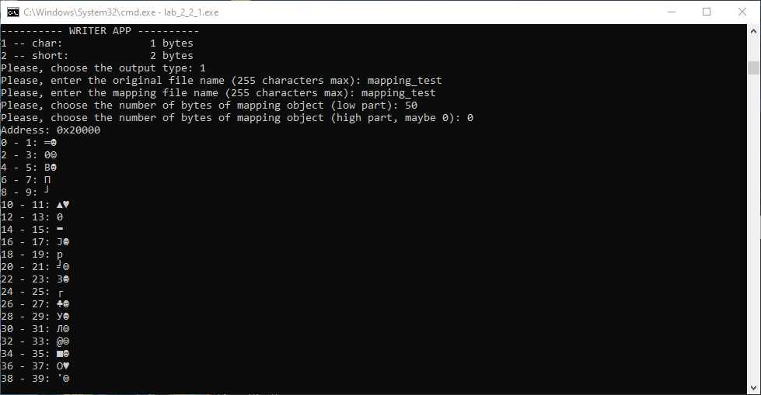

Рисунок 26: Создание проецируемого файла 1 с символьным выводом

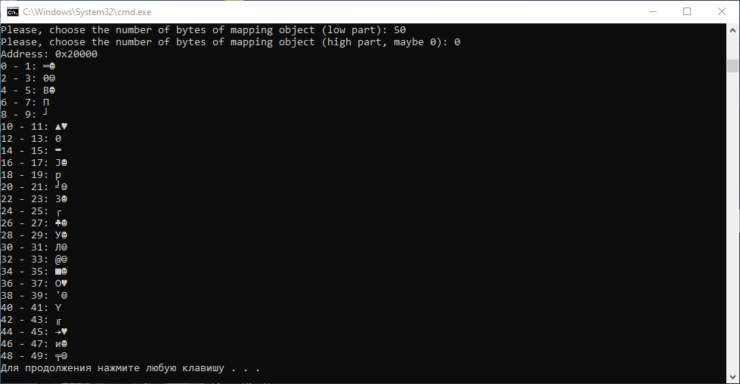

Рисунок 27: Создание проецируемого файла 1 с символьным выводом

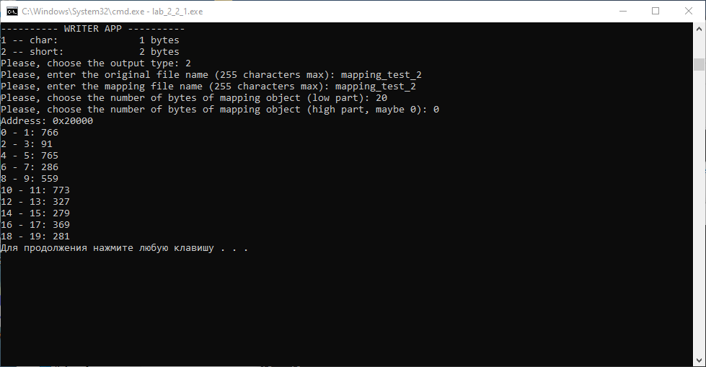

Рисунок 28: Создание проецируемого файла 2 с численным выводом

## 3.2. Открытие проецируемого файла приложением-читателем

В приложении-читателе открывается проецируемый файл (с тем же именем, что и был создан) для чтения. Далее осуществляется проецирование файла в память. Затем осуществляется чтение заданного количества байт с заданным форматом вывода данных, которые можно сравнить с данными, полученными при записи в приложении-писателе.

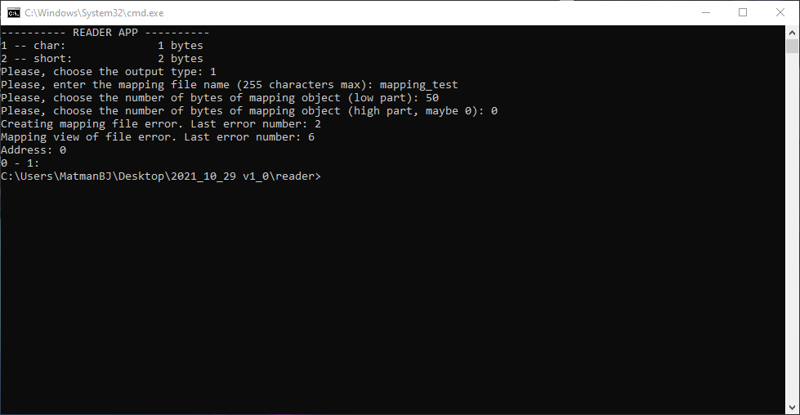

Рисунок 29: Открытие проецируемого файла 1 до его создания

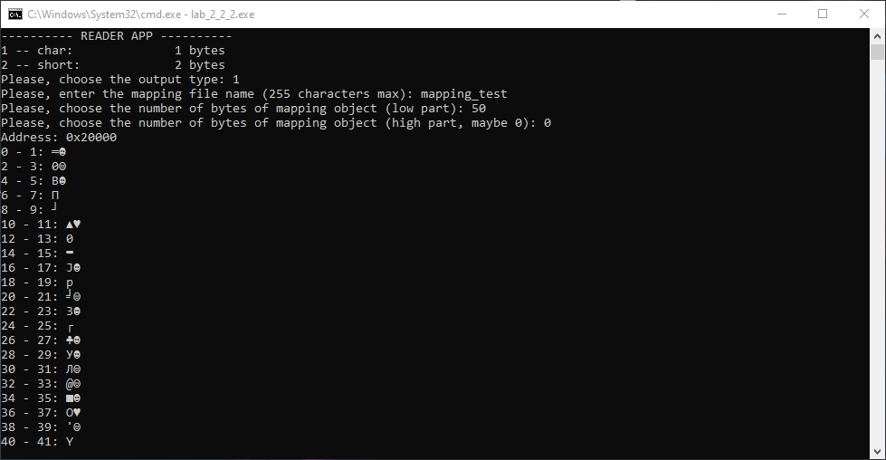

Рисунок 30: Открытие проецируемого файла 1 с символьным выводом

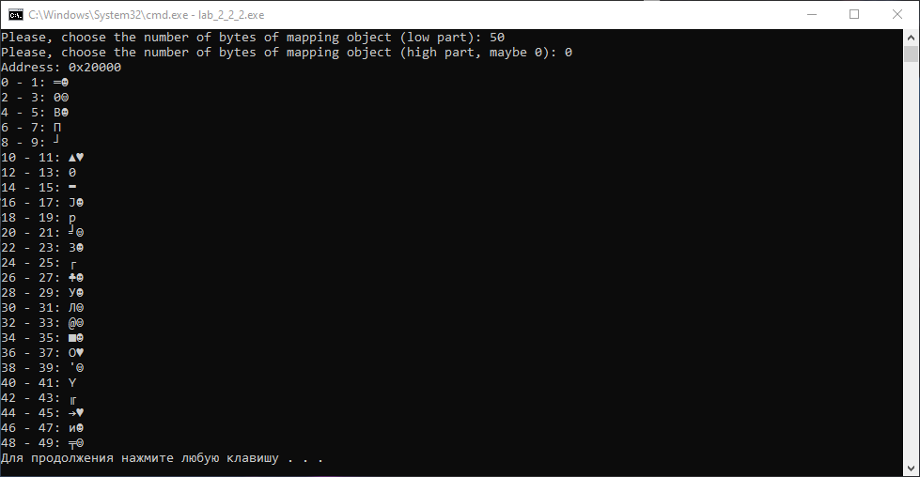

Рисунок 31: Открытие проецируемого файла 1 с символьным выводом

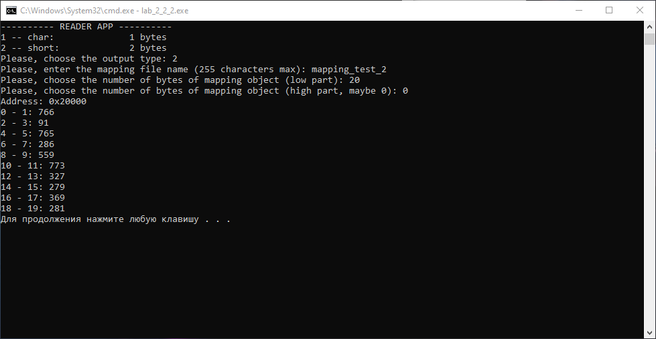

Рисунок 32: Открытие проецируемого файла 2 с численным выводом

## 3.3. Исходный код программы-писателя

/*

Win32 API (WinAPI) is a set of functions in the library <windows.h>

API means "Application Programming Interface"

*/

#include <windows.h> // for WinAPI functions

#include <iostream> // just for working

#include <ctime> // for randomization

#include <string> // for the "string" type using

using namespace std;

// ---------- MAIN ----------

int main (int argc, char* argv[])

{

cout << "---------- WRITER APP ----------\n";

int i; // loop variable

int localEndingType = 1; // type choose for output

// all possible types of types choosing

cout << "1 -- char:\t\t" << sizeof(char) << " bytes\n";

cout << "2 -- short:\t\t" << sizeof(short) << " bytes\n";

int localStartingType = 1; // type choose for input

LARGE_INTEGER localBytes; // default

string createFileName = "localFileOne";

string mappingFileName = "localFileTwo";

// input and output adress and type choosing

do

{

cout << "Please, choose the output type: ";

cin >> localStartingType;

}

while (localStartingType < 1 || localStartingType > 2);

do

{

cout << "Please, enter the original file name (255 characters max): ";

cin >> createFileName;

}

while (createFileName.length() > 255);

do

{

cout << "Please, enter the mapping file name (255 characters max): ";

cin >> mappingFileName;

}

while (mappingFileName.length() > 255);

cout << "Please, choose the number of bytes of mapping object (low part): ";

cin >> localBytes.LowPart;

cout << "Please, choose the number of bytes of mapping object (high part, maybe 0): ";

cin >> localBytes.HighPart;

switch (localStartingType) // starting output type

{

case 1:

localStartingType = sizeof(char);

break;

case 2:

localStartingType = sizeof(short);

break;

default:

localStartingType = sizeof(char);

break;

}

srand((unsigned)time(0));

HANDLE createdFile = CreateFile(

createFileName.c_str(), // filename

GENERIC_READ | GENERIC_WRITE, // desired access [all usage]

FILE_SHARE_DELETE | FILE_SHARE_READ | FILE_SHARE_WRITE, // share mode [all usage]

NULL, // security attributes [NULL has been chosen because of current unusability of the other ones]

CREATE_NEW, // creating/open files [CREATE_NEW is safety for other files]

FILE_ATTRIBUTE_NORMAL, // flags and attributes [normal mode has been chosen because of current unusabilty of the other ones]

NULL // templete file handle [NULL has been chosen because of current unusability of the other ones]

);

if (createdFile == INVALID_HANDLE_VALUE)

{

cout << "Creating file error. Last error number: " << GetLastError() << "\n";

}

HANDLE mappingFileOld = CreateFileMapping(

createdFile, // handle of the created file [choosed the new one]

NULL, // mapping attributes [NULL has been chosen because of current unusability of the other ones]

PAGE_READWRITE, // page protection type [PAGE_READWRITE has been chosen because it' most convinient]

localBytes.HighPart, // high order DWORD (second part)

localBytes.LowPart, // low order DWORD (first part) [0 if the low-part means mapping file size = created file size]

mappingFileName.c_str() // mapping filename [filename]

);

if (mappingFileOld == NULL || GetLastError() == ERROR_ALREADY_EXISTS)

{

cout << "Creating mapping file error. Last error number: " << GetLastError() << "\n";

}

LPVOID mappingOld = MapViewOfFile(

mappingFileOld, // handle of the mapping file

FILE_MAP_WRITE, // special desired access flag [FILE_MAP_WRITE is compatiable with PAGE_READWRITE]

0, // OffsetHigh

0, // OffsetLow

0 // bytes to map [0 means all]

);

if (mappingOld == NULL)

{

cout << "Mapping view of file error. Last error number: " << GetLastError() << "\n";

}

cout << "Address: " << mappingOld << "\n";

// randomization and output loop

for (i = 0; i + 1 < localBytes.QuadPart; i = i + 2)

{

*(short*)(mappingOld + i) = (rand() % 6)*2 + (rand() % 855);

if (localStartingType == 2)

{

cout << i << " - " << i + 1 << ": ";

cout << *(short*)(mappingOld + i) << "\n";

}

else

{

cout << i << " - " << i + 1 << ": ";

cout << *(char*)(mappingOld + i) << *(char*)(mappingOld + i + 0x1) << "\n";

}

}

UnmapViewOfFile(mappingOld); // unmapping current file

CloseHandle(createdFile); // closing handle of original file, NOT THE MAPPING FILE, DON'T DO THAT

//CloseHandle(mappingFileOld);

system("pause");

return 0;

}

## 3.4. Исходный код программы-читателя

/*

Win32 API (WinAPI) is a set of functions in the library <windows.h>

API means "Application Programming Interface"

*/

#include <windows.h> // for WinAPI functions

#include <iostream> // just for working

#include <string> // for the "string" type using

using namespace std;

// ---------- MAIN ----------

int main (int argc, char* argv[])

{

cout << "---------- READER APP ----------\n";

int i; // loop variable

int localEndingType = 1; // type choose for output

// all possible types of types initializing

LARGE_INTEGER localBytes; // default

string mappingFileName = "localFileTwo";

// all possible types of types choosing

cout << "1 -- char:\t\t" << sizeof(char) << " bytes\n";

cout << "2 -- short:\t\t" << sizeof(short) << " bytes\n";

// input and output adress and type choosing

do

{

cout << "Please, choose the output type: ";

cin >> localEndingType;

}

while (localEndingType < 1 || localEndingType > 2);

do

{

cout << "Please, enter the mapping file name (255 characters max): ";

cin >> mappingFileName;

}

while (mappingFileName.length() > 255);

cout << "Please, choose the number of bytes of mapping object (low part): ";

cin >> localBytes.LowPart;

cout << "Please, choose the number of bytes of mapping object (high part, maybe 0): ";

cin >> localBytes.HighPart;

switch (localEndingType) // starting output type

{

case 1:

localEndingType = sizeof(char);

break;

case 2:

localEndingType = sizeof(short);

break;

default:

localEndingType = sizeof(char);

break;

}

bool localRepeat = true; // repeating input

SIZE_T localStartingSize = 0; // memory size for output

SIZE_T localEndingSize = 0; // memory size for output

HANDLE mappingFileNew = OpenFileMapping(

FILE_MAP_WRITE, // special desired access flag [FILE_MAP_WRITE is compatiable with PAGE_READWRITE]

false, // inheritance mechanics -- unuseful here

mappingFileName.c_str() // unique name of the mapping file

);

if (mappingFileNew == NULL)

{

cout << "Creating mapping file error. Last error number: " << GetLastError() << "\n";

}

// ACCESS GRANTED BY MAPPING FILENAME, SO IT MUST BE THE SAME

LPVOID mappingNew = MapViewOfFile(

mappingFileNew, // handle of the mapping file

FILE_MAP_WRITE, // special desired access flag [FILE_MAP_WRITE is compatiable with PAGE_READWRITE]

0, // OffsetHigh

0, // OffsetLow

0 // bytes to map [0 means all]

);

if (mappingNew == NULL)

{

cout << "Mapping view of file error. Last error number: " << GetLastError() << "\n";

}

cout << "Address: " << mappingNew << "\n";

//MEMORY_BASIC_INFORMATION localMBI = {0};

//VirtualQueryEx(GetCurrentProcess(), mappingNew, &localMBI, sizeof(localMBI));

//out << "TRY IT: " << localMBI.RegionSize;

// output loop

// IT COVERS ALL MEMORY CLUSTERS FOR CHAR AND SHORT -- I CHECKED

for (i = 0; i + 1 < localBytes.QuadPart; i = i + 2)

{

if (localEndingType == 2)

{

cout << i << " - " << i + 1 << ": ";

cout << *(short*)(mappingNew + i) << "\n";

}

else

{

cout << i << " - " << i + 1 << ": ";

cout << *(char*)(mappingNew + i) << *(char*)(mappingNew + i + 0x1) << "\n";

}

}

system("pause");

return 0;

}

## 3.5. Выводы по работе проецируемых файлов

Проецируемые файлы работают следующим образом. Происходит выделение страниц в виртуальном адресном пространстве (виртуальной памяти) с соответствующей физической памятью в виде самого файла, который нужно спроецировать, иными словами, логическим адресам (при их достаточном для файла количестве) ставятся в соответствие физические адреса, которые занимает необходимый файл. Это и будет являться проецированием файла в память. Следовательно, изменение и чтение данных по логическим (виртуальным) адресам будет приводить к изменению и чтению данных самого файла соответственно.

## 3.6. Выводы

В ходе выполнения второй части («Использование проецируемых файлов для обмена данными между процессами») лабораторной работы №2 «Управление памятью» было изучено взаимодействие с проецируемыми файлами. Было создано два приложения: приложение-писатель создавало проецируемый файл и заполняло его данными, приложение-читатель открывало проецируемый файл и считывало из него данные. При попытке открыть несуществующий файл возникала ошибка, а при удачном открытии файла информация, считываемая из него, была идентична исходным сгенерированным данным. Таким образом и было исследованы проецируемые файлы.

# 4. Список использованных источников

1. Операционные системы: электронные методические указания к лабораторным работам / Сост.: А. В. Тимофеев. СПб.: Изд-во СПбГЭТУ

«ЛЭТИ», 2016.

2. Таненбаум Э. Современные операционные системы. 2-е изд. – СПб.: Питер, 2002. – 1040 с.: ил.

3. Курс «Операционные системы» в образовательной онлайн-системе Google Класс [сайт]. URL: <https://classroom.google.com/c/Mzg3ODc4NDE5MDU4>.